Statistics with R programming -DAY-6

Thanuja R

192325004

21.

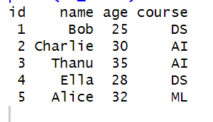

22.

