Autoencoder-Based Adversarial Perturbation Detection Using Transfer Learning
Major Project Phase II Report
submitted by

Mr. Adarsh A S  (USN NNM22IS006) | Mr. Advik A Rai  (USN NNM22IS010)
Mr. V Thanuj  (USN NNM22IS192) | Mr. Vivek D Kulal  (USN NNM22IS204)

To



(Estd. under Section 3, UGC Act 1956)
(Placed under Category ‘A’ by MHRD, Govt. of India; Accredited as ‘A+’ Grade University by NAAC)
In partial fulfilment of the requirements for the award of

BACHELOR OF TECHNOLOGY in
INFORMATION SCIENCE & ENGINEERING

DEPARTMENT OF INFORMATION SCIENCE & ENGINEERING

NMAM INSTITUTE OF TECHNOLOGY, NITTE
April 2026
Autoencoder-Based Adversarial Perturbation Detection Using Transfer Learning
Major Project Phase II Report
submitted by

Mr. Adarsh A S  (USN NNM22IS006) | Mr. Advik A Rai  (USN NNM22IS010)
Mr. V Thanuj  (USN NNM22IS192) | Mr. Vivek D Kulal  (USN NNM22IS204)
Under the Guidance of

Dr. Naganna Chetty

To



(Estd. under Section 3, UGC Act 1956)
(Placed under Category ‘A’ by MHRD, Govt. of India; Accredited as ‘A+’ Grade University by NAAC)
In partial fulfilment of the requirements for the award of

BACHELOR OF TECHNOLOGY in
INFORMATION SCIENCE & ENGINEERING

DEPARTMENT OF INFORMATION SCIENCE & ENGINEERING

NMAM INSTITUTE OF TECHNOLOGY, NITTE
April 2026



Department of Information Science & Engineering

CERTIFICATE

This is to certify that the Project Report of the project work titled “Autoencoder-Based Adversarial Perturbation Detection Using Transfer Learning” is a bonafide research work carried out by Adarsh A S (NNM22IS006), Advik A Rai (NNM22IS010), V Thanuj (NNM22IS192),Vivek D Kulal (NNM22IS204) under the guidance of Dr. Naganna Chetty and co-guidance of Dr. Manjula Gururaj Rao in the Department of Information Science Engineering NMAM Institute of Technology, Nitte.

The same is being submitted to the Nitte (Deemed to be University) in partial fulfillment of the requirements for the award of Bachelor of Technology in Information Science Engineering.

Name & Signature of Guide(s) Name & Signature of HOD

Head of the Institution

Project Viva voce

Name of the Examiners Signature with Date

1. _______________________________ _______________________________

2. ______________________________ ________________________________

ACKNOWLEDGEMENT

Any achievement, be it scholastic or otherwise does not depend solely on the individual efforts but on the guidance, encouragement and cooperation of intellectuals, elders and friends. A number of personalities, in their own capacities have helped me in carrying out this mini-project work. We would like to take this opportunity to thank them all.

First and foremost we would like to thank Dr. Niranjan N Chiplunkar, Principal, NMAMIT, Nitte, for his moral support towards completing my mini-project work.

We would like to thank Dr. Ashwini B, Head of the Department, Information Science & Engineering, NMAMIT, Nitte, for her valuable suggestions and expert advice.

We also extend my cordial thanks to Major-Project Mentors, Dr. Manjula Gururaj Rao and Dr. Naganna Chetty, Mr.Vasudev Pai, Mr. Abhishek Rao, Mr.Vaikunt Pai, Ms.Preethi Salian K for their support and guidance.

We deeply express my sincere gratitude to my guide Dr. Naganna Chetty (Associate Professor), Department of ISE, NMAMIT, Nitte, for his able guidance, regular source of encouragement and assistance throughout this major-project work.

We thank our Parents and all the Faculty members of Department of Information Science & Engineering for their constant support and encouragement.

Last, but not the least, we would like to thank our peers and friends who provided use with valuable suggestions to improve our major-project.

ABSTRACT

Online review systems are widely used for sentiment understanding, rating prediction, and decision support, but such systems can be affected by small linguistic changes that alter model behavior. Adversarial and perturbed text in NLP has therefore become an important research problem, especially in systems where subtle token substitutions, paraphrases, misspellings, and semantically influential modifiers may change the model output [10]-[19]. This project presents an explainable review-analysis system that detects whether a review is clean or perturbed and also predicts its star rating. The system combines semantic representation, autoencoder-based anomaly signals, adverb-focused linguistic features, and machine learning models in a single framework. The implementation uses semantic embeddings together with hybrid features such as reconstruction error, latent distance, anomaly score, adverb count, adverb weight, and average adverb influence. Reconstruction-based anomaly ideas are motivated by recent work on calibrated and layer-wise autoencoder detection methods, which show that abnormal samples can be identified through feature reconstruction behavior [3], [7], [9]. The project also includes an interactive dashboard that provides multiple explanation views, such as SHAP/LIME-based interpretation, adverb ablation analysis, counterfactual explanations, token sensitivity, calibration, and feature-level response analysis. The main contribution of the project is that it does not stop with prediction alone. Instead, it provides a transparent explanation of why a review is classified as clean or perturbed and how specific linguistic choices influence the result. In this way, the project supports the larger research direction of interpretable and trustworthy NLP systems for perturbed text analysis [18], [19].

TABLE OF CONTENTS

CHAPTER NO. | TITLE | PAGE NO.
 | ABSTRACT | 1
 | LIST FIGURES | 4
 | LIST OF TABLES | 5
1. | INTRODUCTION | 6-11
2. | RELATED WORK | 12-18
3. | REQUIREMENTS SPECIFICATION AND PROBLEM STATEMENT | 19-23
 | 3.1 SOFTWARE REQUIREMENTS | 19
 | 3.2 HARDWARE REQUIREMENTS | 20
 | 3.3 PROBLEM STATEMENT | 21
 | 3.4 OBJECTIVES | 21
 | 3.5 METHODOLOGY | 22-23
4. | SYSTEM DESIGN | 24-25
 | 4.1 SYSTEM ARCHITECTURE | 24
 | 4.2 DATA FLOW DIAGRAM | 25
 | 4.5 SUMMARY | 25
5. | SYSTEM IMPLEMENTATION | 26-35
 | 5.1 TEXT PREPROCESSING | 26
 | 5.2 SEMANTIC EMBEDDING GENERATION | 26
 | 5.3 AUTOENCODER-BASED FEATURE EXTRACTION | 27
 | 5.4 ADVERB AND LINGUISTIC FEATURE EXTRACTION | 27
 | 5.5 HYBRID FEATURE CONSTRUCTION | 28
 | 5.6 CLASSIFICATION MODELS FOR CLEAN/PERTURBED DETECTION | 28
 | 5.7 STAR RATING PREDICTION MODELS | 29
 | 5.8 STREAMLIT DASHBOARD IMPLEMENTATION | 29
 | 5.9 SHAP EXPLANATION MODULE | 30
 | 5.10 ADVERB ABLATION IMPACT MODULE | 30
 | 5.11 COUNTERFACTUAL EXPLANATION MODULE | 31
 | 5.12 LIME LOCAL EXPLANATION MODULE | 31
 | 5.13 TOKEN ATTRIBUTION AND DELETION SENSITIVITY | 32
 | 5.14 PDP/ICE VISUALIZATION MODULE | 33
 | 5.15 GLOBAL FEATURE IMPORTANCE AND STABILITY | 33
 | 5.16 CALIBRATION AND CONFIDENCE ANALYSIS | 34
 | 5.17 PRESENTATION-ORIENTED FEATURES | 34
 | 5.18 SUMMARY | 35
6. | SYSTEM TESTING | 36-41
 | 6.1 TESTING OBJECTIVES | 36
 | 6.2 FUNCTIONAL TESTING | 36
 | 6.3 AUTOENCODER TESTING | 37
 | 6.4 PERTURBATION DETECTION TESTING | 38
 | 6.5 RATING PREDICTION TESTING | 38
 | 6.6 EXPLAINABLE AI TESTING | 39
 | 6.7 INTEGRATION TESTING | 40
 | 6.8 SUMMARY | 41
7 | RESULT AND DISCUSSION | 42-51
 | 7.1 MODEL PERFORMANCE SUMMARY | 42
 | 7.2 PRESENTATION SUMMARY AND MODEL AGREEMENT | 43
 | 7.3 CLEAN/PERTURBED PREDICTION AND STAR RATING OUTPUT | 43
 | 7.4 SHAP EXPLANATION OUTPUT | 44
 | 7.5 ADVERB ABLATION IMPACT | 44
 | 7.6 COUNTERFACTUAL EXPLANATION | 45
 | 7.7 LIME LOCAL EXPLANATION | 45
 | 7.8 TOKEN ATTRIBUTION OUTPUT | 46
 | 7.9 PDP/ICE OUTPUT FOR HYBRID FEATURES | 47
 | 7.10 GLOBAL FEATURE IMPORTANCE AND STABILITY | 48
 | 7.11 CALIBRATION AND CONFIDENCE ANALYSIS | 49
 | 7.13 FINAL DISCUSSION | 50
 | 7.14 SUMMARY | 51
8 | CONCLUSION AND NEXT WORK | 52-54
 | 8.1 CONCLUSION | 52
 | 8.2 FUTURE WORK | 53-54
9 | References | 55

LIST OF FIGURES
FIGURE NO. | FIGURE NAME | PAGE NO.
4.1 | SYSTEM ARCHITECTURE OF THE PROPOSED REVIEW ANALYSIS FRAMEWORK | 25
7.1 | PRESENTATION SUMMARY AND MODEL AGREEMENT OUTPUT
7.2 | CLEAN/PERTURBED PREDICTION TABLE AND STAR RATING VISUALIZATION
7.3 | SHAP EXPLANATION FOR LOGISTIC REGRESSION AND LIGHTGBM
7.4 | ADVERB ABLATION IMPACT GRAPH
7.5 | COUNTERFACTUAL EXPLANATION WITH BEFORE-AND-AFTER SENTENCE COMPARISON
7.6 | LIME LOCAL EXPLANATION FOR LIGHTGBM
7.7 | TOKEN ATTRIBUTION USING DELETION SENSITIVITY
7.8 | PDP/ICE PLOT FOR SELECTED HYBRID FEATURE
7.9 | GLOBAL FEATURE IMPORTANCE AND STABILITY OUTPUT
7.10 | CALIBRATION CURVE FOR LOGISTIC REGRESSION AND LIGHTGBM
7.11 | FEATURE GLOSSARY AND PRESENTATION INSIGHT OUTPUT

LIST OF TABLES

TABLE NO. | TABLE NAME | PAGE NO.
6.1 | FUNCTIONAL TESTING RESULTS
6.2 | AUTOENCODER AND FEATURE TESTING
6.3 | PERTURBATION DETECTION TESTING
6.4 | RATING PREDICTION TESTING
6.5 | EXPLAINABLE AI TESTING
6.6 | INTEGRATION TESTING RESULTS
7.1 | PERFORMANCE SUMMARY OF CLASSIFICATION MODELS

Online reviews have become a major source of information for both users and businesses. Customers use reviews to compare products, services, hotels, restaurants, and other offerings, while organizations use reviews to understand satisfaction, identify problems, and improve decisions. Because of this, natural language processing and machine learning are widely used for sentiment analysis, classification, and rating prediction. However, existing systems are often sensitive to small linguistic changes, which makes robustness and interpretability important research problems [18].
A major challenge in review analysis is that small changes in wording can change the output of a model even when the overall topic remains similar. In adversarial NLP literature, this has been shown through synonym substitution attacks, contextual replacement attacks, misspellings, trigger phrases, and token-level perturbations [10]-[17]. In real review text, similar effects may happen through ordinary language variation, especially when users use intensifiers, negations, contrastive phrases, or exaggerated wording. As a result, it is not always enough for a system to produce only a prediction. It must also explain why the prediction changed and whether the wording itself contributed to the output.
This project is built on that motivation. Instead of treating every review as a normal sentiment input, the system attempts to identify whether the review is clean or perturbed. In this work, a perturbed review does not always mean malicious text; rather, it refers to a review whose wording shows unusual or semantically influential characteristics that may affect how the model behaves. The broader literature shows that detectors based only on surface statistics may not be sufficient, and that stronger methods often rely on multiple signals, robust feature spaces, and reconstruction-based behavior [1]-[3], [7].

Another limitation in many review-analysis systems is the lack of interpretability. A model may label a review as suspicious or perturbed, but the user is often left without a clear explanation of which words or features caused the output. This issue has motivated the development of more robust detectors, calibration-aware systems, purification methods, and autoencoder-based mechanisms in recent research [3], [5], [6], [18]. The current project takes a more explanation-oriented approach by combining perturbation detection with a dashboard that reveals the effect of different features and linguistic elements.
The project therefore has two linked goals: first, to classify whether a review is clean or perturbed and predict the corresponding star rating; second, to explain the reasoning behind the result. The system uses embeddings and hybrid features, including reconstruction error and adverb-based influence, so that the final output is based not only on raw text but also on anomaly-aware signals. This follows the broader trend in the literature where feature-space behavior and model sensitivity are treated as important indicators of adversarial or perturbed input [2], [3], [7], [9].
- In summary, the project contributes to the area of trustworthy NLP by building a practical review-analysis system that combines perturbation detection, rating prediction, and explanation. Rather than focusing only on model performance, it also emphasizes transparency, which is increasingly important in modern adversarial and robustness research [18], [19].

Within this project, trust is cultivated through several mechanisms. The system does not depend on a single model; instead, it presents outputs from multiple classifiers. It does not solely employ one explanation method, but rather integrates several explanation techniques. Beyond probability scores, it also evaluates calibration and agreement. Furthermore, it moves beyond abstract feature values to trace the impact of concrete linguistic elements like adverbs. This layered methodology renders the final system more meaningful than a basic classification pipeline.

This project also diverges from standard review analysis by emphasizing perturbation-aware interpretation. While existing large-scale commercial systems may analyze reviews for purposes such as ranking, helpfulness, spam detection, or sentiment, these systems typically lack transparency for the end-user. In contrast, this project is conceived as an interpretable academic system. Its primary objective is not merely text classification, but also to unveil how linguistic variations influence model decisions, making it particularly useful for research, experimentation, and demonstration.

In conclusion, this project introduces a review-analysis framework that integrates semantic embeddings, anomaly-based hybrid features, adverb-focused linguistic analysis, machine learning classification, rating prediction, and explainable AI. It addresses a crucial practical challenge: identifying when subtle wording changes affect a model's behavior and providing clear explanations for such influences. By consolidating prediction and explanation within a single dashboard, the project enhances the transparency, reliability, and real-world applicability of review analysis.

The rest of the report explains the system in detail. It describes the models, the hybrid features, the role of the autoencoder, the adverb-analysis process, the explanation methods, the dashboard design, the testing process, and the final results. The overall goal is to show that review-analysis systems can be made more informative and trustworthy when explanation is treated as an essential part of the pipeline rather than an optional extra.

Chapter 2: Related Work
2.1 Introduction
The problem of adversarial and perturbed text has become an important area of research in natural language processing. Modern text classification systems can achieve high performance on benchmark datasets, but they are still vulnerable to carefully designed or naturally occurring linguistic perturbations. Small changes such as synonym substitution, misspellings, paraphrases, trigger phrases, and style modifications can cause a model to misclassify text while preserving most of the original meaning. This is especially important in review-analysis systems, where a small change in wording can influence classification, rating prediction, or model confidence.
Recent research in this area has focused on several directions. Some works generate adversarial text and show the weakness of existing classifiers. Others propose detection methods based on model features, density estimation, reconstruction error, or ensemble learning. A third line of work studies purification methods, including large language model based correction systems. More recent studies also explore autoencoders, sparse representations, and layer-wise analysis to identify perturbations more effectively. This chapter reviews these contributions and explains how they connect to the current project.

2.2 Multi-Feature Adversarial Detection Methods

One important direction in recent literature is the use of multiple signals for adversarial detection rather than relying on a single score. MAFD: Multiple Adversarial Features Detector (2024) proposes a multi-feature detector that combines segmented perplexity, word frequency, masked language model probability, logits, and ensemble-based signals for adversarial text detection [1]. The strength of this work lies in the fact that it does not assume one feature is enough to detect perturbation. Instead, it uses a collection of signals that together provide a better picture of adversarial behavior.

This approach is relevant because adversarial text can appear normal under one metric but suspicious under another. For example, a sentence may have normal word frequency but unusual masked language model behavior. Multi-feature detection addresses this by combining different views of the same input. However, the limitation noted in the synopsis is that such systems can become computationally expensive and may suffer from overfitting or slower inference [1]. This is important for practical applications such as live dashboards, where explanation speed also matters.
A related line of work is represented by Detection of Adversarial Examples in Text Classification using the RDE Benchmark (2022) [2]. This work emphasizes robust density estimation over model features and proposes a benchmark-style setting for evaluating adversarial detection. The value of this paper is that it frames detection as a feature-space distribution problem. If adversarial samples fall into low-density regions, they can potentially be separated from normal text. The limitation, however, is that density-based methods struggle with high-dimensional spaces and are often more effective against token-level attacks than more semantic paraphrasing-style attacks [2].
These works together show that adversarial detection benefits from richer signal combinations. This idea directly supports the hybrid feature design used in the current project, where semantic embeddings, anomaly signals, and adverb-based features are combined instead of depending on one feature alone.

2.3 Reconstruction-Based and Autoencoder-Centered Detection

Autoencoder-based detection has become a promising direction because it focuses on reconstruction behavior rather than only surface-level token changes. SCRN: Siamese Calibrated Reconstruction Network (ACL 2024) introduces a denoising autoencoder with siamese calibration to improve confidence stability during detection [3]. The strength of SCRN is that it does not only reconstruct text-related features but also calibrates the detector more carefully, which improves reliability. According to the synopsis, the limitation is that the method is designed mainly for AI-generated text detection and may not generalize equally well across all text genres [3].
Layer-wise Autoencoders for Adversarial Detection (2020) [7] extend the reconstruction idea by using autoencoders at hidden layers and combining reconstruction error with latent norms. This is important because adversarial perturbations may not always be obvious at the input level but can become visible in deeper representations. Although this work was mainly tested on vision settings, the core idea is highly relevant for NLP systems that use embeddings or transformer hidden states [7]. It suggests that reconstruction signals can capture abnormality in a learned feature space even when raw text looks normal.Sparse Autoencoders for Layer-wise Perturbations (2025 preprint) push this direction further by focusing on sparse, high-impact hidden features that may be strongly related to perturbation [9]. The main strength of this work is that it tries to detect influential internal components rather than treating all hidden features equally. According to the synopsis, the work is still early and has limited experimental validation, but it points toward a future direction where perturbation detection becomes more selective and representation-aware [9].T3: Tree-Autoencoder for Text Generation (2020) [8] is not directly a detection paper, but it is relevant because it explores text representation through tree-structured autoencoding. The main emphasis of that work is generation rather than detection, but it shows that autoencoder-based frameworks can be adapted to structured text representations. This supports the broader idea that reconstruction and latent encoding can be useful beyond image data and can be meaningful in language-based tasks as well [8].Taken together, these works show that autoencoder-based approaches are valuable because they model what “normal” representations look like. This is closely related to the current project, which uses reconstruction error, latent distance, and anomaly score as important hybrid signals.

2.4 Adversarial Attack Frameworks and Evaluation Stress Tests

To build a strong detector, it is necessary to understand the attacks being defended against. ADAT: Adversarial Attack Framework (LREC-COLING 2024) is useful in this respect because it provides a framework for generating adversarial text through paraphrasing and related transformations [4]. The value of this work is not mainly in defense but in showing that semantic-preserving modifications can still fool models. According to the synopsis, its limitation is that it focuses more on exposing detector weaknesses than on providing a robust defense [4]. Even so, this makes it useful as a stress-testing framework.
TextFooler is one of the most widely cited adversarial text attack methods and uses synonym substitution to generate adversarial samples [10]. It is a strong baseline because it preserves readability while changing prediction outcomes. The limitation mentioned in the synopsis is that it mainly focuses on substitution-based attacks, which means it does not represent all forms of perturbation [10].
BERT-Attack (2020) uses a masked language model to generate strong contextual adversarial substitutions [11]. Its strength is high transferability and more natural perturbation than simpler synonym methods. However, it also requires access to stronger language-model resources and is more computationally intensive [11]. TextBugger (2019) attacks models through character-level and word-level perturbations and shows real-world vulnerability in deployed systems [12]. Its importance lies in demonstrating that even practical applications are vulnerable, not only research benchmarks.
Pruthi et al. (2019) focus on adversarial misspellings and spelling-correction-based defenses [13]. This is useful because many real-world perturbations are not sophisticated semantic attacks; they can be simple character-level distortions that still hurt performance. Universal Adversarial Triggers (2019) show that short, reusable trigger phrases can strongly influence model behavior across inputs [14]. Although such triggers may not always appear naturally in user-generated reviews, they are valuable as robustness stress tests.
FGWS (2020) proposes a frequency-guided word substitution approach [15], while DISP (2019) uses a token-level perturbation discriminator [16]. Dirichlet Neighborhood Ensemble (2021) adds randomized smoothing and neighborhood robustness ideas [17]. Together, these papers show the diversity of adversarial techniques and defenses. They make clear that no single attack or defense is enough to cover the entire problem space.
For the current project, these works are important because they justify why perturbation-aware analysis is needed. Even if the dashboard is not a direct adversarial attack framework, it benefits from this literature by recognizing that subtle wording changes can create measurable model instability.

2.5 LLM-Based Purification and Correction Methods

A more recent direction in the literature uses large language models for adversarial defense or purification. LLMAD: Large Language Model Adversarial Defense (Electronics 2025) combines soft-masking perturbation detection with LLM-based correction [5]. The main idea is that once suspicious parts of the text are identified, an LLM can help repair or rephrase the sentence before classification. This is an attractive direction because LLMs are flexible and can operate at the sentence level rather than only on token replacements.
Similarly, Adversarial Text Purification via LLMs (2024) explores the use of prompted large language models, such as GPT-style systems, to purify adversarial text in an attack-agnostic way [6]. This work is valuable because it treats purification as a general semantic correction problem rather than as a handcrafted defense against one attack class. However, the synopsis clearly notes a key limitation: heavy dependence on LLMs may introduce semantic drift. In other words, the corrected text may no longer preserve the original meaning perfectly [6].
These methods are important because they show a movement from pure detection to detection-plus-correction. However, they are also computationally expensive and can be difficult to control. For this reason, the current project takes a more lightweight and interpretable approach. Instead of purifying every suspicious review through an LLM, it emphasizes explanation, ablation, and semantic analysis. This is a useful distinction in a project setting because it improves transparency and reduces system complexity.

2.6 Robustness Surveys and Conceptual Foundations

The Survey on NLP Adversarial Defenses (2022) [18] is important because it organizes the field into a structured taxonomy. Survey papers do not propose one new method, but they help identify trends, weaknesses, and open challenges. According to the synopsis, this survey is useful as a theoretical foundation for designing new empirical defenses [18]. In the context of this project, it helps situate the work within a larger defense landscape that includes attack detection, purification, smoothing, and robust training.
Carlini et al. are referenced in the synopsis in relation to the broader limits of adversarial robustness [19]. Their work is widely known for showing that adaptive attacks can bypass many detectors and that detection-only approaches are often not enough. Even though the original line of work was heavily associated with image-based robustness, the conceptual warning still applies to text: if a detector is designed narrowly, a stronger attacker may find ways around it. This is useful for the current project because it encourages a balanced claim. The system should be presented as an interpretable perturbation-analysis framework, not as a perfect or complete adversarial defense against every possible attack [19].

2.7 Emerging Themes from the Literature

When the reviewed papers are considered together, several important themes appear.The first theme is that adversarial text is highly diverse. Some attacks modify spelling, some use synonyms, some rely on paraphrasing, and others use trigger phrases. This means perturbation detection cannot depend on one narrow assumption [10][11][12][13][14][15][16][17].
The second theme is that feature-space and representation-level analysis are increasingly important. Papers such as the RDE benchmark study, SCRN, and layer-wise autoencoder methods show that perturbation becomes easier to detect when the system examines learned features rather than only raw text [2][3][7][9].
The third theme is that robustness and explainability need to be connected. Many detection papers identify adversarial samples, but they do not always explain why a specific input was flagged. Purification papers may correct the input, but they can reduce transparency. This leaves room for systems that not only detect perturbation but also explain it clearly.
The fourth theme is the trade-off between robustness and efficiency. Some of the strongest methods are computationally heavy, especially those involving LLM-based correction or many combined features [1][5][6]. This is an important practical issue for systems intended for real-time use.

2.8 Relevance to the Current Project

The current project draws practical motivation from all of these works. From multi-feature detection literature, it adopts the idea that one signal is not enough [1][2]. From reconstruction-based work, it takes the idea that abnormal samples can be identified through reconstruction error and latent behavior [3][7][9]. From adversarial attack papers, it takes the insight that small lexical or semantic changes can cause large model shifts [10][11][12][13][14]. From purification and robustness literature, it takes the broader goal of increasing trust and robustness, while choosing a more interpretable path [5][6][18][19].
At the same time, the current project differs from much of the literature in one clear way. Many surveyed methods aim to generate attacks, build broad detectors, or purify adversarial text. The present project focuses more specifically on review analysis and explanation. Its distinctive angle is to examine perturbation through hybrid semantic-anomaly signals and adverb-centered linguistic analysis. Instead of asking only “is this adversarial?”, it also asks “which part of the wording changed the model’s behavior, and how can that be shown clearly to the user?” This is where the dashboard-oriented and explainability-oriented nature of the project becomes important.

2.9 Summary

The literature shows that adversarial and perturbed text detection is an active and challenging research area. Multi-feature detectors improve robustness but can be computationally expensive [1]. Density-based benchmarks provide useful evaluation settings but struggle with high-dimensional semantic spaces [2]. Reconstruction-based methods using autoencoders and calibrated networks show promise for detecting unusual patterns in learned representations [3][7][9]. Attack-generation papers such as TextFooler, BERT-Attack, TextBugger, and Universal Adversarial Triggers demonstrate how vulnerable text classifiers can be [10][11][12][14]. LLM-based purification methods suggest a correction-oriented future but raise concerns about cost and semantic drift [5][6]. Survey and robustness-limit work remind researchers that no single detector is complete [18][19].These studies collectively motivate the need for systems that are not only perturbation-aware but also interpretable. This is the gap addressed by the current project, which combines hybrid features, anomaly-aware modeling, and explanation-driven review analysis in a practical dashboard setting.

This chapter describes the software and hardware requirements needed for the project, defines the problem addressed by the system, presents the objectives, and explains the methodology followed in implementation. The project is developed as an explainable review analysis system that identifies whether a review is clean or perturbed and also predicts the corresponding star rating. Along with prediction, the system provides explanations through multiple XAI methods such as SHAP, LIME, adverb ablation, counterfactual analysis, token attribution, PDP/ICE plots, and calibration output. The need for such systems is motivated by recent work on adversarial and perturbed text, where subtle changes in wording can strongly influence classification behavior [10]-[19].
3.1 SOFTWARE REQUIREMENTS

The project is implemented using Python because it provides strong support for machine learning, natural language processing, deep learning, and visualization. Python also supports a large number of open-source libraries that make development easier and more flexible. The software stack is chosen so that semantic representation, reconstruction-based analysis, and interpretability modules can be integrated within one environment.

The main software requirement is Python 3.10 or above. The project uses NumPy and Pandas for numerical and tabular processing, scikit-learn for classification models, and joblib for loading trained models. Semantic representation is handled through the Transformers library, while PyTorch is used to run the autoencoder. The use of reconstruction-based anomaly signals is aligned with current research that highlights reconstruction and latent behavior as useful indicators of perturbed inputs [3], [7], [9].

The project also uses spaCy for linguistic analysis, especially for identifying adverbs and related tokens. The text normalization process is supported by helper libraries such as ftfy and unidecode. For boosting-based classification, the project uses XGBoost and LightGBM. SHAP and LIME are used for explanation, Plotly for charts, and Streamlit for the final dashboard interface.

The major software requirements are:
Operating System: Windows 10/11 or Ubuntu/Linux
Programming Language: Python 3.10 or above
Development Tools: VS Code / Jupyter Notebook
Libraries and Frameworks: Streamlit, PyTorch, Transformers, NumPy, Pandas, scikit-learn, joblib, spaCy, ftfy, unidecode, XGBoost, LightGBM, SHAP, LIME, and Plotly.
These software tools are sufficient to develop, run, and visualize the outputs of the project.
3.2 HARDWARE REQUIREMENTS
The hardware requirements of the project are moderate because the system mainly performs inference using already trained models. However, since the project handles semantic embeddings, machine learning models, autoencoder features, and interactive dashboard visualizations, a system with reasonable processing power and memory is needed.
A laptop or desktop with an Intel i5/i7 processor or AMD Ryzen 5/7 processor is suitable for running the project. A minimum of 8 GB RAM is needed, while 16 GB RAM is recommended for smoother execution. SSD storage is preferred because it provides faster loading of models, datasets, and the virtual environment.
A GPU is not compulsory for the current implementation because the dashboard can run on CPU. However, GPU support can be helpful if the project is extended for larger model training or stronger adversarial evaluation in the future.
The required hardware specifications are: Processor: Intel Core i5/i7 or AMD Ryzen 5/7; RAM: Minimum 8 GB, Recommended 16 GB; Storage: Minimum 256 GB SSD, Recommended 500 GB SSD; GPU: Optional; Internet Connection: Required during installation and setup; Display: Standard laptop/desktop display for dashboard visualization.
These hardware requirements are enough to run the project efficiently and demonstrate the dashboard outputs in real time.
3.3 PROBLEM STATEMENT
- Online review platforms are widely used for customer feedback, product evaluation, and service analysis. Machine learning and NLP models are commonly applied to classify reviews, detect sentiment, and predict ratings. However, these models are often sensitive to small linguistic variations. Minor changes in wording, such as adverbs, intensifiers, negations, or unusual phrasing, can affect the output of the model even when the main topic of the sentence remains similar. This challenge is well supported by adversarial text research, which shows that perturbations can significantly alter classifier behavior [10]-[17].
- Most existing systems focus only on prediction accuracy and provide very little explanation about why a review was classified in a particular way. Because of this, users may not understand whether the output was influenced by semantic irregularity, unusual sentence structure, or a small but important word-level change. This creates a lack of transparency and trust.
- The problem addressed in this project is to build an explainable review analysis system that can identify whether a review is clean or perturbed, predict the corresponding star rating, detect the influence of semantically important adverbs and linguistic variations, and explain the prediction in an understandable way.
- The system should not only give a final result, but also provide supporting evidence that helps users understand why the result was produced.
- 3.4 OBJECTIVES
- The objectives of the project are as follows:
- To develop a review analysis system that identifies whether an input review is clean or perturbed.
- To generate semantic and hybrid features such as embeddings, reconstruction error, anomaly score, and adverb-based influence for prediction.
- To predict the corresponding star rating of the review using trained machine learning models.
- To provide explainable outputs through methods such as SHAP, LIME, adverb ablation, counterfactual analysis, token attribution, and other dashboard visualizations.
- These objectives ensure that the system is not limited to prediction alone, but also includes interpretability, trust, and usability.
- 3.5 METHODOLOGY
- The methodology of the project consists of several stages, beginning with text input and ending with explainable dashboard output. In the first stage, the review text is entered by the user through the dashboard and normalized for further processing. In the second stage, the normalized review is passed through the E5 embedding model, which converts the review into a dense semantic vector representation.
- In the third stage, the embedding is processed using the autoencoder. The autoencoder reconstructs the embedding and produces reconstruction error and latent distance. These values are used to measure how unusual the review is compared to the normal review patterns seen in training. This use of reconstruction-based anomaly behavior is consistent with recent autoencoder-centered detection work [3], [7], [9].
- In the fourth stage, linguistic analysis is applied using spaCy. The system detects adverbs and intensifiers in the review. Each adverb is removed one by one, and the semantic difference between the original sentence and the modified sentence is measured. From this, the project computes adverb count, adverb weight, average adverb influence, and identifies the dominant adverb.
- In the fifth stage, the embedding and hybrid features are combined into one feature vector. This feature vector is passed into multiple trained classification models such as Logistic Regression, SVM, Random Forest, XGBoost, and LightGBM. These models classify the review as clean or perturbed. At the same time, separate rating models predict the star rating.
- In the sixth stage, explainability methods are applied. SHAP is used to identify how individual features contribute to the final classification. LIME provides a local explanation around the current input. Adverb ablation analysis shows how the probability changes when adverbs are removed. Counterfactual analysis shows the minimal text change that alters prediction confidence. Token attribution identifies the words with the highest effect on prediction. PDP/ICE plots visualize how selected hybrid features influence output probability. Calibration curves and model agreement are also generated to improve trust in the system. In the final stage, all outputs are displayed in the Streamlit dashboard.
- The methodology therefore combines semantic embeddings, anomaly-aware features, linguistic analysis, machine learning models, and explainable AI into a single integrated framework for review analysis. This design is consistent with recent research that encourages hybrid, interpretable, and robustness-aware approaches for perturbed text [1], [2], [18], [19].

In the first stage, the review text is entered by the user through the dashboard. The text is normalized and cleaned so that encoding issues and unwanted formatting problems are reduced. This makes the input suitable for semantic processing.
In the second stage, the normalized review is passed through the E5 embedding model. The model converts the review into a dense semantic vector that captures the contextual meaning of the sentence. This semantic representation becomes the foundation for the later stages of the system.
In the third stage, the embedding is processed using the autoencoder. The autoencoder reconstructs the embedding and produces reconstruction error and latent distance. These values are used to measure how unusual the review is compared to the normal review patterns seen in training. A normalized anomaly score is then derived from the reconstruction behavior.
In the fourth stage, linguistic analysis is applied using spaCy. The system detects adverbs and intensifiers in the review. Each adverb is removed one by one, and the semantic difference between the original sentence and the modified sentence is measured. From this, the project computes adverb count, adverb weight, average adverb influence, and identifies the dominant adverb.
In the fifth stage, the embedding and hybrid features are combined into one feature vector. This feature vector is passed into multiple trained classification models such as Logistic Regression, SVM, Random Forest, XGBoost, and LightGBM. These models classify the review as clean or perturbed. At the same time, separate rating models predict the star rating.
In the sixth stage, explainability methods are applied. SHAP is used to identify how individual features contribute to the final classification. LIME provides a local explanation around the current input. Adverb ablation analysis shows how the probability changes when adverbs are removed. Counterfactual analysis shows the minimal text change that alters prediction confidence. Token attribution identifies the words with the highest effect on prediction.
PDP/ICE plots visualize how selected hybrid features influence output probability. Calibration curves and model agreement are also generated to improve trust in the system. In the final stage, all outputs are displayed in the Streamlit dashboard. The dashboard includes prediction tables, star-rating visualization, explanation plots, adverb impact graphs, counterfactual comparison, calibration graphs, and interpretation summaries. This makes the project easy to understand, easy to demonstrate, and suitable for both technical analysis and academic presentation.
The methodology therefore, combines semantic embeddings, anomaly-aware features, linguistic analysis, machine learning models, and explainable AI into a single integrated framework for review analysis.

The system design of the project focuses on creating an explainable review analysis pipeline that can process review text, identify perturbations, predict ratings, and generate interpretable outputs. The entire workflow is organized in a step-by-step manner so that the review moves from data collection and preprocessing to feature extraction, prediction, and final visualization. This helps in understanding both the structure and operation of the system clearly. The design reflects current work on perturbation-aware detection, where systems benefit from multiple signals, reconstruction-based cues, and robust analysis pipelines [1]-[3], [7].

The overall architecture of the proposed system is shown in Fig. 4.1. The system starts with review collection, where TripAdvisor reviews are used as the input data source. The reviews are then passed to the preprocessing stage, where the text is cleaned, normalized, and tokenized. This step ensures that the input becomes suitable for semantic analysis and downstream prediction tasks.
In the next stage, feature extraction is performed. Semantic embeddings are generated from the processed review text, and the autoencoder is trained to learn reconstruction-based patterns from the embeddings. These features are useful for identifying unusual or perturbed review behavior. This design is supported by recent work on calibrated and layer-wise reconstruction-based detectors [3], [7], [9]. After this, the extracted features are given to machine learning models for detection and prediction. In this project, models such as Logistic Regression, Support Vector Machine, Random Forest, and Gradient Boosting are used for classification. The final stage is evaluation and visualization, where model outputs are converted into graphs, metrics, and interpretable dashboard results. The complete system architecture and workflow are illustrated in Fig. 4.1.
4. SYSTEM DESIGN

The system design of the project focuses on creating an explainable review analysis pipeline that can process review text, identify perturbations, predict ratings, and generate interpretable outputs. The entire workflow is organized in a step-by-step manner so that the review moves from data collection and preprocessing to feature extraction, prediction, and final visualization. This helps in understanding both the structure and operation of the system clearly.

4.1 SYSTEM ARCHITECTURE

The overall architecture of the proposed system is shown in Fig. 4.1. The system starts with review collection, where TripAdvisor reviews are used as the input data source. The reviews are then passed to the preprocessing stage, where the text is cleaned, normalized, and tokenized. This step ensures that the input becomes suitable for semantic analysis and downstream prediction tasks.
In the next stage, feature extraction is performed. Semantic embeddings are generated from the processed review text, and the autoencoder is trained to learn reconstruction-based patterns from the embeddings. These features are useful for identifying unusual or perturbed review behavior. After this, the extracted features are given to machine learning models for detection and prediction. In this project, models such as Logistic Regression, Support Vector Machine, Random Forest, and Gradient Boosting are used for classification. The final stage is evaluation and visualization, where model outputs are converted into graphs, metrics, and interpretable dashboard results. The complete system architecture and workflow are illustrated in Fig. 4.1.

The data flow of the proposed system can also be understood from Fig. 4.1, since the same figure shows how the review moves through each stage of the pipeline. The flow begins with TripAdvisor review input, followed by preprocessing operations such as cleaning, normalization, and tokenization. After preprocessing, embeddings are generated and passed to the autoencoder and classification modules.
The processed feature set then flows into the prediction stage, where machine learning models classify the review and generate related outputs. Finally, the results move to the evaluation and visualization stage, where the system produces graphs, metrics, and dashboard-based explanations. Thus, Fig. 4.1 represents both the architecture of the system and the data flow between its different modules. This stepwise flow is consistent with perturbation-analysis pipelines that move from raw text to representation-level and model-level reasoning [2], [18].

Fig. 4.1 System Architecture of the Proposed Review Analysis Framework
This chapter explained the system design of the project using a single combined architecture figure. As shown in Fig. 4.1, the project follows a clear pipeline that begins with review collection and preprocessing, continues through embedding and feature extraction, and ends with prediction, evaluation, and visualization. This design supports both effective review analysis and easy interpretation of the final output [18], [19].

4.2 DATA FLOW DIAGRAM
The data flow of the proposed system can also be understood from Fig. 4.1, since the same figure shows how the review moves through each stage of the pipeline. The flow begins with TripAdvisor review input, followed by preprocessing operations such as cleaning, normalization, and tokenization. After preprocessing, embeddings are generated and passed to the autoencoder and classification modules.
The processed feature set then flows into the prediction stage, where machine learning models classify the review and generate related outputs. Finally, the results move to the evaluation and visualization stage, where the system produces graphs, metrics, and dashboard-based explanations. Thus, Fig. 4.1 represents both the architecture of the system and the data flow between its different modules.

4.3 SUMMARY
This chapter explains how the proposed review analysis system was implemented. The implementation combines natural language processing, semantic embedding, anomaly-aware feature extraction, machine learning classification, rating prediction, and explainable AI techniques in a single pipeline. The complete system is designed to accept a review as input, process it step by step, classify it as clean or perturbed, predict the corresponding star rating, and provide explanation for the decision through an interactive dashboard. This overall implementation direction is aligned with recent adversarial and perturbation-aware text analysis research [1]-[3], [18].
This chapter explained the system design of the project using a single combined architecture figure. As shown in Fig. 4.1, the project follows a clear pipeline that begins with review collection and preprocessing, continues through embedding and feature extraction, and ends with prediction, evaluation, and visualization. This design supports both effective review analysis and easy interpretation of the final output.

Chapter 5 System Implementation

This chapter explains how the proposed review analysis system was implemented. The implementation combines natural language processing, semantic embedding, anomaly-aware feature extraction, machine learning classification, rating prediction, and explainable AI techniques in a single pipeline. The complete system is designed to accept a review as input, process it step by step, classify it as clean or perturbed, predict the corresponding star rating, and provide explanation for the decision through an interactive dashboard.
The implementation is divided into multiple modules so that each stage of the system can be developed and tested separately. These modules include text preprocessing, embedding generation, autoencoder-based anomaly feature extraction, adverb-based feature generation, classification and rating prediction, and dashboard-based explanation and visualization.

5.1 Text Preprocessing

The first stage of implementation is text preprocessing. Since review text is collected from real-world sources, it may contain noise such as inconsistent spacing, unwanted symbols, encoding issues, and formatting irregularities. If such text is used directly, it can reduce the quality of the semantic representation and affect downstream predictions. Therefore, preprocessing is necessary to make the input text more consistent and suitable for further analysis.
The system performs normalization using helper functions that clean the input before it is processed. Libraries such as ftfy and unidecode are used to handle text normalization. The main purpose of this stage is to remove text corruption, convert unusual Unicode patterns into standard readable form, and strip unnecessary spaces. If the review is empty after normalization, the system stops further execution and prompts the user to enter valid text.
This preprocessing stage is lightweight but important because it ensures that the same review meaning is preserved while the input becomes easier for the embedding model and the linguistic analysis module to handle. A normalized review also improves consistency when generating features such as adverb influence and token-level variation.

5.2 Semantic Embedding Generation
Once the semantic embedding is generated, it is passed through the autoencoder. The autoencoder is implemented using PyTorch and consists of an encoder and a decoder. The encoder compresses the embedding into a latent representation, and the decoder reconstructs the original embedding from this latent vector. The use of reconstruction behavior for anomaly-aware signals is consistent with recent autoencoder-centered detection literature [3], [7], [9].
After preprocessing, the review is converted into a semantic embedding. This is one of the most important stages of the implementation because the embedding serves as the base representation of the sentence meaning. Instead of using simple bag-of-words or frequency-based text vectors, the project uses the E5 embedding model through the Transformers library.
The E5 model converts each review into a dense vector representation. This vector captures the contextual and semantic meaning of the review rather than only the exact words used. This is useful because small wording differences, such as changing an adverb, may alter the embedding even when the topic remains similar. Such changes become important in a perturbation-aware system like this one.
The embedding module is implemented so that the model is loaded once and reused for future predictions. This makes the system more efficient during repeated analysis in the dashboard. Batch-based embedding logic is also supported internally, although in the live dashboard the most common case is a single review input at a time.
The embedding stage gives the system a strong semantic foundation. All later stages, including the autoencoder, the hybrid feature generation, and adverb impact measurement, rely on the quality of this vector representation.

5.3 Autoencoder-Based Feature Extraction

A unique part of this implementation is its focus on adverb-level analysis. The project uses spaCy to detect adverbs, negations, and intensifier-like words. In addition to part-of-speech detection, the system maintains a custom set of intensifiers such as “very,” “extremely,” “really,” “barely,” and “absolutely.” This combination of rule-based and linguistic detection helps the system capture words that may strongly influence sentence tone and prediction confidence. This is motivated by the broader adversarial literature showing that small token-level changes can strongly affect model behavior [10]-[17].
The purpose of the autoencoder in this project is not text generation, but anomaly-aware feature extraction. When the original embedding and the reconstructed embedding are compared, the difference between them gives the reconstruction error. If the reconstruction error is low, the review is closer to the patterns learned during autoencoder training. If the reconstruction error is high, the review may be semantically unusual or perturbed.
In addition to reconstruction error, the system also calculates latent distance. This represents how far the latent representation of the review is from the center of the learned latent structure. Together, reconstruction error and latent distance provide useful information about how unusual the review appears in semantic space.
The implementation also converts reconstruction error into an anomaly score using percentile normalization. This means the value is interpreted relative to the dataset. A review with a higher percentile anomaly score is considered more unusual compared to the known distribution of samples.
This stage is useful because it adds anomaly awareness to the system. Rather than depending only on supervised classification, the implementation introduces a signal that reflects how well the review fits the normal representation learned by the autoencoder.

5.4 Adverb and Linguistic Feature Extraction

A unique part of this implementation is its focus on adverb-level analysis. The project uses spaCy to detect adverbs, negations, and intensifier-like words. In addition to part-of-speech detection, the system maintains a custom set of intensifiers such as “very,” “extremely,” “really,” “barely,” and “absolutely.” This combination of rule-based and linguistic detection helps the system capture words that may strongly influence sentence tone and prediction confidence.
After detecting the adverbs, the system removes them one at a time and recomputes the embedding for each modified sentence. The semantic difference between the original embedding and the modified embedding is then measured. This difference is interpreted as adverb influence. The highest difference is stored as adverb_weight, while the average difference is stored as avg_adverb_weight.
The number of detected adverbs is recorded as adverb_count. The adverb that produces the strongest semantic drift is considered the dominant adverb. This is useful because it gives the dashboard a direct linguistic explanation. Instead of showing only numeric features, the system can point to a specific word and say that it had the greatest effect on meaning.
This module is important because it connects sentence-level language variation to model-level behavior. It allows the project to move beyond ordinary feature extraction and into interpretable linguistic analysis.

5.5 Hybrid Feature Construction

After computing the semantic embedding, anomaly-related features, and adverb-related features, the next stage is to combine them into a final input representation. This is called the hybrid feature vector. The hybrid feature vector contains:
- the E5 embedding
- reconstruction error
- latent distance
- anomaly score
- The classification stage uses trained machine learning models to decide whether the review is clean or perturbed. The implementation supports multiple models, including Logistic Regression, Support Vector Machine, Random Forest, XGBoost, and LightGBM. These models are loaded from pre-trained .joblib files and used directly during inference. Using multiple models is useful because perturbation-aware analysis benefits from agreement comparison and robustness checking across classifiers [18], [19].
- adverb weight
- average adverb weight
These features are concatenated into one numerical representation and reshaped so they can be passed to the classification and rating models. The reason for constructing a hybrid feature vector is that no single feature type is sufficient on its own. The embedding captures semantic meaning, the autoencoder features capture unusualness, and the adverb features capture local linguistic influence. When used together, these features provide a richer representation of the review.
The implementation is designed so that only the features available in the dataset are used. This makes the system flexible and avoids runtime errors if certain columns are absent. The hybrid construction stage acts as the bridge between feature extraction and final prediction.

5.6 Classification Models for Clean/Perturbed Detection

The classification stage uses trained machine learning models to decide whether the review is clean or perturbed. The implementation supports multiple models, including Logistic Regression, Support Vector Machine, Random Forest, XGBoost, and LightGBM. These models are loaded from pre-trained .joblib files and used directly during inference.
Each model receives the hybrid feature vector and generates a prediction. The prediction is then converted into a user-friendly label: either clean or perturbed. If the model supports probability output, the system also records the confidence or perturbed probability. In cases where probability is not directly available, decision values or fallback predictions are used.
Displaying outputs from multiple models is an important design choice. Instead of relying on a single classifier, the dashboard shows model-wise predictions so that the user can understand whether the decision is consistent across models. This improves interpretability and allows the system to generate a model agreement summary.
The classification implementation is therefore not limited to one output. It is built to present consensus, confidence, and interpretability together.

5.7 Star Rating Prediction Models

In addition to perturbation detection, the project also predicts the likely star rating of the review. This makes the system more practical because it combines content analysis with rating estimation. Separate rating models are used for this purpose, and they operate on the same hybrid feature vector.
The rating models predict classes internally and then convert the output into a 1-to-5 star scale. The final star rating is displayed numerically and also in a visual star format. This visual star representation improves presentation quality and makes the output easier to understand, especially for demonstrations.
By including both clean/perturbed classification and star prediction, the system provides two related but different kinds of information. One describes the quality or unusualness of the review text, while the other estimates the rating implied by the language used in the review.

The SHAP module is implemented to explain feature contribution for two main models: Logistic Regression and LightGBM. These two models were selected because they work well with the available feature types and support practical explanation behavior. In the broader context of this project, explanation is important because detection-only systems are often difficult to trust without feature-level justification [18], [19].

The entire system is presented through a Streamlit dashboard. Streamlit is used because it allows rapid development of interactive interfaces directly from Python code. The dashboard acts as the frontend of the project and includes user input, model predictions, ratings, graphs, explanation panels, and presentation-friendly summaries.
The dashboard begins with a text area where the user enters a review. After clicking the analysis button, the system processes the review and displays outputs in multiple sections. These include prediction overview, SHAP explanation, adverb ablation, counterfactual explanation, LIME explanation, token attribution, PDP/ICE output, global importance, calibration, glossary, and summary interpretation.
Custom styling is also added through embedded CSS to improve the appearance of the dashboard. Cards, banners, highlighted comparison boxes, and structured explanation blocks are used so that the dashboard looks more professional and is easier to present. The implementation is therefore not only functional but also designed for visual clarity.

The adverb ablation module is one of the core explanation components of the project. Its implementation is based on intervention rather than only attribution. The system removes each detected adverb one by one, recomputes the embedding and hybrid features, and reruns the selected models. It then compares the new probability with the original probability. This module operationalizes the same concern highlighted in adversarial text studies: even small wording changes can produce significant model shifts [10]-[17].

The SHAP module is implemented to explain feature contribution for two main models: Logistic Regression and LightGBM. These two models were selected because they work well with the available feature types and support practical explanation behavior.
For each selected model, SHAP values are computed for the current review input. These values show how much each feature contributes to pushing the prediction toward clean or perturbed. The implementation extracts the top SHAP features and displays them as interactive bar charts. Positive SHAP values indicate movement toward the perturbed class, while negative values indicate movement away from it.
The SHAP module helps users understand which features influenced the prediction the most. For example, it may show that anomaly score, reconstruction error, or adverb weight strongly contributed to the review being classified as perturbed.

5.10 Adverb Ablation Impact Module

The adverb ablation module is one of the core explanation components of the project. Its implementation is based on intervention rather than only attribution. The system removes each detected adverb one by one, recomputes the embedding and hybrid features, and reruns the selected models. It then compares the new probability with the original probability.
The difference between the two probabilities is recorded as the adverb’s impact. A large probability change indicates that the adverb has a strong influence on the prediction. The results are displayed in both tabular and graphical forms. The system also summarizes which adverb had the largest effect and reports it as the dominant impact adverb.This module is important because it translates abstract feature change into concrete language-level explanation. It helps answer the question: “Which word changed the meaning and the model output most?”
5.11 Counterfactual Explanation Module

The counterfactual explanation module tries to find a small edit that changes the model confidence or prediction most strongly. In this project, the implementation focuses mainly on removing or replacing important adverbs and intensifiers. The system generates several candidate versions of the input sentence, recomputes the model output for each one, and selects the candidate that produces the strongest shift.
The best counterfactual is then displayed to the user along with the change in probability. A side-by-side before-and-after comparison is also shown in the dashboard. Changed words are highlighted to make the explanation visually clear.
This module is useful because it answers a practical question: “What should change in the sentence for the model to think differently?” That makes it especially valuable in a project presentation.

5.12 LIME Local Explanation Module

The LIME module is implemented for LightGBM-based local explanation. It works by sampling points around the current input and learning a simple interpretable model that approximates the behavior of the original model in that local neighborhood.
The output of the LIME module is displayed as a feature-weight chart. Features with positive weights push the prediction toward perturbed, while features with negative weights push it toward clean. Although SHAP is the primary explanation tool for structured feature contribution, LIME acts as a supporting explanation and gives another viewpoint for understanding the current prediction.
This dual use of SHAP and LIME helps strengthen interpretability and reduces dependence on only one explanation method.

5.13 Token Attribution and Deletion Sensitivity

The token attribution module works at the word level. Instead of changing a selected feature value directly, the system removes one token from the review at a time and observes how much the model probability changes. This approach is called deletion sensitivity.
The implementation first tokenizes the sentence, then creates multiple reduced versions of the sentence with one token removed in each version. For each reduced version, the embedding and hybrid features are recalculated and passed to the XAI models. The average probability change is used as a measure of token importance.The output of this module helps identify which words in the review carry the strongest influence. This is especially useful when the important word is not an adverb, or when the model reacts strongly to a content word, negation, or unusual phrase.

To understand how the model behaves more generally, the project includes a global feature importance module. In this implementation, a sample of the dataset is selected, and feature values are permuted one by one. The drop in model accuracy caused by shuffling a feature is treated as a measure of that feature’s importance. This complements the local explanation methods and supports the broader trust goal of the project [18], [19].

The PDP/ICE module is used to understand how changing one hybrid feature affects the perturbed probability. The implementation allows the user to select a hybrid feature such as anomaly score, reconstruction error, or adverb weight. A grid of values is generated across the feature’s range, and the selected model recomputes the output while keeping the rest of the input fixed.
The resulting graph shows how the probability changes as the chosen feature moves from lower to higher values. This helps the user understand feature sensitivity and directionality. If the line rises when the feature increases, it means higher feature values increase the likelihood of the perturbed class. If it falls, the opposite is true.
This module is useful because it explains model behavior at the feature level rather than only at the word or instance level.

Confidence alone is not enough in a prediction system. A model may produce a high confidence value and still be wrong. Therefore, the project also implements calibration analysis. In this module, predictions over sampled data are grouped by confidence range, and the observed accuracy is compared with the predicted confidence. This is useful because current robustness literature stresses that reliability matters alongside raw accuracy [3], [18], [19].

To understand how the model behaves more generally, the project includes a global feature importance module. In this implementation, a sample of the dataset is selected, and feature values are permuted one by one. The drop in model accuracy caused by shuffling a feature is treated as a measure of that feature’s importance.
The process is repeated with different random seeds so that the system can also estimate stability. A feature that consistently causes a larger accuracy drop is considered important and stable. These results are shown as bar charts with uncertainty values.
This module gives a broader view than local methods such as SHAP and LIME. It helps answer the question: “Which engineered features matter most across multiple samples, not just for this one review?”

5.16 Calibration and Confidence Analysis

Confidence alone is not enough in a prediction system. A model may produce a high confidence value and still be wrong. Therefore, the project also implements calibration analysis. In this module, predictions over sampled data are grouped by confidence range, and the observed accuracy is compared with the predicted confidence.
If confidence and actual accuracy are close, the model is considered better calibrated. The dashboard displays calibration curves for the selected XAI models. These curves help users understand whether the probability output should be trusted.
This is useful in an academic project because it shows that the system does not only focus on prediction and explanation, but also on reliability.

5.17 Presentation-Oriented Features

The implementation also includes several presentation-oriented features that make the project more suitable for demonstrations and viva discussions. These include:
- executive summary banner
- model agreement chart
- confidence label
- star visualization
- feature glossary
- This chapter explained the implementation of the proposed system in detail. The project begins with text preprocessing and semantic embedding generation, then extracts anomaly-based and adverb-based hybrid features, and finally uses these features for classification and rating prediction. On top of the prediction pipeline, the system implements multiple XAI modules including SHAP, LIME, adverb ablation, counterfactual analysis, token attribution, PDP/ICE, global feature importance, and calibration. The complete implementation is therefore consistent with recent work that combines robustness, feature-space analysis, and interpretability for perturbed text [1]-[3], [18], [19].
- insight boxes
- downloadable text summary
These additions do not change the core predictive logic, but they improve communication of results. A project dashboard becomes much stronger when it not only computes results but also presents them clearly.

5.18 Summary

This chapter explained the implementation of the proposed system in detail. The project begins with text preprocessing and semantic embedding generation, then extracts anomaly-based and adverb-based hybrid features, and finally uses these features for classification and rating prediction. On top of the prediction pipeline, the system implements multiple XAI modules including SHAP, LIME, adverb ablation, counterfactual analysis, token attribution, PDP/ICE, global feature importance, and calibration.
The complete implementation is integrated into a Streamlit dashboard so that the user can enter a review and immediately obtain both prediction and explanation. This makes the system not only technically useful but also suitable for presentation and further academic analysis.

System testing is an important stage in the development of the project because it ensures that the implemented modules work correctly and produce meaningful outputs. Since the proposed system combines text preprocessing, semantic embedding, autoencoder-based anomaly detection, machine learning classification, star rating prediction, and explainable AI modules, testing must cover both the functional behavior of the system and the correctness of the generated outputs. This is especially important in perturbation-aware NLP systems, where robustness and interpretability must both be validated [18], [19].

Chapter 6

System testing is an important stage in the development of the project because it ensures that the implemented modules work correctly and produce meaningful outputs. Since the proposed system combines text preprocessing, semantic embedding, autoencoder-based anomaly detection, machine learning classification, star rating prediction, and explainable AI modules, testing must cover both the functional behavior of the system and the correctness of the generated outputs.
The main purpose of testing in this project is to verify that the system accepts valid input, processes the review successfully, generates predictions without errors, and produces explanation outputs that are consistent with the design of the dashboard. This chapter briefly presents the testing carried out for the different parts of the system.

6.1 TESTING OBJECTIVES
The testing objectives of the project are:
- To verify that the system accepts review input and handles invalid input properly.
- To check that embeddings, hybrid features, and model predictions are generated correctly.
- To test whether the dashboard shows clean/perturbed predictions and star rating outputs.
- To ensure that SHAP, LIME, adverb ablation, counterfactual explanation, token attribution, PDP/ICE plots, and calibration outputs are generated successfully.
- To confirm that the full system works as an integrated pipeline without runtime failure.

6.2 FUNCTIONAL TESTING

Functional testing was carried out to verify whether each major component of the system performs its intended function. The review input box was tested using both valid and invalid inputs. Empty text was correctly identified, and the system displayed a warning message instead of proceeding with prediction. Valid review text was successfully normalized, embedded, and passed through the downstream pipeline.
The prediction tables were tested using different reviews containing positive, negative, mixed, and adverb-rich language. The clean/perturbed classification results were displayed correctly for all available models, and the star-rating prediction section showed both the numeric rating and the visual star representation. The dashboard also successfully displayed explanation sections after prediction.
Table 6.1 Functional Testing Results
Test Case | Input Type | Expected Output | Actual Output | Status
Empty review input | Blank text | Warning message should be shown | Warning displayed correctly | Pass
Valid review input | Normal sentence | Review should be processed | Review processed correctly | Pass
Clean/Perturbed prediction | Review text | Prediction table should appear | Prediction table displayed | Pass
Rating prediction | Review text | Star rating output should appear | Star rating displayed correctly | Pass
Summary banner | Review text | Executive summary should be shown | Summary displayed | Pass

6.3 AUTOENCODER TESTING

The autoencoder module was tested to ensure that reconstruction error and latent distance are generated correctly for the given embedding. Reviews with more regular wording generally produced lower reconstruction error, while reviews with unusual or mixed phrasing showed relatively higher values. This confirmed that the autoencoder was contributing anomaly-related information to the hybrid feature vector.
The anomaly score derived from reconstruction error was also checked. The score was displayed correctly in the dashboard and changed according to the review input. This confirmed that the autoencoder-based anomaly stage was functioning properly.
Table 6.2 Autoencoder and Feature Testing
Test Case | Expected Output | Actual Output | Status
Embedding generation | Semantic vector should be created | Embedding generated successfully | Pass
Reconstruction error | Value should be computed | Computed successfully | Pass
Latent distance | Value should be computed | Computed successfully | Pass
Anomaly score | Normalized anomaly value should appear | Displayed correctly | Pass
Hybrid feature generation | Combined feature vector should be formed | Generated successfully | Pass

6.4 PERTURBATION DETECTION TESTING

The perturbation detection module was tested using reviews with ordinary wording as well as reviews containing stronger adverbs, unusual emphasis, and mixed signals. The classification models generated outputs for all supported inputs. The system also displayed confidence values where available.
To test adverb-level behavior, reviews containing multiple adverbs such as “extremely,” “really,” “barely,” and “surprisingly” were entered into the dashboard. The adverb ablation section showed probability differences when those adverbs were removed one at a time. This confirmed that the perturbation analysis module was functioning as intended.
Table 6.3 Perturbation Detection Testing
Test Case | Expected Output | Actual Output | Status
Normal review | Likely clean output | Clean prediction shown | Pass
Adverb-rich review | Perturbation-sensitive output | Perturbed/shifted output shown | Pass
Adverb detection | Adverbs should be identified | Adverbs detected correctly | Pass
Dominant adverb selection | Most influential adverb should appear | Dominant adverb displayed | Pass
Adverb ablation graph | Probability change graph should appear | Graph displayed correctly | Pass

6.5 RATING PREDICTION TESTING

The star-rating prediction module was tested to confirm that the system could generate ratings from 1 to 5 using the loaded rating models. Reviews with strong positive tone generally produced higher predicted ratings, while reviews with stronger negative content produced lower ratings.
The star-rating visualization was also tested. The numeric prediction was correctly converted into a visual star format. This improved the presentation quality and made it easier to interpret the result.
Table 6.4 Rating Prediction Testing
Test Case | Expected Output | Actual Output | Status
Positive review | Higher star rating | Higher rating predicted | Pass
Negative review | Lower star rating | Lower rating predicted | Pass
Mixed review | Mid-range star rating | Mid-range rating predicted | Pass
Star visual output | Stars should be shown | Visual stars displayed correctly | Pass

6.6 EXPLAINABLE AI TESTING

The SHAP and LIME modules were tested to confirm that explanation graphs could be generated for the selected models. SHAP plots for Logistic Regression and LightGBM were displayed successfully. LIME explanations were also produced for the LightGBM model when the input was valid.
The counterfactual module was tested using sentences with strong adverbs. The system successfully generated a modified sentence and displayed the resulting probability shift. Token attribution was also tested, and the dashboard correctly showed which tokens caused the highest change when removed. PDP/ICE plots and global feature importance graphs were displayed correctly for supported hybrid features.
Table 6.5 Explainable AI Testing
Test Case | Expected Output | Actual Output | Status
SHAP explanation | SHAP chart should be displayed | Displayed successfully | Pass
LIME explanation | LIME chart should be displayed | Displayed successfully | Pass
Counterfactual explanation | Modified sentence should be generated | Generated successfully | Pass
Token attribution | Important tokens should be shown | Displayed successfully | Pass
PDP/ICE plot | Feature response graph should appear | Displayed successfully | Pass
Global importance | Feature importance graph should appear | Displayed successfully | Pass

6.7 DASHBOARD AND INTEGRATION TESTING

Since the project is implemented as a Streamlit dashboard, integration testing was important. The full system was tested from input stage to final explanation output. The review entered by the user successfully passed through normalization, embedding generation, feature extraction, classification, star-rating prediction, and all explanation modules without pipeline failure.
The executive summary banner, model agreement chart, glossary, explanation blocks, and calibration graphs were displayed correctly. This confirmed that the different modules were properly integrated and that the user interface was able to handle the outputs of the backend system.

Table 6.6 Integration Testing Results
Test Case | Expected Output | Actual Output | Status
End-to-end review analysis | Full pipeline should run successfully | Full pipeline executed | Pass
Dashboard rendering | All sections should load correctly | All sections rendered | Pass
Prediction + explanation integration | Prediction and XAI sections should match | Output shown correctly | Pass
Summary generation | Presentation summary should appear | Summary displayed | This chapter presented the testing carried out for the proposed system. Functional testing confirmed that the system accepts valid review input and produces prediction outputs correctly. Autoencoder testing verified that anomaly-related features such as reconstruction error, latent distance, and anomaly score were computed successfully. Perturbation detection testing confirmed that adverb influence and dominant adverb logic worked as expected. Rating prediction testing verified that the star output was generated properly. Explainable AI testing showed that SHAP, LIME, counterfactual, token attribution, PDP/ICE, and calibration outputs were successfully displayed. Finally, integration testing confirmed that all modules worked together correctly in the Streamlit dashboard. This reinforces the project’s goal of combining robustness-aware review analysis with usable explanation support [18], [19].
Downloadable output | Summary file should be generated | File generated correctly | Pass

6.8 SUMMARY

This chapter presented the testing carried out for the proposed system. Functional testing confirmed that the system accepts valid review input and produces prediction outputs correctly. Autoencoder testing verified that anomaly-related features such as reconstruction error, latent distance, and anomaly score were computed successfully. Perturbation detection testing confirmed that adverb influence and dominant adverb logic worked as expected. Rating prediction testing verified that the star output was generated properly. Explainable AI testing showed that SHAP, LIME, counterfactual, token attribution, PDP/ICE, and calibration outputs were successfully displayed. Finally, integration testing confirmed that all modules worked together correctly in the Streamlit dashboard.

This chapter presents the results obtained from the proposed review analysis system and explains the outputs generated by the dashboard. The project produces two categories of results. The first category includes model performance results such as accuracy, precision, recall, F1-score, ROC-AUC, and PR-AUC. The second category includes dashboard-based outputs such as prediction summaries, star-rating outputs, SHAP explanations, adverb ablation impact, counterfactual explanations, token attribution, PDP/ICE plots, global feature importance, and calibration curves. These outputs are important because modern perturbed-text systems must be evaluated not only by classification strength but also by transparency and trust [18], [19].

The results indicate that hybrid semantic and anomaly-aware features work effectively for perturbation detection. In particular, the high ROC-AUC and PR-AUC values suggest that the system can separate clean and perturbed samples well across threshold settings. This supports the broader literature that argues for multi-signal and feature-space approaches rather than single-signal detection [1]-[3].

This chapter presents the results obtained from the proposed review analysis system and explains the outputs generated by the dashboard. The project produces two categories of results. The first category includes model performance results such as accuracy, precision, recall, F1-score, ROC-AUC, and PR-AUC. The second category includes dashboard-based outputs such as prediction summaries, star-rating outputs, SHAP explanations, adverb ablation impact, counterfactual explanations, token attribution, PDP/ICE plots, global feature importance, and calibration curves.
The purpose of this chapter is not only to report performance values, but also to explain what each result means and how it supports the goal of building an interpretable perturbation-aware review analysis system.

7.1 MODEL PERFORMANCE SUMMARY

The performance of the classification models is summarized in Table 7.1. These values are taken from the generated results file of the project. The table shows that Logistic Regression, XGBoost, and LightGBM perform strongly, with LightGBM achieving the highest overall accuracy among the listed models. Logistic Regression also performs very well and is useful because of its simpler and more interpretable nature. SVM and Random Forest perform reasonably, but their recall and F1-scores are lower when compared with the stronger boosting-based models.
The results indicate that hybrid semantic and anomaly-aware features work effectively for perturbation detection. In particular, the high ROC-AUC and PR-AUC values suggest that the system can separate clean and perturbed samples well across threshold settings.

Table 7.1 Performance Summary of Classification Models
Model | Accuracy | Precision | Recall | F1-Score | ROC-AUC | PR-AUC
Logistic Regression | 98.44% | 96.78% | 95.37% | 96.07% | 99.88% | 99.54%
SVM (RBF) | 94.71% | 93.26% | 79.27% | 85.70% | 98.79% | 95.44%
Random Forest | 91.24% | 92.76% | 60.98% | 73.58% | 97.48% | 91.12%
XGBoost | 98.63% | 97.39% | 95.73% | 96.56% | 99.89% | 99.61%
LightGBM | 98.73% | 98.48% | 95.12% | 96.77% | The model agreement chart complements this summary by showing how many models classify the review as clean and how many classify it as perturbed. This is important because agreement across models increases trust in the final decision. If most models agree, the result appears more stable. If models disagree strongly, the user can interpret the prediction with more caution. Such stability concerns are central in perturbation-aware and adversarial robustness literature [18], [19]. | 99.68%

From Table 7.1, it can be observed that LightGBM gives the best balance of accuracy, precision, F1-score, and AUC performance. Logistic Regression also gives competitive performance and remains especially useful for explanation because linear models are easier to interpret. Random Forest performs comparatively lower in recall, meaning that it misses a larger number of perturbed reviews. SVM performs better than Random Forest overall, but still does not match the top boosting models.

7.2 PRESENTATION SUMMARY AND MODEL AGREEMENT

The first visible output of the dashboard is the presentation summary, which is generated at the top of the interface. This section gives the final prediction, the main reason, and the confidence level for the current review. It is designed to help the user quickly understand the result before exploring the technical details.
The model agreement chart complements this summary by showing how many models classify the review as clean and how many classify it as perturbed. This is important because agreement across models increases trust in the final decision. If most models agree, the result appears more stable. If models disagree strongly, the user can interpret the prediction with more caution.
The presentation summary and agreement visualization are shown in Fig. 7.1.

Fig. 7.1 Presentation Summary and Model Agreement Output
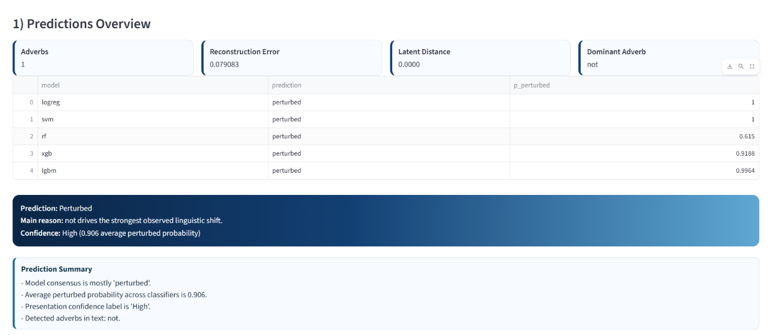

7.3 CLEAN/PERTURBED PREDICTION AND STAR RATING OUTPUT
The next result block in the dashboard shows prediction outputs for all loaded classifiers and rating models. Each classification model predicts whether the review is clean or perturbed. The rating models predict the likely star rating, and the output is displayed both numerically and through a visual star representation.
This section is important because it combines two forms of review understanding in one place. The classification output explains whether the review appears semantically normal or unusual, while the rating output estimates the sentiment strength or quality level implied by the language. The visual star display improves readability and makes the result easier to explain during presentation.
This result is useful because it identifies which hybrid features contributed most to the final prediction. For some reviews, anomaly score or reconstruction error may dominate. For other reviews, adverb-based features such as adverb weight or average adverb influence may have stronger contribution. This makes SHAP one of the most important feature-level explanation outputs in the system, particularly when interpreted together with reconstruction-based detection ideas [3], [7], [9].
Fig. 7.2 Clean/Perturbed Prediction Table and Star Rating Visualization
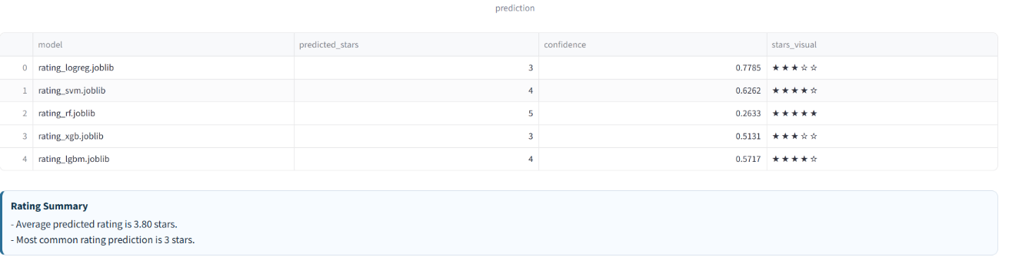

7.4 SHAP EXPLANATION OUTPUT

This output is especially useful because it provides intervention-based explanation instead of only feature attribution. Rather than only saying that an adverb-related feature is important, the system can show that removing a particular adverb causes a significant shift in probability. This helps identify the dominant adverb and connect model behavior directly to sentence meaning. The result is closely related to adversarial text findings showing that local wording changes can produce disproportionate model shifts [10]-[17].
This result is useful because it identifies which hybrid features contributed most to the final prediction. For some reviews, anomaly score or reconstruction error may dominate. For other reviews, adverb-based features such as adverb weight or average adverb influence may have stronger contribution. This makes SHAP one of the most important feature-level explanation outputs in the system.
The SHAP explanation output is shown in Fig. 7.3.

Fig. 7.3 SHAP Explanation for Logistic Regression and LightGBM
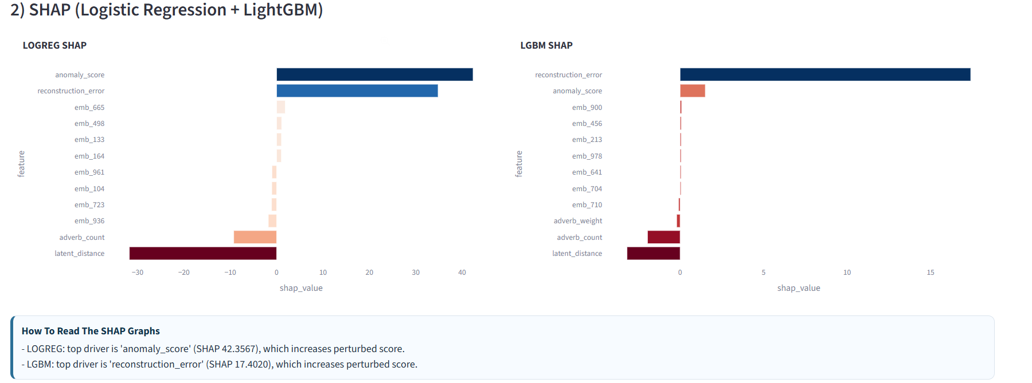
The result is displayed as a table and a before-versus-after comparison. This is important because it answers a practical question: what should change in the review for the model to think differently? It also makes the explanation much easier to understand for non-technical users, since the modified sentence can be compared directly with the original one. The counterfactual output is shown in Fig. 7.5.
One of the key contributions of the project is the adverb ablation module. In this result, the system removes each detected adverb one at a time, recomputes the hybrid feature vector, and measures how much the perturbed probability changes. This gives a direct estimate of how much each adverb influences the model decision.
This output is especially useful because it provides intervention-based explanation instead of only feature attribution. Rather than only saying that an adverb-related feature is important, the system can show that removing a particular adverb causes a significant shift in probability. This helps identify the dominant adverb and connect model behavior directly to sentence meaning.
The adverb ablation graph and summary output are shown in Fig. 7.4.
Fig. 7.4 Adverb Ablation Impact Graph
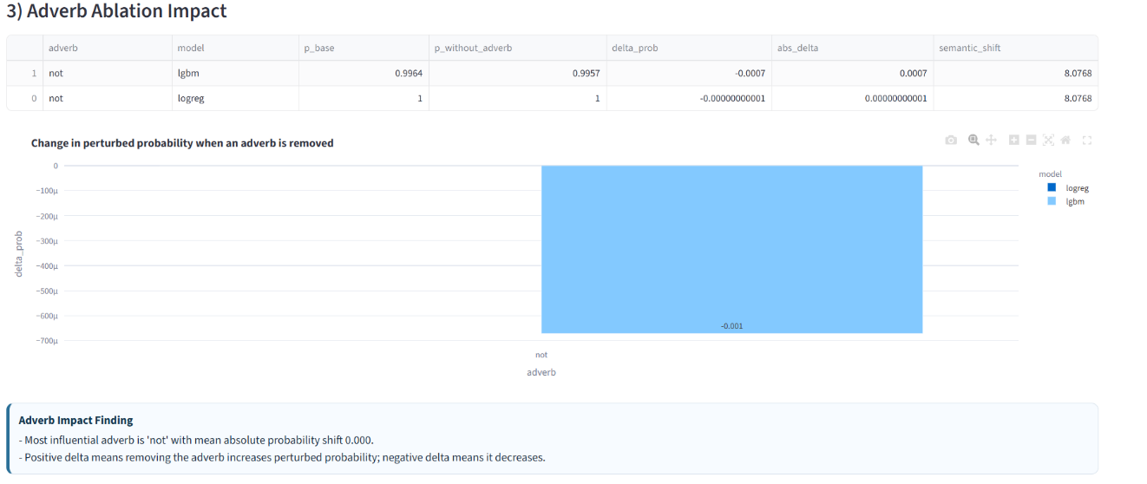
7.6 COUNTERFACTUAL EXPLANATION
The counterfactual explanation section shows how a small change in the review can alter the prediction. The system generates candidate edits, such as removing or replacing influential adverbs, and selects the one that causes the strongest change in model confidence.
The result is displayed as a table and a before-versus-after comparison. This is important because it answers a practical question: what should change in the review for the model to think differently? It also makes the explanation much easier to understand for non-technical users, since the modified sentence can be compared directly with the original one.The counterfactual output is shown in Fig. 7.5.
Fig. 7.5 Counterfactual Explanation with Before-and-After Sentence Comparison
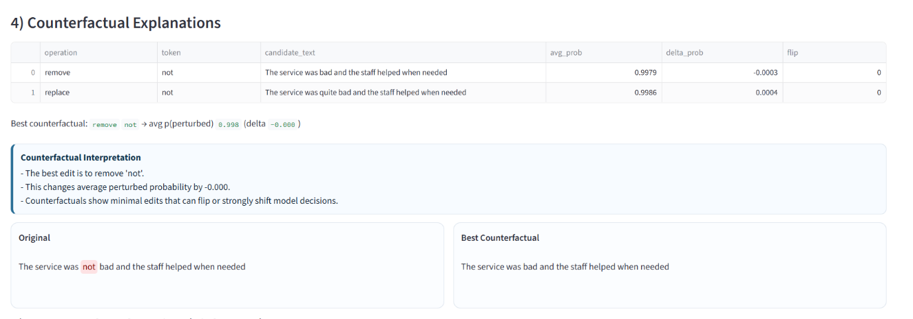
7.7 LIME LOCAL EXPLANATION
This output is useful because not all important tokens are adverbs. In some cases, content words, negations, or evaluative terms may strongly affect the prediction. Token attribution therefore gives another layer of explanation and helps detect whether the model depends too much on specific words. This is closely aligned with prior attack literature where token-level changes have a large effect on model outputs [10]-[17].
This result helps confirm whether the same features that appear important in SHAP also have strong local influence under LIME. If both methods highlight similar features, the explanation becomes more convincing. If they differ, it suggests that the local decision surface may be more complex than expected.
The LIME output is shown in Fig. 7.6.

Fig. 7.6 LIME Local Explanation for LightGBM
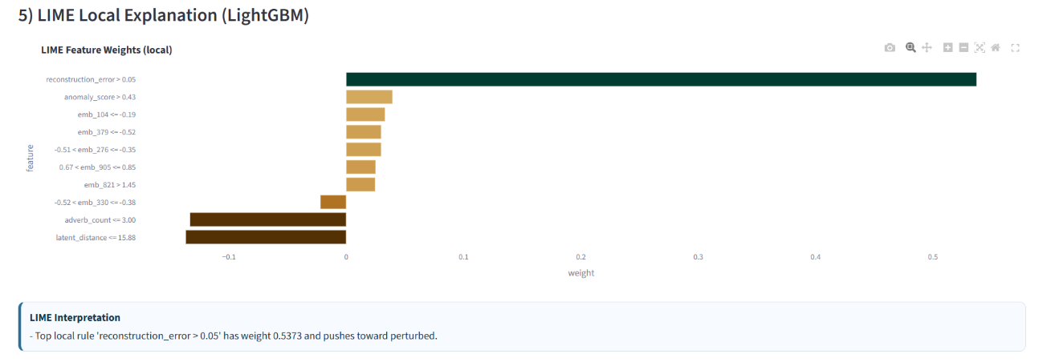
7.8 TOKEN ATTRIBUTION OUTPUT
The token attribution module measures the effect of deleting one token at a time from the input sentence. This result shows which word causes the largest average probability shift when removed.
This output is useful because not all important tokens are adverbs. In some cases, content words, negations, or evaluative terms may strongly affect the prediction. Token attribution therefore gives another layer of explanation and helps detect whether the model depends too much on specific words.
The token attribution graph is shown in Fig. 7.7.

Fig. 7.7 Token Attribution Using Deletion Sensitivity
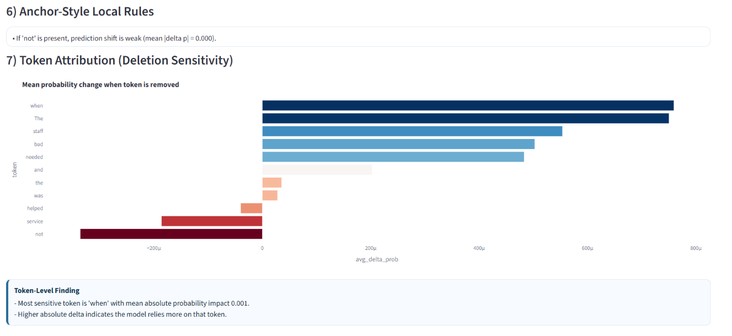
7.9 PDP/ICE OUTPUT FOR HYBRID FEATURES
The PDP/ICE section shows how changing one hybrid feature affects the predicted perturbed probability. This is useful for understanding the direction and sensitivity of model behavior. For example, if the curve rises when anomaly score increases, that means the model treats a higher anomaly score as a stronger sign of perturbation.
This output helps interpret the model beyond one single review. While SHAP and LIME are mainly local explanations, PDP/ICE gives a feature-response view that helps explain how the model reacts when one feature changes. In this project, it is especially useful for features such as reconstruction error, anomaly score, and adverb weight.
The PDP/ICE output is shown in Fig. 7.8.

This result is valuable because it complements the local explanation methods. Instead of explaining only one review, it shows which features matter most more generally. If a feature such as anomaly score or adverb weight consistently causes a large accuracy drop when disturbed, that feature can be considered globally important. This supports the broader goal of robustness-aware interpretation [18], [19].

Fig. 7.8 PDP/ICE Plot for Selected Hybrid Feature
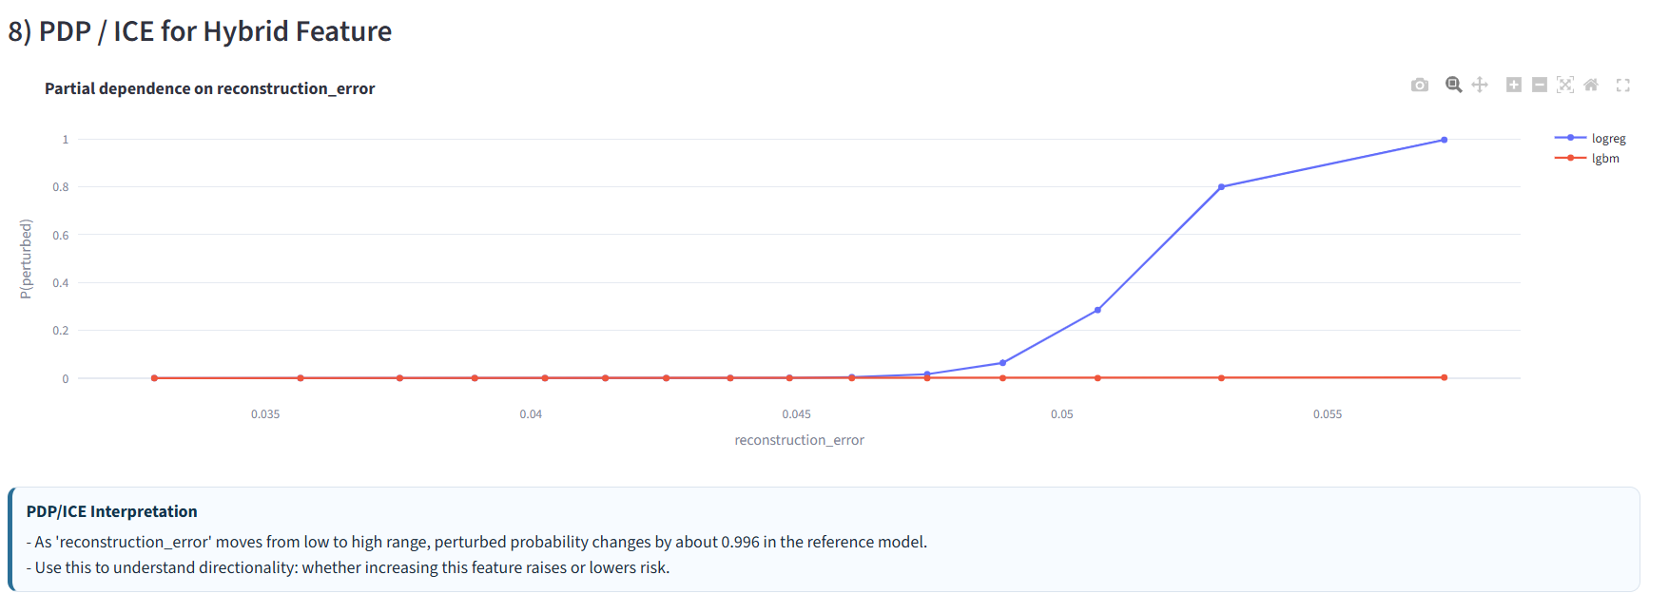
This is important because explanation alone is not enough if the confidence value is unreliable. Calibration gives an additional trust signal. In the current project, Logistic Regression and LightGBM calibration outputs are shown to help users judge how much the confidence scores should be trusted. This concern about reliability is consistent with recent adversarial defense discussions [3], [18], [19].
The global importance section shows which engineered features remain important across a sample of the dataset. It does this by permuting features and measuring how much model accuracy drops. The output also includes a stability estimate across multiple runs.
This result is valuable because it complements the local explanation methods. Instead of explaining only one review, it shows which features matter most more generally. If a feature such as anomaly score or adverb weight consistently causes a large accuracy drop when disturbed, that feature can be considered globally important.
The global importance and stability result is shown in Fig. 7.9.
Fig. 7.9 Global Feature Importance and Stability Output
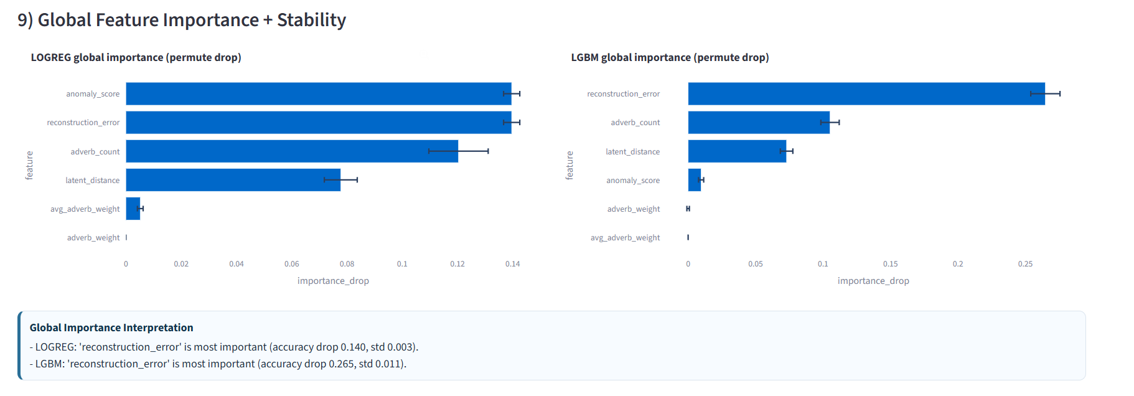
7.11 CALIBRATION AND CONFIDENCE ANALYSIS
The calibration section compares predicted confidence with observed accuracy. This result helps determine whether a high probability really corresponds to a trustworthy prediction. A well-calibrated model should show predicted confidence values that closely match actual correctness.
This is important because explanation alone is not enough if the confidence value is unreliable. Calibration gives an additional trust signal. In the current project, Logistic Regression and LightGBM calibration outputs are shown to help users judge how much the confidence scores should be trusted.
The calibration output is shown in Fig. 7.10.
The dashboard outputs also show that the project goes beyond basic prediction. SHAP and LIME explain feature-level influence, adverb ablation explains intervention-level influence, counterfactuals explain how predictions can change, token attribution highlights important words, PDP/ICE explains feature sensitivity, global importance explains broader feature relevance, and calibration explains confidence reliability. This combination reflects the larger need for interpretable and trustworthy perturbed-text systems [18], [19].
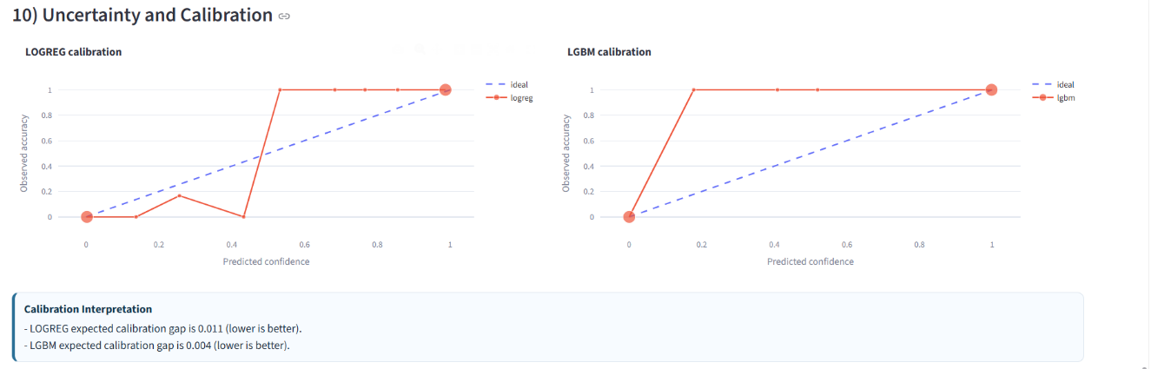
7.12 GLOSSARY AND INTERPRETATION PANELS
The dashboard also includes a feature glossary and interpretation blocks. These outputs explain technical terms such as reconstruction error, anomaly score, adverb weight, and latent distance in a user-friendly way. This improves presentation quality and helps non-technical users understand the outputs without needing detailed prior knowledge.

This chapter presented the main results of the project. The performance table showed that the classification models achieved strong results, with LightGBM and Logistic Regression performing especially well. The dashboard outputs demonstrated that the system can explain predictions using multiple complementary methods. Together, these results confirm that the proposed system is effective for review perturbation detection, star rating prediction, and explainable AI based interpretation [1]-[3], [18], [19].

The results show that the proposed system performs well both as a perturbation detector and as an explainable dashboard. The classification performance values indicate that hybrid semantic and anomaly-aware features are effective. Among the tested models, LightGBM and Logistic Regression are especially useful because they combine strong performance with practical explainability.
The dashboard outputs also show that the project goes beyond basic prediction. SHAP and LIME explain feature-level influence, adverb ablation explains intervention-level influence, counterfactuals explain how predictions can change, token attribution highlights important words, PDP/ICE explains feature sensitivity, global importance explains broader feature relevance, and calibration explains confidence reliability.
This combination makes the project strong from both a technical and presentation point of view. It does not only produce a label, but also gives supporting evidence for why that label was produced.

7.14 SUMMARY

This chapter presented the main results of the project. The performance table showed that the classification models achieved strong results, with LightGBM and Logistic Regression performing especially well. The dashboard outputs demonstrated that the system can explain predictions using multiple complementary methods. Together, these results confirm that the proposed system is effective for review perturbation detection, star rating prediction, and explainable AI based interpretation.

This chapter presents the conclusion of the project and discusses possible future improvements. The project was developed to address the problem of identifying whether a review is clean or perturbed while also predicting its star rating and explaining the reason behind the prediction. The system combines semantic embedding, anomaly-aware feature generation, machine learning prediction, and explainable AI into a single interactive dashboard. This direction is consistent with current research showing that robust text analysis requires more than simple classification and must account for perturbation, calibration, and interpretability [3], [7], [18].

Chapter 8. Conclusion and Future Work
The results show that the hybrid feature-based approach is effective for perturbation detection. The performance table indicates that models such as LightGBM and Logistic Regression perform especially well. More importantly, the explanation modules make the project stronger by showing which features or words influence the output the most. Among these, adverb ablation is a particularly useful contribution because it directly connects word-level changes to model-level probability shifts. This contribution fits well with recent literature on perturbed text, which emphasizes that small changes in wording can strongly affect classifier behavior [10]-[17].
Therefore, the project successfully achieves its aim of building a transparent, interpretable, and practical review analysis framework. It demonstrates that review classification can be made more meaningful when prediction is supported by explanation. Instead of only answering “what is the output?”, the project also answers “why was this output produced?” This aligns with the larger research direction of trustworthy NLP systems [18], [19].

8.1 CONCLUSION

The main goal of this project was to build a review analysis system that does more than only generate a prediction. In many standard NLP systems, the user only receives the final output, such as a sentiment label or rating, without understanding how the model reached that result. This project improves that process by combining prediction with explanation.
The implemented system accepts review text, performs text normalization, and converts the review into a semantic embedding using the E5 model. The embedding is then processed through an autoencoder to generate anomaly-related features such as reconstruction error, latent distance, and anomaly score. At the same time, the system performs linguistic analysis to detect adverbs and intensifiers and calculates adverb count, adverb weight, and average adverb influence. These semantic, anomaly-based, and linguistic features are combined into a hybrid representation and passed to classification and rating models.
The classification models identify whether the review is clean or perturbed, while the rating models predict the corresponding star rating. The project also includes a Streamlit dashboard that presents the outputs in an easy-to-understand and presentation-friendly way. Important explanation methods such as SHAP, LIME, adverb ablation, counterfactual analysis, token attribution, PDP/ICE plots, global feature importance, and calibration are integrated into the same system.
The results show that the hybrid feature-based approach is effective for perturbation detection. The performance table indicates that models such as LightGBM and Logistic Regression perform especially well. More importantly, the explanation modules make the project stronger by showing which features or words influence the output the most. Among these, adverb ablation is a particularly useful contribution because it directly connects word-level changes to model-level probability shifts.
Therefore, the project successfully achieves its aim of building a transparent, interpretable, and practical review analysis framework. It demonstrates that review classification can be made more meaningful when prediction is supported by explanation. Instead of only answering “what is the output?”, the project also answers “why was this output produced?”

Finally, future work can explore stronger robustness analysis by testing the system against more adversarially modified review inputs. This would help measure how well the hybrid features and explanation modules perform under deliberately crafted perturbations, especially against attack families discussed in the current literature [4], [10]-[17].
In summary, the current project provides a strong foundation for explainable review analysis, and there are several opportunities to improve it further in terms of dataset coverage, explanation quality, usability, and robustness [18], [19].
Although the project achieves its current objectives successfully, there is scope for further improvement and extension.
One possible future direction is to expand the dataset. At present, the project is mainly focused on review-based data, and it can be extended to include additional domains such as e-commerce reviews, restaurant reviews, product feedback, or social-media comments. This would help test whether the model generalizes well across different styles of user-generated text.
Another useful extension is to include more advanced explanation methods. The current system already provides multiple XAI outputs, but future work can include transformer attention analysis, gradient-based token attribution, or richer local explanation methods to further improve interpretability.
The project can also be extended by adding a stronger benchmarking framework. At present, the dashboard focuses mainly on prediction and explanation for a given review. Future work can include a benchmark page showing comparative evaluation of models across different metrics, datasets, and perturbation settings.
A further improvement would be the addition of export-friendly reporting features. The current system already provides a downloadable summary, but future versions could include PDF export with embedded graphs and explanation panels so that the output can be directly used in reports and presentations.
The project may also be improved by adding a special presenter mode. Such a mode could simplify the interface by hiding technical detail and showing only the most important outputs, such as final verdict, confidence, dominant adverb, and top explanation chart. This would make the system even more suitable for live demonstrations.
Finally, future work can explore stronger robustness analysis by testing the system against more adversarially modified review inputs. This would help measure how well the hybrid features and explanation modules perform under deliberately crafted perturbations.
In summary, the current project provides a strong foundation for explainable review analysis, and there are several opportunities to improve it further in terms of dataset coverage, explanation quality, usability, and robustness.

Chapter 9 References

[1] “MAFD: Multiple Adversarial Features Detector,” 2024.

[2] “Detection of Adversarial Examples in Text Classification (RDE Benchmark),” 2022.

[3] “SCRN: Siamese Calibrated Reconstruction Network,” in Proceedings of the ACL, 2024.

[4] “ADAT: Adversarial Attack Framework,” in Proceedings of the LREC-COLING, 2024.

[5] “LLMAD: Large Language Model Adversarial Defense,” Electronics, 2025.

[6] “Adversarial Text Purification via Large Language Models,” 2024.

[7] “Layer-wise Autoencoders for Adversarial Detection,” 2020.

[8] “T3: Tree-Autoencoder for Text Generation,” 2020.

[9] “Sparse Autoencoders for Layer-wise Perturbations,” preprint, 2025.

[10] “TextFooler,” 2019/2020.

[11] “BERT-Attack,” 2020.

[12] “TextBugger,” 2019.

[13] Pruthi et al., “Combating Adversarial Misspellings,” 2019.

[14] “Universal Adversarial Triggers,” 2019.

[15] “FGWS,” 2020.

[16] “DISP,” 2019.

[17] “Dirichlet Neighborhood Ensemble,” 2021.

[18] “Survey on NLP Adversarial Defenses,” 2022.

[19] N. Carlini et al., “On Adversarial Robustness Limits.”

