**PROJECT TITLE: Smart Parking System**

**PROJECT OBEJECTIVES:**

The Smart Parking System is designed to address the challenges associated with finding parking spaces in urban areas. The primary objectives of this project are to:Develop a real-time parking availability system that helps drivers locate open parking spots in their vicinity.

Utilize IoT sensors to monitor parking space occupancy and relay this information to a centralized systemCreate a mobile app that provides users with real-time parking availability information and navigationto the nearest open spot.

Integrate Raspberry Pi devices into the parking infrastructure to act as IoT gateways for sensor data collection.Implement efficient and reliable code for data processing, storage, and communication within the system.

**IOT SENSOR SETUP:**

The IoT sensor setup consists of various sensors strategically placed in parking spaces. These sensors can include ultrasonic or magnetic sensors to detect the presence of a vehicle. Each sensor is connected to a microcontroller or edge device that collects data and transmits it to a central server. The sensors provide real-time information about parking space occupancy.

**MOBILE APP DEVELOPMENT:**

The real-time parking availability information. The app is developed for both Android and iOS platforms and includes the following features:

* Real-time parking space availability display on a map.
* User registration and login.
* GPS-based location services to assist users in finding parking spaces near their current location.
* Navigation assistance to guide users to the nearest open parking spot.
* User feedback and ratings for parking spaces.
* Push notifications for updates on parking availability.

**RASHPERRY PI INTEGRATION:**

Raspberry Pi devices are integrated into the system as IoT gateways to collect data from the sensors and transmit it to the central server. Each Raspberry Pi is equipped with Wi-Fi or Ethernet connectivity and is responsible for aggregating data from multiple sensors, ensuring efficient communication, and securely transmitting the data to the central server.

**CODE IMPLEMTATION:**

The code implementation involves several components:

**Sensor Data Collection:** Code running on microcontrollers collects data from IoT sensors and transmits it to the Raspberry Pi.

**Raspberry Pi Gateway:** Code on the Raspberry Pi receives and processes sensor data, then sends it to the central server using secure communication protocols.

**Central Server:** The server receives, processes, and stores the incoming data. It also hosts the database for parking space occupancy.

**Mobile App:**The app communicates with the server to access real-time parking availability information and provides navigation services to users.

**Data Analytics:** The server can also perform data analytics to optimize parking space allocation and monitor trends in parking occupancy.

**Benefits:** The real-time parking availability system offers several benefits:

**Reduced Search Time:** Drivers can quickly find available parking spaces, reducing the time spent searching for parking.

**Improved Traffic Flow**: Efficient parking space allocation can help reduce congestion and traffic in urban areas.

**Eco-Friendly**: By reducing the time spent searching for parking, the system can help decrease fuel consumption and emissions.

**User Convenience**: The mobile app provides a user-friendly interface, making it easier for drivers to locate parking spaces and navigate to them.

**Data-Driven Insights**: The system collects valuable data on parking space utilization, which can be used for future city planning and resource allocation.

**SCHEMATIC DIAGRAM**:

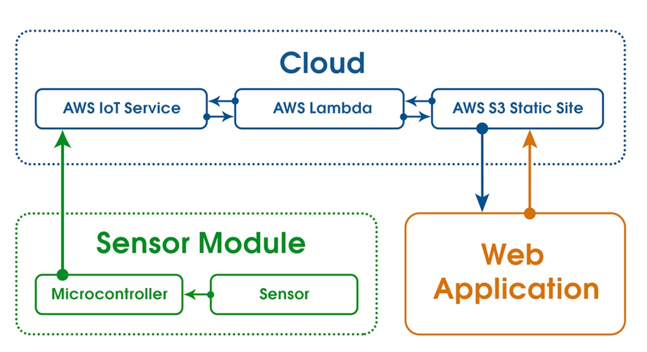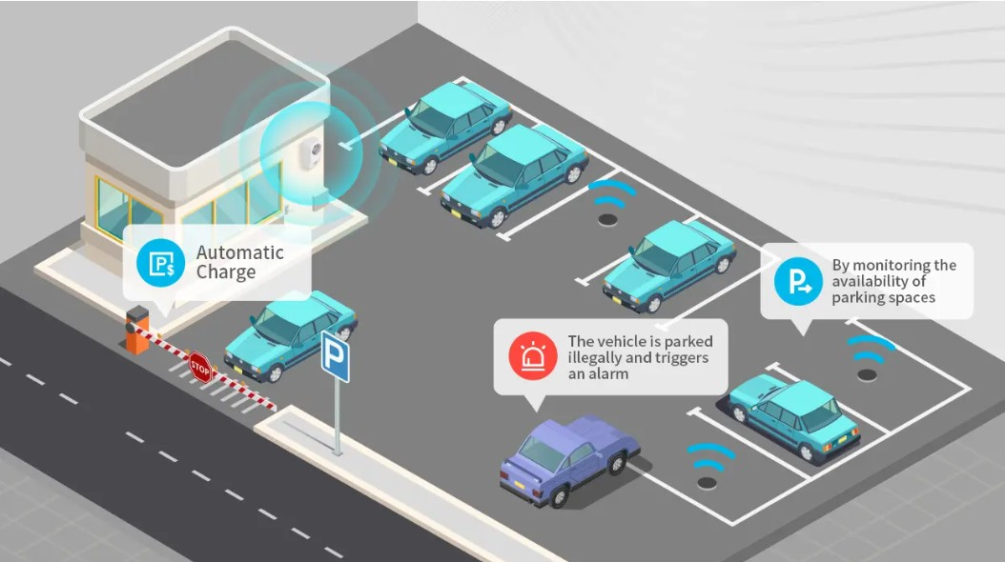

**MOBILE APP AND IOT SENSOR:**

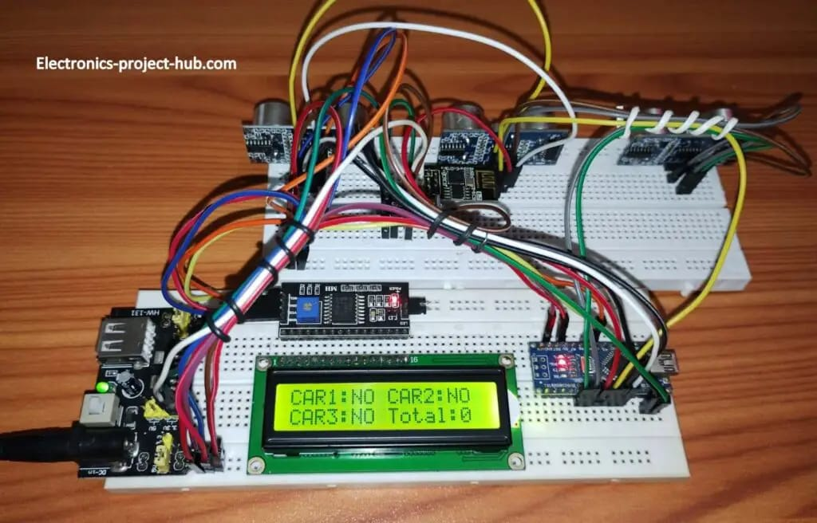

**REAL-TIME PARKING AVAILABILITY SYSTEM**:

A real-time parking availability system can bring several benefits to drivers and help alleviate common parking issues in a smart parking project:

1. **Time Savings:** Drivers can quickly locate available parking spaces using the mobile app or other means, reducing the time and frustration typically spent searching for parking. This is especially valuable in crowded urban areas or during peak hours.

2. **Fuel Efficiency:** The ability to find a parking spot efficiently minimizes the need to circle the area, reducing fuel consumption and emissions. This is an environmentally friendly aspect of the system.

3. **Reduced Stress:** Drivers experience less stress and anxiety when they know they can easily find parking, leading to a more enjoyable and less hectic driving experience.

4. **Cost Savings:** Real-time parking information allows drivers to make informed decisions about where to park, potentially selecting more affordable parking options. Over time, this can lead to cost savings.

5. **Improved Traffic Flow**: By reducing the number of cars circling the area in search of parking, the system helps decrease traffic congestion, making the roads safer and more efficient for everyone.

6. **Enhanced User Experience:** The mobile app often provides additional features like navigation to the chosen parking spot, mobile payments, and even the ability to reserve parking spaces in advance, making the overall parking experience more convenient.

7. **Data-Driven Urban Planning:** The system collects valuable data on parking space usage, helping city planners make informed decisions about parking infrastructure, pricing, and policies. This data can lead to more efficient urban development.

8. **Accessibility:** Real-time parking information can assist individuals with disabilities by helping them locate accessible parking spaces more easily.

9. **Safety:** Reducing the need to circle for parking spots can lead to a decrease in accidents and traffic-related incidents, enhancing road safety.

10. **Convenience:** Drivers can receive real-time notifications or updates about parking availability, helping them plan their parking in advance.