Lab Experiments
Experiment 33. Morphological Operations Using OpenCV – Morphological Gradient Technique
Aim:To implement the Morphological Gradient operation on an input image using OpenCV and detect the boundaries or edges of objects in the image.
Algorithm
- Start the program.
- Import the OpenCV library.
- Read the input image
- Convert the image into grayscale.
- Create a structuring element/kernel.
- Perform dilation on the image.
- Perform erosion on the image.
- Subtract the eroded image from the dilated image.
- Display the original and morphological gradient images.
- Save the output image.
- Stop the program.
Code
import cv2
image=cv2.imread("exp21.jpg")
if image is None:
print("Error: Image not found!")
exit()
gray=cv2.cvtColor(image,cv2.COLOR_BGR2GRAY)
kernel=cv2.getStructuringElement(cv2.MORPH_RECT,(5,5))
gradient=cv2.morphologyEx(gray,cv2.MORPH_GRADIENT,kernel)
cv2.imshow("Original Image",gray)
cv2.imshow("Morphological Gradient",gradient)
cv2.imwrite("exp21 gradient output.jpg",gradient)
cv2.waitKey(0)
cv2.destroyAllWindows()
Execution
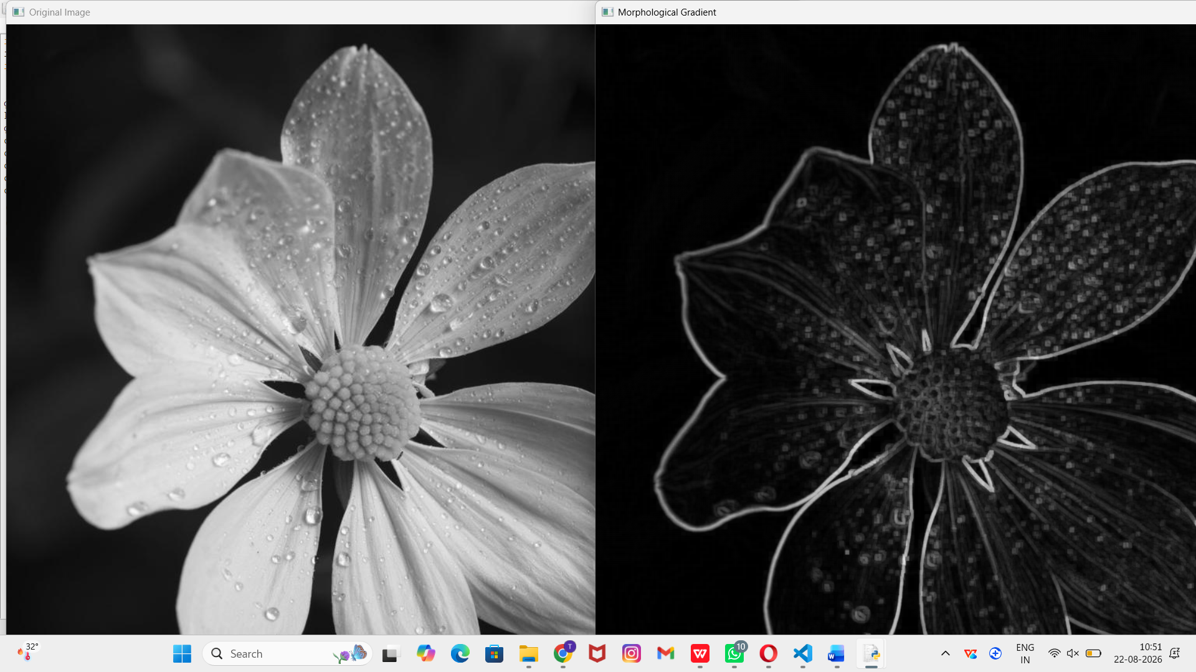
Result: Thus, the Morphological Gradient technique was successfully implemented using OpenCV. The resulting image clearly highlights the object boundaries and edges by calculating the difference between dilation and erosion.

