Lab Experiments
Experiment34: Morphological Operations Using OpenCV – Top Hat Technique
Aim:To implement the Top Hat morphological operation on an input image using OpenCV and extract small bright objects or details from the image.
Algorithm
- Start the program.
- Read the input image
- Convert the image into grayscale.
- Create a structuring element using a 5×5 kernel.
- Apply the Top Hat morphological operation.
- Display the original and Top Hat images.
- Save the output image.
- Stop the program.
Code
import cv2
image=cv2.imread("exp19.jpg")
if image is None:
print("Error: Image not found!")
exit()
gray=cv2.cvtColor(image,cv2.COLOR_BGR2GRAY)
kernel=cv2.getStructuringElement(cv2.MORPH_RECT,(5,5))
tophat=cv2.morphologyEx(gray,cv2.MORPH_TOPHAT,kernel)
cv2.imshow("Original Image",gray)
cv2.imshow("Top Hat Operation",tophat)
cv2.imwrite("exp19 top hat output.jpg",tophat)
cv2.waitKey(0)
cv2.destroyAllWindows()

Sample Input: Output:
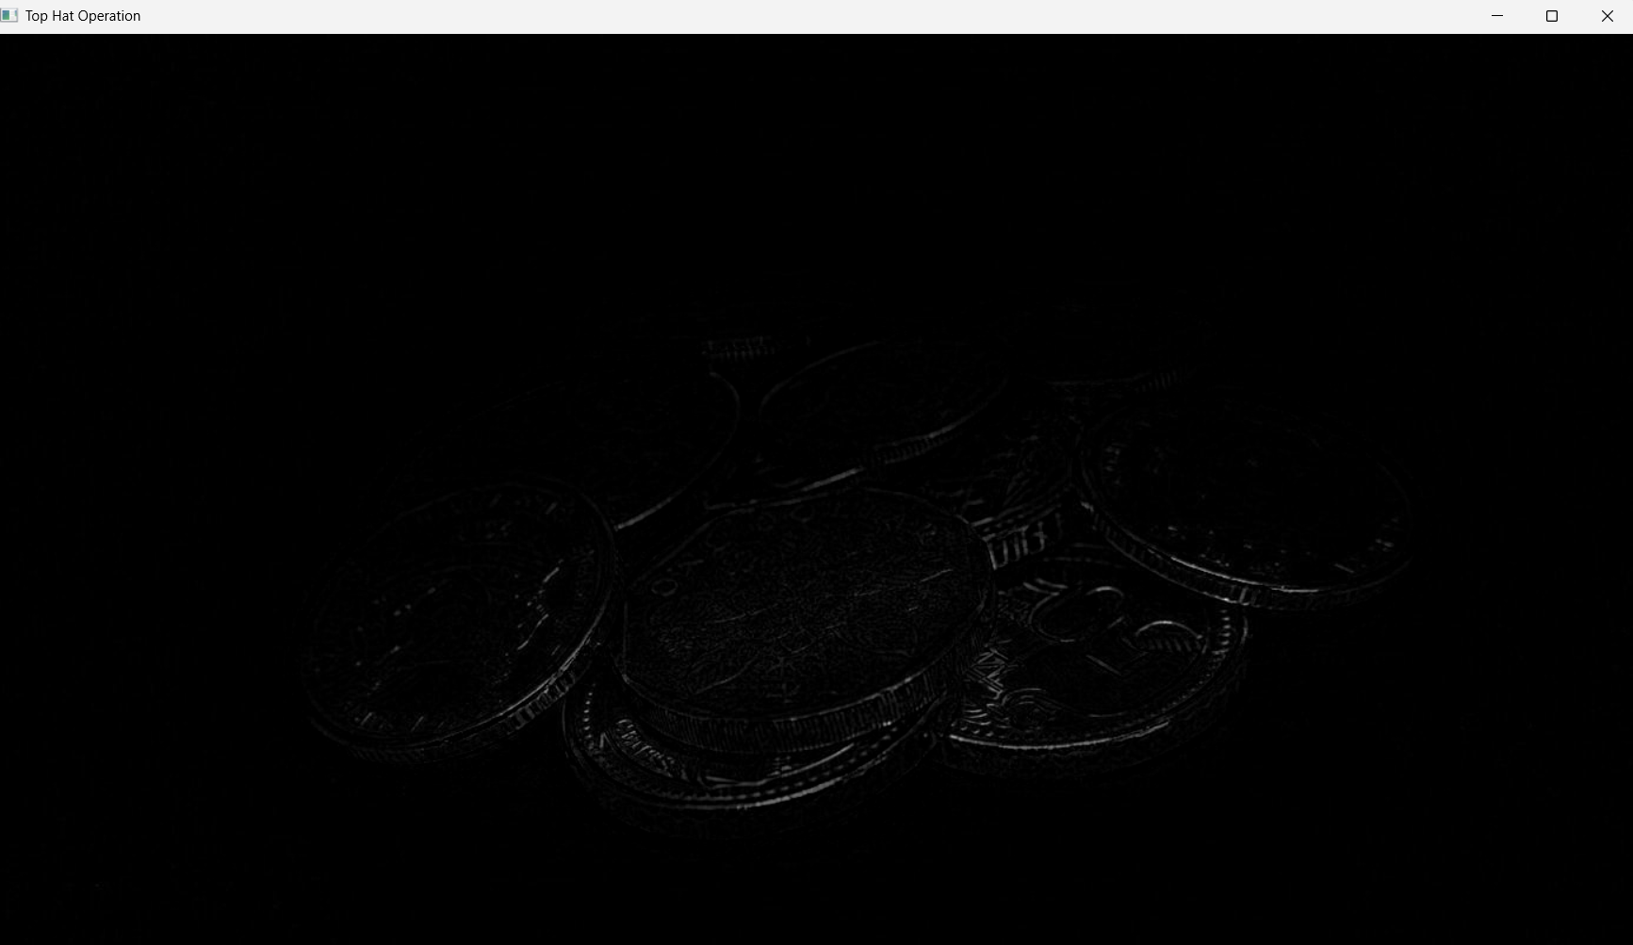
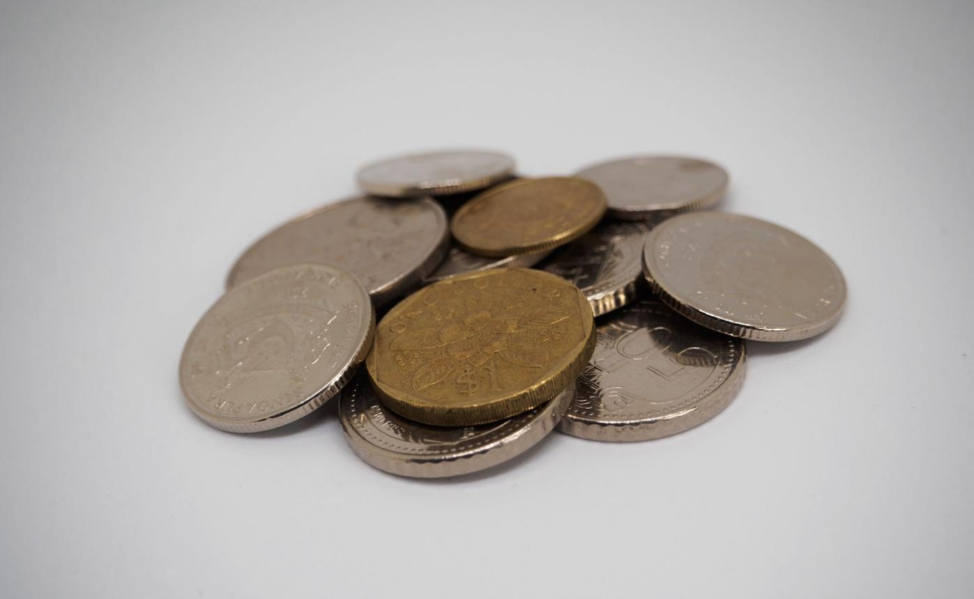

Result: Thus, the Top Hat morphological operation was successfully implemented using OpenCV. The technique extracts small bright features and details from the input image.

