Lab Experiments
Experiment 29: Morphological Operation – Erosion Using OpenCV
Aim:To perform morphological erosion on an image using OpenCV.
Algorithm
- Read the input image.
- Convert the image into grayscale.
- Create a structuring element (kernel).
- Apply the erosion operation using cv2.erode().
- Display the input and eroded images.
- Save the output image as exp29.jpg.
Code
import cv2
import numpy as np
img = cv2.imread("exp29.jpg")
gray = cv2.cvtColor(img, cv2.COLOR_BGR2GRAY)
kernel = np.ones((5, 5), np.uint8)
erosion = cv2.erode(gray, kernel, iterations=1)
cv2.imshow("Input Image", img)
cv2.imshow("Eroded Image", erosion)
cv2.imwrite("exp29.jpg", erosion)
cv2.waitKey(0)
cv2.destroyAllWindows()
Sample Input
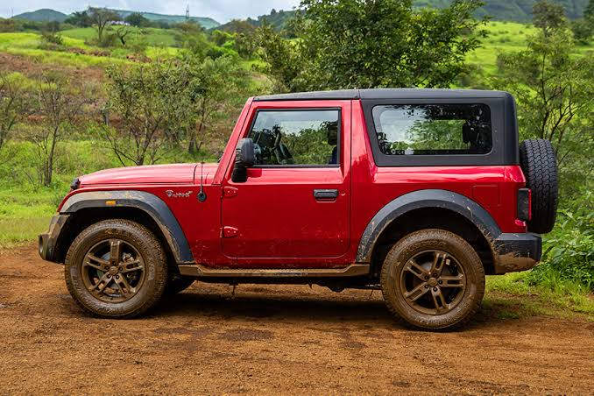
Output:
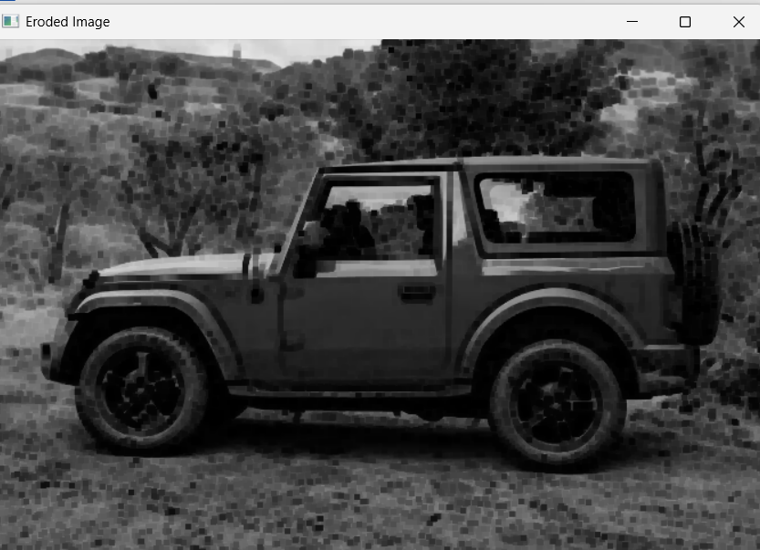

Result: The morphological erosion operation was successfully performed using OpenCV. Erosion reduces the white regions and removes small unwanted objects or noise from the image.

