Lab Experiments
17. Perform Edge Detection using Sobel Matrix along X-axis
Aim : To detect edges in an image using the Sobel operator along the X-axis.
Algorithm:
- Read the input image
- Load the image using OpenCV.
- Convert to Grayscale
- Convert the image to grayscale.
- Apply Sobel Operator (X-axis)
- Use Sobel kernel to detect horizontal intensity changes.
- Convert to Absolute Values
- Convert negative gradients to positive.
- Display the Output
- Show the detected edges.
Code:
import cv2
image = cv2.imread("exp17.jpg")
if image is None:
print("Error: Image not found!")
exit()
gray = cv2.cvtColor(image, cv2.COLOR_BGR2GRAY)
sobelx = cv2.Sobel(gray, cv2.CV_64F, 1, 0, ksize=3)
sobelx = cv2.convertScaleAbs(sobelx)
cv2.imshow("Original Image", image)
cv2.imshow("Sobel X Edge Detection", sobelx)
cv2.waitKey(0)
cv2.destroyAllWindows()
Sample Input: Output:
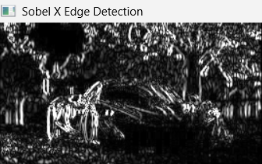


Result
Edges are successfully detected using the Sobel operator along the X-axis.

