Lab Experiments
Experiment 25: Image Sharpening Using Gradient Masking
Aim:To perform image sharpening using gradient masks and enhance the edges and fine details of the image.
Algorithm
- Read the input image.
- Convert the image to grayscale.
- Define the horizontal and vertical gradient masks.
- Apply both masks to the input image.
- Calculate the gradient magnitude from the two gradient images.
- Add the gradient image to the original image to obtain the sharpened image.
- Display and save the sharpened image.
Code
import cv2
import numpy as np
img = cv2.imread("exp25.jpg", 0)
gx = np.array([[-1,-2,-1],
[0,0,0],
[1,2,1]])
gy = np.array([[-1,0,1],
[-2,0,2],
[-1,0,1]])
x = cv2.filter2D(img, cv2.CV_64F, gx)
y = cv2.filter2D(img, cv2.CV_64F, gy)
grad = cv2.magnitude(x, y)
grad = cv2.convertScaleAbs(grad)
sharp = cv2.add(img, grad)
cv2.imwrite("sharpened25.jpg", sharp)
cv2.imshow("Original", img)
cv2.imshow("Sharpened", sharp)
cv2.waitKey(0)
cv2.destroyAllWindows()

Sample Input
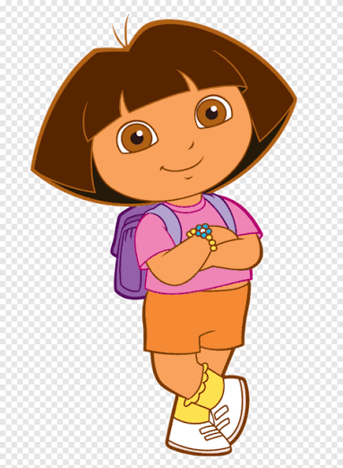
Output:
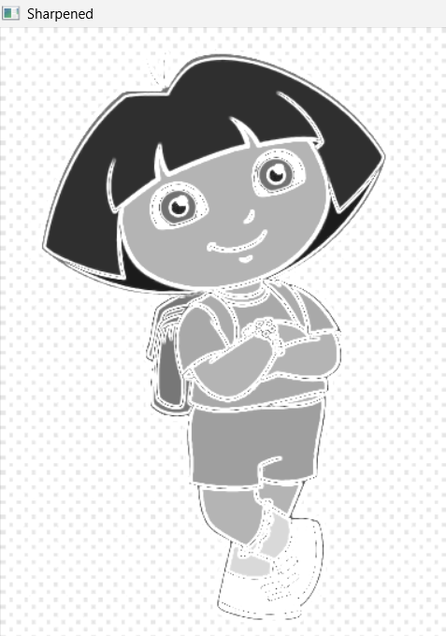

Result:
Thus, image sharpening using gradient masking was successfully performed, and the sharpened image with enhanced edges was obtained

