Lab Experiments
Experiment 31: Morphological Operations Using OpenCV – Opening Technique
Aim:To implement morphological opening operation on an input image using OpenCV and remove small unwanted noise from the image.
Algorithm
- Start the program.
- Import the required OpenCV library.
- Read the input image.
- Convert the image into grayscale if required.
- Create a suitable structuring element/kernel.
- Perform erosion on the image using the kernel.
- Perform dilation on the eroded image.
- The combination of erosion followed by dilation produces the Opening operation.
- Display the original and opened images.
- Save the output image.
- Stop the program.
Code
import cv2
image = cv2.imread("exp31.jpg")
if image is None:
print("Error: Image not found!")
exit()
gray = cv2.cvtColor(image, cv2.COLOR_BGR2GRAY)
kernel = cv2.getStructuringElement(cv2.MORPH_RECT, (5, 5))
opening = cv2.morphologyEx(gray, cv2.MORPH_OPEN, kernel)
cv2.imshow("Original Image", gray)
cv2.imshow("Opening Operation", opening)
cv2.imwrite("exp31 output.jpg", opening)
cv2.waitKey(0)
cv2.destroyAllWindows()
Execution
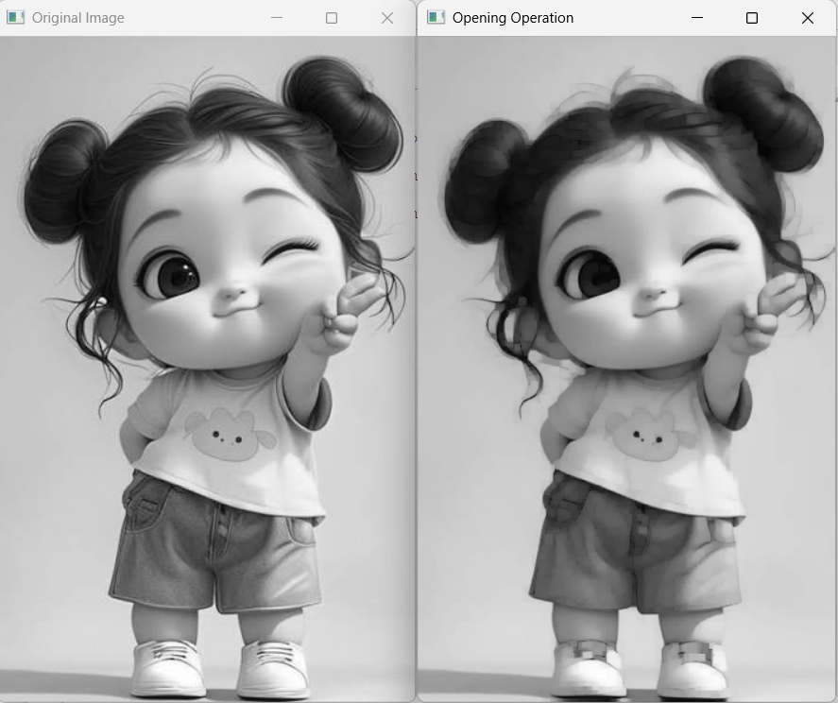
Result:Thus, the morphological opening operation was successfully implemented using OpenCV. The operation effectively removes small unwanted objects and noise from the input image while preserving the important larger structures.

