Lab Experiments
11. Perform Perspective Transformation on an Image.
Aim: To perform a perspective transformation on an input image using Python and OpenCV.
Algorithm:
- Import the OpenCV and NumPy libraries.
- Read the input image.
- Define four source points on the original image.
- Define four corresponding destination points.
- Compute the perspective transformation matrix using cv2.getPerspectiveTransform().
- Apply the transformation using cv2.warpPerspective().
- Display the original and transformed images.
Code:
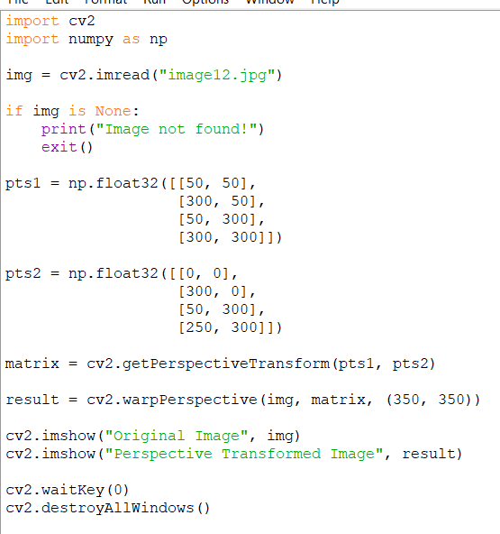
Sample Input: Output:
