Lab Experiments
20. Image Sharpening Using Laplacian Mask
Aim:To perform image sharpening using a Laplacian mask with a negative center coefficient.
Procedure
- Read the input image.
- Convert the image into grayscale.
- Apply the Laplacian mask to the image.
- Subtract the Laplacian result from the original image to sharpen it.
- Display the original and sharpened images.
- Save the sharpened image as exp20.jpg.
Python Code
import cv2
img = cv2.imread("exp20.jpg", 0)
lap = cv2.Laplacian(img, cv2.CV_64F, ksize=3)
sharp = cv2.convertScaleAbs(img - lap)
cv2.imshow("Input Image", img)
cv2.imshow("Sharpened Image", sharp)
cv2.imwrite("exp20_output.jpg", sharp)
cv2.waitKey(0)
cv2.destroyAllWindows()
Sample Input: Output:
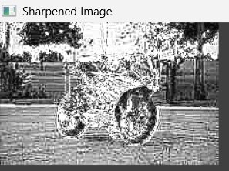
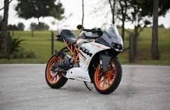

Result: Thus, the input image was successfully sharpened using a Laplacian mask with a negative center coefficient.

