Lab Experiments
Experiment 21: Image Sharpening Using Laplacian Mask with Diagonal Neighbors
Aim:To perform image sharpening using a Laplacian mask with an extension of diagonal neighbors.
Procedure
- Read the input image.
- Convert the image into grayscale.
- Apply the 8-neighbor Laplacian mask to the image.
- Subtract the Laplacian result from the original image to sharpen it.
- Display the original and sharpened images.
- Save the sharpened image as exp21_output.jpg.
Python Code
import cv2
import numpy as np
img = cv2.imread("exp21.jpg", 0)
mask = np.array([[1, 1, 1],
[1, -8, 1],
[1, 1, 1]])
lap = cv2.filter2D(img, cv2.CV_64F, mask)
sharp = cv2.convertScaleAbs(img - lap)
cv2.imshow("Input Image", img)
cv2.imshow("Sharpened Image", sharp)
cv2.imwrite("exp21_output.jpg", sharp)
cv2.waitKey(0)
cv2.destroyAllWindows()
Sample Input: Output:
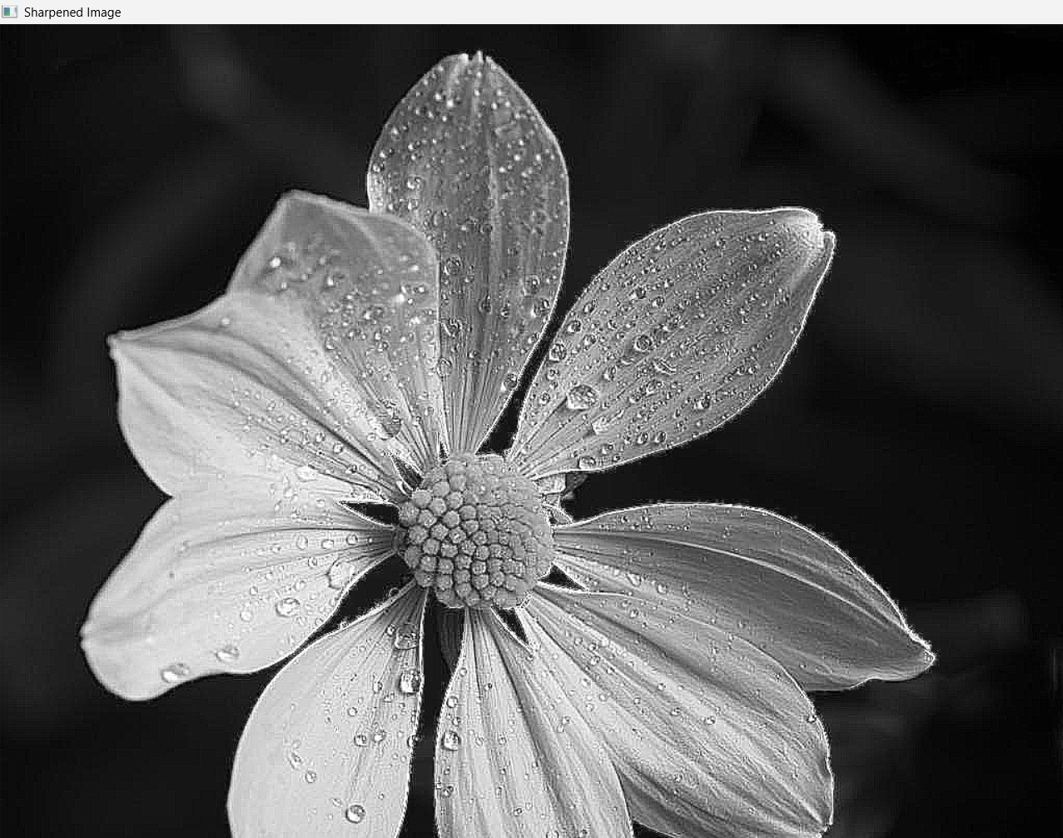
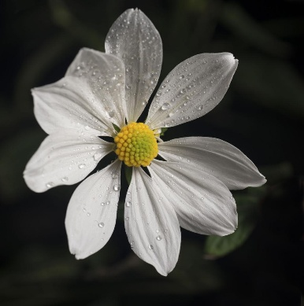

Result: Thus, the image was successfully sharpened using a Laplacian mask with diagonal neighbors.

