Lab Experiments
Experiment 23: Image Sharpening Using Unsharp Masking
Aim: To perform image sharpening using the unsharp masking technique by subtracting a blurred version of the image from the original image.
Algorithm
- Read the input image.
- Convert the image to grayscale.
- Blur the image using a Gaussian filter.
- Subtract the blurred image from the original image to obtain the unsharp mask.
- Add the unsharp mask to the original image to obtain the sharpened image.
- Display the original, blurred, and sharpened images.
- Save the sharpened image.
Code
import cv2
img = cv2.imread("exp23.jpg", 0)
blur = cv2.GaussianBlur(img, (5,5), 0)
mask = cv2.subtract(img, blur)
sharp = cv2.add(img, mask)
cv2.imwrite("sharpened23.jpg", sharp)
cv2.imshow("Original", img)
cv2.imshow("Blurred", blur)
cv2.imshow("Sharpened", sharp)
cv2.waitKey(0)
cv2.destroyAllWindows()

Sample Input

Output:
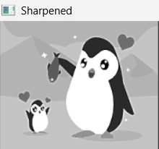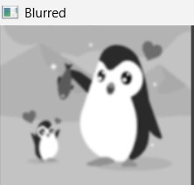

Result:
Thus, the image sharpening using unsharp masking was successfully performed. The blurred image was subtracted from the original image and the resulting mask was added to the original image to obtain the sharpened image.

