Lab Experiments
19.Edge Detection Using Sobel Matrix Along XY Axis
Aim:To perform edge detection of an input image using the Sobel operator along the X and Y axes.
Algorithm:
- Read the input image.
- Convert the image into grayscale.
- Apply the Sobel operator in the X-direction to detect vertical edges.
- Apply the Sobel operator in the Y-direction to detect horizontal edges.
- Combine the X and Y gradients to obtain the final edge image.
- Display the input image, Sobel-X, Sobel-Y, and final edge-detected images.
Code:
import cv2
img = cv2.imread("exp19.jpg", 0)
sx = cv2.Sobel(img, cv2.CV_64F, 1, 0, ksize=3)
sy = cv2.Sobel(img, cv2.CV_64F, 0, 1, ksize=3)
sx = cv2.convertScaleAbs(sx)
sy = cv2.convertScaleAbs(sy)
edge = cv2.addWeighted(sx, 0.5, sy, 0.5, 0)
cv2.imshow("Input", img)
cv2.imshow("Sobel X", sx)
cv2.imshow("Sobel Y", sy)
cv2.imshow("Sobel XY", edge)
cv2.waitKey(0)
cv2.destroyAllWindows()
Sample Input: Output:
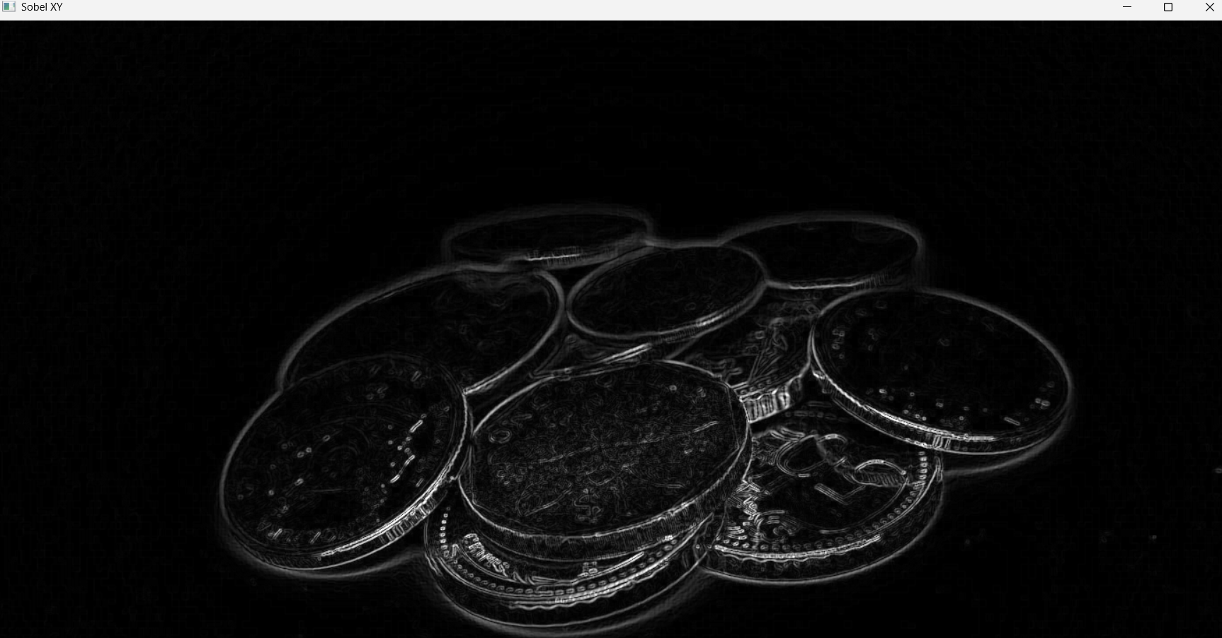


Result
Thus, the edges of the input image were successfully detected using the Sobel operator along the X and Y axes.

