Lab Experiments
Experiment 28: Image Boundary Detection Using Convolution Kernel
Aim:To find the boundary/edges of an image using a convolution kernel in OpenCV.
Algorithm
- Read the input image.
- Convert the image into grayscale.
- Define an edge-detection convolution kernel.
- Apply the kernel to the image using cv2.filter2D().
- Display the original and boundary-detected images.
- Save the output image as exp28.jpg.
Code
import cv2
import numpy as np
img = cv2.imread("exp28.jpg")
gray = cv2.cvtColor(img, cv2.COLOR_BGR2GRAY)
kernel = np.array([
[-1, -1, -1],
[-1, 8, -1],
[-1, -1, -1]
])
boundary = cv2.filter2D(gray, -1, kernel)
cv2.imshow("Input Image", img)
cv2.imshow("Boundary Image", boundary)
cv2.imwrite("exp28_output.jpg", boundary)
cv2.waitKey(0)
cv2.destroyAllWindows()

Sample Input

Output:
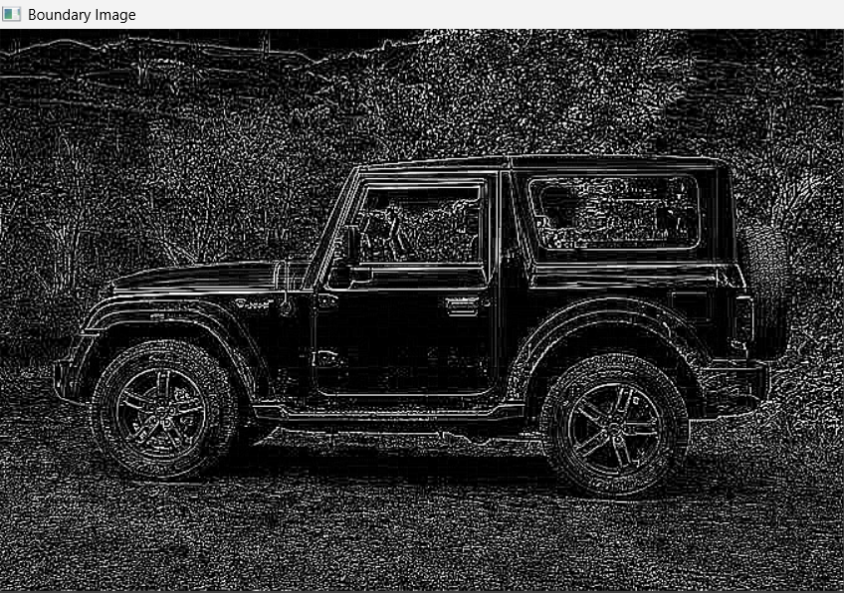

Result:The boundary of the given image is detected successfully using a convolution kernel.

