Lab Experiments
Experiment 35:Morphological Operations Using OpenCV – Black Hat Technique
Aim:To implement the Black Hat morphological operation on an input image using OpenCV and observe the difference between the closing operation and the original image.
Algorithm
- Start the program.
- Import the required OpenCV library.
- Read the input image in grayscale mode.
- Create a suitable structuring element/kernel.
- Apply the Black Hat operation using morphological closing.
- Display the original image and Black Hat image.
- Save the output image if required.
- Stop the program.
Black Hat = Closing − Original Image
Code
import cv2
img = cv2.imread("exp28.jpg", 0)
kernel = cv2.getStructuringElement(cv2.MORPH_RECT, (9, 9))
blackhat = cv2.morphologyEx(img, cv2.MORPH_BLACKHAT, kernel)
cv2.imshow("Original Image", img)
cv2.imshow("Black Hat Image", blackhat)
cv2.waitKey(0)
cv2.destroyAllWindows()

Execution:
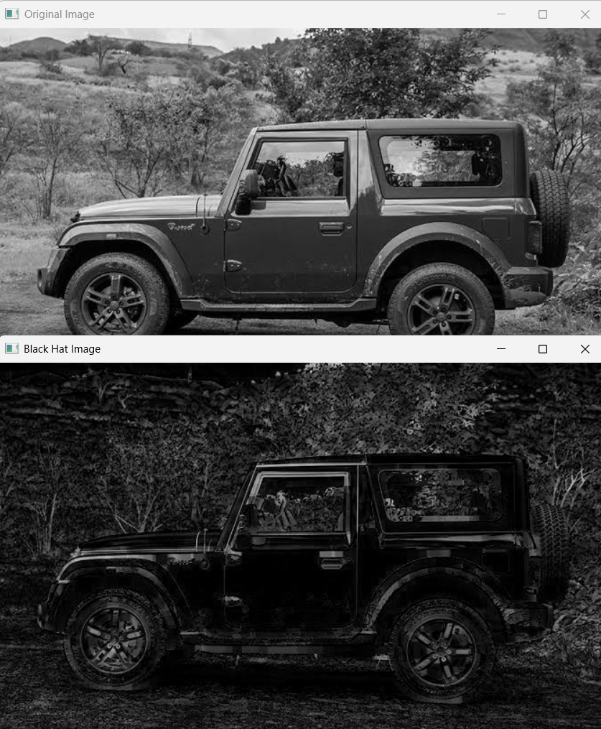
Result:Thus, the Black Hat morphological operation was successfully implemented using OpenCV to extract dark details from the input image.

