Lab Experiments
Experiment 36. Recognise Watch from Given Image Using OpenCV
Aim:To recognize a watch object from the given image using general object recognition techniques in OpenCV.
Algorithm
- Start the program.
- Read the given watch image using OpenCV.
- Convert the image to grayscale.
- Detect edges using the Canny edge detector.
- Detect circular regions using the Hough Circle Transform.
- Check for a circular watch-dial-like region.
- If a suitable circular object is detected, display “Watch Detected”.
- Draw the detected circle on the image.
- Display the result.
- Stop the program.
Code
import cv2
img = cv2.imread("watch.jpg")
gray = cv2.cvtColor(img, cv2.COLOR_BGR2GRAY)
gray = cv2.GaussianBlur(gray, (5, 5), 0)
circles = cv2.HoughCircles(
gray,
cv2.HOUGH_GRADIENT,
dp=1.2,
minDist=50,
param1=100,
param2=50,
minRadius=30,
maxRadius=150
)

if circles is not None:
circles = circles[0]
x, y, r = max(circles, key=lambda c: c[2])
x, y, r = int(x), int(y), int(r)
cv2.circle(img, (x, y), r, (0, 255, 0), 3)
cv2.putText(img, "Watch Detected",
(x - 70, y - r - 10),
cv2.FONT_HERSHEY_SIMPLEX,
0.8, (0, 255, 0), 2)
print("Watch Detected")
else:
print("Watch Not Detected")
cv2.imshow("Watch Recognition", img)
cv2.waitKey(0)
cv2.destroyAllWindows()
Execution:
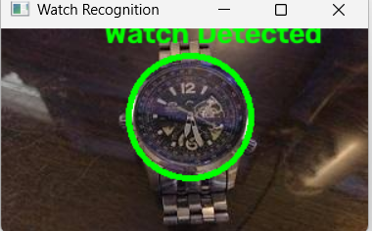
Result: Thus, the watch in the given image was recognized successfully using OpenCV, by detecting the circular watch dial and marking the detected object.

