Lab Experiments
Experiment38:Face Detection Using OpenCV
Aim:To detect human faces in an image or video using the Haar Cascade Classifier in OpenCV.
Algorithm
- Start the program.
- Load the Haar Cascade face detection model.
- Read the input image.
- Convert the image to grayscale.
- Detect faces using detectMultiScale().
- Draw rectangles around the detected faces.
- Display the output image.
- Stop the program.
Code
import cv2
img = cv2.imread("face.jpg")
ycrcb = cv2.cvtColor(img, cv2.COLOR_BGR2YCrCb)
lower = (0, 133, 77)
upper = (255, 173, 127)
mask = cv2.inRange(ycrcb, lower, upper)
contours, _ = cv2.findContours(
mask, cv2.RETR_EXTERNAL, cv2.CHAIN_APPROX_SIMPLE
)
count = 0
for c in contours:
x, y, w, h = cv2.boundingRect(c)

if w > 50 and h > 50 and 0.5 < w/h < 2:
cv2.rectangle(img, (x, y), (x+w, y+h), (255, 0, 0), 2)
count += 1
print("Number of faces detected:", count)
cv2.imshow("Face Detection", img)
cv2.waitKey(0)
cv2.destroyAllWindows()
Execution:
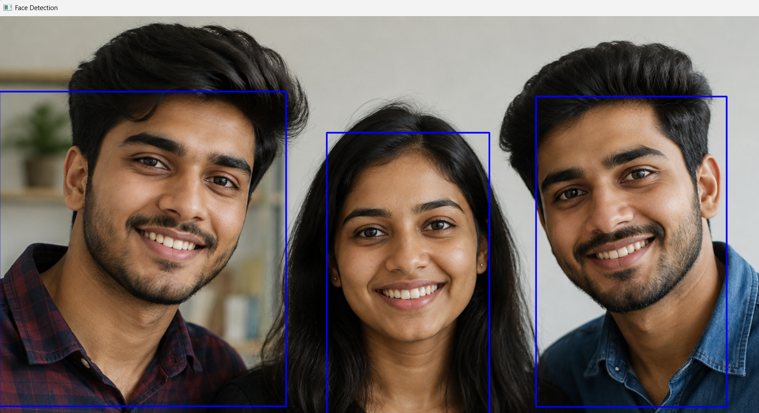

Result:Thus, human faces were successfully detected using OpenCV and the Haar Cascade Classifier.

