Lab Experiments
Experiment 40. Draw Rectangular Shape and Extract Objects Using OpenCV
Aim:To draw rectangular bounding boxes around objects in the given image and extract the detected objects using OpenCV.
Algorithm
- Read the input image.
- Convert the image to grayscale.
- Apply thresholding to separate objects from the background.
- Find contours in the image.
- Find the bounding rectangle for each contour.
- Draw rectangles around the detected objects.
- Extract the objects using the bounding rectangle coordinates.
- Display the original and extracted objects.
- Stop the program.
Code
import cv2
img=cv2.imread("players.jpg")
if img is None:
print("Image not found")
exit()
gray=cv2.cvtColor(img,cv2.COLOR_BGR2GRAY)
_,thresh=cv2.threshold(gray,120,255,cv2.THRESH_BINARY)
contours,_=cv2.findContours(thresh,cv2.RETR_EXTERNAL,cv2.CHAIN_APPROX_SIMPLE)
count=0
for c in contours:
x,y,w,h=cv2.boundingRect(c)
if w>50 and h>50:
cv2.rectangle(img,(x,y),(x+w,y+h),(0,255,0),2)
count+=1
print("Objects detected:",count)
cv2.imshow("Object Detection",img)
cv2.waitKey(0)
cv2.destroyAllWindows()
Execution:
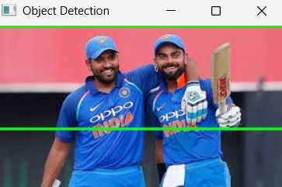
Result: Thus, rectangular bounding boxes were successfully drawn and the objects were extracted from the given image using OpenCV.

