Lab Experiments
14. Homography Matrix Transformation
Aim :To perform image transformation using a Homography Matrix and obtain a perspective-transformed image using Python and OpenCV
Algorithm:
- Import the required libraries (cv2 and numpy).
- Read the input image.
- Define four source points on the original image.
- Define four corresponding destination points for the transformed image.
- Compute the homography matrix using cv2.findHomography().
- Apply the homography transformation using cv2.warpPerspective().
- Display the original image and the transformed image.
- Print the homography matrix.
- End the program.
Code:
import cv2
import numpy as np
img = cv2.imread("image14.jpg")
src_pts = np.float32([
[50, 50],
[350, 50],
[50, 300],
[350, 300]
])
dst_pts = np.float32([
[10, 100],
[400, 30],
[80, 350],
[420, 300]
])
H, status = cv2.findHomography(src_pts, dst_pts)
result = cv2.warpPerspective(img, H, (500, 400))
cv2.imshow("Original Image", img)
cv2.imshow("Homography Transformation", result)
cv2.waitKey(0)
cv2.destroyAllWindows()
Sample Input: Output:
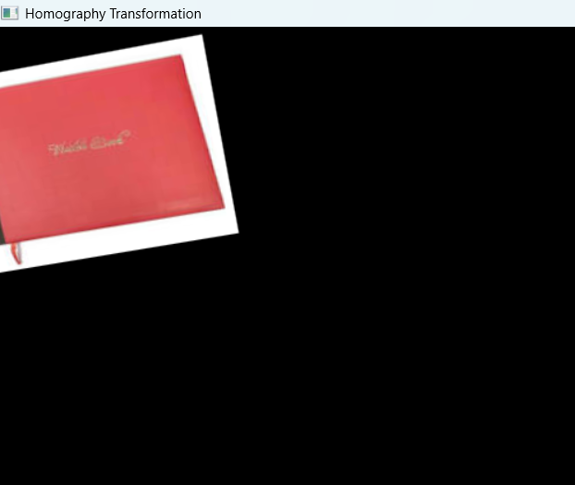


Result
The homography matrix was successfully computed, and the input image was transformed into the desired perspective using OpenCV.

