Lab Experiments
Experiment 26: Insert Watermark to the Image Using OpenCV
AimTo insert a watermark text into an image using OpenCV in Python.
Algorithm
- Read the input image.
- Define the watermark text.
- Select the font, position, size, and thickness of the watermark.
- Insert the watermark onto the image using cv2.putText().
- Save the watermarked image.
- Display the original and watermarked images.
Code:
import cv2
img = cv2.imread("exp26.jpg")
text = "Spiderman"
cv2.putText(img, text, (50, 50),
cv2.FONT_HERSHEY_SIMPLEX, 1,
(255, 255, 255), 2)
cv2.imwrite("watermarked26.jpg", img)
cv2.imshow("Watermarked Image", img)
cv2.waitKey(0)
cv2.destroyAllWindows()
Sample Input


Output:
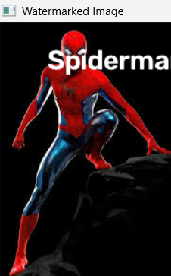

Result:
Thus, the watermark was successfully inserted into the image using OpenCV.

