Lab Experiments
Experiment 24: Image Sharpening Using High-Boost Masks
Aim:To perform image sharpening using a high-boost mask and enhance the edges and fine details of the image.
Algorithm
- Read the input image.
- Convert the image to grayscale.
- Define a high-boost mask with .
- Apply the mask to the input image using convolution.
- Obtain the sharpened image.
- Display the original and sharpened images.
- Save the sharpened image.
High-Boost Mask
Using :
Code
import cv2
import numpy as np
img = cv2.imread("exp24.jpg", 0)
mask = np.array([[-1,-1,-1],
[-1,10,-1],
[-1,-1,-1]])
sharp = cv2.filter2D(img, -1, mask)
cv2.imwrite("sharpened24.jpg", sharp)
cv2.imshow("Original", img)
cv2.imshow("Sharpened", sharp)
cv2.waitKey(0)
cv2.destroyAllWindows()

Sample Input
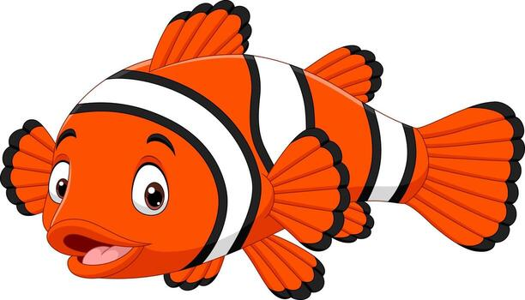
Output:
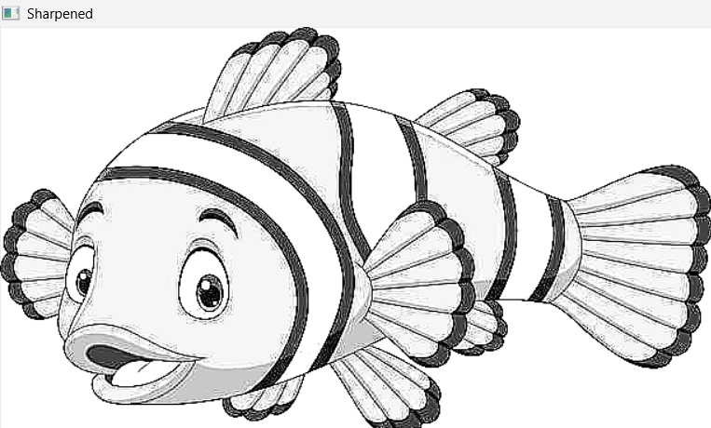

Result:
Thus, image sharpening using a high-boost mask was successfully performed, and the sharpened image was obtained with enhanced edges and details.

