Lab Experiments
Experiment 30: Morphological Operation – Dilation Using OpenCV
Aim:To perform morphological dilation on an image using OpenCV.
Algorithm
- Read the input image.
- Convert the image to grayscale.
- Create a structuring element (kernel).
- Apply dilation using cv2.dilate().
- Display the input and dilated images.
- Save the output as exp30.jpg.
Code
import cv2
import numpy as np
img = cv2.imread("exp26.jpg")
gray = cv2.cvtColor(img, cv2.COLOR_BGR2GRAY)
kernel = np.ones((5, 5), np.uint8)
dilation = cv2.dilate(gray, kernel, iterations=1)
cv2.imshow("Input Image", img)
cv2.imshow("Dilated Image", dilation)
cv2.imwrite("exp30.jpg", dilation)
cv2.waitKey(0)
cv2.destroyAllWindows()
Sample Input
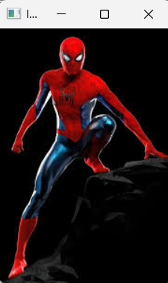
Output:
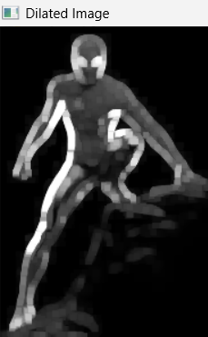

Result: The morphological dilation operation was successfully performed using OpenCV. Dilation expands the bright/white regions of the image and helps fill small gaps and connect nearby objects.

