Lab Experiments
Experiment 32. Morphological Operations Using OpenCV – Closing Technique
Aim:To implement morphological closing operation on an input image using OpenCV for filling small holes and closing small gaps in objects.
Algorithm
- Start the program.
- Import the OpenCV library.
- Read the input image exp 25.jpg.
- Convert the image into grayscale.
- Create a suitable structuring element/kernel.
- Perform dilation on the image.
- Perform erosion on the dilated image.
- The combination of dilation followed by erosion produces the Closing operation.
- Display the original and processed images.
- Save the output image.
- Stop the program.
Code
import cv2
image = cv2.imread("exp25.jpg")
if image is None:
print("Error: Image not found!")
exit()
gray = cv2.cvtColor(image, cv2.COLOR_BGR2GRAY)
kernel = cv2.getStructuringElement(cv2.MORPH_RECT, (5, 5))
closing = cv2.morphologyEx(gray, cv2.MORPH_CLOSE, kernel)
cv2.imshow("Original Image", gray)
cv2.imshow("Closing Operation", closing)
cv2.imwrite("exp25 closing output.jpg", closing)
cv2.waitKey(0)
cv2.destroyAllWindows()
Execution
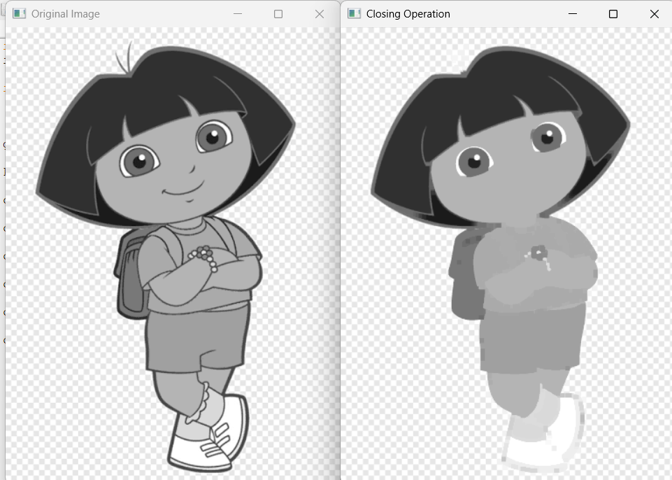
Result: Thus, the morphological closing operation was successfully implemented using OpenCV. The technique effectively fills small holes, closes gaps, and connects nearby regions in the input image.

