Lab Experiments
Experiment 27: Do Cropping, Copying and pasting image inside another image using OpenCV.
Aim:To perform cropping, copying, and pasting of a selected portion of one image inside another image using OpenCV in Python.
Algorithm
- Import the OpenCV library.
- Read the source image and destination image.
- Select a rectangular region from the source image using cropping coordinates.
- Copy the cropped region.
- Select the position in the destination image where the cropped image should be pasted.
- Paste the cropped image into the selected region.
- Display the original, cropped, and final images.
- Save the final output image.
Code
import cv2
img = cv2.imread("exp27.jpg")
crop = img[50:200, 50:200
img[250:400, 250:400] = crop
cv2.imshow("Original Image", cv2.imread("exp27.jpg"))
cv2.imshow("Cropped Image", crop)
cv2.imshow("Final Image", img)
cv2.imwrite("exp27_output.jpg", img)
cv2.waitKey(0)
cv2.destroyAllWindows()

Sample Input
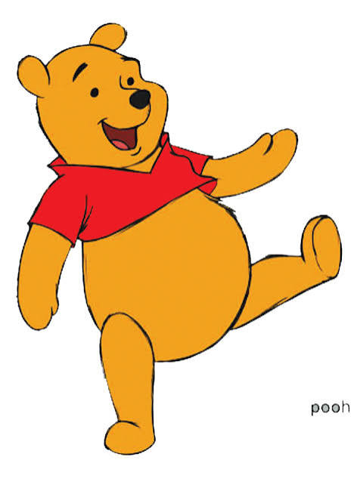

Output:
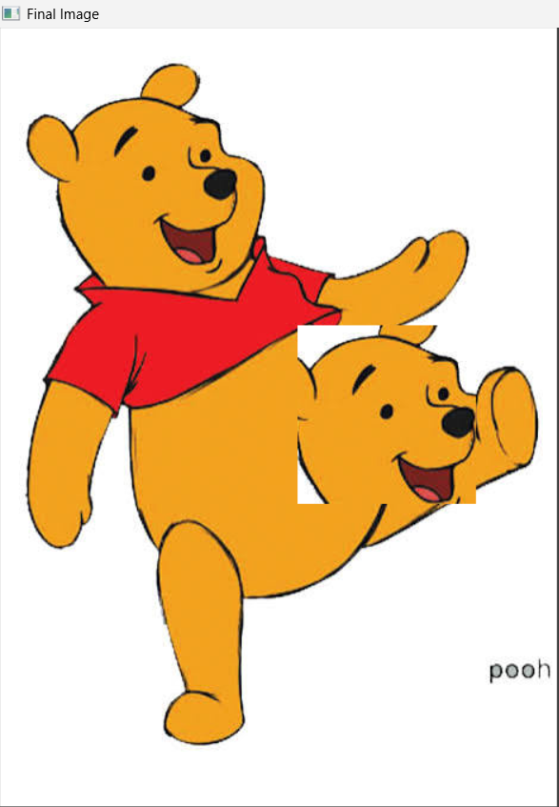

Result:
The image portion is successfully cropped, copied, and pasted inside the same image using OpenCV.

