Lab Experiments
Experiment 22: Image Sharpening Using Laplacian Mask with Positive Center Coefficient
Aim:To perform image sharpening using a Laplacian mask with a positive center coefficient and enhance the edges and fine details of the image.
Algorithm
- Read the input image.
- Convert the image into grayscale.
- Define the Laplacian sharpening mask
- Apply the mask to the image using convolution.
- Obtain the sharpened image.
- Display the original and sharpened images.
- Save the sharpened image.
Python Code
import cv2
import numpy as np
img = cv2.imread("exp22.jpg", 0)
mask = np.array([[0,-1,0],
[-1,5,-1],
[0,-1,0]])
sharp = cv2.filter2D(img, -1, mask)
cv2.imwrite("sharpened.jpg", sharp)
cv2.imshow("Original Image", img)
cv2.imshow("Sharpened Image", sharp)
cv2.waitKey(0)
cv2.destroyAllWindows()
Sample Input: Output:
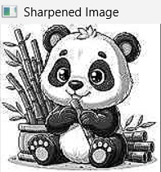


Result: Thus, the image sharpening using a Laplacian mask with positive center coefficient was successfully performed, and the sharpened image was obtained

