CSA4312-INTERENET PROGRAMMING
Name:Y.Thanushma
Registration Number:192425355
LAB EXPERIMENT

2.Hotel Room Booking Website
AIM
To design and develop a hotel room booking website named Velora Stays using HTML, CSS, and JavaScript. The website allows users to search for rooms, view room details, register, log in, book rooms, manage reservations, and view booking history. It also provides an administrator dashboard to manage room prices, room availability, bookings, registered users, and website information.
ALGORITHM
- Start the application by opening the HTML file in a web browser.
- Display the homepage with navigation menus, room search options, and featured rooms.
- Allow users to enter the destination, check-in date, check-out date, and number of guests.
- Validate the entered details and display available rooms based on guest capacity and booking dates.
- Display room details, including room type, price, facilities, and guest capacity
- Allow users to log in or register before making a reservation.
- Collect the booking details and validate the dates and number of guests.
- Calculate the total booking price and request confirmation from the user.
- Save the confirmed booking and display the booking details in the user's dashboard.
- Allow users to view booking history, update their profile, modify eligible reservations, and cancel eligible bookings.
- Allow the administrator to log in and access the administrator dashboard.
- Display booking statistics, room management options, all bookings, and registered users.
- Allow the administrator to update room prices, room quantities, booking details, and website information.
- Store the application data in the browser's local storage.
- Display the updated information and return to the homepage when required.
- Stop.
SOFTWARE REQUIREMENTS
HTML
CSS
JavaScript
Visual Studio Code
Google Chrome or any modern web browser
Output:
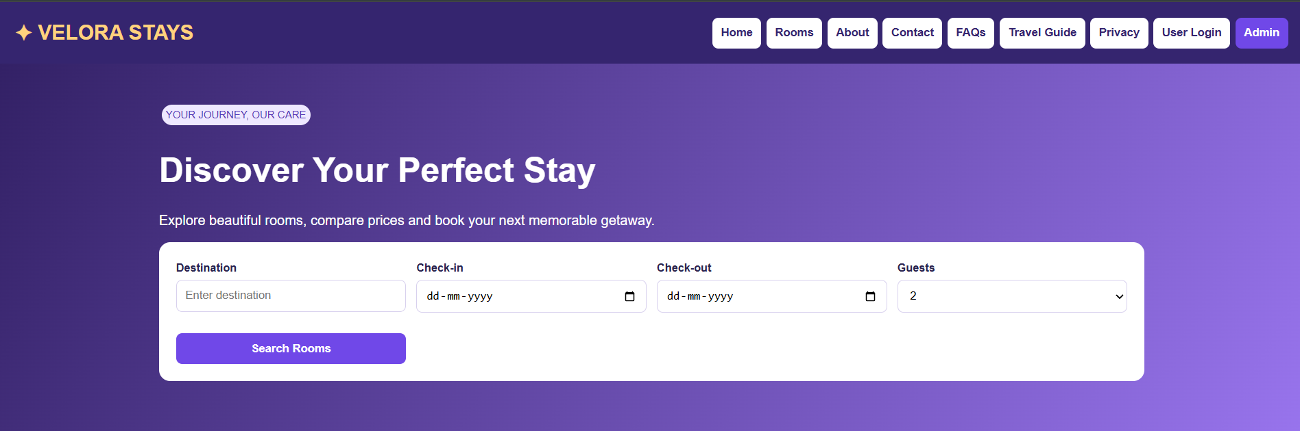
HomePage
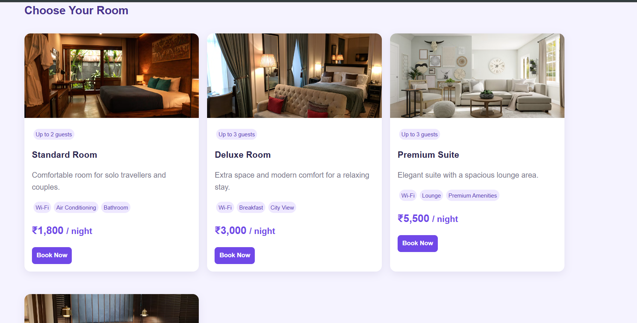
Available Rooms
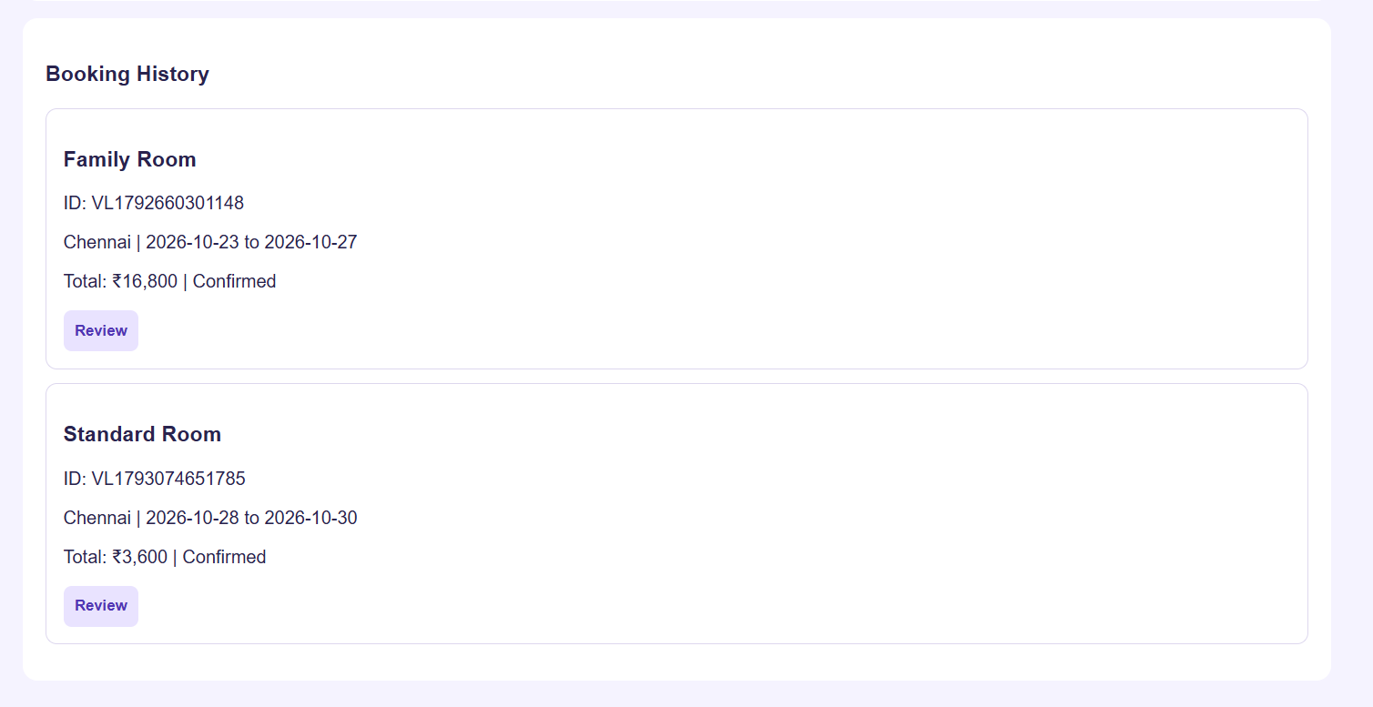
Booking History
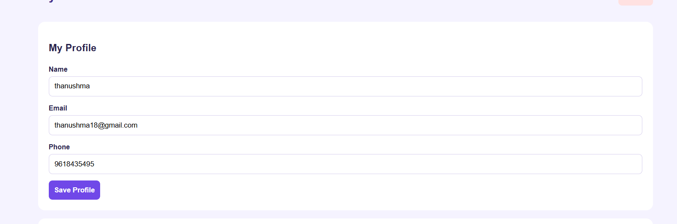
User Login

