CSA4312-INTERENET PROGRAMMING
Name:Y.Thanushma
Registration Number:192425355
LAB EXPERIMENT

3.Bus Ticket Booking System

AIM

To design and develop a Bus Ticket Booking System using HTML, CSS, and JavaScript that allows users to search for buses, select source and destination, choose travel dates, view available buses, book tickets, and view booking details. The system provides a simple and user-friendly interface for online bus reservations.

ALGORITHM
- Start the application by opening the HTML file in a web browser.
- Display the homepage with the bus booking form.
- Allow users to enter the source, destination, journey date, and number of passengers.
- Validate the entered details.
- Display the available buses based on the selected route and journey date.
- Show bus details, including bus name, departure time, arrival time, ticket price, and available seats.
- Allow users to select a bus and choose their seats.
- Collect passenger details such as name, age, and contact number.
- Calculate the total ticket fare based on the number of selected seats.
- Display the booking summary and request confirmation.
- Confirm the booking and generate a booking ID or ticket details.
- Allow users to view their booking information.
- Display the booking confirmation and journey details.
- Stop.
- Allow the administrator to update room prices, room quantities, booking details, and website information.
- Store the application data in the browser's local storage.
- Display the updated information and return to the homepage when required.
- Stop.
SOFTWARE REQUIREMENTS
HTML
CSS
JavaScript
Visual Studio Code
Google Chrome or any modern web browser
Output:
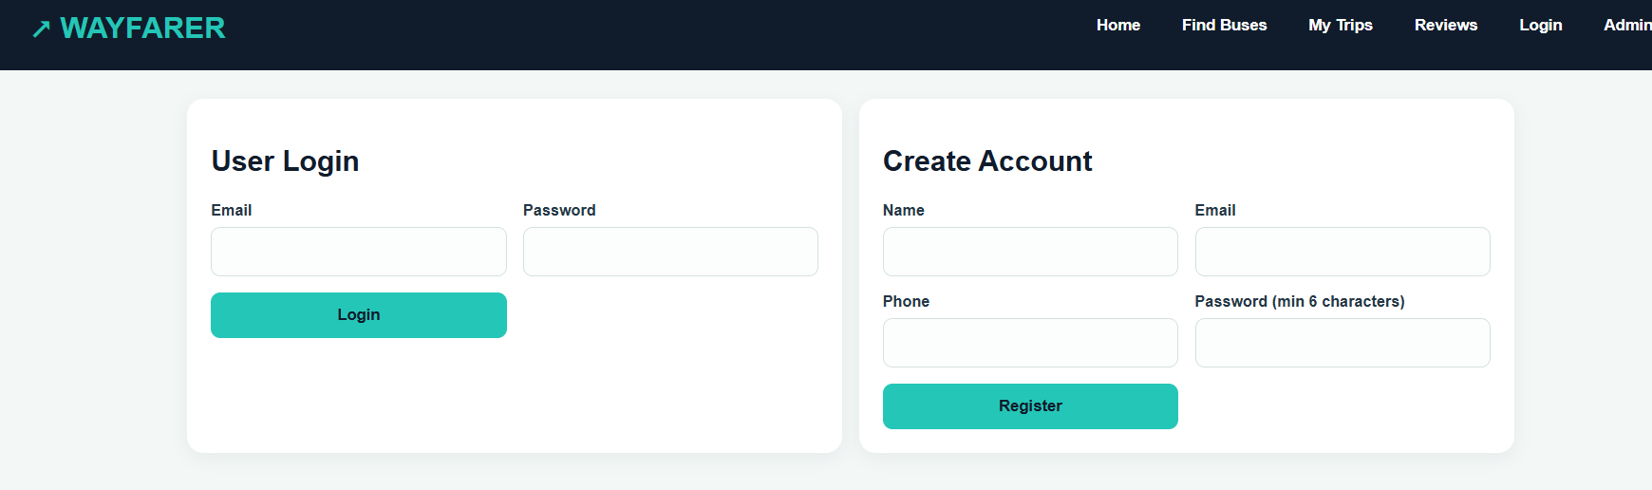
User Login
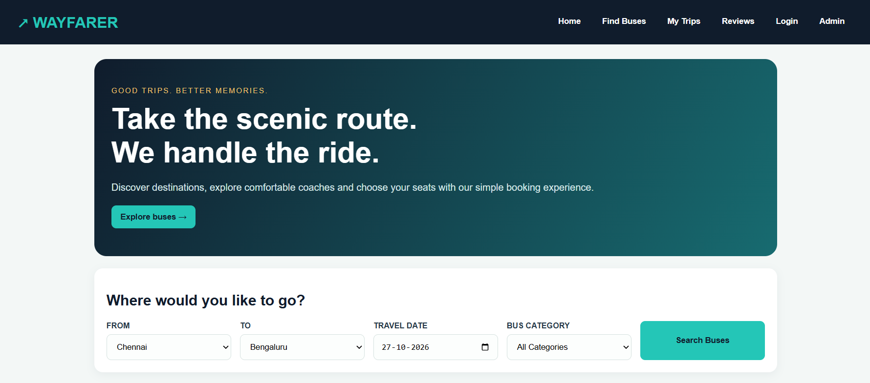
Destination Selection
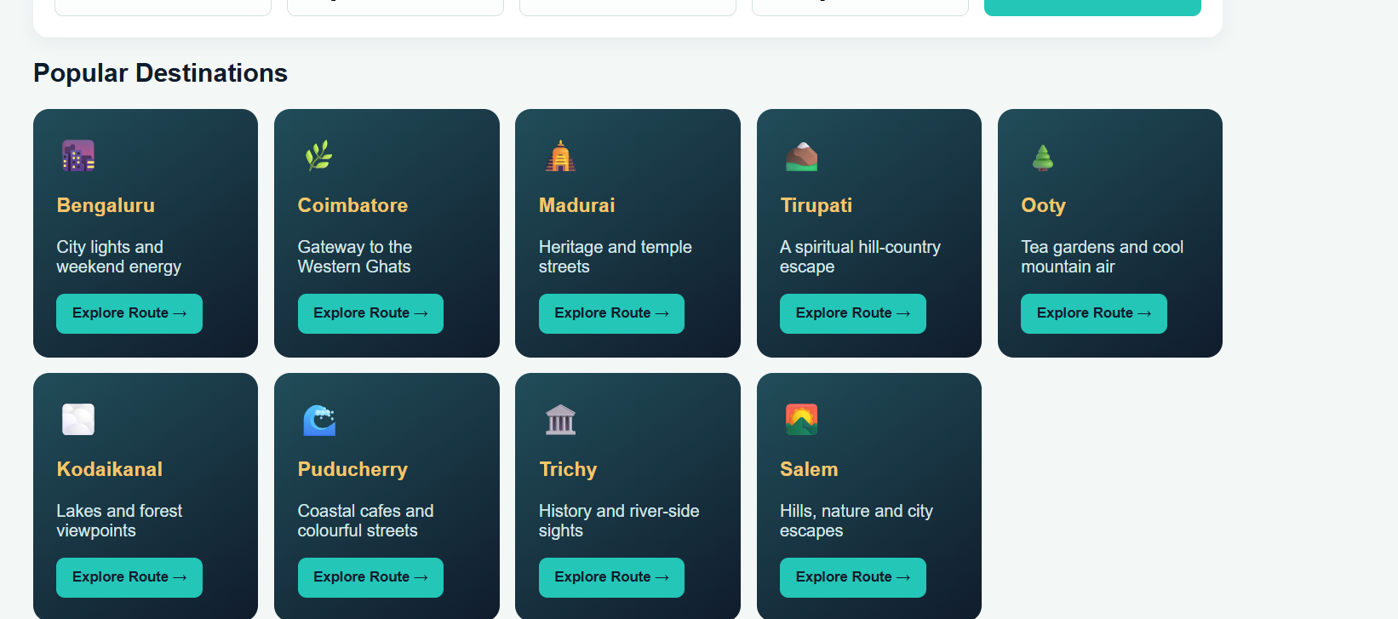
Popular Destination Suggestion
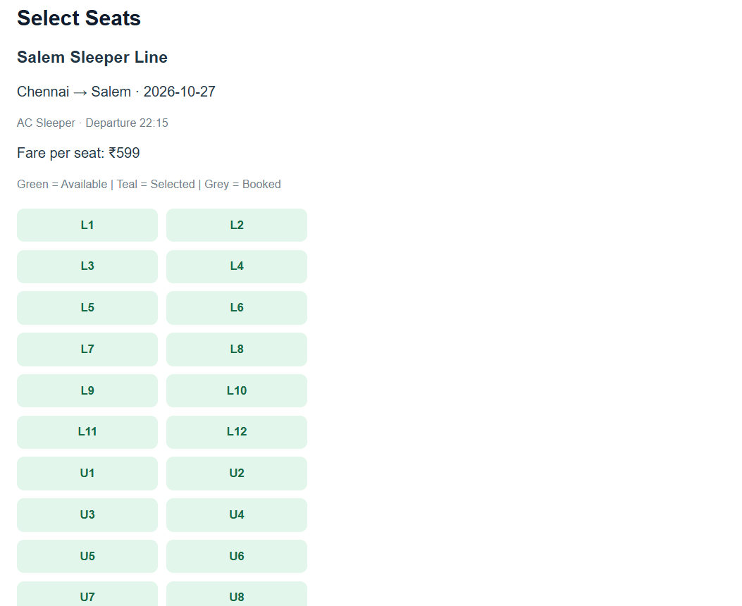
Seat Selection
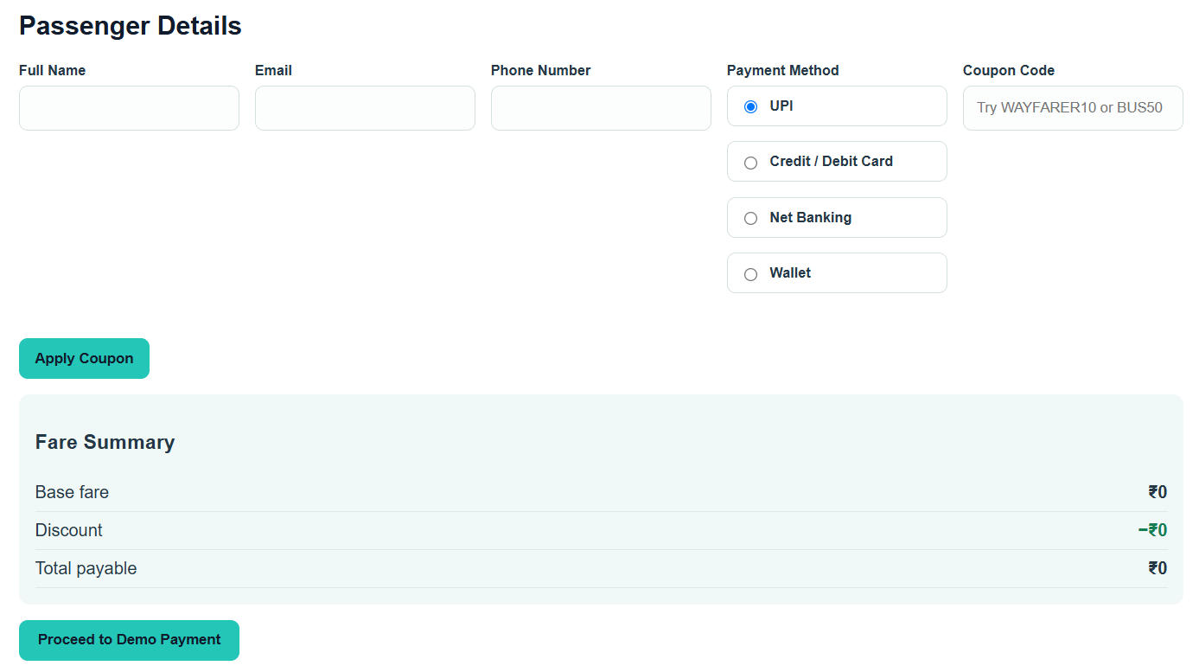
Payment

