CSA4312-INTERENET PROGRAMMING
Name:Y.Thanushma
Registration Number:192425355
LAB EXPERIMENT

4.Railway Ticket Booking System

Aim
To design and develop a Railway Ticket Booking System using HTML, CSS, and JavaScript that allows users to search for trains, select source and destination stations, choose journey dates, view available trains, book tickets, and view booking details. The system provides a user-friendly interface for railway reservations.

Algorithm
- Start the application by opening the HTML file in a web browser.
- Display the homepage with the railway ticket booking form.
- Allow users to enter the source station, destination station, journey date, and number of passengers.
- Validate the entered details.
- Display the available trains based on the selected source, destination, and journey date.
- Display train details, including train name, train number, departure time, arrival time, journey duration, and ticket fare.
- Allow users to select a train and choose their preferred seats or class, if available.
- Collect passenger details such as name, age, and gender.
- Calculate the total ticket fare based on the selected passengers and class.
- Display the booking summary and request confirmation.
- Confirm the booking and generate a booking reference or PNR number.
- Display the ticket details, including train information, passenger details, journey date, and fare.
- Allow users to view their booking information and check booking status, if supported.
- Display the booking confirmation message.
- Stop.
- Store the application data in the browser's local storage.
- Display the updated information and return to the homepage when required.
- Stop.
SOFTWARE REQUIREMENTS
HTML
CSS
JavaScript
Visual Studio Code
Google Chrome or any modern web browser
Output:

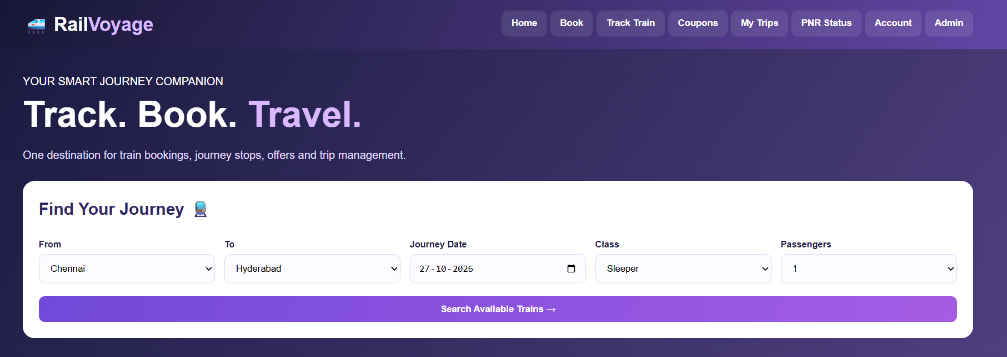
Home Page
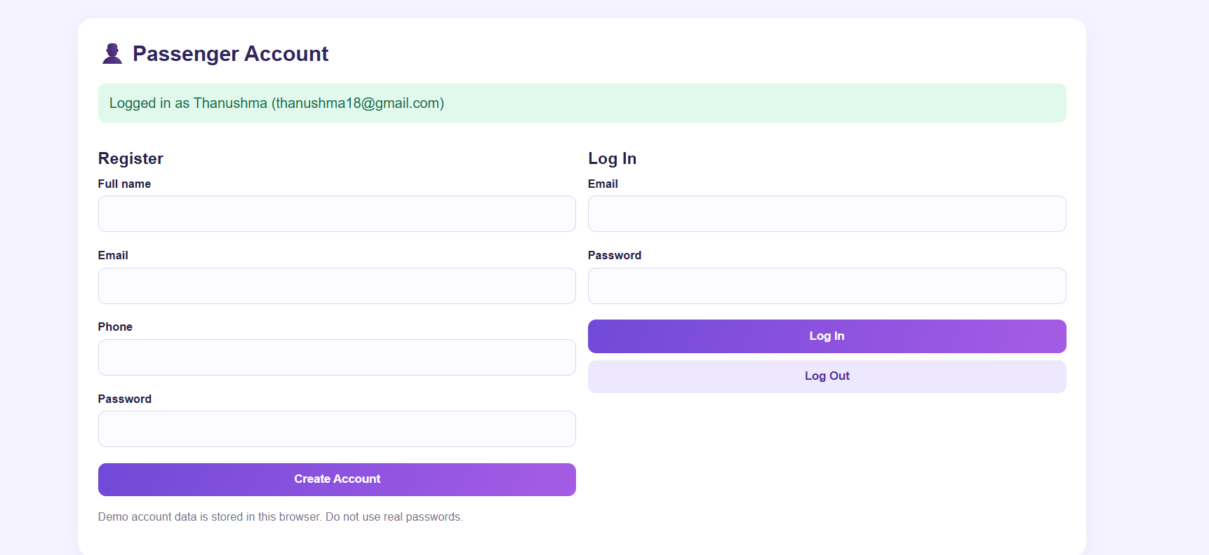
User Login
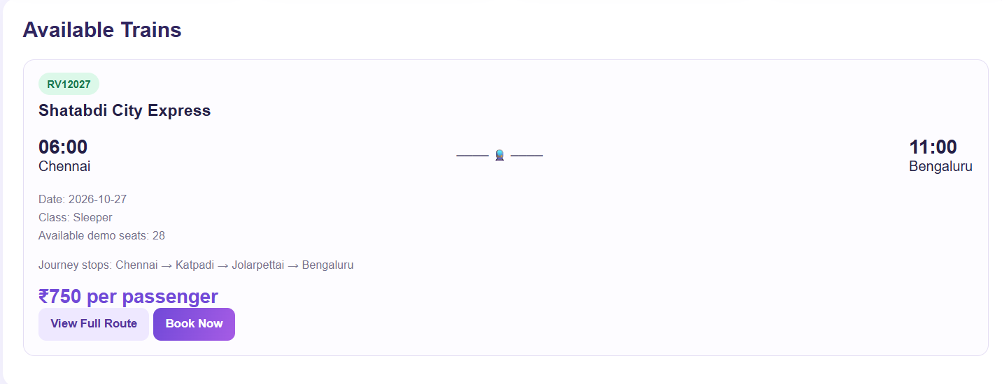
Available Trains
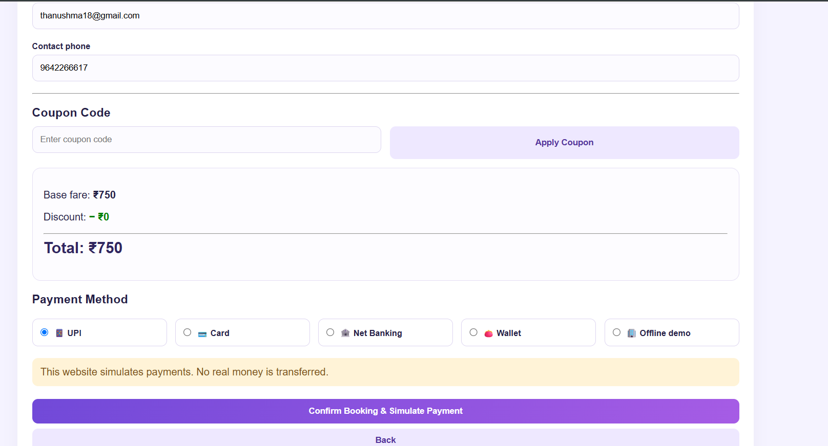
Payment
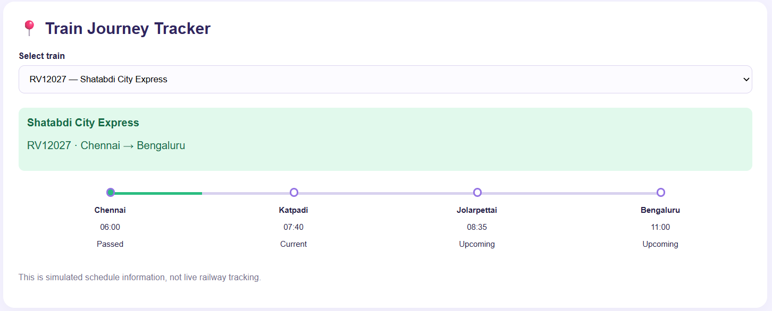
Journey Tracker

