CSA4312-INTERENET PROGRAMMING
Name:Y.Thanushma
Registration Number:192425355
LAB EXPERIMENT

1.Library Management
Aim
To design and develop a colourful Library Management System website using HTML, CSS, and JavaScript to manage book searching, student login, registration, borrowing history, study materials, and contact information.
Algorithm
- Start.
- Create an HTML page for the Library Management System.
- Apply CSS to design a colourful and attractive webpage.
- Create navigation links for Home, Login, Register, Books, Materials, and Contact.
- Design student login and registration forms.
- Display the book catalog with book names, authors, and availability.
- Implement JavaScript to search books by name or author.
- Display borrowing history and fine details.
- Provide dropdown menus for academic year and semester.
- Create a contact form for user messages.
- Save the HTML file and run it in a web browser.
- Test the website and verify the output.
- Stop.

Output:
Dashboard
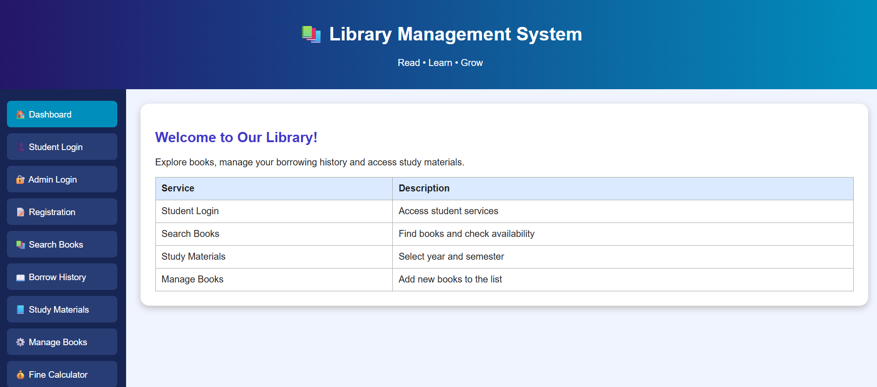

Student and Admin Login
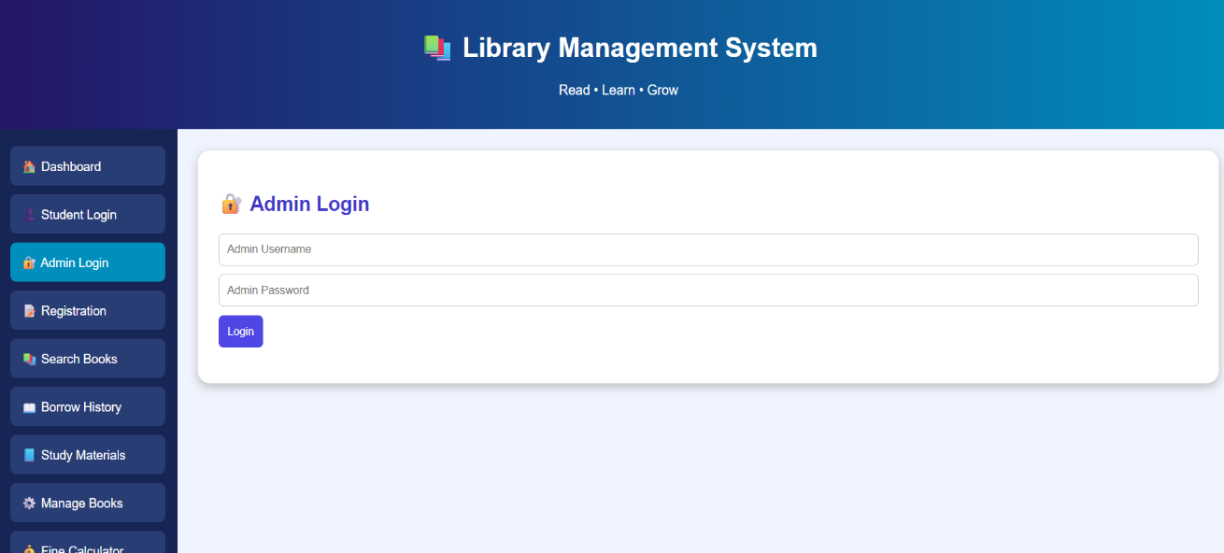
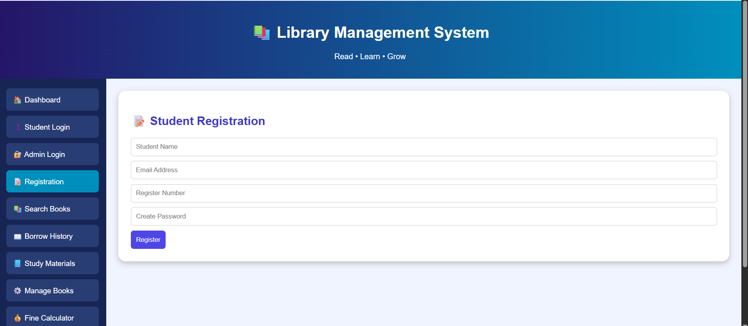
Search Books
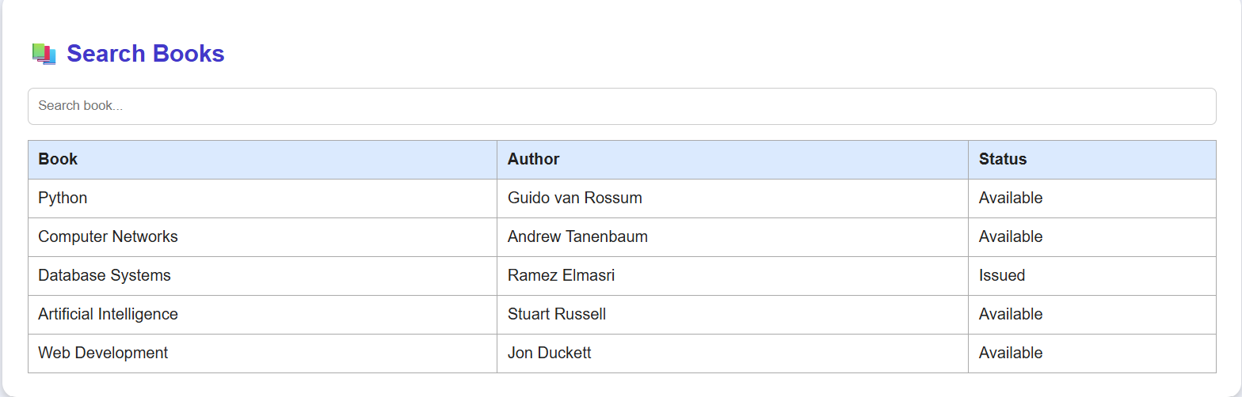
Borrow History
