3. Design a CPU scheduling program with C using First Come First Served technique with the
following considerations.
a. All processes are activated at time 0.
b. Assume that no process waits on I/O devices.

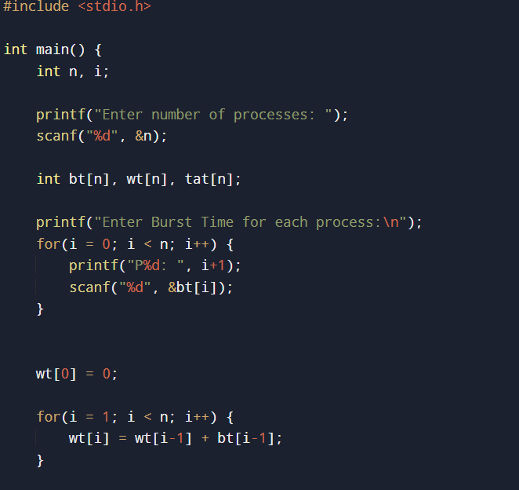
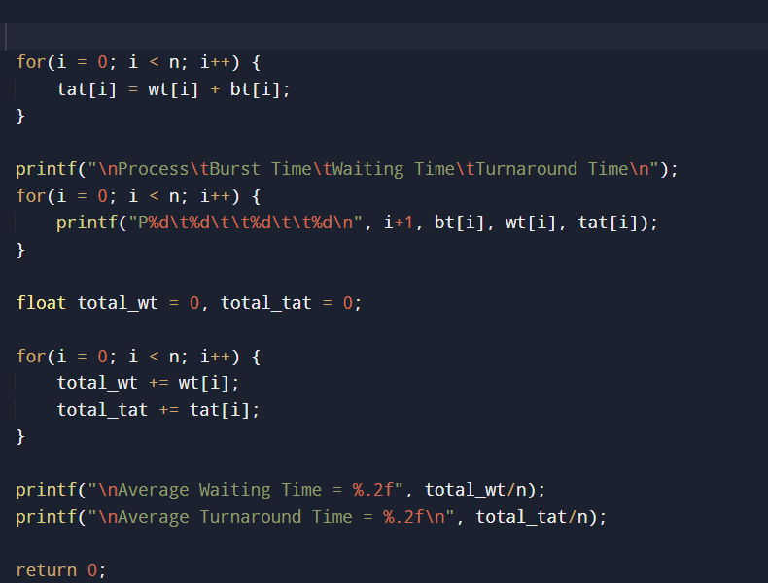
OUTPUT
