5.Construct a scheduling program with C that selects the waiting process with the highest priority to execute next.
CODE:
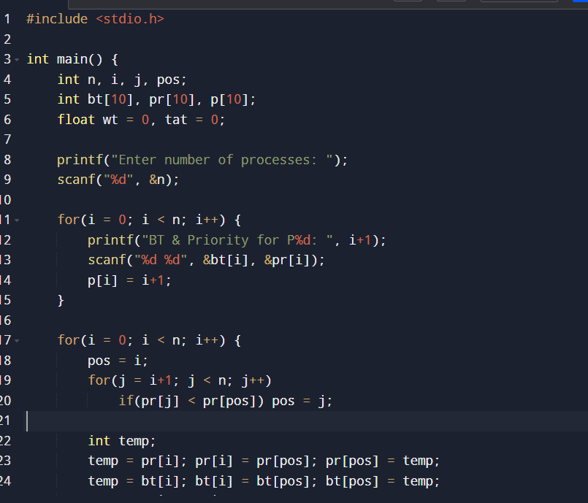
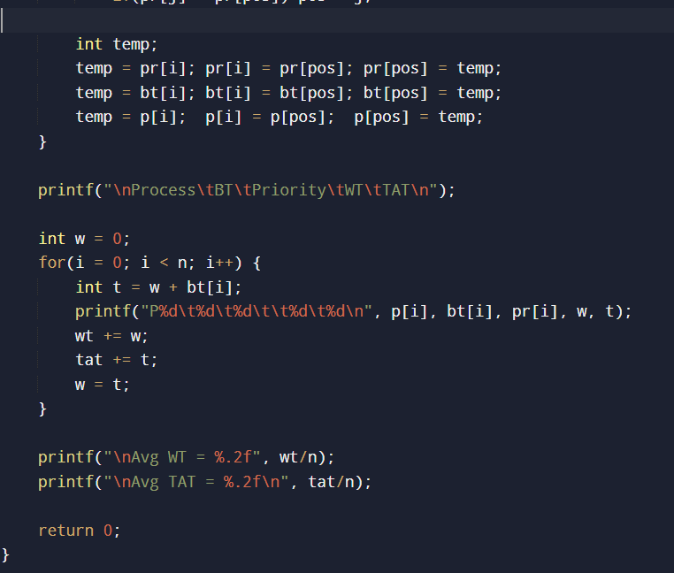

OUTPUT
