1.Create a new process by invoking the appropriate system call. Get the process identifier of the currently running process and its respective parent using system calls and display the same using a C program.
CODE:
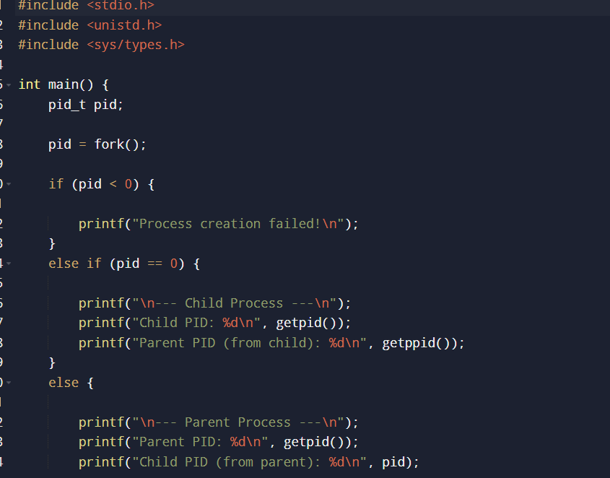
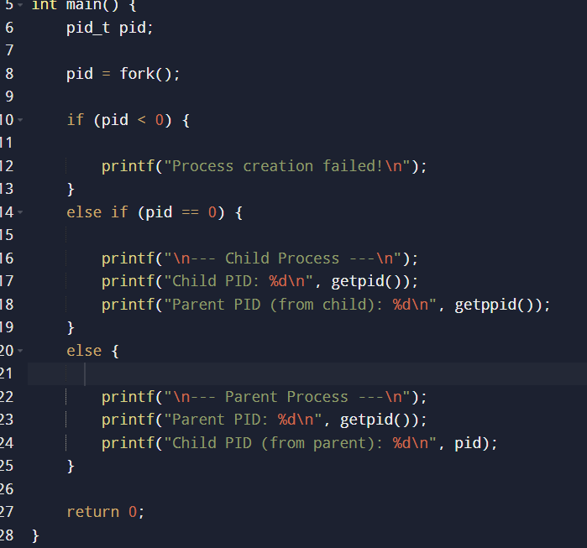
OUTPUT
