C Programming – Assignment 1
Task 1 – Understand the Problem and Identify the Data

Code
#include <stdio.h>

#define FREE_UNITS 100
#define RATE2 2.25
#define RATE3 4.50
#define FIXED_CHARGE 50.00

int main(void) {
unsigned int previous, current, units;
double energy_charge, total;
int household;

printf("Enter household number: ");
scanf("%d", &household);

printf("Enter previous reading: ");
scanf("%u", &previous);

printf("Enter current reading: ");
scanf("%u", &current);

units = current - previous;

if (units <= FREE_UNITS)
energy_charge = 0;
else if (units <= 200)
energy_charge = (units - FREE_UNITS) * RATE2;
else
energy_charge = 100 * RATE2
+ (units - 200) * RATE3;

total = FIXED_CHARGE + energy_charge;

printf("\nHousehold Number: %d\n", household);
printf("Units Consumed: %u\n", units);
printf("Energy Charge: Rs %.2f\n", energy_charge);
printf("Fixed Charge: Rs %.2f\n", FIXED_CHARGE);
printf("Total Bill: Rs %.2f\n", total);

return 0;
}

Output
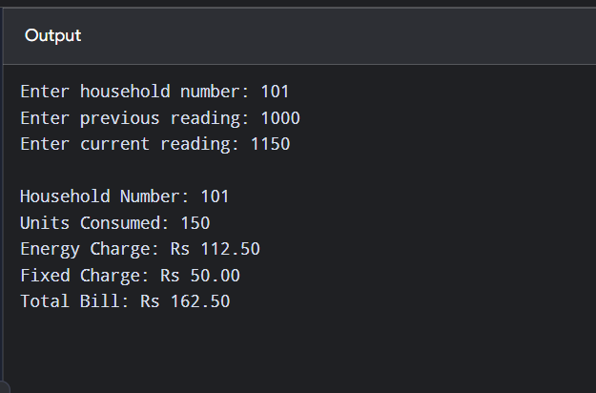
Output for household 101 (previous 1000, current 1150)

Explanation
- Constants: FREE_UNITS, RATE2, RATE3 and FIXED_CHARGE are defined with #define, so the tariff is changed in one place only.
- Inputs: household number (int), previous reading and current reading (unsigned int, because readings are never negative). They are read with %d and %u.
- Units: units = current − previous = 1150 − 1000 = 150.
- Energy charge: the first 100 units are free, so only 150 − 100 = 50 units are charged at Rs 2.25, giving Rs 112.50. Above 200 units the rate would be Rs 4.50.
- Total: fixed charge + energy charge = 50.00 + 112.50 = Rs 162.50, which matches the output.
- Printing: %.2f prints exactly two decimal places (paise).
- Rule checked: the total equals the sum of its parts and the bill is not negative.
- Assumptions: one tariff for all households, current reading ≥ previous reading, and money held in double for now (Task 2 changes this to paise).

