VISVESVARAYA TECHNOLOGICAL UNIVERSITY
“Jnana Sangama”, Machhe, Belagavi, Karnataka-590018


Lab Experiment Record
Project Management with Git [BCSL358C]
Submitted in partial fulfillment towards AEC of 3rd semester of
Bachelor of Engineering
in
Computer Science and Engineering
(Artificial Intelligence & Machine Learning)

Submitted by
THANUSHREE M R
4GW24CI058


DEPARTMENT OF CSE (Artificial Intelligence & Machine Learning)
GSSS INSTITUTE OF ENGINEERING & TECHNOLOGY FOR WOMEN
(Affiliated to VTU, Belagavi, Approved by AICTE, New Delhi & Govt. of Karnataka)
K.R.S ROAD, METAGALLI, MYSURU-570016, KARNATAKA
(Accredited by NAAC)
EXPERIMENT 1: SETTING UP AND BASIC COMMANDS
PROCEDURE
- Open Git Bash and move to the project folder created on the Desktop using the cd command.
- Initialize the folder as a Git repository using the git init command.
- Create a new text file using Notepad to store the experiment content.
- Add the created file to the staging area using the git add command.
- Check the status of the repository using the git status command.
- Commit the staged file to the local repository using the git commit command.
- Link the local repository to the remote GitHub repository using the git remote add origin command.
- Rename the default branch to main using the git branch M main command.
- Synchronize the local repository with the remote repository using the git pull --rebase command.
- Push the committed files from the local repository to the GitHub repository using the git push command.

GIT REPO URL :
https://github.com/thanushreemrthanu25-design/usn58
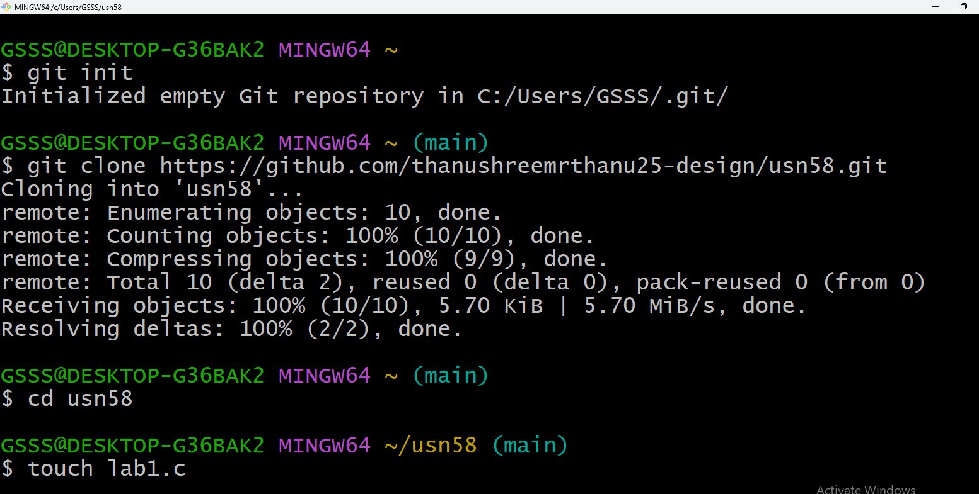

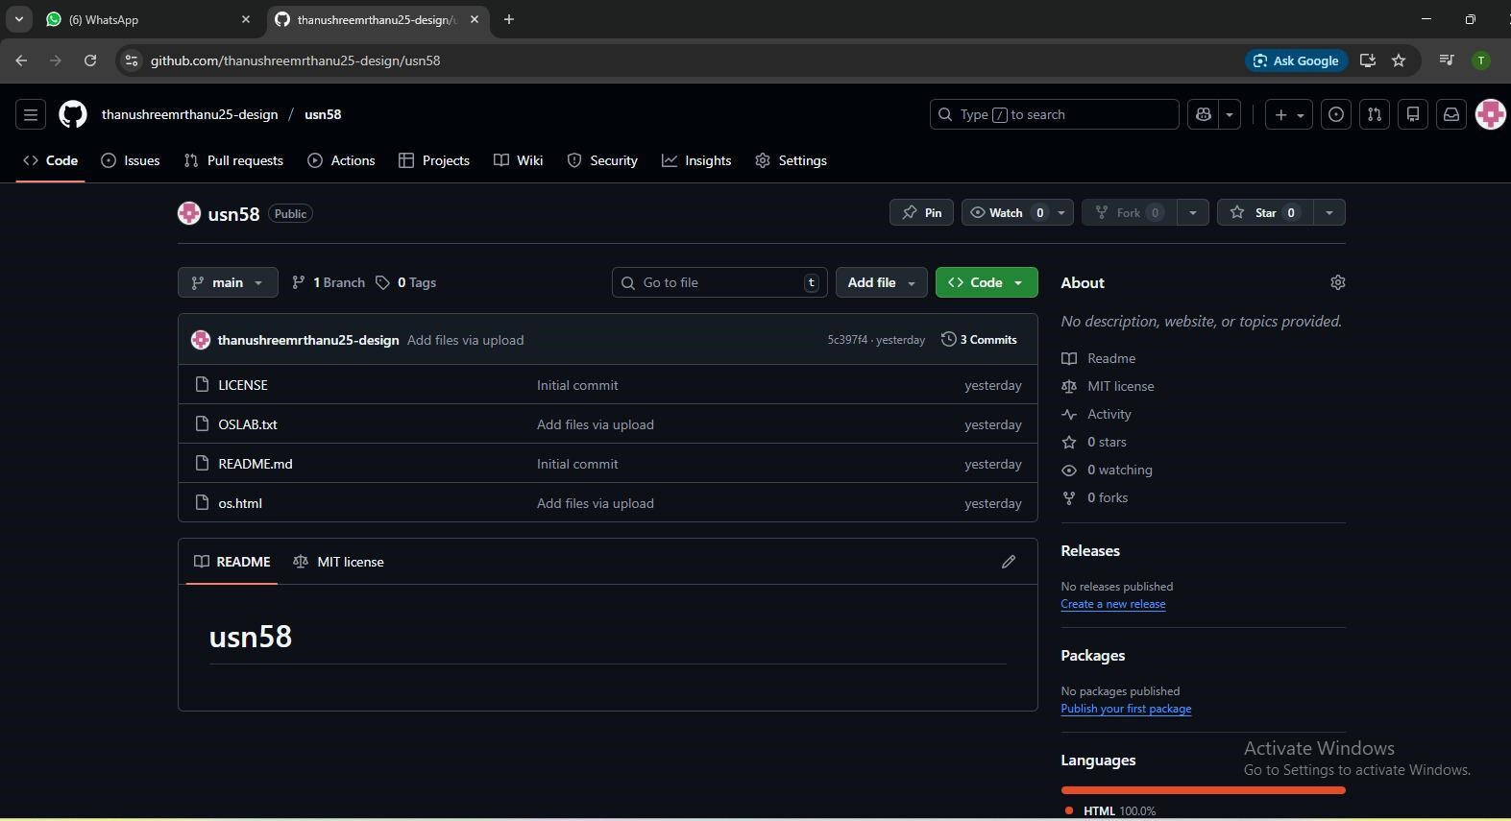

COMMANDS USED:

git init notepad lab1.txt git add lab1.txt git status
git commit -m "Experiment 1: Initial repository setup and first commit" git remote add origin https://github.com/chinmayimohan2006-web/github.git git branch -M main git pull --rebase origin main
git push -u origin main
EXPERIMENT 2: CREATING AND MERGING
BRANCHES
PROCEDURE
- Open Git Bash and move to the project directory.
- Switch to the main branch using the git checkout command.
- Create a new branch named feature-branch and switch to it.
- Modify an existing file using Notepad.
- Add the modified file to the staging area.
- Commit the changes in the feature branch.
- Switch back to the main branch.
- Merge the feature-branch into the main branch.

COMMANDS USED:
git checkout main git checkout -b feature-branch notepad lab1.txt git add lab1.txt git commit -m "Experiment 2: Changes in feature branch" git checkout main git merge feature-branch

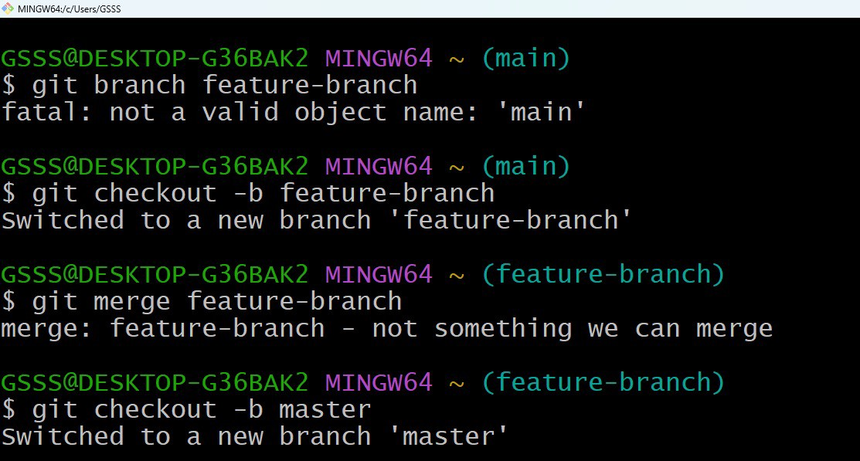

EXPERIMENT 3: CREATING AND MERGING BRANCHES

PROCEDURE:

- Open Git Bash and move to the project directory.
- Modify an existing file using Notepad.
- Check the repository status using the git status command.
- Save the uncommitted changes using the git stash command.
- Verify that the working directory is clean.
- Switch to another branch.
- Apply the stashed changes using the git stash apply command.
- Check the repository status again.

COMMANDS USED:

notepad lab1.txt , git status , git stash , git checkout feature1 , git stash apply , git status

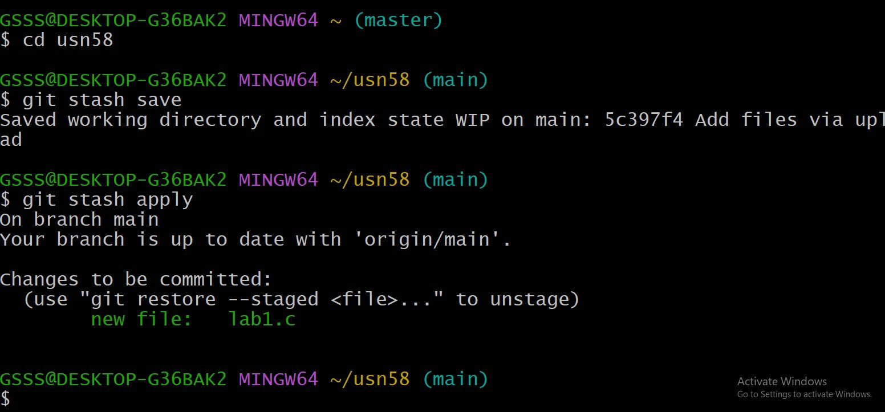

EXPERIMENT 4: COLLABORATIONS AND REPORT REPOSITORIES

PROCEDURE:

- The terminal was navigated to the Desktop using the cd command.
- The remote GitHub repository was copied to the local system using the git clone command.
- The cloned repository folder was accessed using the cd command.
- The files present in the repository were displayed using the ls command.
- The current status of the repository was checked using the git status command.

COMMANDS USED:

cd ~/OneDrive/Desktop git clone <repository-URL>
cd <repository-folder>
ls git status

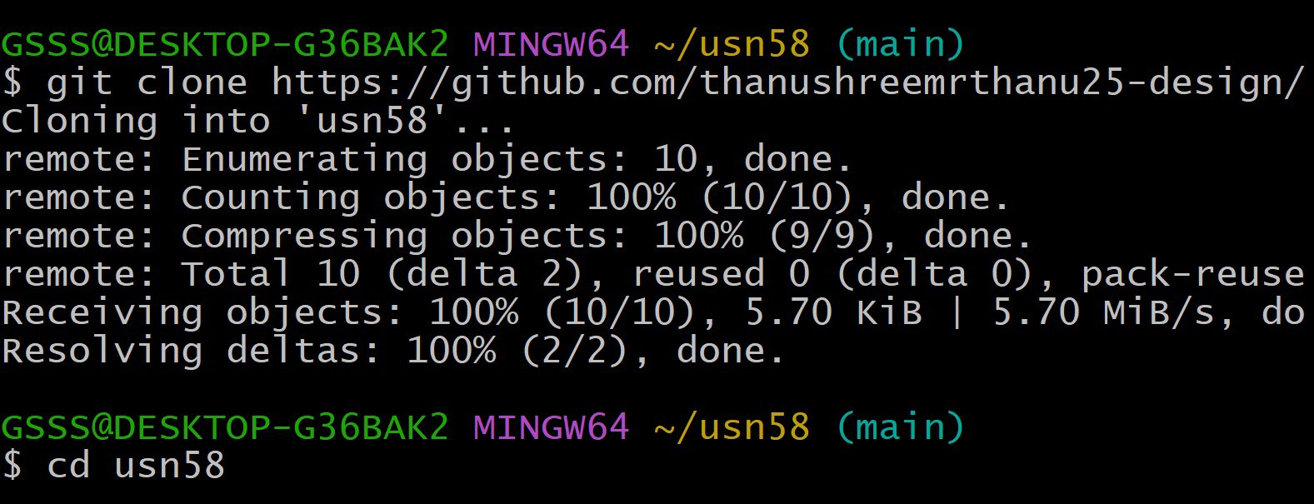

EXPERIMENT 5: COLLABORATIONS AND REPORT REPOSITORIES

PROCEDURE:

- The terminal was navigated to the local GitHub repository directory.
- The current branch and working tree status were verified using the git status command.
- The latest changes from the remote repository were fetched using the git fetch origin command.
- The local branch was synchronized with the remote main branch using the git rebase origin/main command.
- The repository status was checked again to ensure that the working tree was clean and up to date.

COMMANDS USED:

cd ~/OneDrive/Desktop/github , git status , git status , git fetch origin, git rebase origin/main

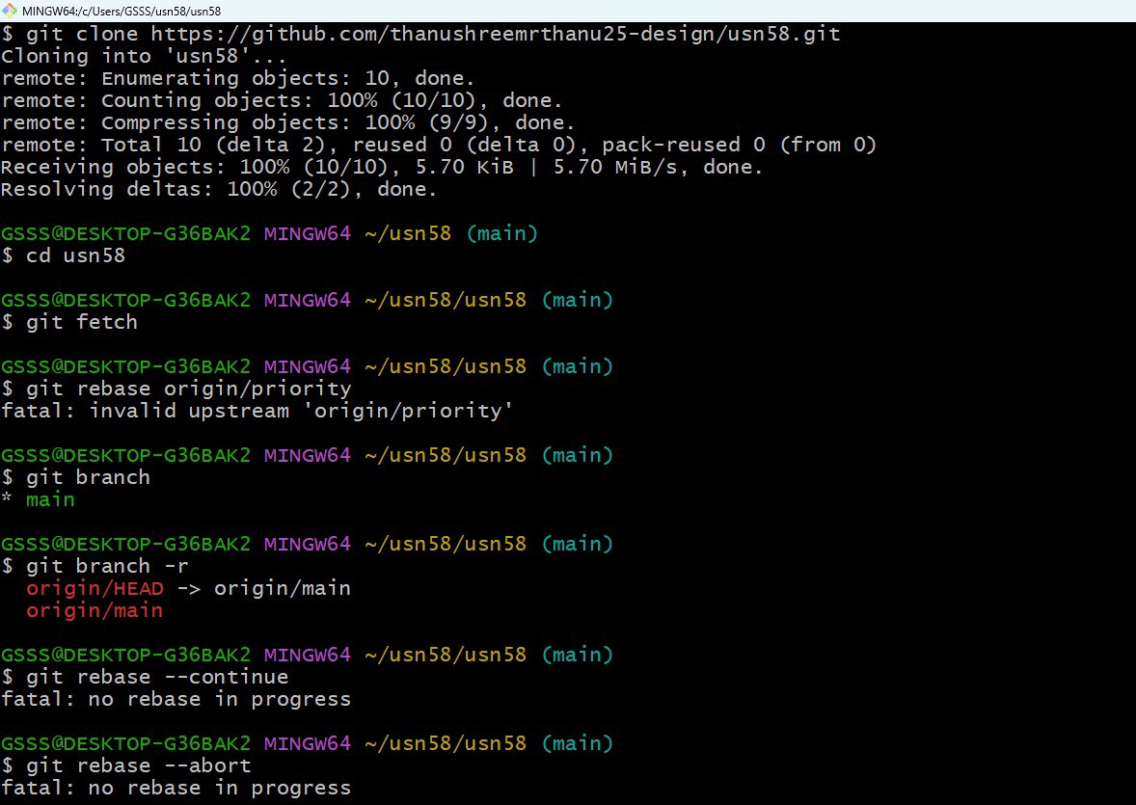

EXPERIMENT 6: COLLABORATION AND REMOTE REPOSITORIES

PROCIDURE:

- The list of available branches was displayed using the git branch command.
- The current working branch was switched to the main branch using git checkout main.
- The changes from the feature branch were merged into the main branch using the git merge feature1 command.
- The status of the repository was verified using the git status command to ensure successful merge.

COMMANDS USED:

git branch, git checkout main, git , git merge feature1, git status

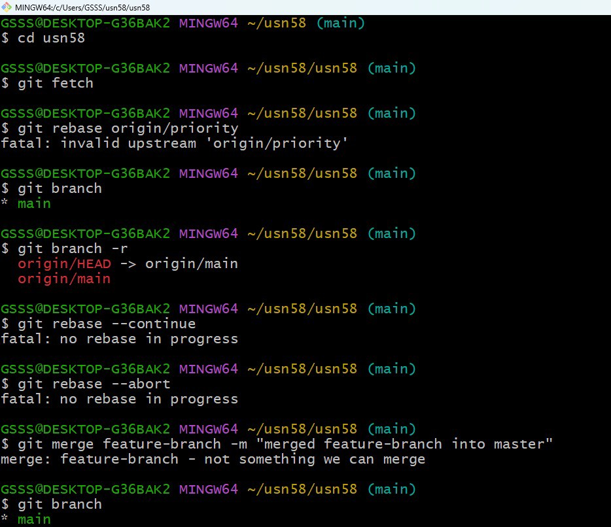

EXPERIMENT 7: GIT TAGS AND RELEASES

PROCEDURE:

- The working branch was verified and switched to the main branch using the git checkout main command.
- The current repository status was checked using git status.
- A tag named v1.0 was created using the git tag command to mark an important version of the project.
- The list of available tags was displayed using the git tag command.
- The commit history was viewed using git log --oneline to confirm that the tag was attached to the correct commit.

COMMANDS USED:

git checkout main , git status, git tag v1.0, git tag , git log –oneline

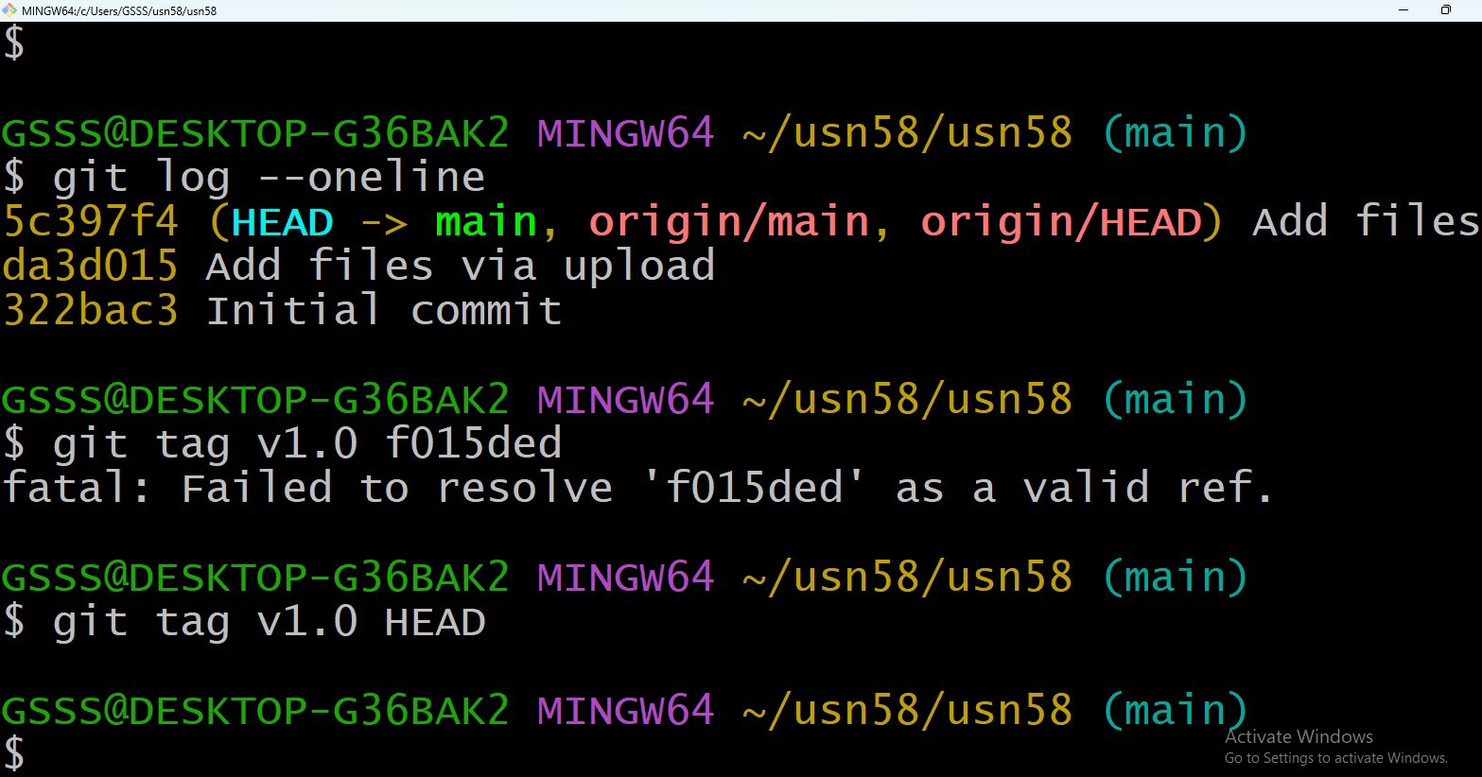

EXPERIMENT 8: ADVANCED GIT OPERATIONS

PROCEDURE:

- The commit history was viewed using the git log --oneline command.
- A new branch named feature1 was created using git checkout -b feature1.
- The file lab1.txt was modified using Notepad.
- The modified file was staged using the git add command.
- The changes were committed using the git commit command.
- The working branch was switched back to main using git checkout main.
- The commit from the feature branch was applied to the main branch using the git cherrypick command.
- The commit history was verified to confirm successful cherry-pick.

COMMANDS USED:

git log –oneline , git checkout -b feature1 notepad lab1.txt git add lab1.txt
git commit -m "Commit for cherry-pick experiment" git checkout main git cherry-pick feature1
git log --oneline

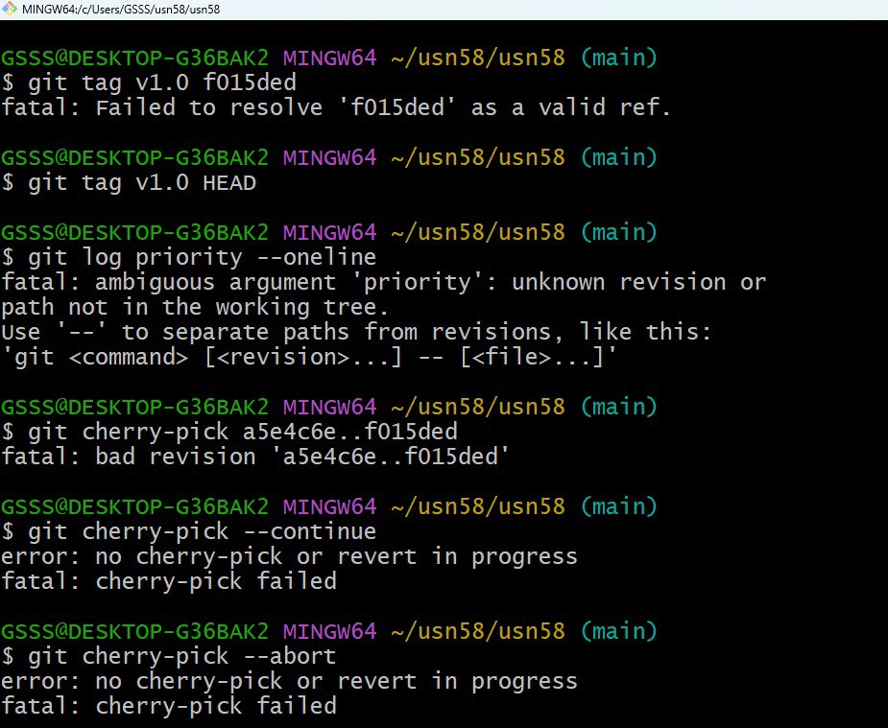

EXPERIMENT 9: ANALYSING AND CHANGING GIT
HISTORY

PROCEDURE:
- The commit history of the repository was viewed using the git log --oneline command to display concise commit information.
- The complete commit history with author name, date, and commit message was viewed using the git log command.
- A specific commit was selected from the history and its detailed information was displayed using the git show command.
- The changes made in the selected commit were analyzed using the diff output.

COMMANDS USED:
git log –oneline , git log ,
git show <commit-id>

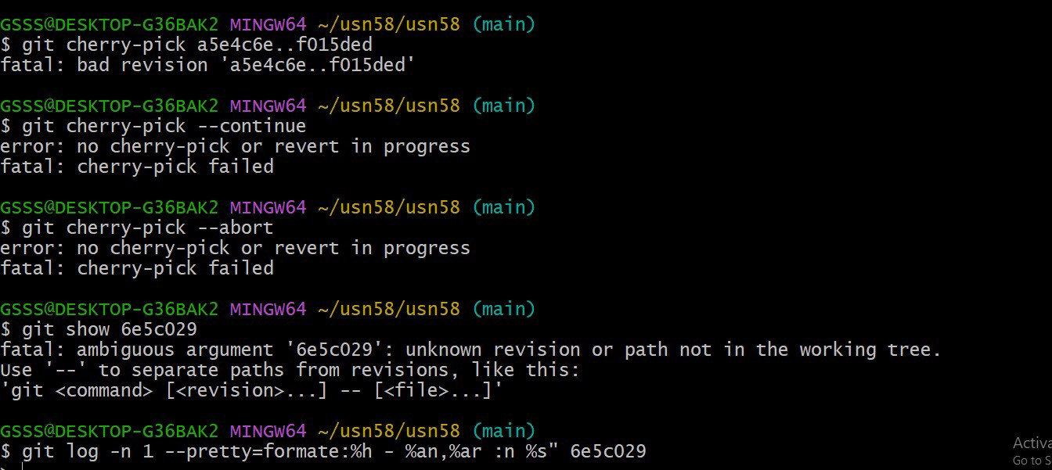

EXPERIMENT 10: ANALYSING AND CHANGING GIT
HISTORY
PROCEDURE:
- The current status of the repository was checked using the git status command.
- The file lab1.txt was modified using Notepad.
- The repository status was checked again to confirm that the file was modified.
- The modified file was restored to its last committed state using the git restore lab1.txt command.
- The repository status was verified to ensure that the working tree was clean.

COMMANDS USED:
git status notepad lab1.txt git status

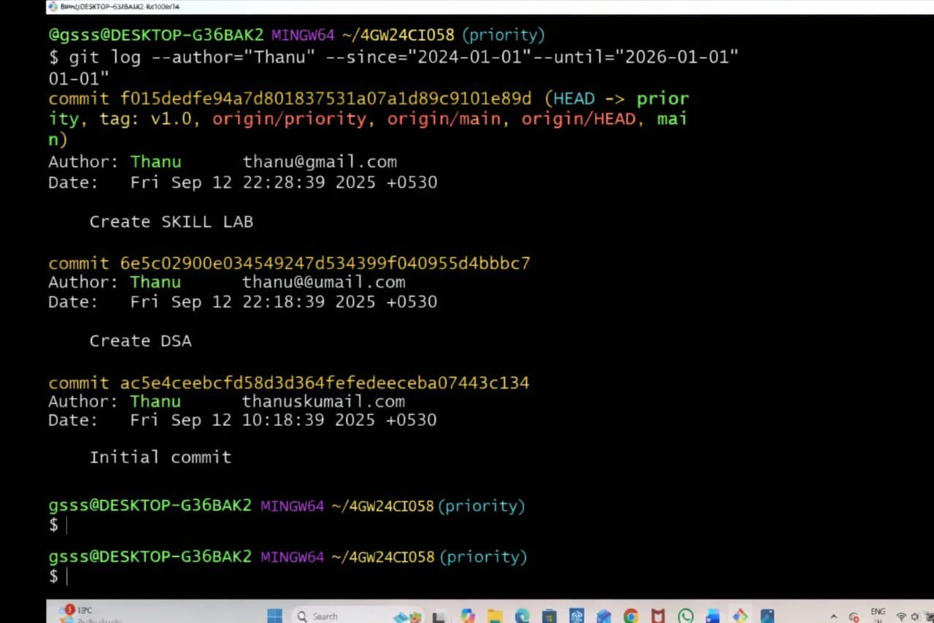

EXPERIMENT 11: ANALYSING AND CHANGING GIT
HISTORY
PROCEDURE:
- The current status of the local repository was checked using the git status command.
- The committed changes were pushed to the remote GitHub repository using the git push origin main command.
- After pushing, the status was verified to ensure the local and remote repositories were synchronized.
- The updated files and commits were verified on the GitHub repository.
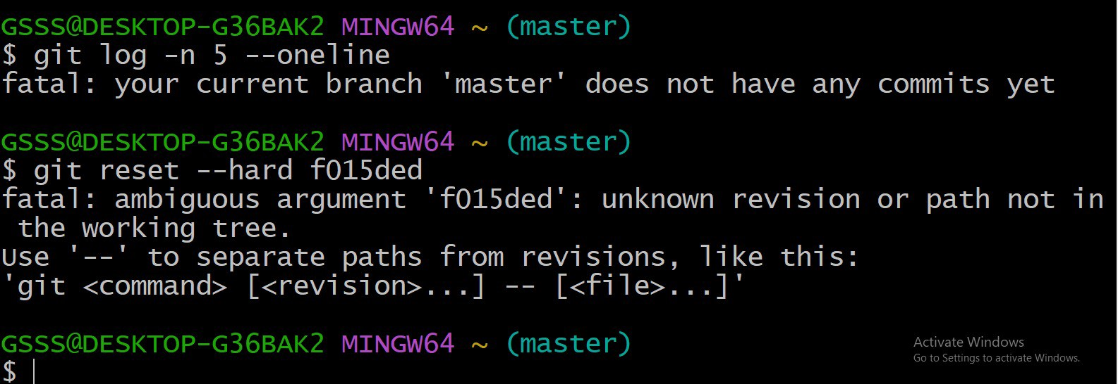

COMMAND USERS:
git status, git push origin
EXPERIMENT 12: ANALYSING AND CHANGING GIT HISTORY

PROCEDURE:

- The commit history was viewed using the git log --oneline command.
- The commit that needed to be undone was identified.
- The git revert command was used to reverse the changes made by the selected commit.
- A new revert commit was created without deleting previous commits.
- The repository status and commit history were verified.
- The revert commit was pushed to the remote GitHub repository

COMMANDS USED:

git log –oneline, git revert <commit-id>, git status, git pus git push origin main







