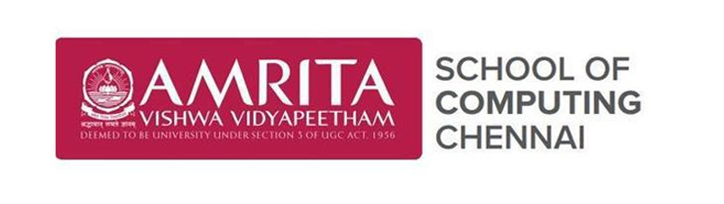

Academic year 2025-2026

**20CYS401**

**Secure Software Engineering**

Lab Record

*Submitted by*

P Thanusree

CH.EN.U4CYS22038

**Amrita Vishwa Vidyapeetham Chennai – 601 103, Tamil Nadu, India.**

**October 2025**

**Question:For the given application complete full secure devops lifecycle within single lab session**

**Application name: Feeddback submission portal**

**Suggested technology stack:Node.js+mongoDB**

**Focus area/expected output:cross site scripting prevention**

**3.Design using Draw.io**

Create a **Level 0 Data Flow Diagram (DFD)** showing: • User → App → Database • Authentication and CRUD operations.

