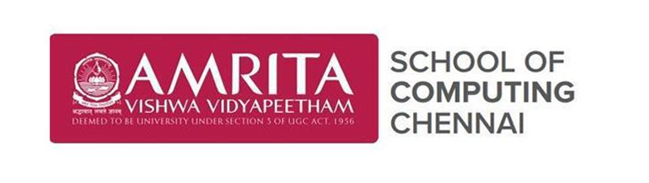

Academic year 2025-2026

**20CYS401**

**Secure Software Engineering**

Lab Record

*Submitted by*

P Thanusree

CH.EN.U4CYS22038

**Amrita Vishwa Vidyapeetham Chennai – 601 103, Tamil Nadu, India.**

**October 2025**

**Question:For the given application complete full secure devops lifecycle within single lab session**

**Application name: Feeddback submission portal**

**Suggested technology stack:Node.js+mongoDB**

**Focus area/expected output:cross site scripting prevention**

**9.Final Output**

Run the application inside Kubernetes and show the final result in browser or CLI.

In which ip and port its running:

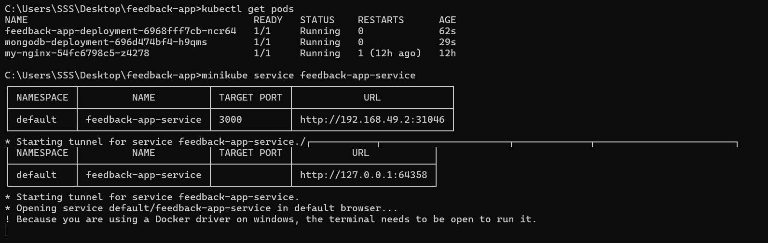

**Data stored in MongoDB till now:**

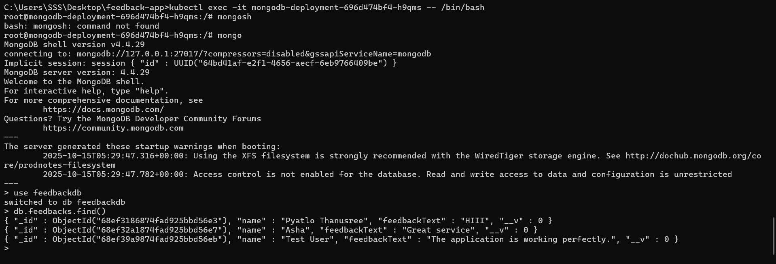

**Normal feedback:**

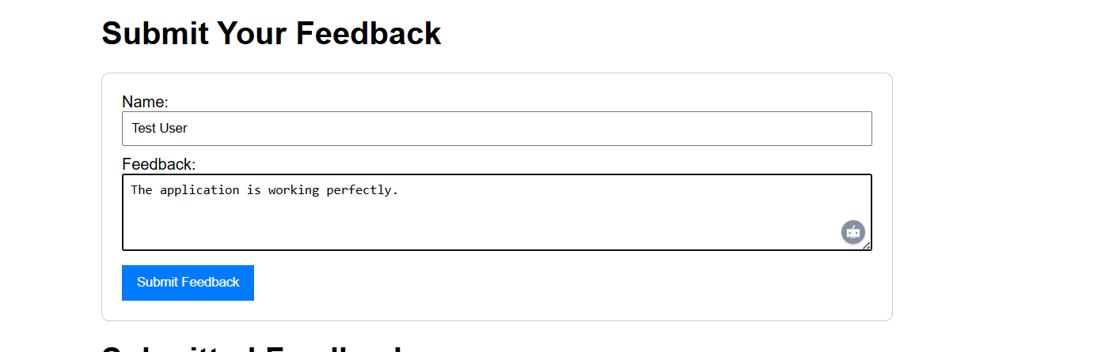

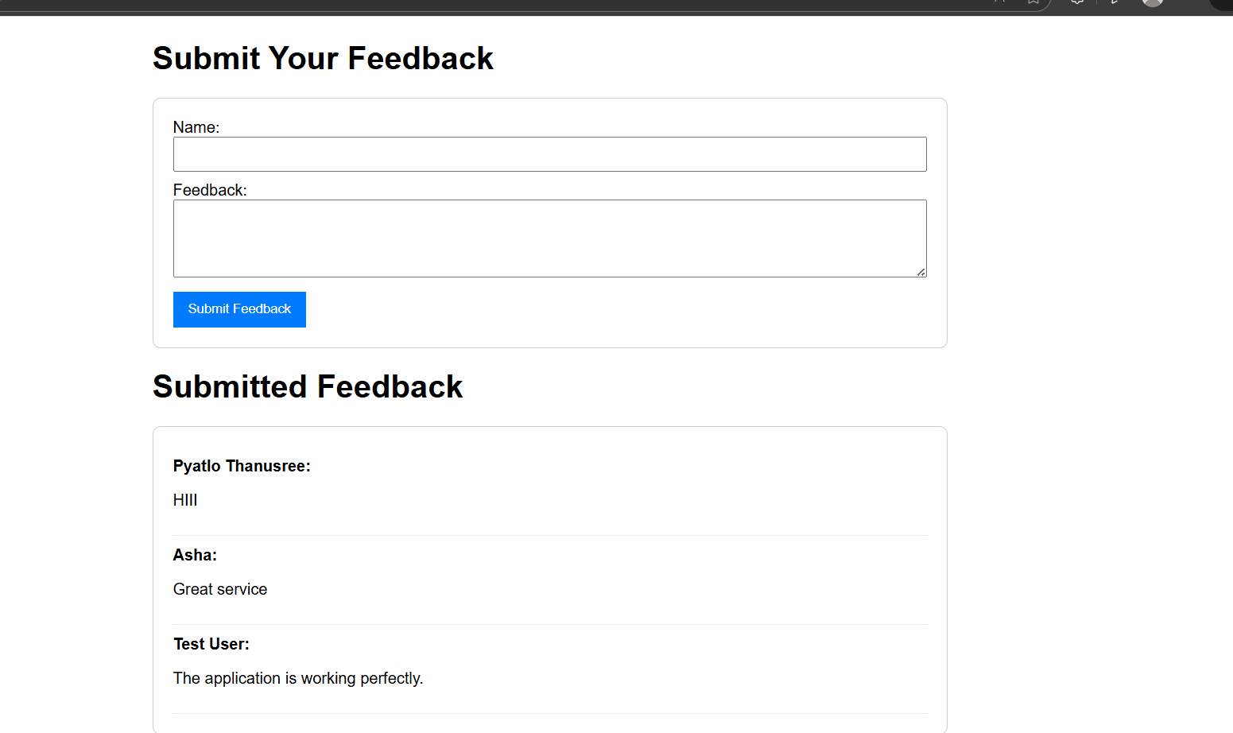

**Feedback With script(got detected):**

