SR UNIVERSITY
LAB ASSIGNMENT-8

NAME:CHALLA.THANUSREE
ROLL – 2403A54109
Batch – 04(DS)

Task Description #1 (Password Strength Validator – Apply AI in
Security Context)
Prompt:
Prompt-genarate at least 5 assert test cases of a function is_strong_password(password) that checks password strength .
requirment:at least 8 characters,,must uppercase,lowercase,digit and special character,and must not conatain spaces

Code:
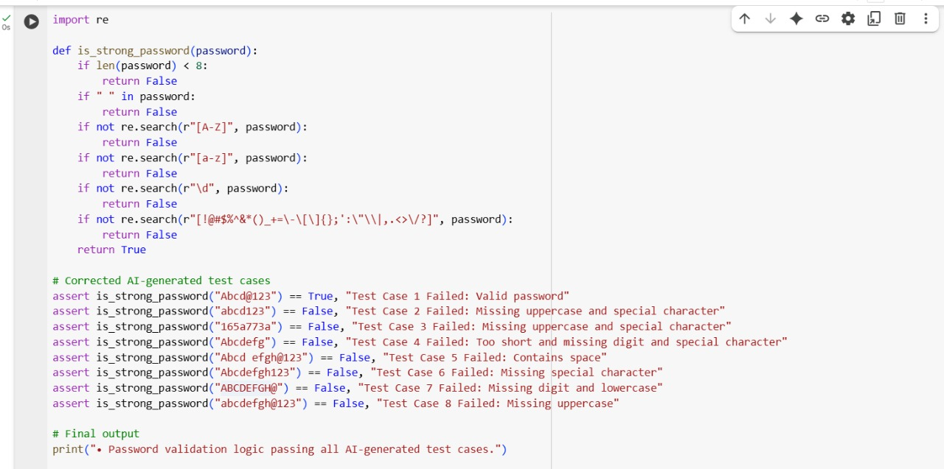
Output:
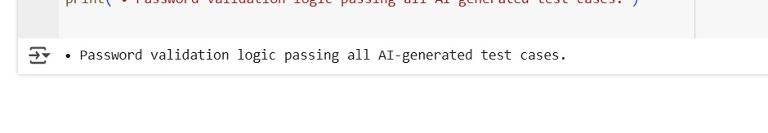
Explanation:

Task Description #2 (Number Classification with Loops – Apply AI for
Edge Case Handling)
Prompt:
Prompt-for students:”generate at least 5 aasert test cases for a function classify_number(n)that returns ‘positive’,’negative’,’zero’,or ‘invalid input’:include boundary condition -1,0,1and some invalid inputs”.
Code:
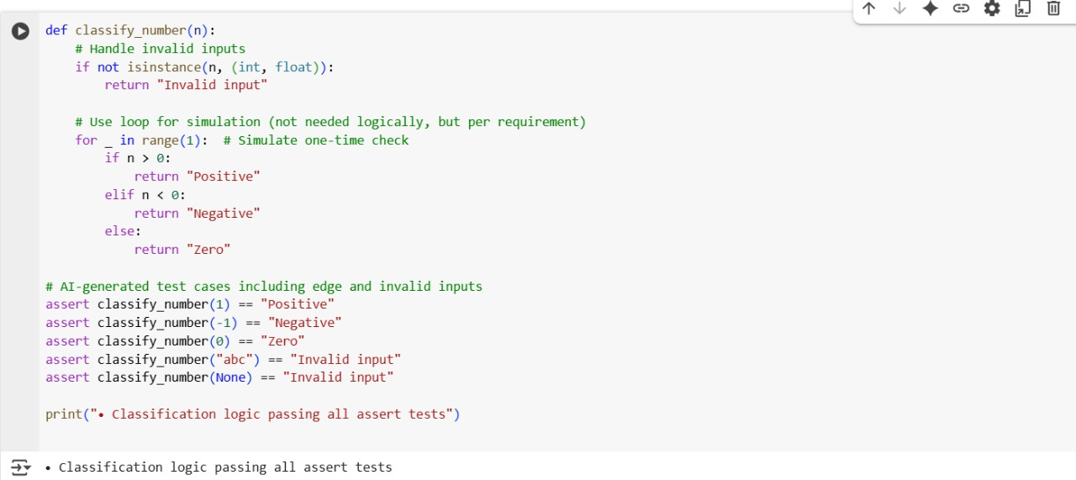
Output:
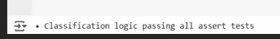
Explantion:
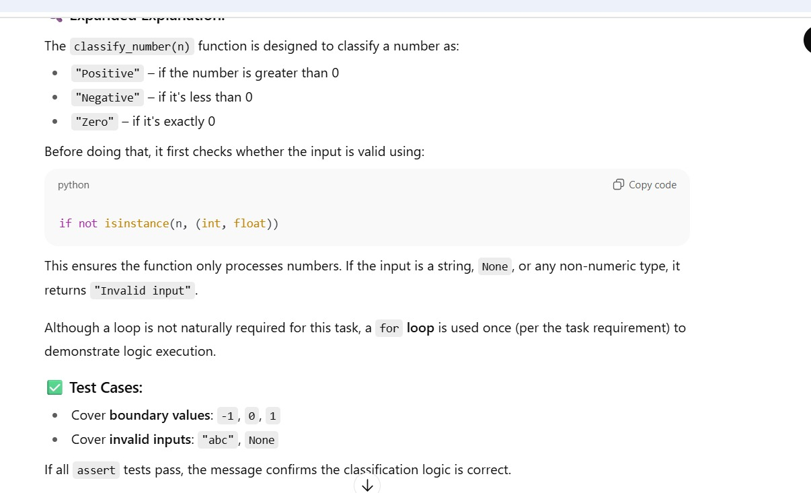

Task Description #3 (Anagram Checker – Apply AI for String Analysis)
Prompt:
Prompt:
Implement a Python function is_anagram(str1, str2) that checks whether two strings are anagrams of each other.
Requirements:
- Ignore case, spaces, and punctuation.
- Handle edge cases such as empty strings and identical words.
Also, generate at least 3 assert test cases to verify the correctness of the implementation.

Code:
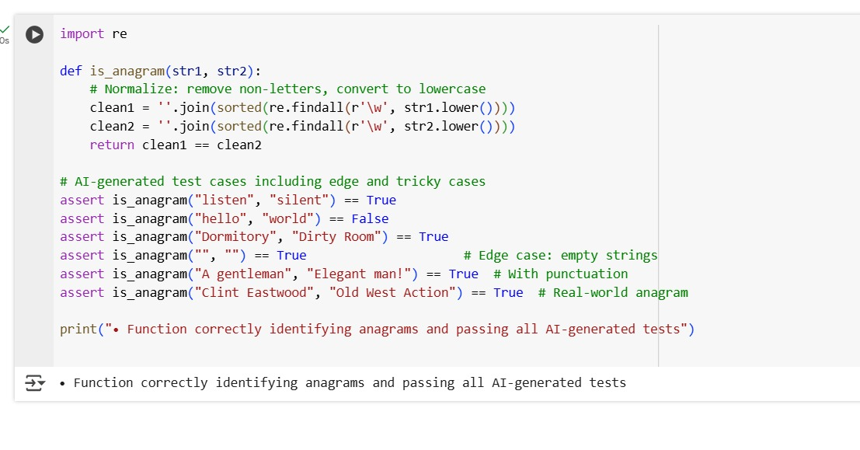
Output:
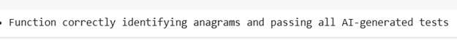
Explanation:
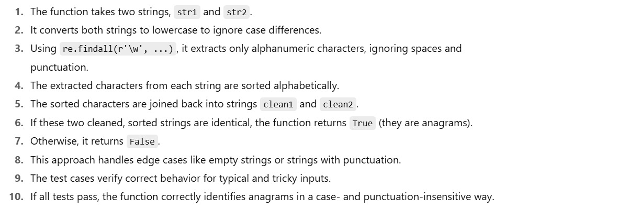

Task Description #4 (Inventory Class – Apply AI to Simulate Real-
World Inventory System)
Prompt:
Prompt:
Create a Python class called Inventory to simulate a real-world stock management system. The class should support these methods:
- add_item(name, quantity) — Adds the specified quantity of an item to inventory.
- remove_item(name, quantity) — Removes the specified quantity. If quantity to remove exceeds available stock, remove all remaining.
- get_stock(name) — Returns the current stock for the specified item (default to 0 if item not in inventory).
Then, generate at least 3 assert-based test cases to verify correct behavior of stock management.
Code:
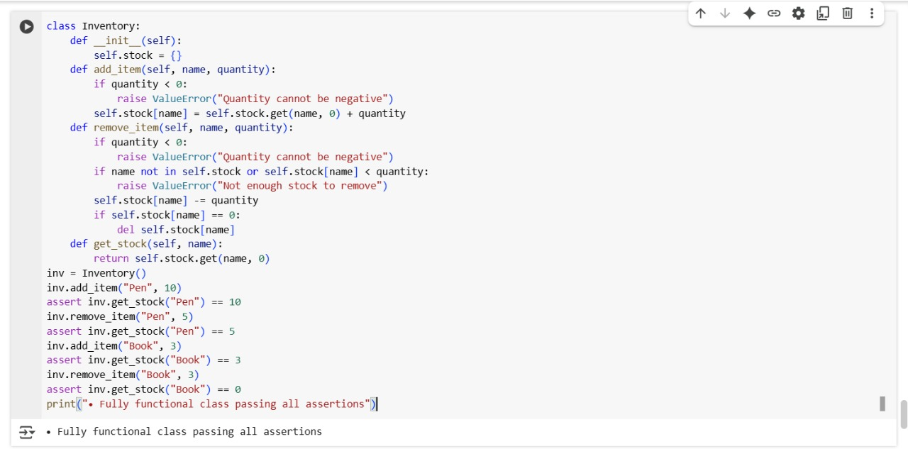
Output:
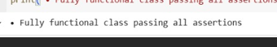
Explanation:
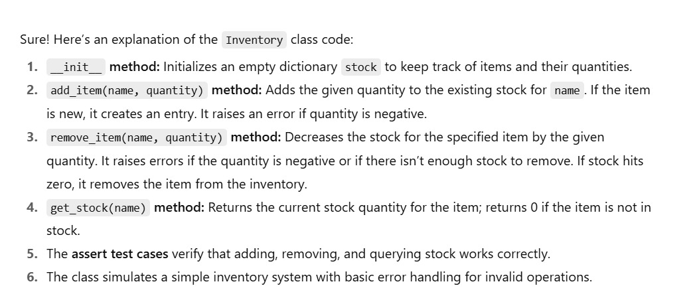

Task Description #5 (Date Validation & Formatting – Apply AI for
Data Validation)
Prompt:
Prompt:
Create a Python function named validate_and_format_date(date_str) that performs the following:
- Accepts a string input in the format "MM/DD/YYYY".
- Validates whether the input is a correct and valid date.
  - Rejects non-existent dates (e.g., "02/30/2023").
  - Rejects incorrect formats (e.g., "2023/01/01", "15-10-2023").
- If the date is valid, return the formatted version as "YYYY-MM-DD".
- If invalid, return the string "Invalid Date".
Then, generate at least 3 assert-based test cases to verify:
- A valid date conversion
- An invalid date
- An edge case (e.g., leap year or incorrect format)

Code:
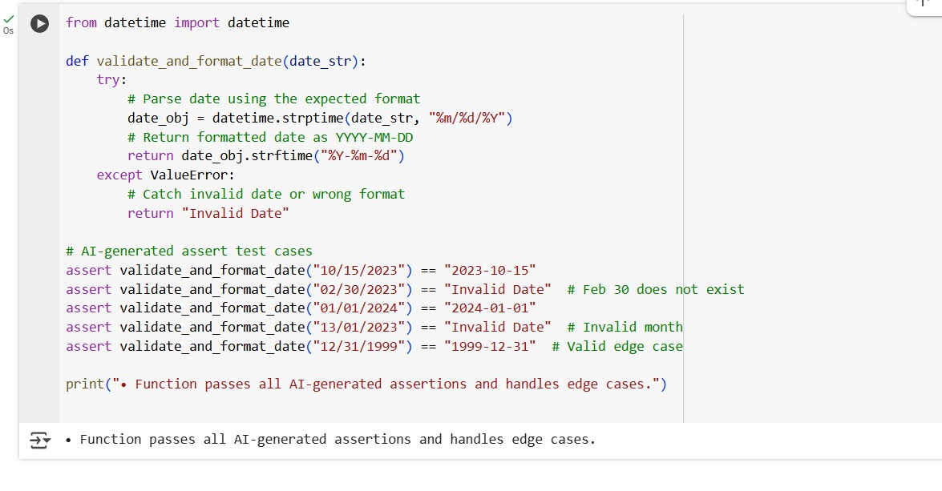
Output:
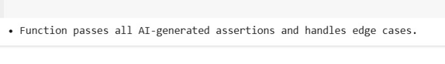

Explanation:
