SR UNIVERSITY
ASSIGNMENT NO 12

NAME:CHALLA.THANUSREE
HALL TICKET NO :2403A54109
BATCH NO:04(DS)

Task 1: Implementing Bubble Sort with AI Comments

Prompt:

1. Write a basic Bubble Sort implementation in Python.
2. Once your code is complete, ask ChatGPT to:
- Add inline comments explaining the key parts of the logic (like comparisons, swapping, loop passes, and early termination).
- Provide a time complexity analysis (best, average, worst case).

CODE:
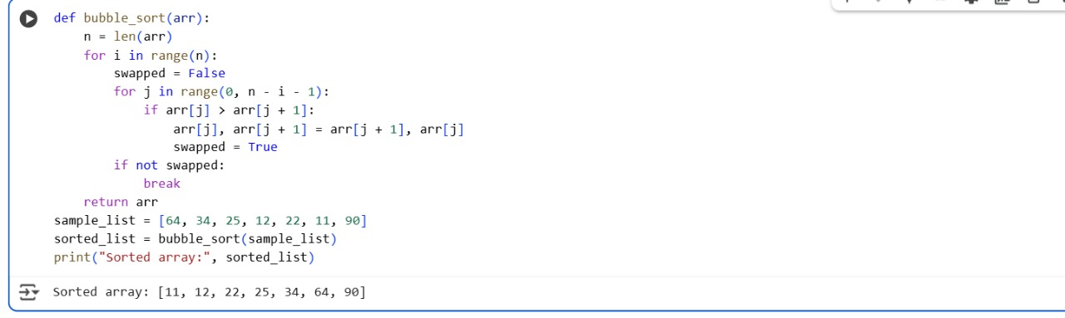
OUTPUT:
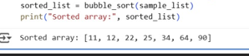
EXPLANATION:
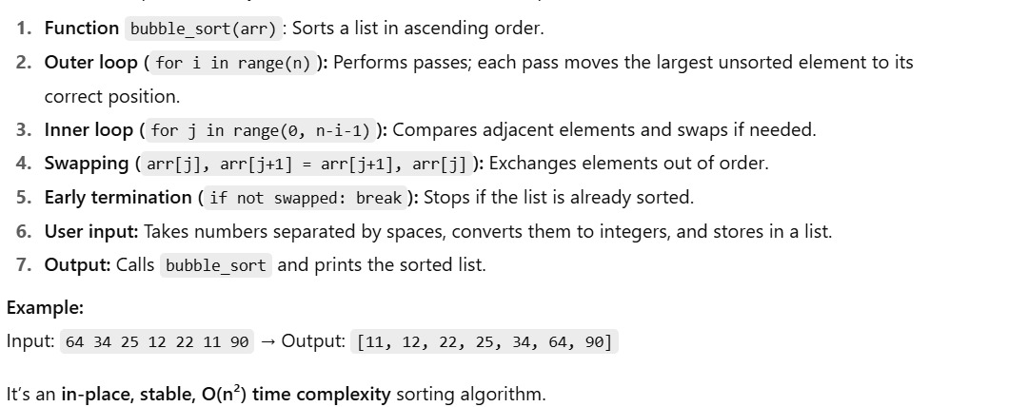

Task 2: Optimizing Bubble Sort → Insertion Sort

PROMPT:
Python implementation of Bubble Sort. I want you to analyze it and suggest a more efficient sorting algorithm for a partially sorted array. Then, provide the code for the suggested algorithm and explain why it performs better on this specific type of input.
CODE:
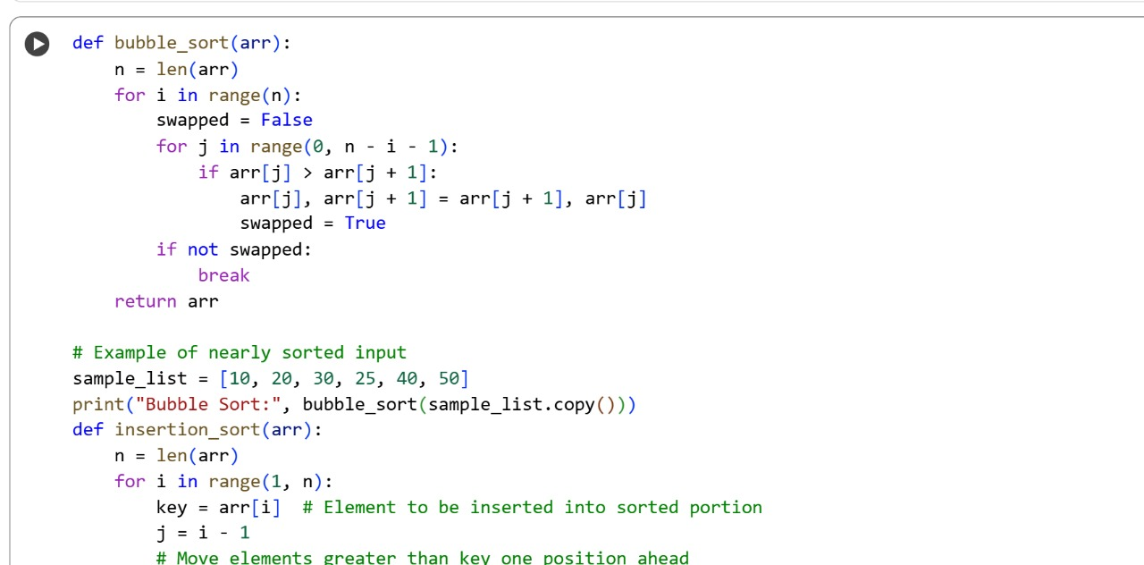
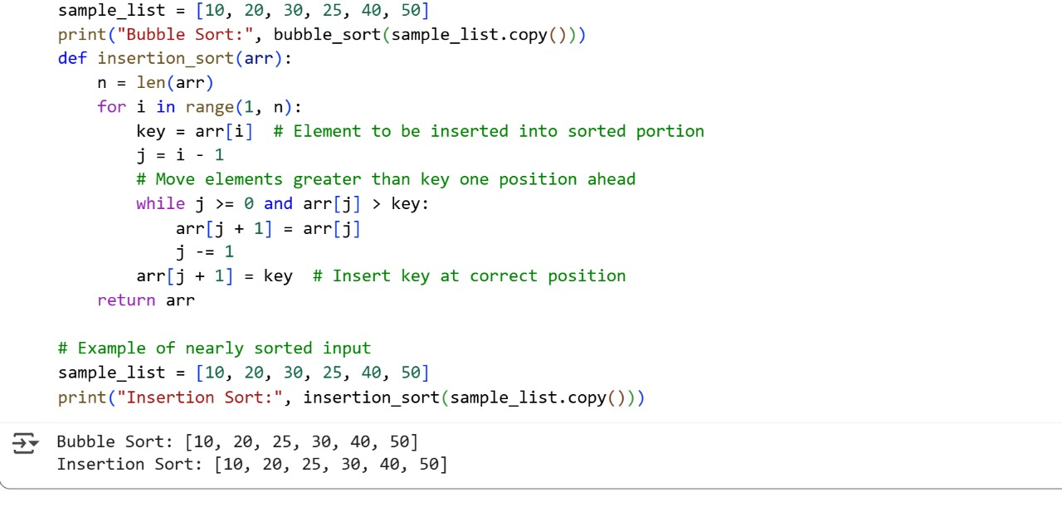
OUTPUT:
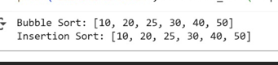
EXPLANATION:
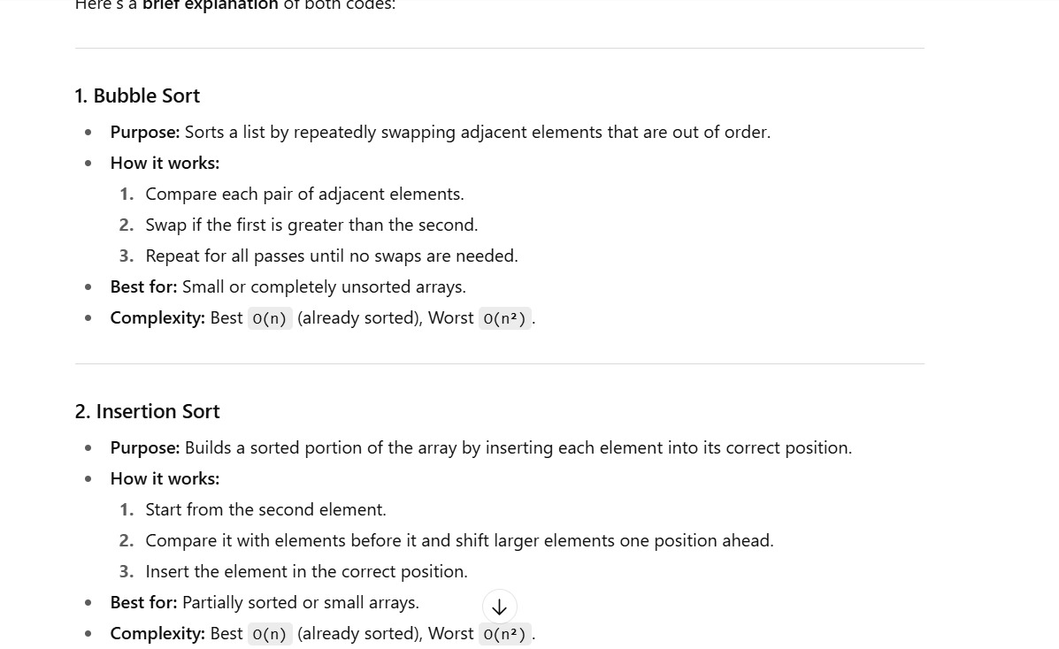

Task 3: Binary Search vs Linear Search

PROMPT:
1.Add detailed docstrings to both functions.
2.Include performance notes in the docstrings, explaining the time complexity for best and worst-case scenarios.
3. Explain the key differences between the two algorithms.
4. Explain when Binary Search is the better choice and why.

CODE:
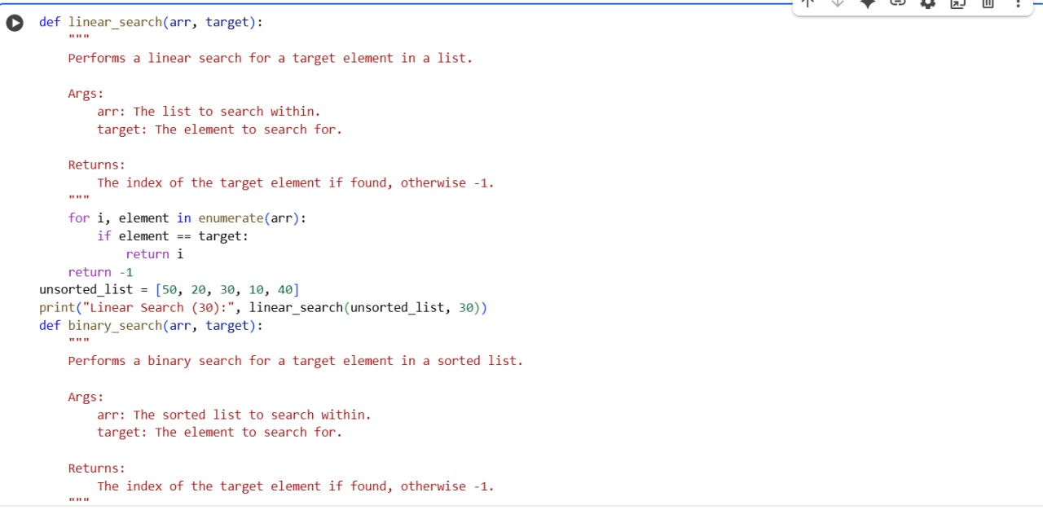
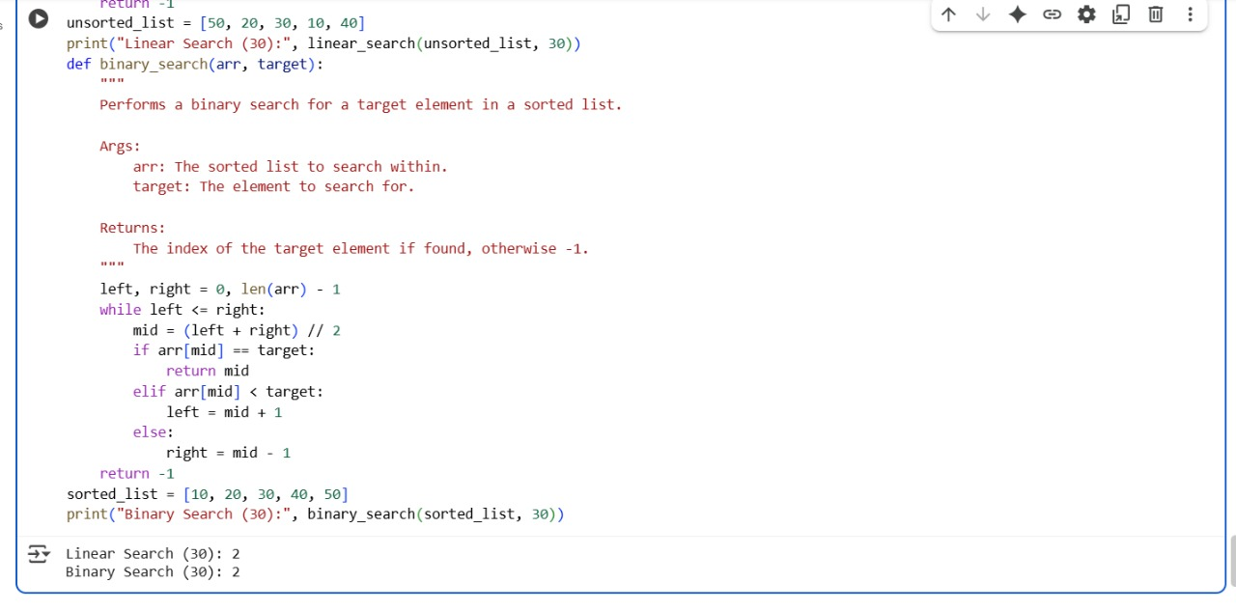
OUTPUT:
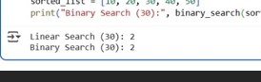

EXPLANATION:
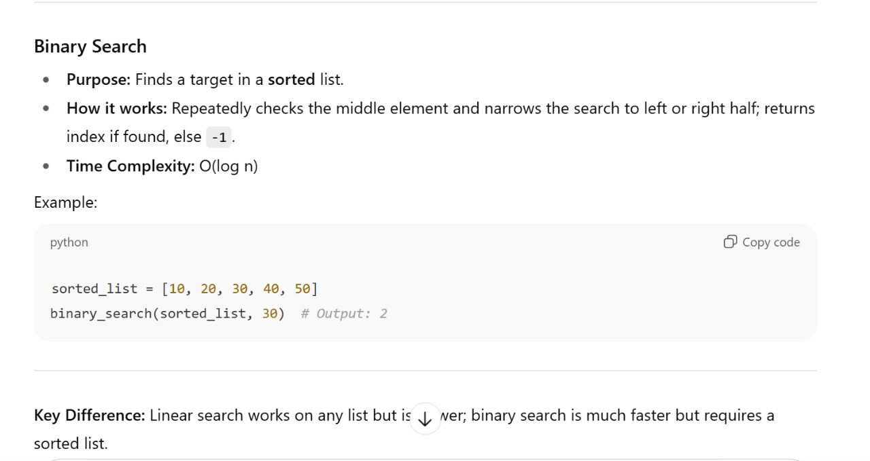
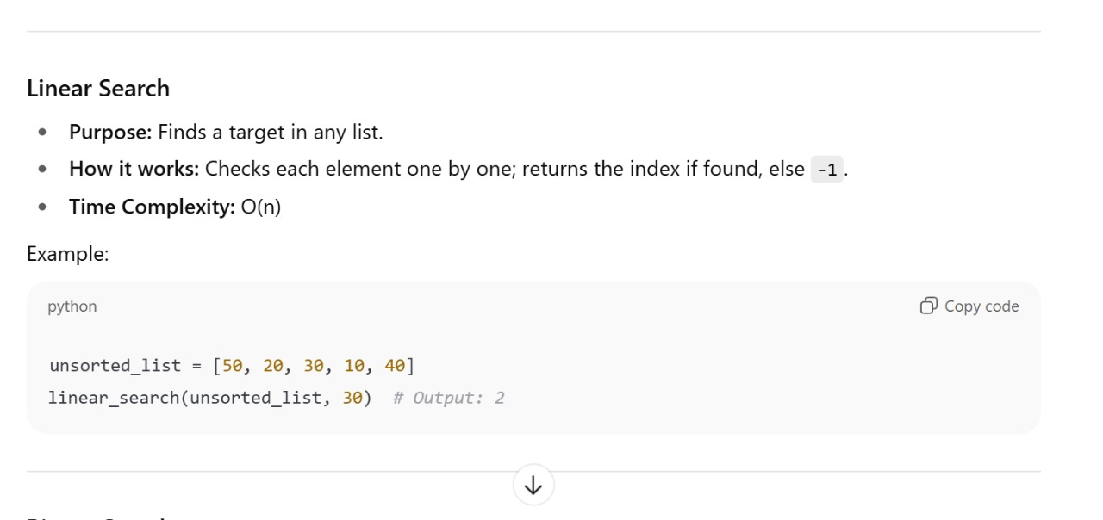

Task 4: Quick Sort and Merge Sort Comparison

PROMPT:
compare the performance of Quick Sort and Merge Sort on three types of input:
- A randomly ordered list
- An already sorted list
- A reverse-sorted list

CODE:
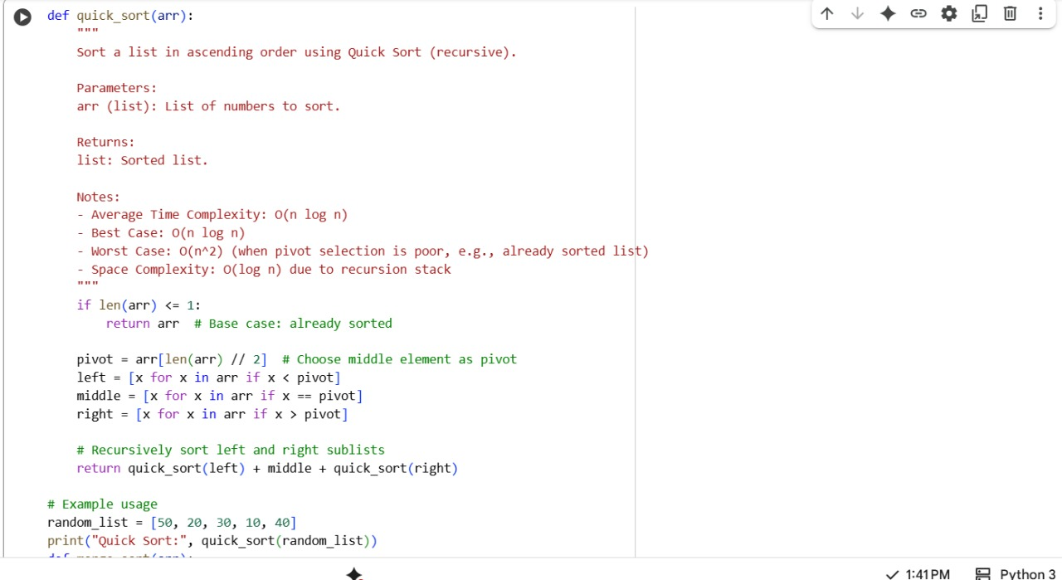

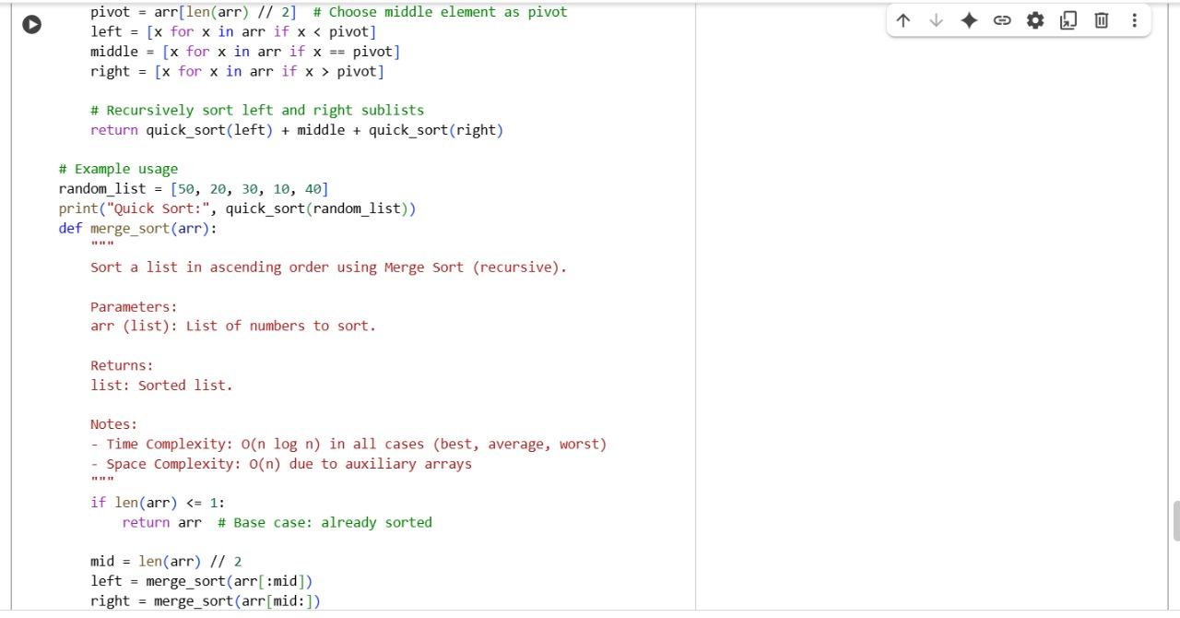

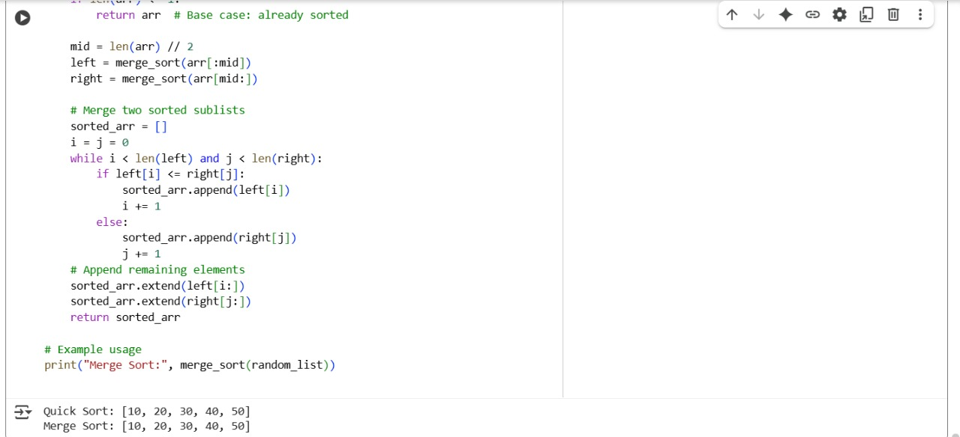
OUTPUT:
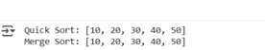

EXPLANTION:
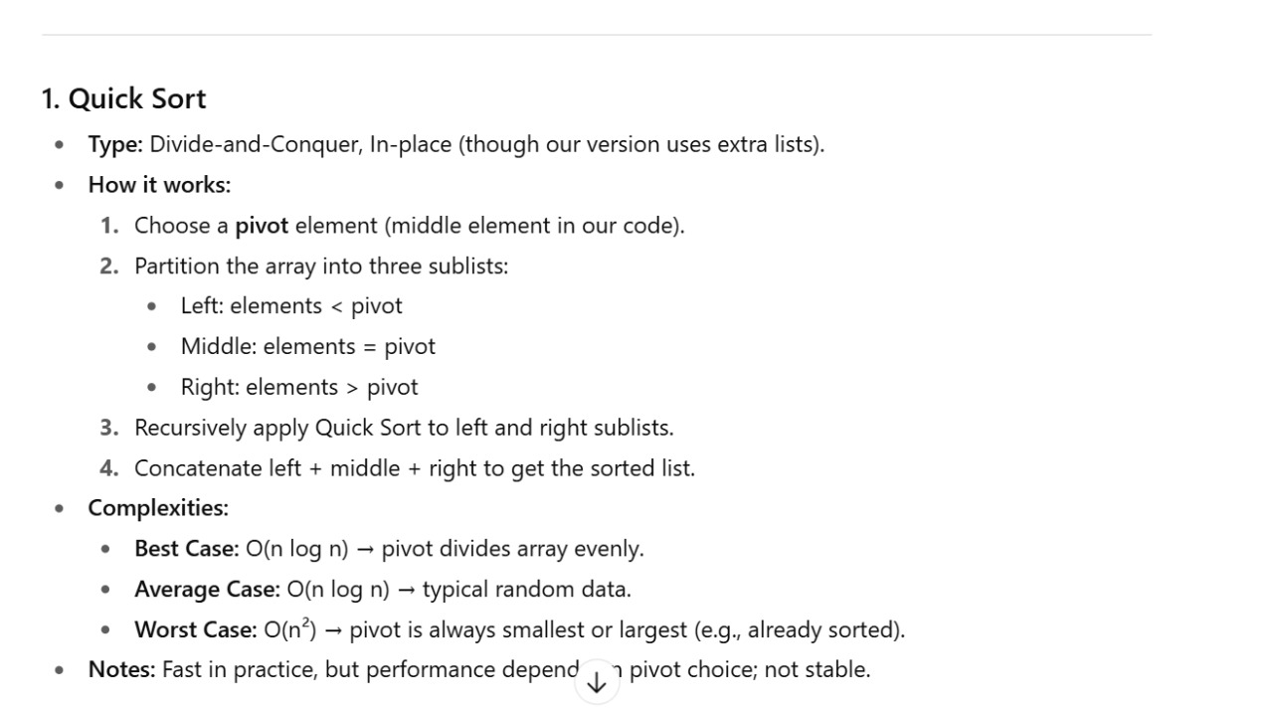
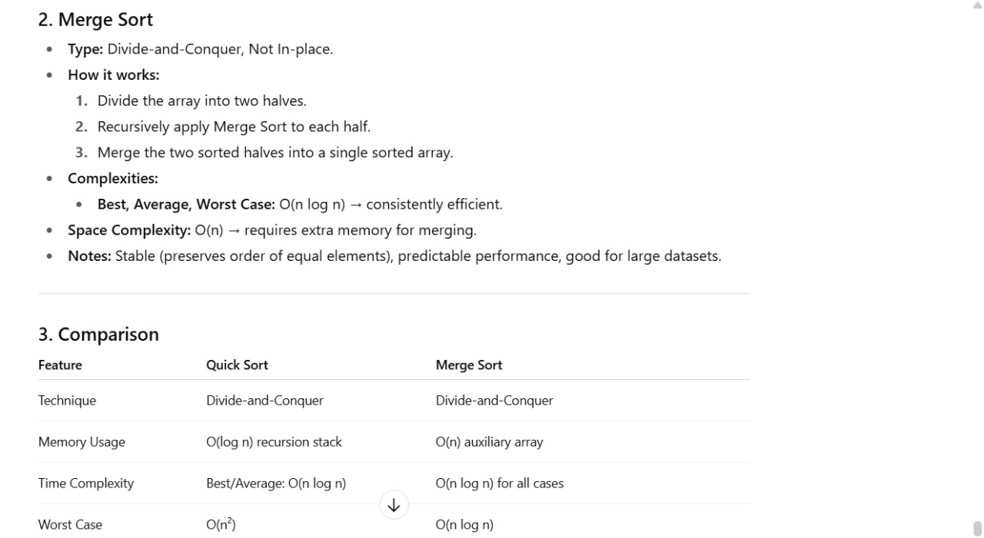

Task 5: AI-Suggested Algorithm Optimization

PROMPT:
"I wrote a brute-force Python function to find duplicates in a list using nested loops (O(n²) time).
Can you optimize this algorithm to run in O(n) time using a more efficient approach like sets or dictionaries?
Please explain how your optimized solution improves the time complexity and why it performs better on large inputs."
CODE:
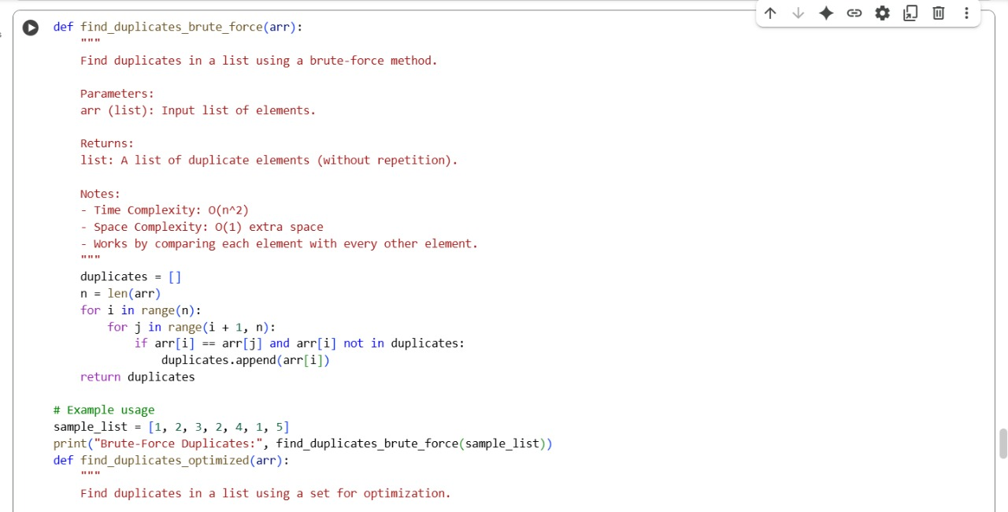
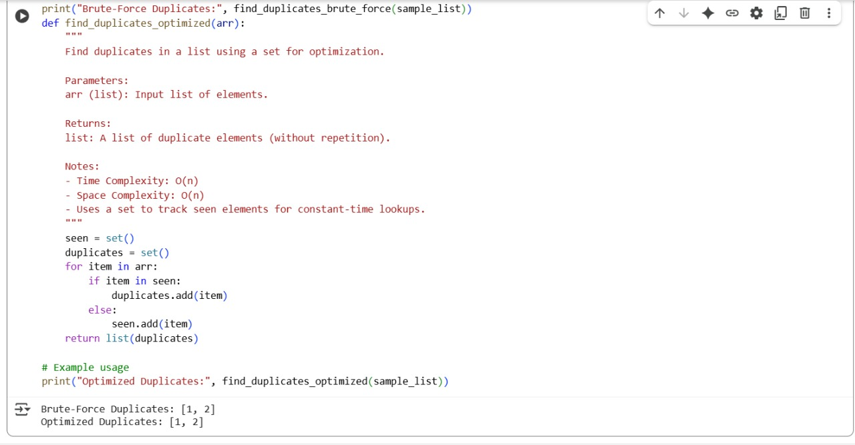
OUTPUT:
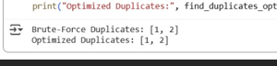
EXPLANATION:
