SR UNIVERSITY
ASSIGNMENT N0 # 11

NAME : CHALLA.THANUSREE
HALL TICKET NUMBER:2403A54109
BATCH NO:4(DS)

Task 1: Implementing a Stack (LIFO)
PROMPT:
write a Python Stack class with push(), pop(), peek(), and is_empty() methods. Include a code skeleton with Google-style docstrings. After that, help me test it with some sample data. Then suggest optimizations or alternatives like using collections.deque.
CODE:
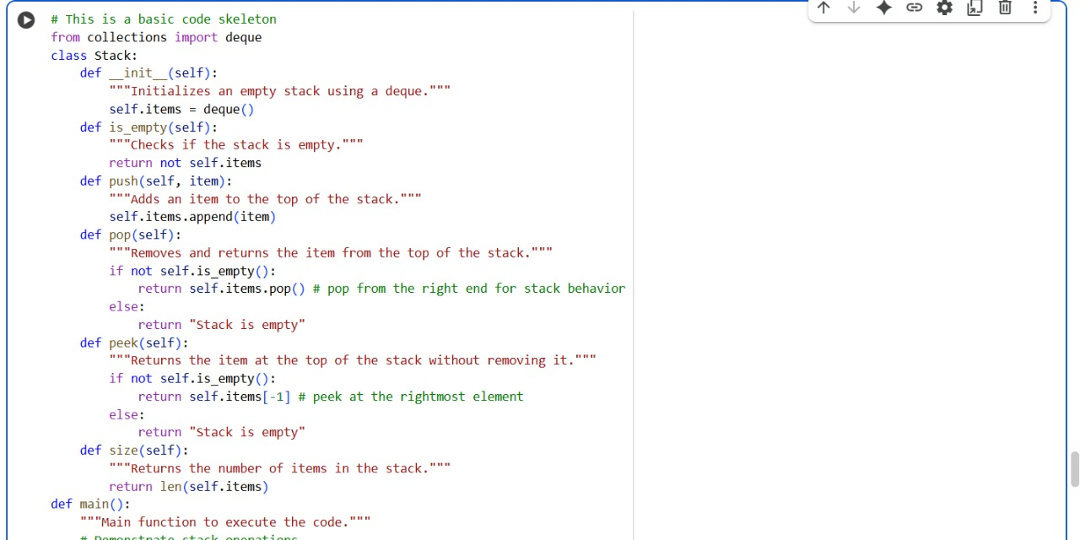
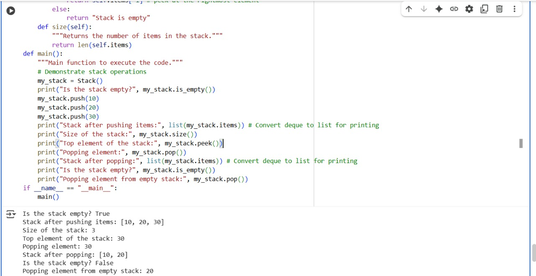
OUTPUT:
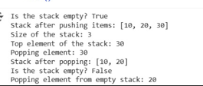

EXOLANATION:
Task 2: Queue Implementation with Performance Review
PROMPT:
Implement a Queue class in Python with enqueue(), dequeue(), and is_empty() using a list.

CODE:
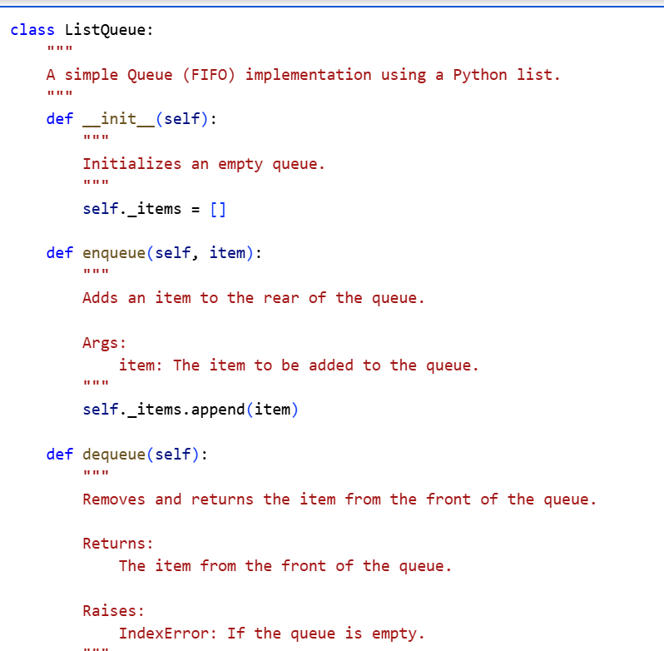
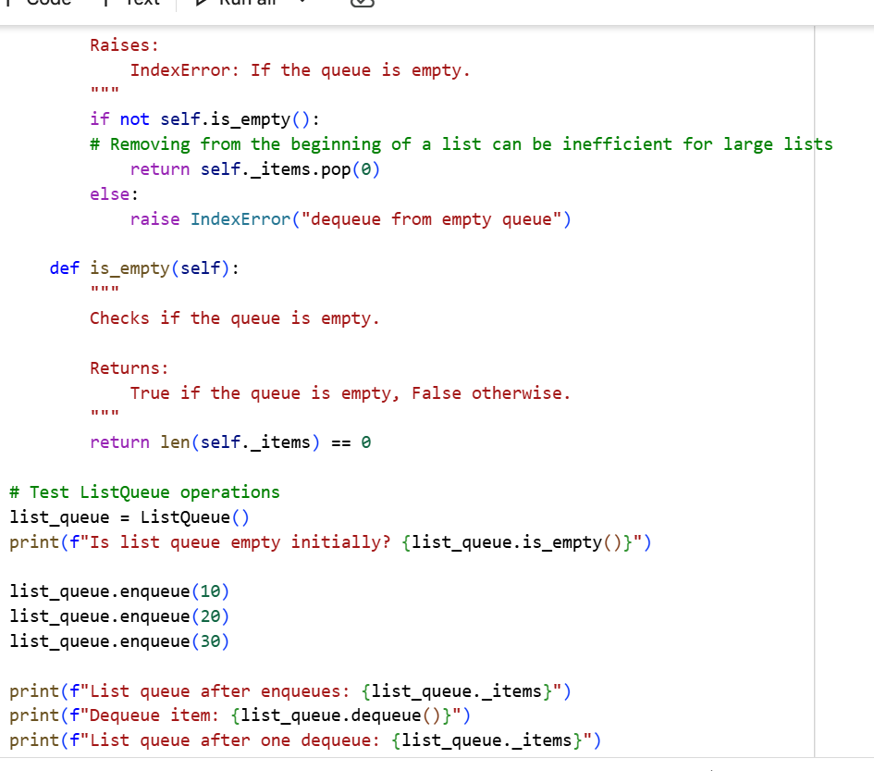
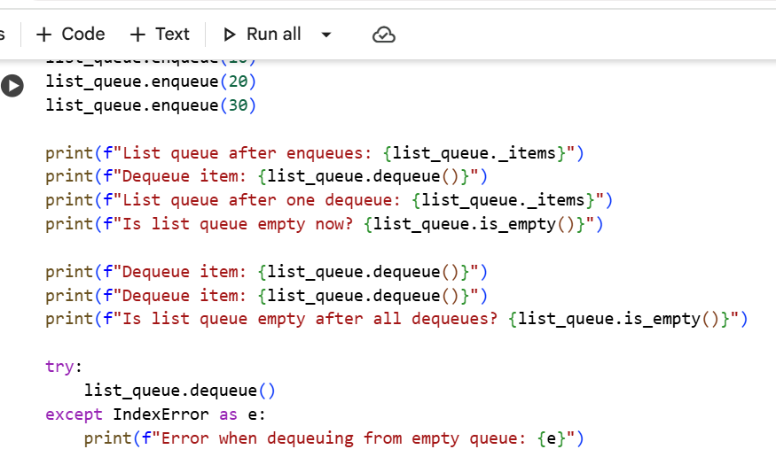
OUTPUT:
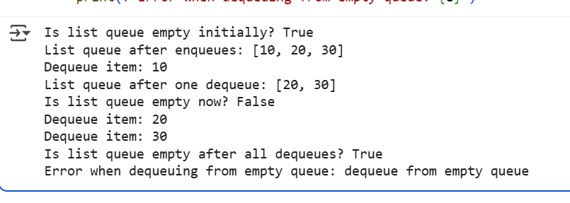
EXPLANATION:
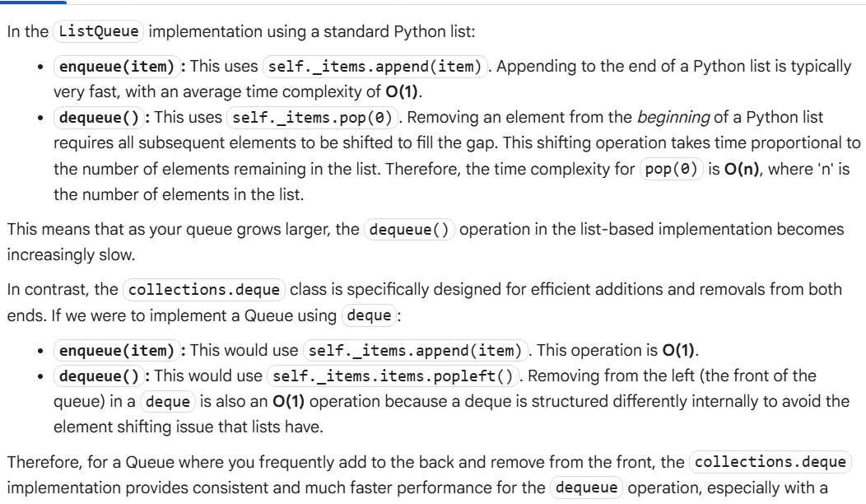

Task 3: Singly Linked List with Traversal
PROMPT:
Implement a singly linked list in Python with insert_at_end(), delete_value(), and traverse() methods. Use a class-based approach with Node and LinkedList classes. Add inline comments to explain pointer updates during insertions and deletions. Also, suggest test cases to validate each operation
CODE:
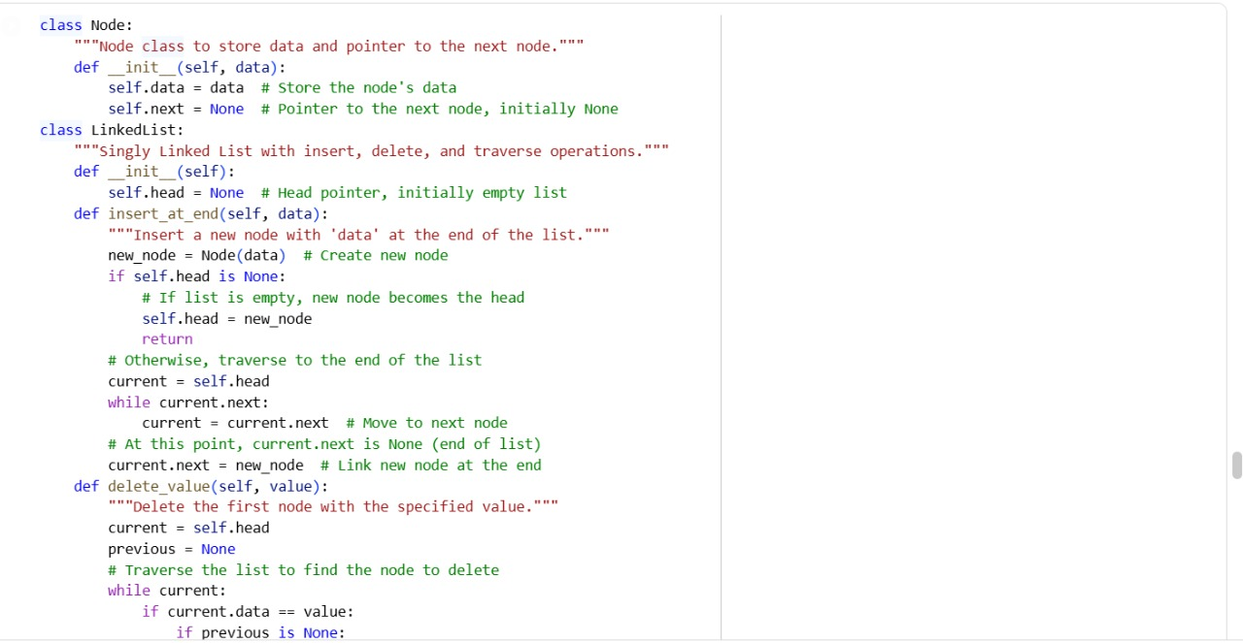
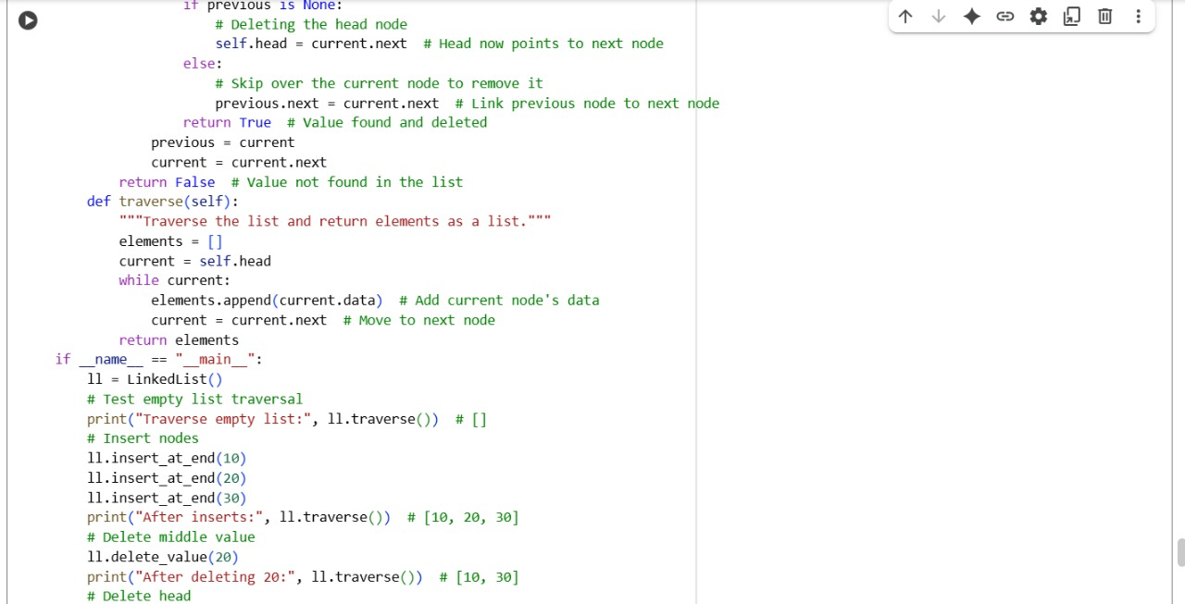

OUTPUT:
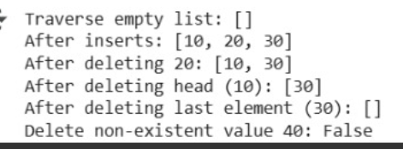
EXPLANATION:
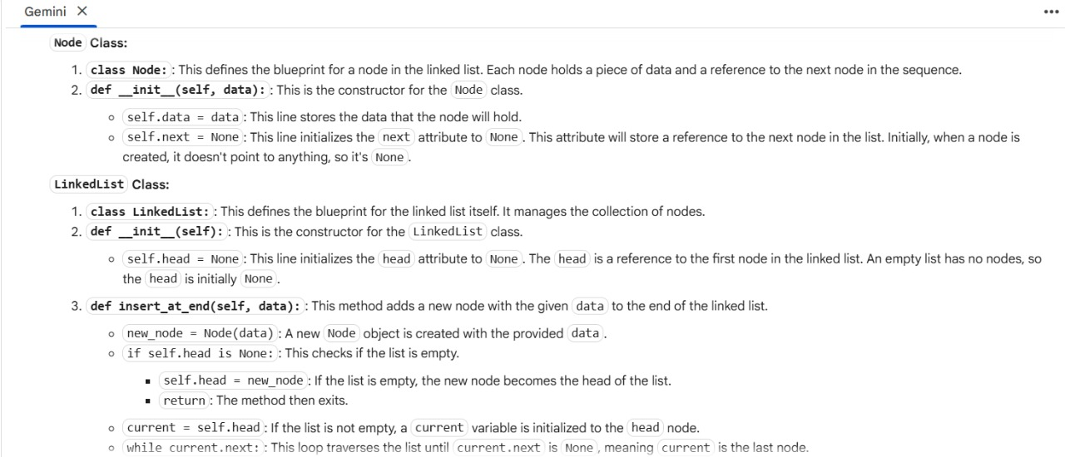
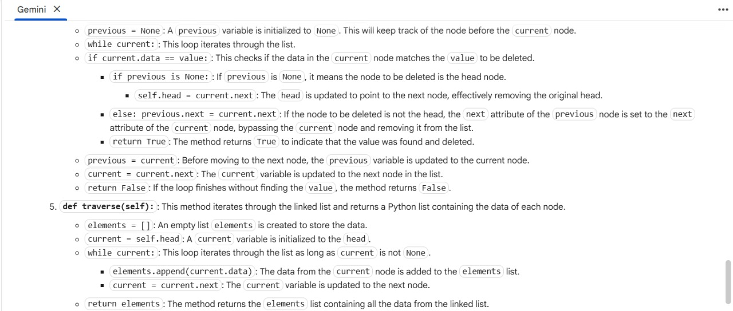
Task 4: Binary Search Tree (BST)

PROMPT:
written Python class for a Binary Search Tree with Node and BST classes. Help me complete the missing methods: insert(), search(), and inorder_traversal(). Add meaningful Google-style docstrings. Then show how to test the BST with a list of integers and compare the search() results for both present and absent elements.

CODE:
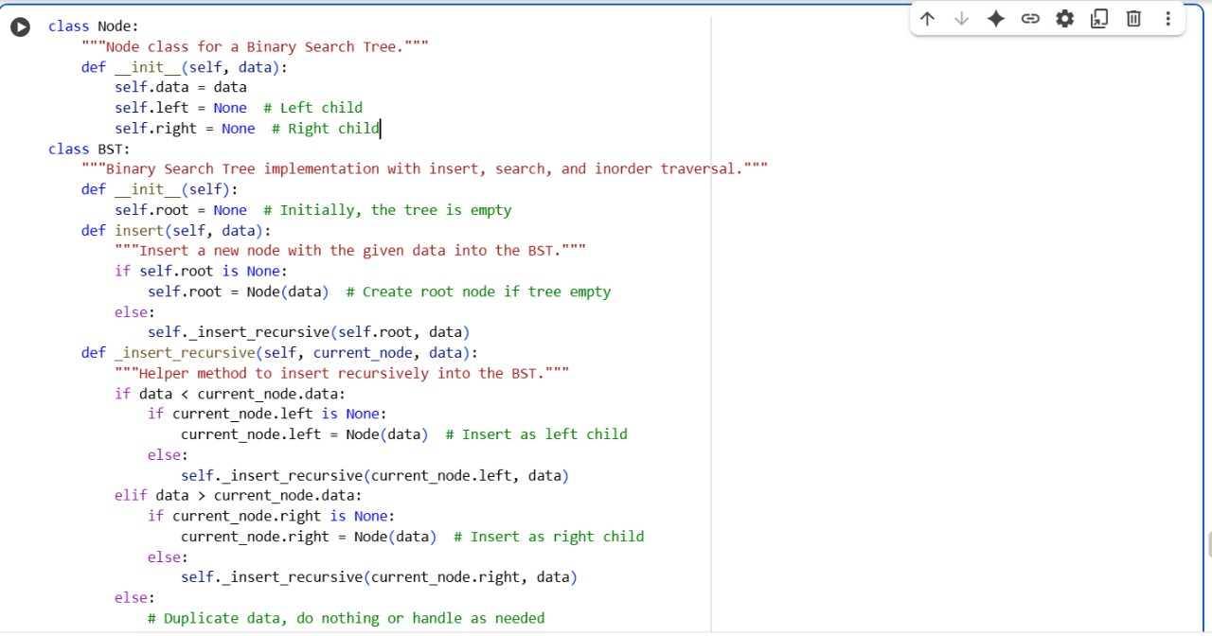
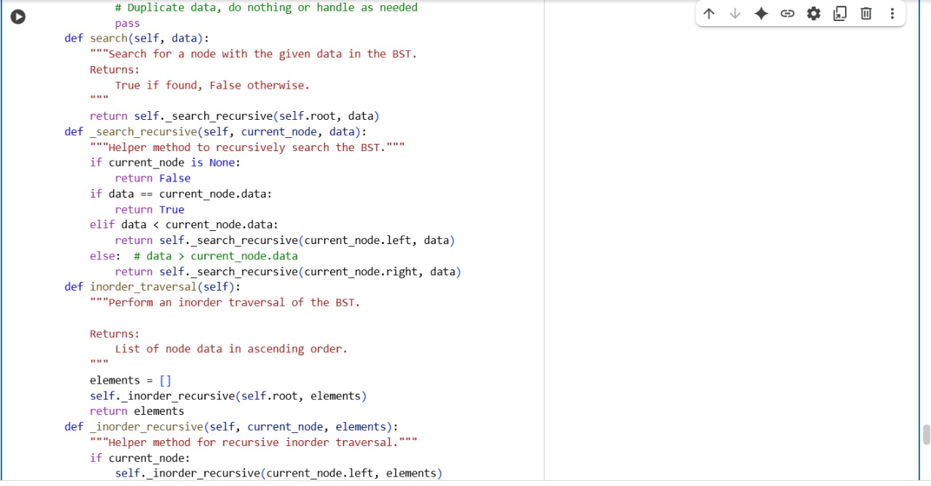
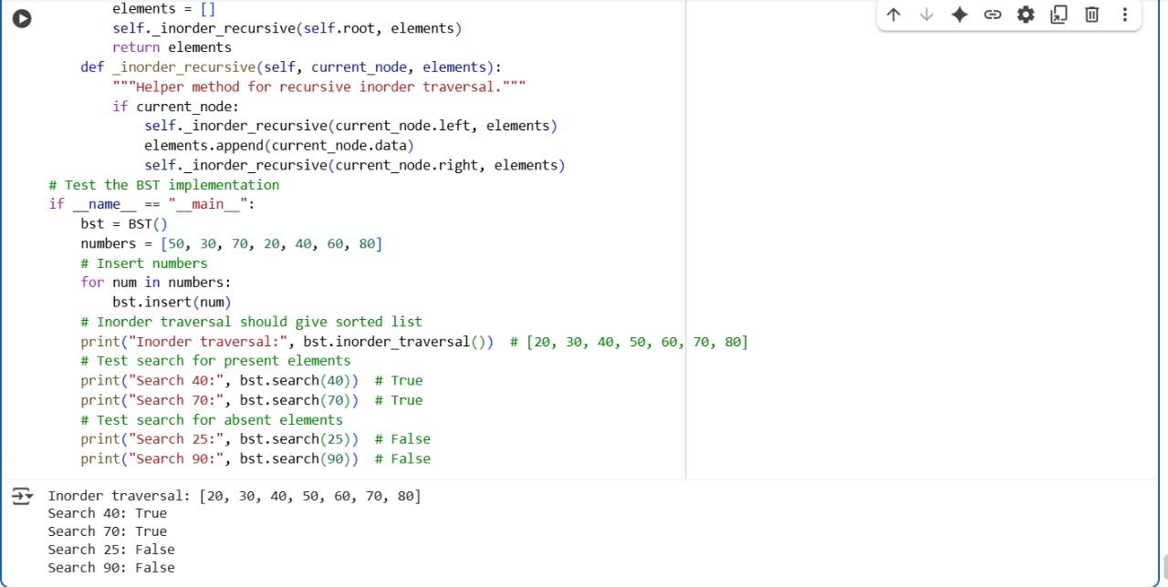

OUTPUT:
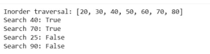
EXPLANATION:
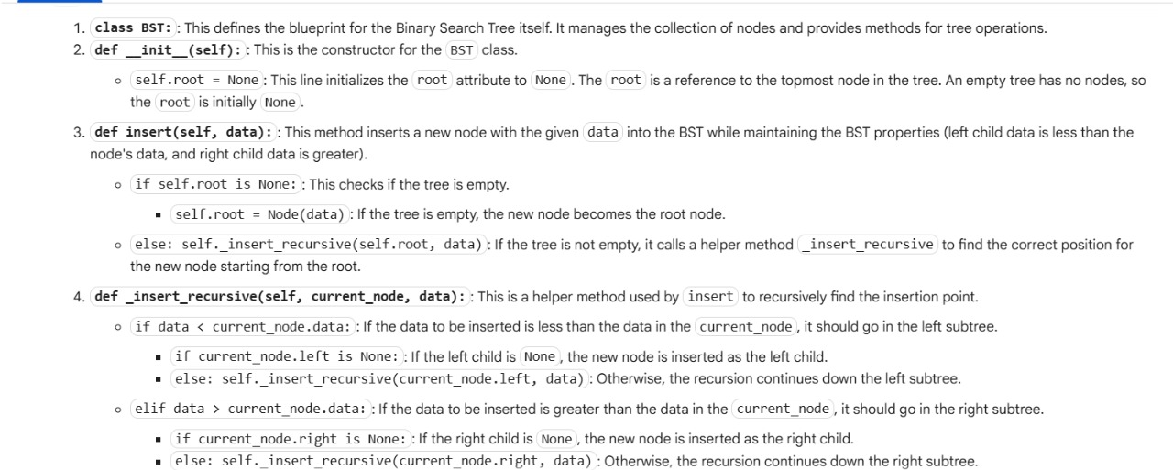
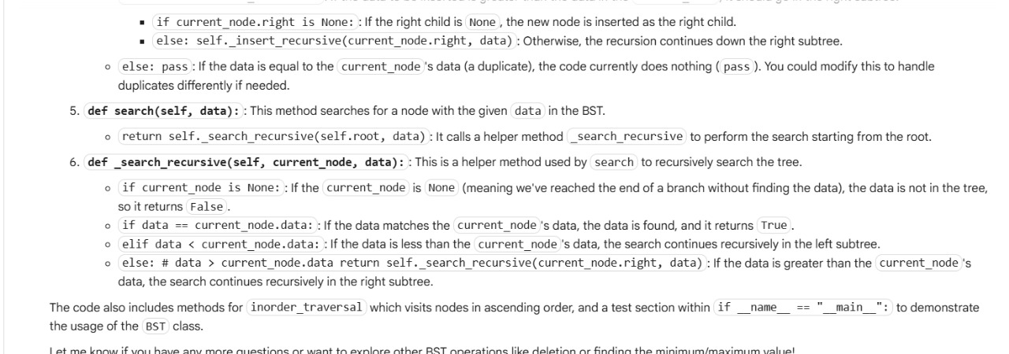

Task 5: Graph Representation and BFS/DFS Traversal
PROMPT:
Python using an adjacency list (dictionary). Then write both BFS() and DFS() traversal methods with inline comments explaining each step. Also, compare recursive vs iterative DFS if there’s a difference in behavior or performance
CODE:
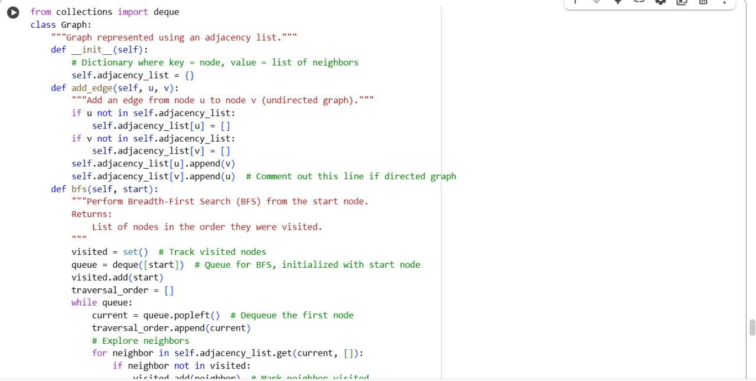
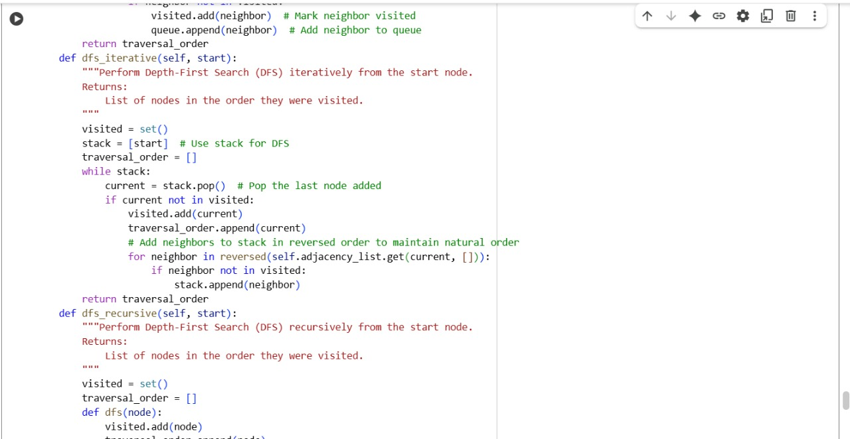
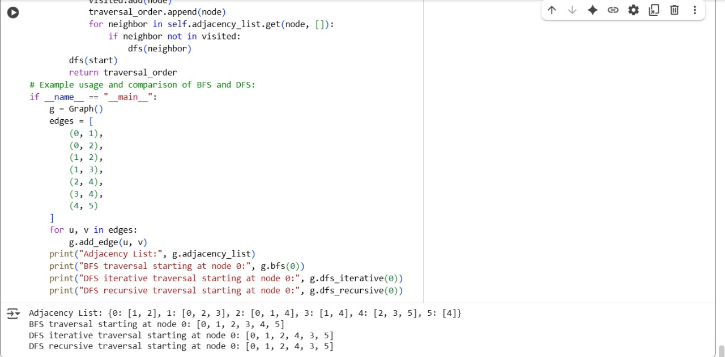
OUTPUT:
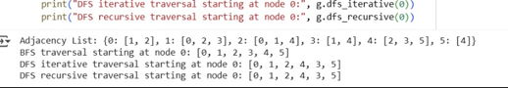
EXPLANATION:
