**DOCUMENTATION ON FINANCIAL DATA SET**

The top five rows of the data

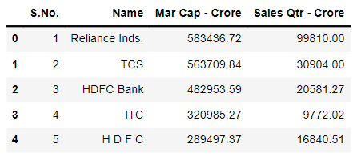

The bottom five rows of the data

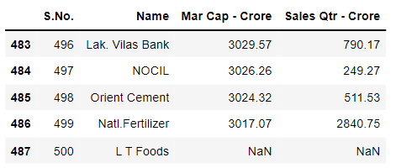

Shape of thee data



Info about the data

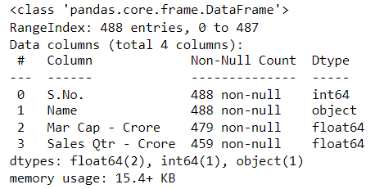

We are dropping the ‘S.no’ column because it doesn’t signify anything.

There are null values present in the dataset

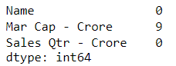

We impute the null value with median value

Now there are no null values

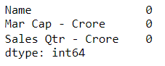

* There are no duplicate values present in the dataset

Now the data summary is

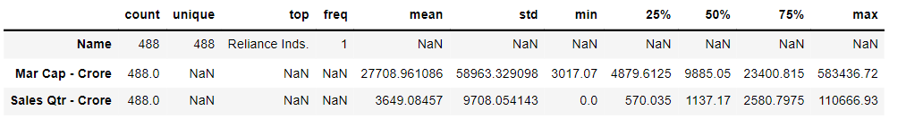

UNIVARIATE ANALYSIS:

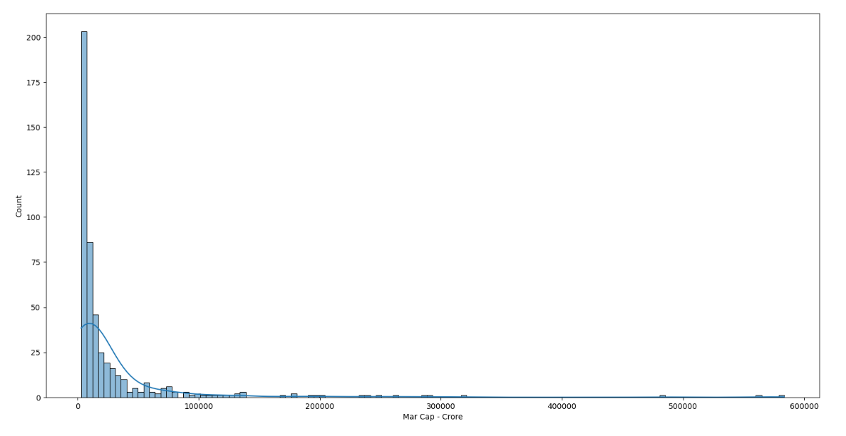

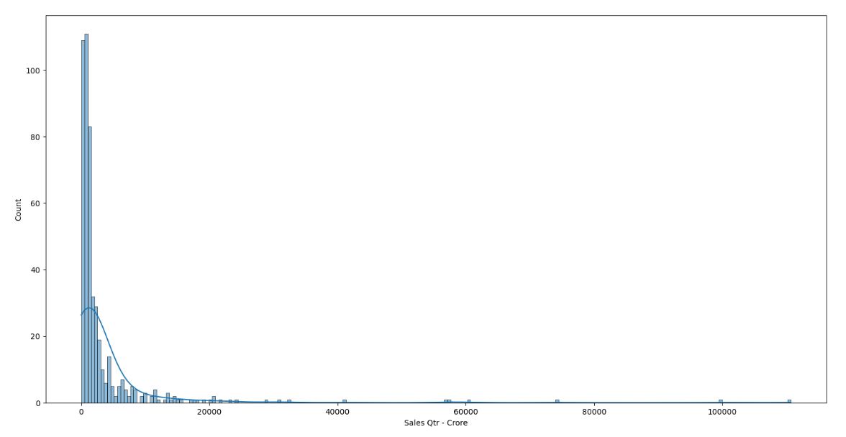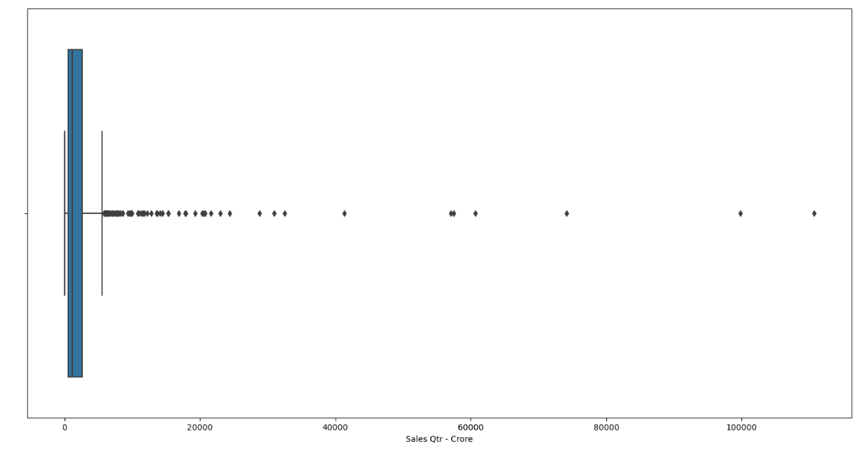

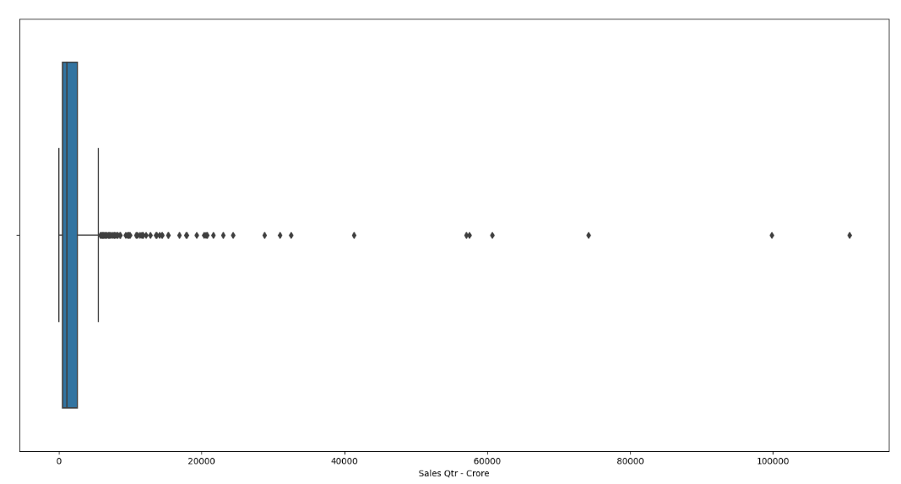

Pair plot:

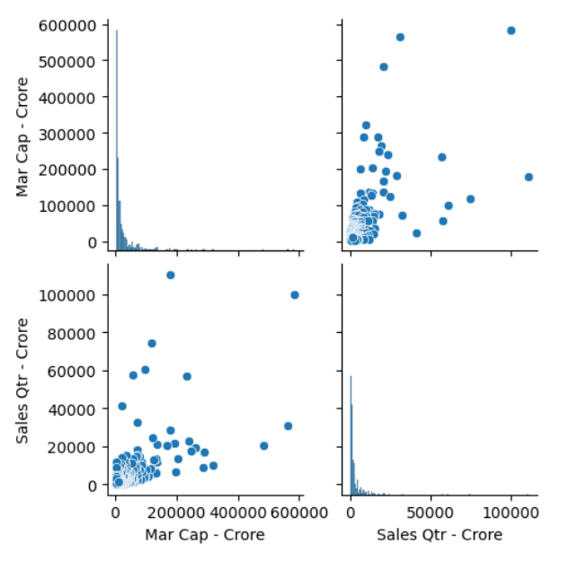

Data summary of the dataset

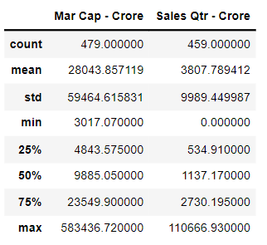

**Correlation :**

