Game Design Document

Fill up the Following document

1. Write the title of your project.

Space Shooter

1. What is the goal of the game?

The goal of the game is that the space shooter (player) shoots and kills the aliens (enemies (non-player characters)) who are in a mindset to attack it.

1. Write a brief story of your game?

A spaceship (space shooter/player) is in the space. It is sent by NASA to destroy an asteroid which is on its way to earth. This asteroid is very dangerous and can damage a huge area of the US. This spaceship is on its way to launch a missile before it is close to the earth so that it can save lives. There are many enemies who do not want the spaceship to enter its territory and plans on destroying it. The spaceship has to kill these enemies and destroy the asteroid.

1. Which are the playing characters of this game?

* Playing characters are the ones which respond to the user based on the input from the user
* Cars, monkeys, dinos, wizards etc, are the playing characters in the game.

|  |  |  |
| --- | --- | --- |
| Number | Character Name | What can this character do? |
| 1 | Space shooter/player | Fire bullets to kill the enemies |
| 2 |  |  |
| 3 |  |  |
| 4 |  |  |
| 5 |  |  |
| 6 |  |  |
| 7 |  |  |
| 8 |  |  |

1. Which are the Non Playing Characters of this game?

* Non Playing characters are the ones which don't have an action or a behaviour when the user interacts with the game.
* Hurdles, stones, bananas, coins, etc are non playing characters in the game.

|  |  |  |
| --- | --- | --- |
| Number | Character Name | What can this character do? |
| 1 | Aliens/enemies | Destroy the space shooter by just touching it |
| 2 |  |  |
| 3 |  |  |
| 4 |  |  |
| 5 |  |  |
| 6 |  |  |
| 7 |  |  |
| 8 |  |  |

Draw your imagination of this game. What does this game look like?

* Draw the game either on your computer or on paper,
* Add images of scenes of the game to show each of the playing and non-playing characters at least once. 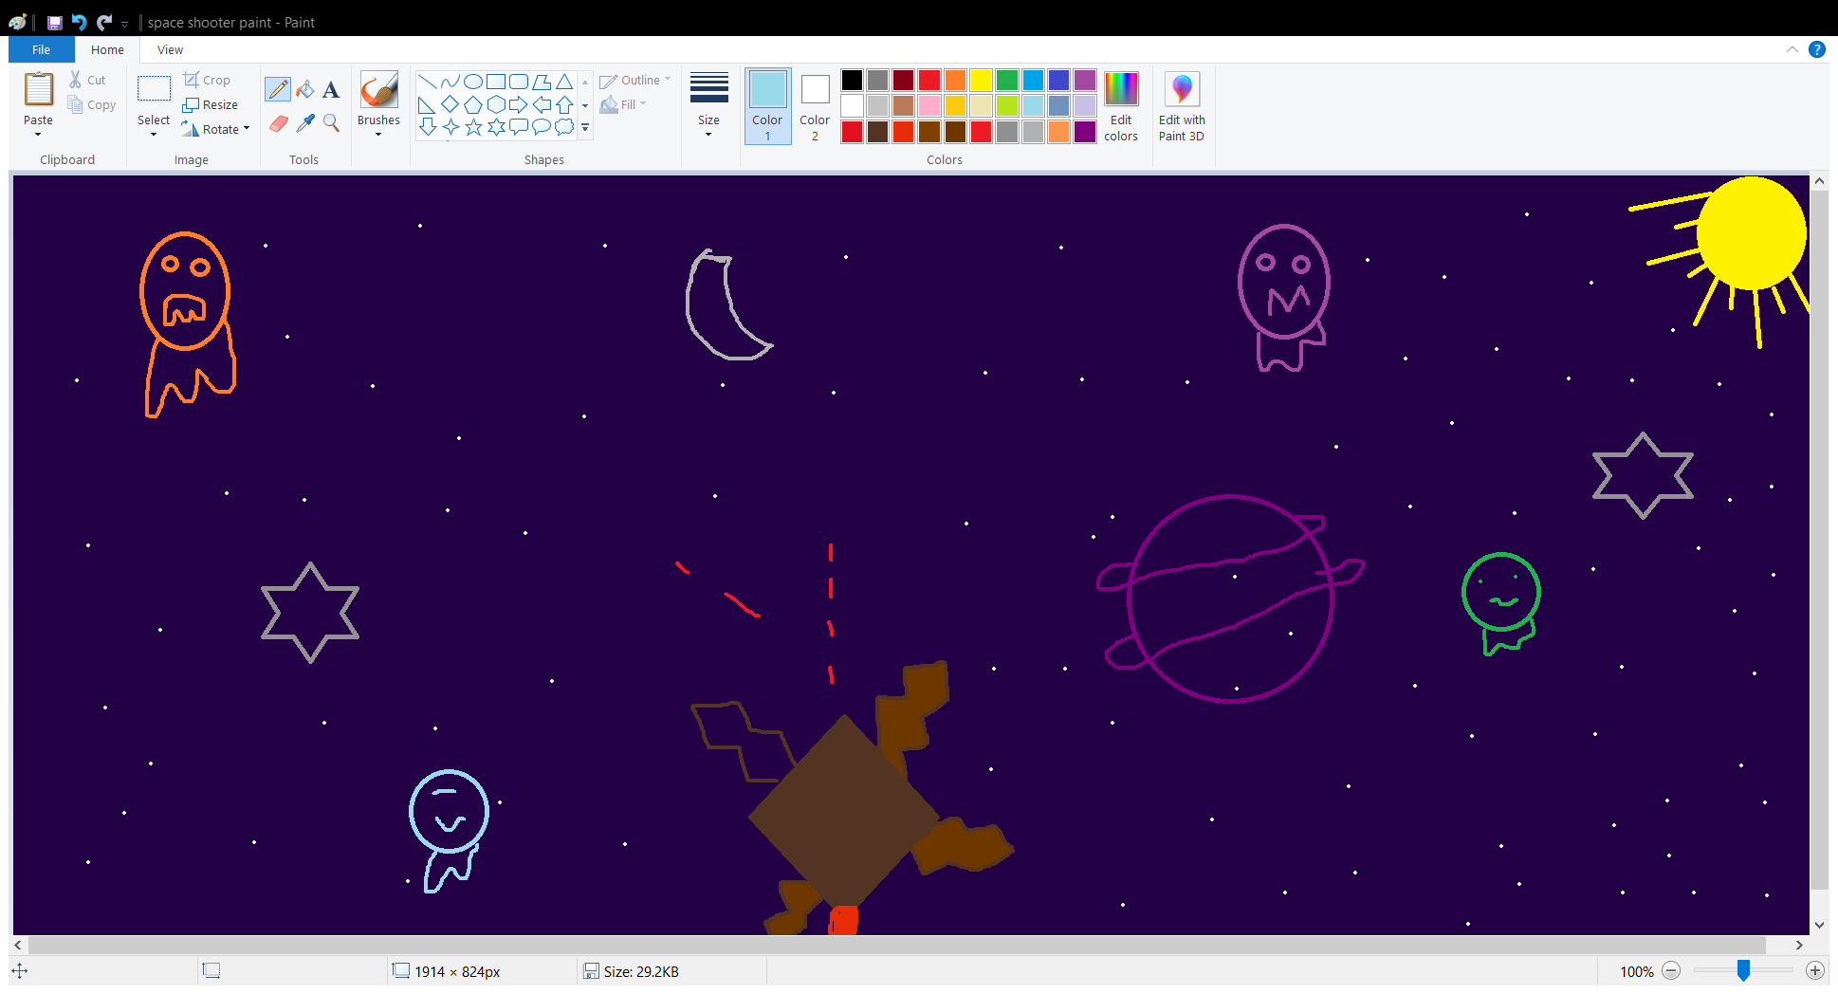

How do you plan to make your game engaging?

I can make this game engaging by adding different levels to it and increasing the speed after a particular score is obtained by the user. I can also make it more engaging by adding visual and sound effects after the highest score obtained and when the game is over.