Name | Ashutosh Thanvi
DTU ID | S252568
Course | Scientific Programming in Wind Energy
Assignment 3 | Wind turbine modelling
Date | 05th December 2025

Executive Summary
A wind turbine modelling tool was developed in python using Blade Element Momentum (BEM) theory. The objective of this project is to develop a steady-state Blade Element Momentum (BEM) model to predict the aerodynamic performance of a wind turbine. The model will compute key performance metrics such as power output, thrust, and torque as functions of wind speed, rotor speed, and blade pitch angle.

Algorithm chart flow
The below figure shows the algorithm of the tool.
Interpolate for omega and pitch for every wind speed based on operational strategy
Plot Power and Thrust as a function of wind speeds
Plot aerofoil shapes
Application of Blade Element Momentum theory include loss corrections
Extract Aerofoil data & Operational conditions
Read Blade Geometry and Operational conditions

Blade Geometry - Chord, twist, air foil data along the span
Operational conditions – wind speed , rotor speed, pitch angle
Air foil data for each aerofoil - x/c, y/c, Cl and Cd as a function of angle of attack

Methodology- BEM
Consider a wind turbine rotor with radius $R$, we can consider a blade element at span position $r$ with element length of $dr$, as shown in below: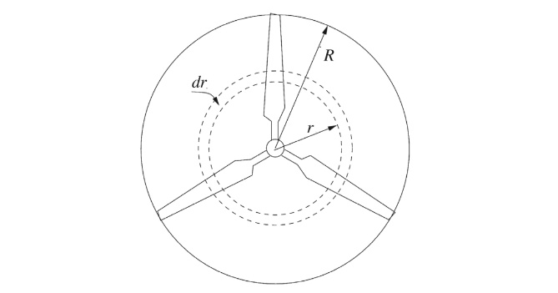
Source: Figure 3.8 in (Hansen, 2015)
We can then calculate the local solidity $σ(r)$, defined as the fraction of the annular area in the control volume, which is covered by blades as follows:
$$σ(r)=\frac{c(r)B}{2πr}$$
where $B$ denotes the number of blades that is 3 for the turbine we considered.
Assume the local chord length at this span position is $c(r)$, the local twist angle is $β(r)$, and the rotor is operated at the following conditions:
- Inflow wind speed: $V_{0}$
- Blade pitch angle: $θ_{p}$
- Rotational speed: $ω$
Note that given the rotor radius $R$, the inflow wind speed $V_{0}$ and the rotational speed $ω$, the tip speed ratio $λ$, or TSR, is given by:
$$λ=\frac{ωR}{V_{0}}$$
Based on the procedure described in Chapter 6 of (Hansen 2015), the following steps can be taken to solve the steady BEM equations to obtain the axial ($a$) and tangential ($a^{'}$) induction factors and compute the contribution of thrust and torque of this blade element:
- Step 1: Initialize $a$ and $a^{'}$, typically $a=a^{'}=0$.
- Step 2: Compute the flow angle $ϕ$ using the following equation:
$$tan⁡ϕ=\frac{(1-a)V_{0}}{(1+a^{'})ωr}$$
- Step 3: Compute the local angle of attack $α$ using the following equation:
$$α=ϕ-(θ_{p}+β)$$
- Step 4: Compute $C_{l}(α)$ and $C_{d}(α)$ by interpolation based on the airfoil polars.
- Step 5: Compute $C_{n}$ and $C_{t}$ with:
$$C_{n}=C_{l}cos⁡ϕ+C_{d}sin⁡ϕ$$
$$C_{t}=C_{l}sin⁡ϕ-C_{d}cos⁡ϕ$$
- Step 6: Update $a$ and $a^{'}$ with:
$$a=\frac{1}{4\sin^{2}⁡ϕ/[σ(r)C_{n}]+1}$$
$$a^{'}=\frac{1}{4sin⁡ϕcos⁡ϕ/[σ(r)C_{t}]-1}$$
- Step 7: If $a$ and $a^{'}$ have changed more than a certain tolerance, go back to Step 2, otherwise continue to Step 8.
- Step 8: Compute the local contribution of this blade element to the thrust and torque as:
$$dT=4πrρV_{0}^{2}a(1-a)dr$$
$$dM=4πr^{3}ρV_{0}ωa^{'}(1-a)dr$$
Loop over all blade elements, we can then integrate to get the thrust ($T$) and torque ($M$), then the (aerodynamic) power output of the rotor can be computed as:
$$P=Mω$$

Results
Aerofoil shapes for 50 aerofoils along the blade span
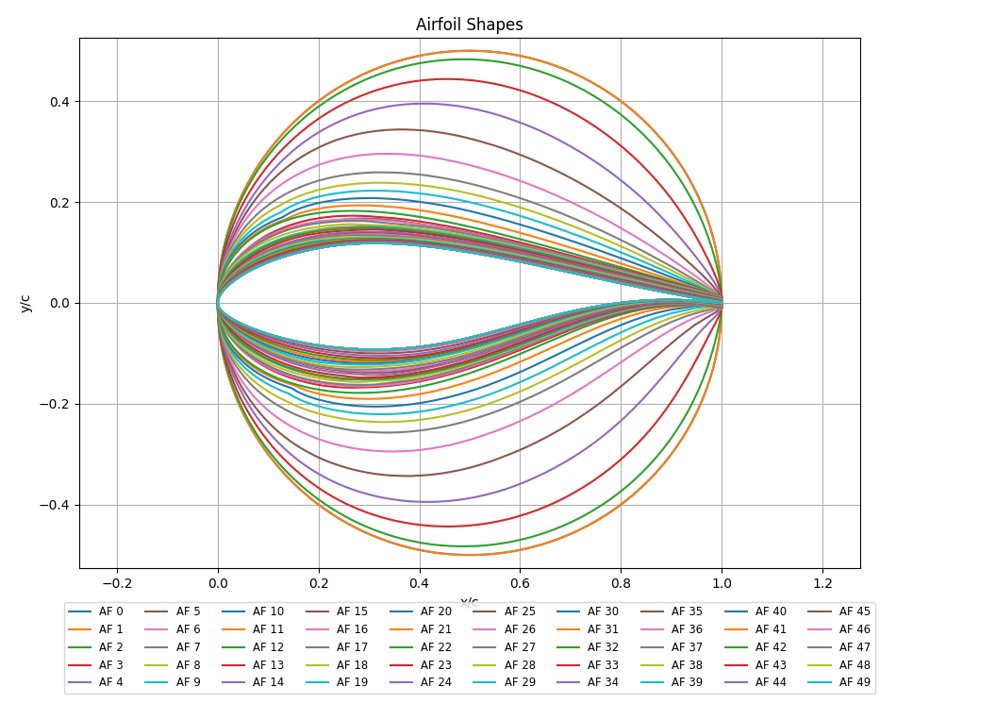

Rotor Power (MW) Vs Wind speed (m/s) and Thrust (kN) Vs Wind speed (m/s)
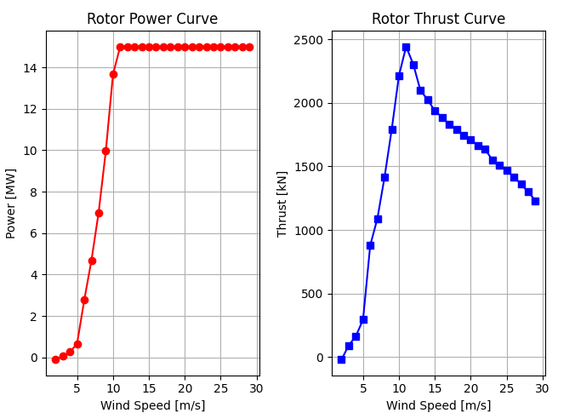
The rates power of the turbine is 15MW and the rated speed is 11m/s. The thrust increases up to rated wind speed and then decreases due to pitching of blades.

