Numerical mesoscale modelling of Inconel 617
  - Hot deformation at 900 to 1200 °C and 0.001 to 0.1 s⁻¹
Technical revision prepared 4 October 2026
Project authors: Sandhra M Lal, Aiswarya R, Thanvir Diouf and Mamidi Mahima Praharsha, Department of Mechanical Engineering, National Institute of Technology Calicut.
This report presents a reproducible cellular automaton study of hot deformation in Inconel 617. It describes the implemented material candidates, governing equations, numerical method and process comparisons. The results support evaluation of a working computational model; measured stress–strain and microstructure data are needed before quantitative material predictions can be validated.

Abstract
A two-dimensional cellular automaton represents grain ownership, grain-scale dislocation density, nucleation of discontinuous dynamic recrystallization and grain-boundary migration during uniform hot deformation of Inconel 617. The implementation uses SI units, a fully filled Voronoi initial lattice, physical nucleus and nucleation-band dimensions, bounded Poisson capture probabilities and simultaneous state updates. Dislocation density is advanced with a positive split integration scheme. Four distinct constitutive candidates are available: CAC2, MAIN9, FINAL_CA and VARIANT.
The numerical checks establish reproducible execution, finite physical states and selected integration and interface-refinement properties. The new comparisons quantify sensitivity to process conditions, model choice, random seed and discretization. They are simulator outputs and numerical verification results. Experimental flow curves, calibrated grain-size and DRX measurements, and the neural-network source are not available as auditable raw data. Consequently, the revised work supports an executable research model but does not yet establish independently validated Inconel 617 predictions.

Reading guide
Sections 1 to 3 define the material, constitutive candidates and governing equations. Sections 4 to 6 describe FINAL_CA and the numerical method. Sections 7 to 9 present verification, simulated results and sensitivity. Sections 10 and 11 set out validation requirements and conclusions. References and the reproducibility record follow.

1 Material and scope
Inconel alloy 617 is a solid-solution-strengthened nickel-chromium-cobalt-molybdenum alloy. Table 1 gives the manufacturer’s limiting composition. Actual specimen chemistry must be taken from its heat certificate [1].
Table 1 Selected limiting composition of Inconel alloy 617 in mass percent [1]
Element | Limit
Nickel | 44.5 minimum
Chromium | 20.0 to 24.0
Cobalt | 10.0 to 15.0
Molybdenum | 8.0 to 10.0
Aluminium | 0.8 to 1.5
Iron | 3.0 maximum
Carbon | 0.05 to 0.15

The intended application range is 1173.15 to 1473.15 K (900 to 1200 °C), with constant strain rates of 0.001 to 0.1 s⁻¹. The production matrix samples six conditions within this range rather than mapping the full domain. Babu et al. studied alloy 617 at 1173 to 1473 K and 0.001 to 10 s⁻¹ and identified an optimum domain of 1323 to 1423 K and 0.001 to 0.1 s⁻¹ [2]. Their average activation energy is 481 kJ mol⁻¹, distinct from the 493.039 kJ mol⁻¹ implemented by FINAL_CA. This literature provides experimental context; its processing map does not independently validate the simulator.

Research objective
The objective is to link imposed temperature and strain rate to the simulated flow curve, recrystallized area fraction and grain size, while separating material calibration from numerical implementation. The model treats discontinuous recrystallization through discrete boundary nuclei and migration driven by stored dislocation energy and curvature.

Model boundaries
The lattice remains fixed and two dimensional; the macroscopic specimen does not change shape with imposed strain. Temperature and strain rate are uniform and constant in each run. The model does not resolve continuous recrystallization, twinning, subgrain evolution, precipitate pinning or explicit solute drag. Orientation is a scalar angle modulo π rather than a complete crystallographic orientation. These restrictions are important when comparing the lattice with EBSD or inverse pole figure maps.
A recent alloy 617 study reports a transition between discontinuous recrystallization with some twinning-induced recrystallization at higher temperatures and lower rates, and continuous recrystallization with recovery at lower temperatures [7]. This supports assessing the present model’s mechanism coverage rather than assuming one boundary-nucleation description is sufficient across the entire range.

2 Constitutive candidates and implementation
The four candidate parameter sets share the same numerical engine. Their names select different constitutive equations, not different alloys or independently validated material databases. This separation supports matched comparisons of calibration choices while keeping geometry and numerical controls fixed.
Table 2 Constitutive candidates retained in the corrected implementation
Candidate | Model option | Distinguishing calibration
CAC2 | --model cac2 | Qp = 482319.715 J mol⁻¹; fixed G = 46.4 GPa; distinct peak-stress, recovery, mobility and nucleation laws.
MAIN9 | --model main9 | Qp = 493039 J mol⁻¹; Z-dependent critical factor; nucleation exponent includes a rate multiplier.
FINAL_CA | --model final_ca | Critical factor 0.95; temperature-only nucleation exponent; used for the six-condition process comparison.
VARIANT | --model variant | Temperature-linear peak-stress and recovery fits; fixed nucleation rate; 450 J mol⁻¹ mobility exponent requiring calibration.

All four parameter sets are implemented in src/inconel617/MaterialModels.java. Grain ownership, dislocation-density advancement, nucleation and migration are handled by src/inconel617/DrxSimulation.java. The applied strain rate equals the entered value, with no hidden multiplier. Temperature, length and output units are explicit.
The --model option selects a parameter set; the --preset final-report option also supplies the 400 × 400 cell geometry and 58 μm nominal initial grain diameter used for the main comparisons. Explicit command-line options override preset values. Every run records its resolved settings, seed and executable fingerprint in run.properties.

Calibration and evidence
FINAL_CA uses Qp = 493039 J mol⁻¹, stress exponent 3.86, intercept ln A = 40.26 and constitutive coefficient αs = 0.005439 MPa⁻¹. These values define the implemented candidate, not an independently validated fit. Exponent and intercept must be assessed together against measured flow curves before either is replaced. Taylor αT = 0.5 is a separate dimensionless coefficient.
The repository includes source code, tests, recorded simulation runs and numerical diagnostics. It does not contain an experimental validation dataset. Raw flow curves, EBSD/IPF measurements, specimen strains and segmentation rules are needed to calculate material prediction errors. Numerical verification and experimental validation are therefore reported separately.

3 Governing variables and equations
Table 3 Symbols and units used consistently in the corrected simulator
Symbol | Meaning | Unit
T | Absolute temperature | K
ε and ε̇ | True strain and imposed strain rate | 1 and s⁻¹
ρ | Dislocation density | m⁻²
G and b | Shear modulus and Burgers vector | Pa and m
αT | Taylor stress coefficient | 1
αs | Hyperbolic-sine stress coefficient | MPa⁻¹
K1 and K2 | Hardening and recovery coefficients | m⁻¹ and 1
M | Grain-boundary mobility | m⁴ J⁻¹ s⁻¹
γ and κ | Boundary energy and signed curvature | J m⁻² and m⁻¹
P and v | Boundary pressure and migration speed | Pa and m s⁻¹
Ṅ and Areact | Nucleation intensity and reactive area | m⁻² s⁻¹ and m²
h and w | Cell spacing and physical nucleation-band width | m
Qp Qf Qn | Activation energies | J mol⁻¹ in exponent evaluation
R and kB | Gas and Boltzmann constants | J mol⁻¹ K⁻¹ and J K⁻¹

Hardening recovery and flow stress
$\frac{dρ}{dε} = K_{1}\sqrt{ρ} + \frac{1}{bd} − K_{2}ρ$ (1)
$σ = α_{T}Gb\sqrt{ρ̄}$ (2)
The grain diameter d is area-equivalent and changes with its live lattice area. The mean density ρ̄ is weighted by cell area over the whole domain. Taylor αT = 0.5 is dimensionless and distinct from αs in the empirical stress law. Constants are b = 2.5 × 10⁻¹⁰ m, R = 8.314 J mol⁻¹ K⁻¹ and kB = 1.38064852 × 10⁻²³ J K⁻¹. Initial densities are sampled from 10⁶ to 10⁷ m⁻² and require material calibration. A newborn grain starts at 1 m⁻², which is a numerical assumption rather than a measured nucleus density.

4 FINAL CA constitutive calibration
FINAL_CA is the selected candidate for the six-condition process comparison. It provides a critical-density factor of 0.95 and a temperature-only nucleation exponent. The constants below describe the implemented equations; their empirical uncertainties have not been established.
$ln Z = ln ε̇ + \frac{Q_{p}}{RT}$ (3)
$Q_{p} = 493039 J {mol}^{−1} ; K_{2} = exp(8.9 − 0.15 ln Z)$ (4)
$σ_{p} = \frac{1}{α_{s}} asinh[exp(\frac{ln Z − 40.26}{3.86})]$ (5)
$α_{s} = 0.005439 {MPa}^{−1} ; K_{1} = \frac{K_{2}σ_{p} × {10}^{6}}{α_{T}Gb}$ (6)
$ρ_{sat} = {(\frac{K_{1}}{K_{2}})}^{2} ; ρ_{cr} = 0.95² ρ_{sat}$ (7)
$f_{ss} = min[1, 0.0096 ln Z + 0.526]$ (8)
For a recrystallized grain, the hardening coefficient in Eq. 1 is multiplied by fss, capped at 1. The saturation density in Eq. 7 is a hardening/recovery reference scale, with no imposed ceiling. The finite-grain term 1/(bd) means it is not the exact equilibrium of the complete Eq. 1. Likewise, σp is a fitted stress scale, not a guarantee of the simulated peak. Logarithms of Z and strain rate use the numerical convention with rate expressed in s⁻¹.
$G(T) = 78.9 × {10}^{9} [1 − 0.64 \frac{T − 300}{1453 + 273.15}] Pa$ (9)
Equation 9 uses an empirical modulus relation with a 1453 °C reference coefficient. That coefficient is not a verified alloy 617 melting temperature: the manufacturer gives a melting range of 1332 to 1380 °C [1]. The modulus relation requires independent assessment before its coefficients are replaced.
$Q_{f} = \frac{130}{1 + {(T/1333)}^{37}} + 620 (kJ {mol}^{−1})$ (10)
$D_{eff} = 1.7 × {10}^{−22} exp[−\frac{Q_{f} × 1000}{RT}] exp(0.091 Q_{f})$ (11)
$M = \frac{D_{eff}b}{k_{B}T}$ (12)
For Eq. 12 to yield mobility in m⁴ J⁻¹ s⁻¹, the effective coefficient Deff must have units m³ s⁻¹, consistent with a diffusivity multiplied by boundary width. The effective width and prefactor interpretation are not established, so mobility remains a calibration assumption. The denominator is kBT. Recovery coefficient K2 is a separate quantity used in the density equation.

5 Nucleation and grain boundary migration
$n_{p}(T) = \frac{0.61}{1 + {(T/1338)}^{59}} + 0.39$ (13)
$Ṅ = 3.83 × {10}^{15} exp[−\frac{120000}{RT}] {(ε̇/0.2)}^{n_{p}}$ (14)
The FINAL_CA exponent np depends only on temperature. MAIN9 additionally multiplies its exponent by the strain rate divided by 0.001 s⁻¹ and raised to power 0.05; FINAL_CA excludes that multiplier. The reference 0.2 has units s⁻¹. Ṅ is interpreted as nuclei per reactive area per time; its absolute scale and nucleation geometry need calibration against measured DRX kinetics.
$A_{react,c} = \frac{1}{2} wh n_{faces,c}$ (15)
$p_{nuc,c} = 1 − exp[−Ṅ A_{react,c} Δt ω_{c}]$ (16)
Each unlike lattice face contributes half of the configured physical band width to each side of the interface. The number of unlike four-neighbour faces defines nfaces,c. The excess-density weight below applies only when the candidate density exceeds the critical density. Candidates are visited in a seeded random order; each cell is considered once. The circular nucleus patch is confined to its parent grain and domain, and accepted patches cannot overlap.
$ω_{c} = \frac{ρ_{c} − ρ_{cr}}{ρ_{max} − ρ_{cr}}$ (16a)
$P_{t←s} = α_{T}Gb^{2}(ρ_{t} − ρ_{s}) − γ_{st}κ_{s}$ (17)
$λ_{t←s} = max(0, M P_{t←s}/h)$ (18)
$p_{capture,t} = 1 − exp(−Δt ∑ λ_{t←s})$ (19)
Migration pressure combines the difference in stored dislocation energy and curvature pressure. A target boundary cell receives competing capture hazards from its four face neighbours. If capture occurs, a source is selected in proportion to its hazard. All proposals read the same old lattice and are committed together, preventing grain-loop order from setting capture priority.

Boundary energy and curvature
The high-angle energy γm is 0.8 J m⁻². Below the 15° scalar misorientation threshold, the Read–Shockley relation scales that energy. At or above 15° it is γm; at zero misorientation it is zero.
$γ = γ_{m} r(1 − ln r) ; r = θ/15°$ (20)
$κ = \frac{1.25(15 − n_{same})}{25h}$ (21)
Curvature uses a 5×5 kink stencil, where nsame counts cells of the source grain including the centre. Exterior stencil samples are clamped at the domain edge. This discrete approximation can retain orientation and resolution bias.

6 Numerical method and output measurements

Initial structure and physical dimensions
Separated random seed positions are placed with a bounded procedure and assigned across a fully filled Voronoi lattice. The seed count follows the physical domain area divided by the requested initial-grain area. The achieved number-mean diameter is measured from the resulting cells and need not exactly equal the requested diameter. One 64-bit random seed controls initialization and subsequent stochastic events.
Table 4 Standard corrected-engine settings unless a comparison specifies otherwise
Setting | Value | Interpretation
Domain | 100 × 100 cells at 1 μm | 100 × 100 μm physical area
Initial diameter | 13 μm | Requested area-derived grain scale
Nucleus diameter | 1 μm | Physical patch diameter; clipped by parent grain
Nucleation band | 2 μm | Fixed physical width across refinement
Applied strain | 1.38 | Uniform accumulated true strain
Random seed | 42 | One realization; ensembles reported separately
Migration limit | 0.25 | Maximum total incoming hazard per step
Temperature and rate | Constant in a run | CLI conversion °C to K uses 273.15

The final-report preset selects FINAL_CA, 400×400 cells at 1 μm spacing and a 58 μm requested initial diameter, with strain 1.38, seed 42, a 1 μm nucleus and a 2 μm band. Section 8 states the production-run configuration. Nucleus diameter and band width are starting assumptions requiring calibration. Pixel-centre inclusion and clipping mean a nucleus patch’s measured area-equivalent diameter can differ from its nominal diameter.

Time integration and state consistency
Before mutation, the engine predicts density and migration hazards. It shrinks and recomputes the trial step until the complete incoming hazard is bounded, while also respecting the maximum strain increment, recovery limit and remaining requested strain. Trial steps do not consume random numbers. Density uses exact half-step recovery, a Heun hardening step and a second exact half-step recovery. New nuclei are inserted after density advancement and begin hardening on the following step. Cell ownership, live grain counts and boundary lists are rebuilt after every committed update.

Reported quantities
Each grain area is its live cell count n multiplied by h². Its area-equivalent diameter follows Eq. 22. Mean total and DRX diameters are arithmetic means over active grains in the respective populations; they are not area-weighted mean diameters. DRX fraction is the area fraction of cells carrying recrystallized grain status, not an EBSD segmentation result. Flow stress uses area-weighted density in Eq. 2. Output includes the initial state and lands exactly on the requested final strain. CSV tables and run.properties record units, parameters, model provenance and seed; image colours label grain identity rather than crystallographic IPF colour.
$d = \sqrt{\frac{4A}{π}} ; A = nh^{2}$ (22)

7 Numerical verification
Numerical verification asks whether the stated discrete model is implemented consistently and produces controlled calculations. Experimental validation asks whether it represents the material. Passing software checks addresses the first question and cannot establish the second.
Table 5 Completed verification evidence
Check | Observed result | Scope
Regression suite | 16 tests passed | Units, material coefficients, conservation, positivity, seeded reproducibility, boundary state, output and selected refinements.
Density integration | Reference 110.186725 MPa | Coarse and fine errors 0.2025% and 0.0353%; single-grain numerical solver check.
Reactive boundary area | 48 μm² at both spacings | 24 μm straight interface; 2 μm band; cell spacing 1 and 0.5 μm.
Short endpoint checks | 12 scenarios completed | CAC2, MAIN9 and VARIANT at 900/1200 °C, 0.001/0.1 s⁻¹, strain 0.1.
Production matrix | 18 runs completed | Six conditions × three laws; matched physical geometry and seed, strain 1.38.
Selected diagnostics | 6 additional runs completed | Baseline, 2 additional seeds, 2 domain sizes and one halved strain-step cap; full stochastic convergence unestablished.
Independent output audit | 24 endpoint runs; 696 saved samples | Counts, DRX area/fraction consistency, diameter bounds, sampled peaks and record hashes pass.

The straight-interface test keeps its physical interface length and band width fixed. It shows that integrated nucleation intensity does not vanish when h is reduced. Diagonal staircase interfaces still measure length along square-lattice faces. This test therefore does not prove full spatial convergence of microstructure evolution.
The production outputs were checked for complete run records, source and executable hashes, finite nonnegative physical quantities, DRX fractions within [0, 1], final strain 1.38 and time equal to strain divided by the imposed rate. Saved incoming hazards remained no greater than 0.25. CSV endpoints were reconciled with each run summary. This checks output consistency; it does not identify experimental fit quality.
All 6 matched rate pairs and 12 temperature pairs show the expected stress directions at endpoints and sampled peaks. These are descriptive diagnostics. The one-grain endpoints are within 0.068% of the full hardening/recovery equilibrium calculated at fixed final diameter; finite strain and integration effects remain. This is not a controlled convergence test or empirical agreement. Detailed checks are in analysis/validation.json.

Interpretation of numerical limits
The migration limit is a nondimensional total incoming hazard, not a measured continuous boundary displacement. At a limit of 0.25, the associated aggregate capture probability is 1 − exp(−0.25), approximately 0.221. Refinement must hold physical domain, grain scale, nucleus scale and band width fixed. Changing the number of cells without holding these quantities fixed mixes a numerical-resolution change with a different physical problem.

8 Simulated process comparisons
The 18-run matrix compares CAC2, MAIN9 and FINAL_CA at six temperature/rate conditions. Every run uses a 400 × 400 μm square, 1 μm cell spacing, 58 μm nominal initial diameter, 1 μm nucleus diameter, 2 μm band, seed 42 and target strain 1.38. The achieved initial number-mean diameter is 56.865 μm over 61 grains. Maximum strain increment is 0.00138 and total incoming hazard is capped at 0.25. Samples are saved at strain spacing 0.05 plus the exact endpoint. Final time is 1380 s at 0.001 s⁻¹ and 13.8 s at 0.1 s⁻¹. Table 6 reports FINAL_CA; Appendix A records all three candidates.
Table 6 FINAL_CA simulated endpoint values at the stated comparison configuration
T °C | Rate s⁻¹ | Stress MPa | DRX size μm | DRX fraction | Mean size μm
950 | 0.001 | 208.904 | 4.793 | 0.134169 | 7.858
1050 | 0.001 | 85.885 | 83.006 | 1.000000 | 83.006
1050 | 0.1 | 227.951 | 10.985 | 1.000000 | 10.985
1100 | 0.1 | 160.842 | 27.755 | 1.000000 | 27.755
1200 | 0.001 | 26.041 | 451.352 | 1.000000 | 451.352
1200 | 0.1 | 86.485 | 114.444 | 1.000000 | 114.444

FINAL_CA reaches full recrystallized ownership in five conditions; the 950 °C/0.001 s⁻¹ run ends at fraction 0.134169. Its DRX-only mean is 4.793 μm and total mean 7.858 μm, so these two statistics must not be interchanged. At 1050 °C, increasing rate from 0.001 to 0.1 s⁻¹ raises final stress from 85.885 to 227.951 MPa and lowers total mean diameter from 83.006 to 10.985 μm. At 1200 °C/0.001 s⁻¹ the last grain occupies the entire square: 451.352 μm is its area-equivalent circular diameter, not a resolved material-scale grain prediction.

How to read the process curves
At a fixed strain, decreasing strain rate increases elapsed time and changes the empirical Z-dependent coefficients. A change in DRX may reflect both mechanisms. Temperature also affects G, peak stress, recovery, mobility and nucleation. Several simultaneous changes make it unsafe to attribute a trend to one coefficient without a controlled sensitivity study. The figures on the next page show simulated responses labelled by model and process condition.
The initial and final measured grain diameters, cumulative nuclei and active DRX population should be read together. A nucleus can be inserted and subsequently disappear; cumulative nuclei count is therefore not equivalent to active recrystallized grain count or DRX fraction. Small nuclei may also be prevented from growing by surface-energy pressure.

9 New simulation figures and sensitivity
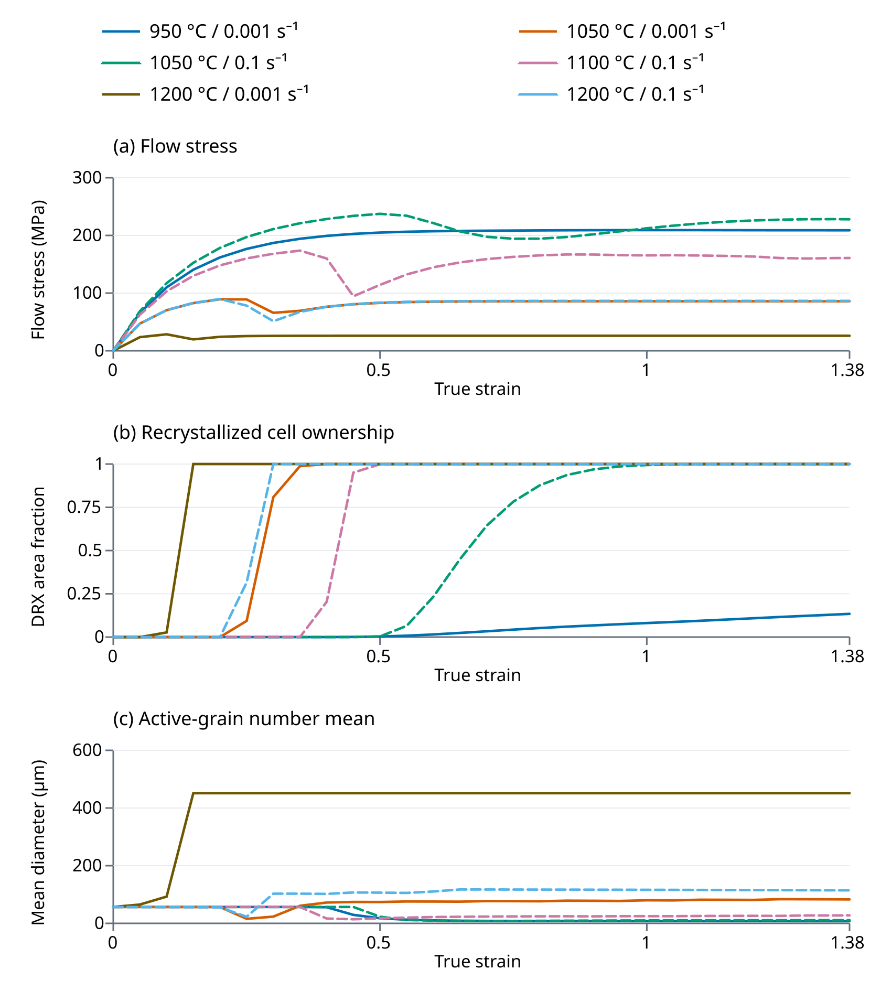
Figure 1 New FINAL_CA outputs at six matched conditions. All curves are simulations. Diameter is the number mean over active grains; at 1200 °C/0.001 s⁻¹ it reaches the one-grain domain limit.
DRX fraction is current recrystallized ownership and can decrease as small nuclei disappear. Saved curves may miss intermediate extrema. In particular, the reported sampled peak stress is the maximum saved at 0.05 strain intervals, rather than the maximum of every integration step.

9 New simulation figures and sensitivity (continued)
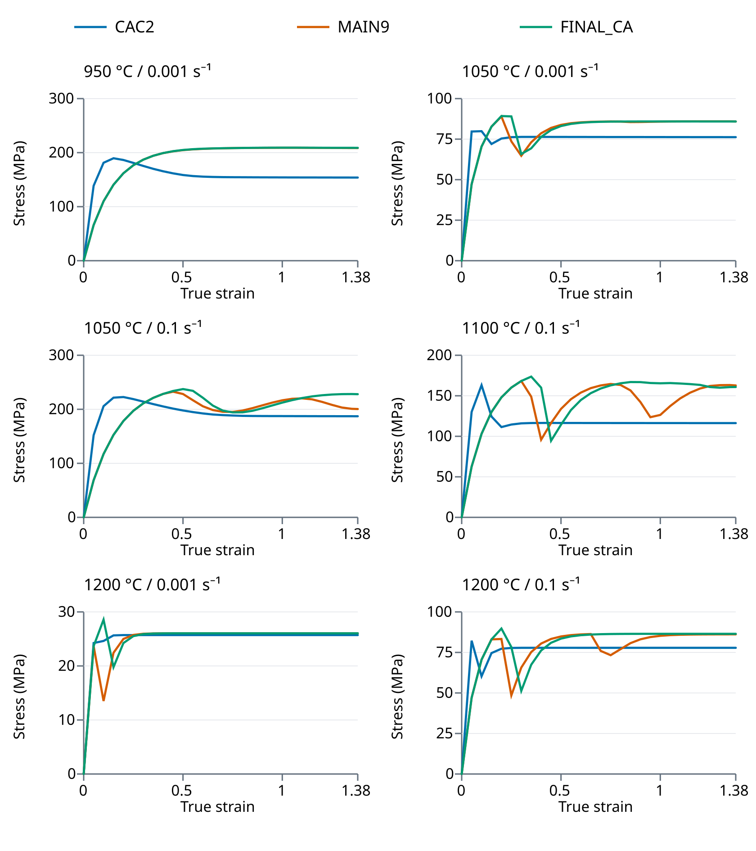
Figure 2 Simulated flow curves for three constitutive candidates under identical geometry, nominal microstructure and seed. Different empirical laws produce different responses within the same numerical engine.
Model choice also changes the microstructure. At 950 °C/0.001 s⁻¹ the endpoint DRX fractions are 1.000 for CAC2, 0.149319 for MAIN9 and 0.134169 for FINAL_CA. Similar stress in two candidates does not establish agreement on nucleation kinetics or grain size.

9 Selected sensitivity diagnostics
Selected diagnostics use FINAL_CA at 1100 °C and 0.001 s⁻¹, with target strain 1.38 and the Section 8 physical scales. The baseline uses a 400 μm domain, 1 μm cells, seed 42 and maximum strain increment 0.00138. The table compares endpoints except the explicitly marked intermediate grid observation and includes the actual number of surviving grains where relevant.
Table 7 Selected numerical and model sensitivity checks
Comparison | Observation | Implication
Seeds 42 to 44 | Stress 56.603–56.710 MPa; mean 128.743–163.282 μm; DRX fraction 1 for all. | Small stress range with appreciable grain-size variability; 3 realizations only.
Domain sides 200, 400 and 800 μm | Mean diameters 126.428, 163.282, 163.935 μm; 3, 7, 27 live grains. | 400 and 800 μm means are close in this realization; 200 μm has only 3 surviving grains.
Nuclei per μm², same domain order | 0.0073500, 0.0063125, 0.0038500 | Normalize extensive counts by physical area; geometry and stochastic variability remain.
Maximum strain step halved | Stress 56.648 MPa (+0.079%); mean 127.466 μm (-21.94%). | One-seed stochastic diagnostic; a small stress change does not show converged microstructure.
Intermediate grid comparison only, ε = 0.5 | 1 → 0.5 μm spacing: stress 56.439 → 56.388 MPa (-0.091%); mean 126.591 → 138.893 μm (+9.72%). | Matched saved strain, not endpoint 1.38. The finer run was stopped at strain 0.95; no completed grid run is counted.

Three seeds are a small stochastic sample and do not define confidence intervals. Changing domain size changes the initial grain count and geometry; equal seed values do not preserve an identical initial microstructure. Changing integration steps changes the number and order of random draws, so a single-seed step comparison combines numerical and realization differences. Nuclei are normalized by physical area for domain comparisons. These diagnostics do not establish full stochastic time or spatial convergence. No completed production result at 0.5 μm cell spacing is included. The straight-interface and single-grain tests in Section 7 address only selected numerical properties. The partial grid comparison at ε = 0.5 has DRX fraction 1 for both spacings and nuclei density 0.0063125 → 0.0101125 μm⁻² (+60.20%). Its saved prefixes were checked for source/configuration identity, file hashes, exact sample time, finite quantities and bounded hazards. Finer integer seed-placement bounds change physical Voronoi positions and the initial random sequence; this comparison mixes resolution with realization changes. The partial records are in analysis/partial_grid_diagnostic.json. A separate 720 s retry timed out at last saved strain 0.85 after 96511 steps; its partial outputs are preserved and excluded from the completed-run count.

10 Experimental validation and neural network status

Microstructure comparisons
Microstructure validation requires measured grain-size distributions, recrystallized area fractions and boundary statistics at matched temperature, rate and specimen strain. Comparisons must use compatible physical field sizes and segmentation definitions. The simulation figures in this report show numerical outputs; no experimental microstructure comparison or prediction error is established.
An IPF map encodes crystallographic orientation, while the Java pictures assign palette colours from grain identifiers. Colour resemblance does not verify texture or crystallographic orientation. A useful comparison would measure grain-size distributions, aspect ratios, DRX fraction and boundary statistics with matched specimen strain, physical field size and segmentation definitions.

Calibration and validation data
Fitting mobility or recovery to a flow curve is calibration. Assessing the same fitted curve is a fit-quality check. Validation should reserve independent temperatures, strain rates or specimens and then compare predictions without retuning. Visual resemblance alone does not establish quantitative agreement, and numerical uncertainty must be considered alongside measurement uncertainty.
Required experimental records are heat composition and treatment, initial grain distribution, specimen geometry, true stress/strain conventions, temperature/rate histories, raw curves, final specimen strain, EBSD/IPF scale and orientation metadata, and segmentation rules for recrystallization. Digitised published data should retain the figure/page and digitisation uncertainty. Each calibration coefficient should have a source, units, fitting method, fitted range and reported uncertainty.

Surrogate modelling extensions
No ANN or PINN implementation or neural-network training dataset is included in this repository. An extension would need to document its training and validation split, network architecture, activations, optimization settings and held-out numerical errors. Physics-informed training additionally requires governing residuals, derivative construction, collocation points, boundary/initial conditions and loss weights. These would be new research components rather than capabilities demonstrated by the current simulator.
An ANN surrogate could be useful after the CA model is calibrated. It should be evaluated on held-out process conditions and compared with a simple regression baseline. A PINN extension requires explicit governing residuals and independent tests of both prediction error and residual satisfaction. Learning a simulator’s outputs does not make those outputs experimental evidence.

11 Conclusions and next research steps
The project provides a reproducible cellular automaton engine with separately selectable constitutive candidates. Consistent SI units, simultaneous Poisson capture, finite physical nuclei, a fixed physical nucleation band, positive density integration and exact output endpoints provide controlled numerical execution. FINAL_CA is the candidate used for the principal process comparison; CAC2 and MAIN9 show how different material laws affect the resulting stress and microstructure.
The 18 matched-condition runs quantify a strong constitutive dependence: at 950 °C/0.001 s⁻¹ CAC2 reaches full DRX while FINAL_CA retains a fraction of 0.134169. The long, hot 1200 °C/0.001 s⁻¹ runs end at a common one-grain domain limit. Selected diagnostics show that final stress can be stable while grain statistics vary appreciably. The corrected implementation therefore supports auditable numerical research and comparative trends, while independent material validation and full stochastic convergence remain unfinished.
The unresolved material assumptions include nucleus diameter, reactive-band width, initial density, modulus calibration, effective mobility dimensions and empirical activation/stress parameters. Stress exponent and intercept require a consistent fit against measured curves. The model is a numerically verified computational candidate whose material calibration remains to be validated.

Priorities for further work
First, assemble an auditable experimental dataset with condition, specimen strain and measurement definitions. Second, fit flow and microstructure outputs jointly, reserve validation conditions and report errors with measurement uncertainty and random-seed intervals. Third, refine h and the integration controls while holding physical dimensions fixed and using consistent initial microstructures. Fourth, assess whether omitted continuous recrystallization, twinning or solute-drag physics is required by the remaining discrepancies.
A component-scale FEM coupling should follow material validation and should preserve the local temperature/rate histories and state-variable meaning. Likewise, an ANN or PINN should be introduced with a defined scientific purpose and a documented comparison against the calibrated CA model and independent measurements.

Reproducibility record
The 24 completed production runs comprise 18 matched-condition runs and 6 selected diagnostic runs including their baseline. The repository root contains src/, test.sh, run.sh and analysis/. Regular compilation targets Java 17; the frozen production batch uses the Java 21 compiler and runtime recorded in its manifest. Run records include results.csv, run.properties and summary.txt. Numeric comparisons are in analysis/comparison_metrics.csv and analysis/summary.json. Source SHA-256: 219dc596d88136b03574f0dcd49976812deb0c82019c03a57c099302bf240217. Engine bytecode SHA-256, aggregated over 8 executable classes: b8ab94c497bd8dcadb1f66af85f2e4d33511350a984b443c6778ac46f45514f0.
README.md gives repository-relative commands and describes the model options. MODEL_NOTES.md records equations, units and calibration assumptions; VERIFICATION.md describes completed checks. The frozen reference build and recorded outputs support executable and data-integrity checks. Simulation tables should be regenerated after any source, coefficient or numerical-control change.

Appendix A Complete model comparison
All 18 runs use the Section 8 configuration and seed 42. Values are simulated endpoints at ε = 1.38. Diameter is the arithmetic number-mean area-equivalent diameter over all active grains. These rows support comparisons among the three retained candidates, rather than an experimental ranking of their accuracy.
Table A1 Endpoint stress, DRX fraction and total mean diameter for the matched matrix
T °C | Rate s⁻¹ | Model | Stress MPa | DRX fraction | Mean size μm
950 | 0.001 | CAC2 | 153.891 | 1.000000 | 3.563
950 | 0.001 | MAIN9 | 208.517 | 0.149319 | 6.808
950 | 0.001 | FINAL_CA | 208.904 | 0.134169 | 7.858
1050 | 0.001 | CAC2 | 76.216 | 1.000000 | 33.557
1050 | 0.001 | MAIN9 | 85.868 | 1.000000 | 73.209
1050 | 0.001 | FINAL_CA | 85.885 | 1.000000 | 83.006
1050 | 0.1 | CAC2 | 187.128 | 0.999975 | 3.636
1050 | 0.1 | MAIN9 | 200.489 | 1.000000 | 10.107
1050 | 0.1 | FINAL_CA | 227.951 | 1.000000 | 10.985
1100 | 0.1 | CAC2 | 116.280 | 1.000000 | 17.156
1100 | 0.1 | MAIN9 | 162.759 | 1.000000 | 32.004
1100 | 0.1 | FINAL_CA | 160.842 | 1.000000 | 27.755
1200 | 0.001 | CAC2 | 25.714 | 1.000000 | 451.352
1200 | 0.001 | MAIN9 | 26.041 | 1.000000 | 451.352
1200 | 0.001 | FINAL_CA | 26.041 | 1.000000 | 451.352
1200 | 0.1 | CAC2 | 77.853 | 1.000000 | 93.522
1200 | 0.1 | MAIN9 | 86.161 | 1.000000 | 247.295
1200 | 0.1 | FINAL_CA | 86.485 | 1.000000 | 114.444

At 1200 °C and 0.001 s⁻¹ every candidate ends with one live grain. The common diameter 451.352 μm equals the area-equivalent circular diameter of the entire 400 × 400 μm domain. Agreement on that diameter demonstrates a shared finite-domain limit; it does not establish agreement on the material’s grain size.

References
[1] Special Metals Corporation. INCONEL alloy 617. Technical bulletin SMC-029, March 2005. Composition, physical properties and melting range.
https://www.specialmetals.com/documents/technical-bulletins/inconel/inconel-alloy-617.pdf
[2] Babu KA, Mandal S, Kumar A, Athreya CN, de Boer B, Sarma VS. Characterization of hot deformation behavior of alloy 617 through kinetic analysis, dynamic material modeling and microstructural studies. Materials Science and Engineering A 664 (2016), 177–187.
https://doi.org/10.1016/j.msea.2016.04.004
[3] Ding R, Guo ZX. Microstructural modelling of dynamic recrystallisation using an extended cellular automaton approach. Computational Materials Science 23 (2002), 209–218.
https://doi.org/10.1016/S0927-0256(01)00211-7
[4] Liu YX, Lin YC, Zhou Y. 2D cellular automaton simulation of hot deformation behavior in a Ni-based superalloy under varying thermal-mechanical conditions. Materials Science and Engineering A 691 (2017), 88–99.
https://doi.org/10.1016/j.msea.2017.03.039
[5] Babu KA, Prithiv TS, Gupta A, Mandal S. Modeling and simulation of dynamic recrystallization in super austenitic stainless steel employing combined cellular automaton, artificial neural network and finite element method. Computational Materials Science 195 (2021), 110482.
https://doi.org/10.1016/j.commatsci.2021.110482
[6] Liu YX, Ke ZJ, Li RH, Song JQ, Ruan JJ. Study of Grain Growth in a Ni-Based Superalloy by Experiments and Cellular Automaton Model. Materials 14 (2021), 6922.
https://doi.org/10.3390/ma14226922
[7] Du Z, Chen F, Li R, Jiao Y, Li X, Qiao X. Hot deformation behavior and microstructure evolution of Inconel 617 alloy. Journal of Materials Research (2026), published 29 May 2026.
https://doi.org/10.1557/s43578-026-01878-7

Role of the literature
References 2 and 7 supply alloy 617 hot-deformation context. References 3 and 4 support the CA modelling approach, while Reference 6 addresses static grain growth in another Ni-based superalloy. Reference 5 concerns super austenitic stainless steel and supplies an example of CA-to-ANN-to-FEM methodology. Its reported validation accuracy is not transferable to Inconel 617. The literature supports the cited studies within their own conditions; it does not substitute for validation of the present coefficients and implementation.

