Agrovoltaic Canopy for Protection and Sustainable Farming: a six-sensor, wire-driven canopy that tilts its panels to optimise crop light and electricity, harvests rain and pays the farmer
Site study: Thiagarajar College of Engineering ground, Madurai (9.88 N, 78.08 E)
Final-year project report - computer-based study. Updated 2026-10-25 for the six-sensor controller; every number traces to a file listed in PROOF_INDEX.md.

Abstract
We design and simulate a stainless-steel wire-rope canopy that carries pivoting solar panels 4.5 m above crops. One motor moves a single drive wire so that all panels tilt between 15 and 60 deg, or lie nearly flat (3 deg fall to a gutter) in rain for rain harvesting. Six sensors decide the tilt: a pyranometer, a PAR sensor under the canopy, a DHT11 (temperature and humidity), a soil moisture sensor and a rain sensor. At each step the controller picks the angle with the best combined score (50 % electricity, 50 % crop light value); the PAR reading corrects the model, and hot dry air or dry soil lower the light the crop needs, so the panels give more shade (protection). Rain makes the panels a flat roof that fills a cistern. The electricity is sold to a nearby industry and the farmer receives a monthly share. The study is computational: MATLAB and Simulink models, a browser digital twin, AutoCAD drawings, a bill of materials and ray-traced renders, all driven by one design file. The PV model agrees with PVGIS within +5 %; the shadow model agrees with a 3-D ray tracer to a mean difference of 0.010. In a year-long test with noisy sensors the controller reaches 99.6 % of the best possible combined score (82 % of the best electricity and 98 % of the best crop light value), against 98.8 % for the monthly plan and 91.2 % for a fixed 45 deg panel; MATLAB and the web twin make identical decisions. A structural screening shows that 12.5 m bays fail and a 5 m rope grid passes, with a stronger winch, 6 mm drive wire, M24 turnbuckles and larger anchors. Farmer income (about INR 2 lakh per hectare per month) depends on assumed tariff and share, and investor payback is long (about 41 years in the base case).

1 Introduction
Smallholder farmers depend on crop income that is exposed to weather and prices. Agrivoltaics - growing crops under or between solar panels - can add a stable second income and, in dry climates, can save water (Dupraz et al. 2011; Barron-Gafford et al. 2019; Weselek et al. 2019). Field systems in Germany reported land-use gains of 56-70 % in 2017 and nearly 90 % in the hot summer of 2018 (Trommsdorff et al. 2021). This project asks whether a low-cost wire-rope canopy with a rain-harvesting flat mode and a hourly controller can give a Tamil Nadu farmer both water and a monthly solar income.
- O1 Define a buildable geometry from the project specification and guidelines (design, drawings, bill of materials).
- O2 Model the sun, shadow, crop light and PV output and validate them against independent references.
- O3 Build a digital twin with sensors, a controller, water balance and economics.
- O4 Develop and test the six-sensor control algorithm, measure how close it gets to the best possible electricity and crop light, and compare it with fixed designs and the monthly plan.
- O5 Quantify the economics and their uncertainty for the farmer and the investor.
Scope: computer-based only. No physical prototype and no field measurements are claimed.

2 Related work and gap
Agrivoltaic studies show that partial shade can keep or improve yields of shade-tolerant crops while adding electricity, but results depend on crop, climate and layout, and microclimate effects remain uncertain (Weselek et al. 2019). Design guidance exists (Fraunhofer ISE; DIN SPEC 91434) and emphasises machinery clearance and light distribution. The gap this project targets is the combination of (a) a wire-rope structure with a single wire-driven two-position panel mechanism, (b) a flat sealed rain-harvest mode feeding irrigation, (c) an hourly tilt controller that co-optimises energy and crop light, and (d) a farmer-income contract model. We do not claim that the combination is absolutely novel: a formal prior-art search has not been done (see NEEDED_DOCUMENTS.md).

3 Design
All geometry is defined in design/design.json. The pivot-axis height is derived: required lowest-edge clearance + half the panel width x sin(maximum tilt). Presets are recommended, wire_spec, smallholder, custom and feasible.
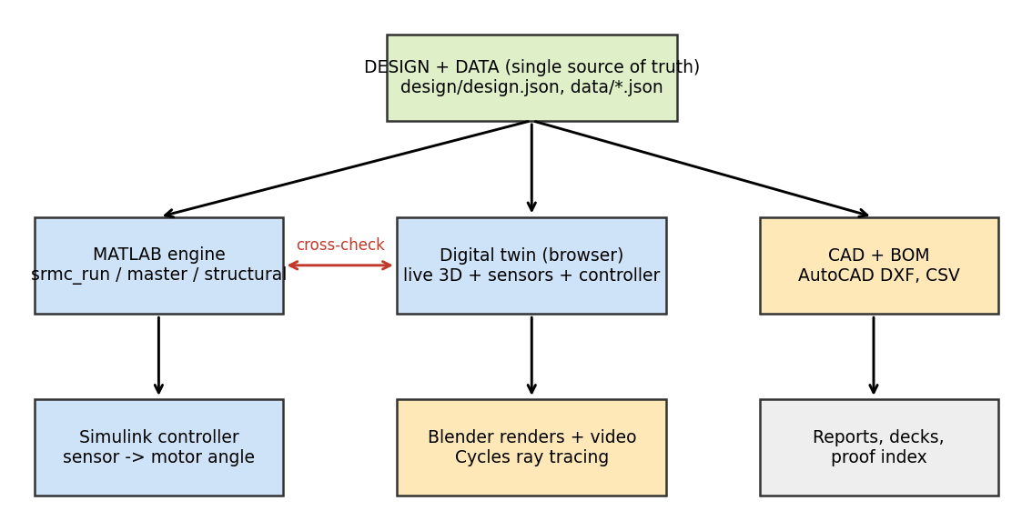
Figure 1. One design file feeds the MATLAB engine, the digital twin, the drawings and the renders.
Item | Wire-driven spec (Rev 1.0) | SRMC guidelines | Used
Mechanism / tilt | flat or 15-60 deg, encoder 0.5 deg | - | spec
Clearance | >= 4.0 m | 4.5 m | 4.5 m
Column spacing | 12-18 m rows | 4-5 m | 5 m (structure check)
Carrier wire | - | SS316 16 mm 7x19 | 16 mm; stays 20 mm
Drive wire | SS316 4 mm 7x7 | - | 4 mm

Checked design (preset feasible): 10 panels, 2.497 m wide on a 2.5 m pitch along a 25 m wire run; pivot height 5.58 m; lowest edge 4.50 m at 60 deg; carrier-rope grid every 5 m (sag span/12); pivot tube CHS 114.3x4; 36 columns RHS 200x200; one motor winch (<= 30 m, <= 20 panels).
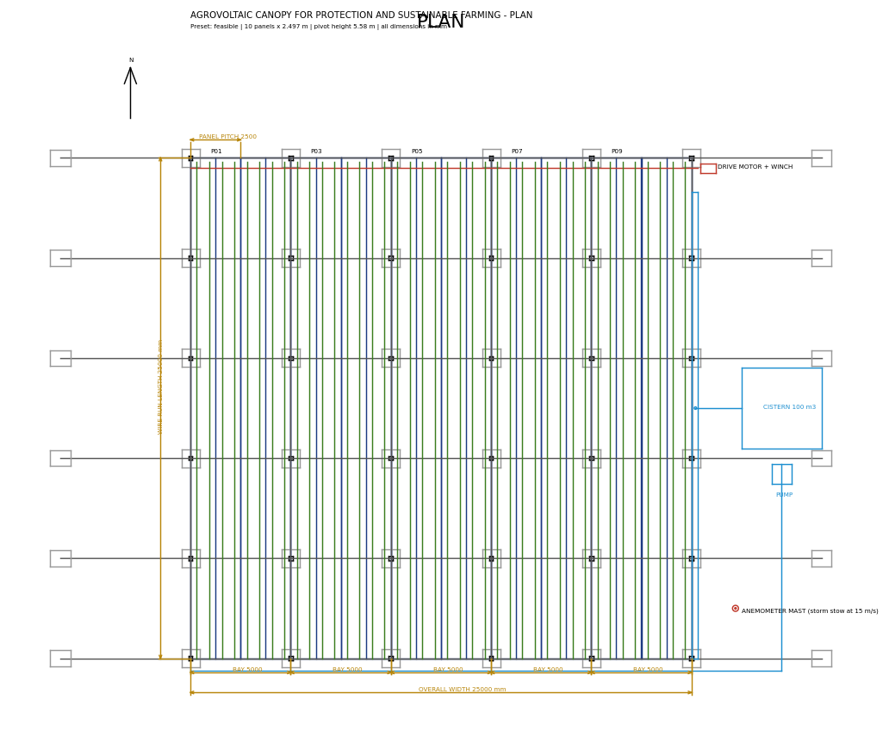
Figure 2. Plan (DXF generated from the design file).
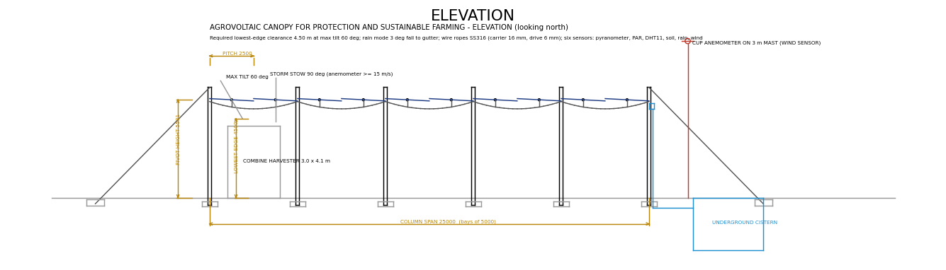
Figure 3. Elevation with the clearance check.
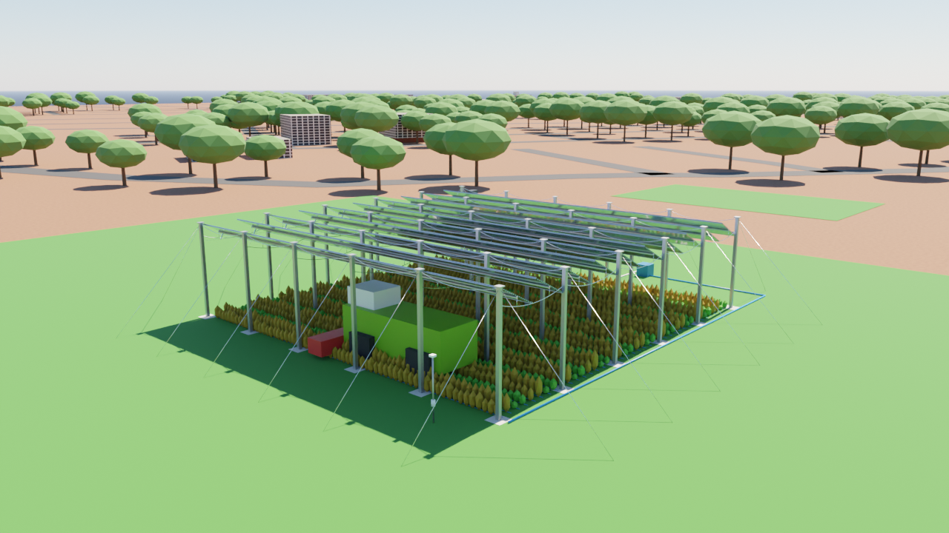
Figure 4. Ray-traced render of the checked design on the TCE ground.

4 Models
- Solar geometry: declination 23.45 sin(360/365 (284+n)); hour angle 15 (hour - 12); sun vector from latitude 9.88 N.
- Irradiance: monthly clearness index (NASA POWER) times extraterrestrial radiation; diffuse fraction by Erbs et al. (1982); beam from the remainder.
- Shadow and crop light: 2-D ray casting in the east-west plane for 40 ground points per pitch every hour; isotropic sky view factor; four zone strips per pitch.
- PV: plane-of-array irradiance with incidence-angle modifier (b0 = 0.05) and row self-shading; Huld (2010) c-Si power model with Faiman-type cell temperature; 14 % system losses.
- Water: daily root-zone balance (FAO-56 style) with Hargreaves-Samani reference evapotranspiration; sealed flat canopy catches rain events of 5 mm or more (first flush 0.5 mm, runoff 0.85); drip efficiency 0.9; underground cistern.
- Crop yield: potential yield x light factor x temperature factor x soil factor x (1 - Ky (1 - ETa/ETc)).
- Controller (six sensors): rain sensor wet = flat roof 3 deg; pyranometer below 20 W/m2 = night park 15 deg; otherwise try every angle 15-60 deg (5 deg coarse, 0.5 deg fine) and pick the maximum of J = w PV/PVmax + (1-w) crop-value/cropmax (w = 0.5). The PAR reading corrects the modelled crop light (ratio limited to 0.7-1.3); DHT11 vapour-pressure deficit and soil moisture give a stress that lowers the light the crop needs. The angle changes only if the score gain is above 2 %. The hourly monthly plan (SRMC-DT) is kept as the planner and the fallback if a sensor fails. The anemometer adds wind stow: at 15 m/s (54 km/h) or more the panels go edge-on at 90 deg, resuming below 12 m/s.
- Economics (per hectare): solar revenue = energy x tariff; farmer = share x solar revenue + crop net (paid at harvest); investor = (1 - share) x solar revenue - O&M.

5 Verification and validation
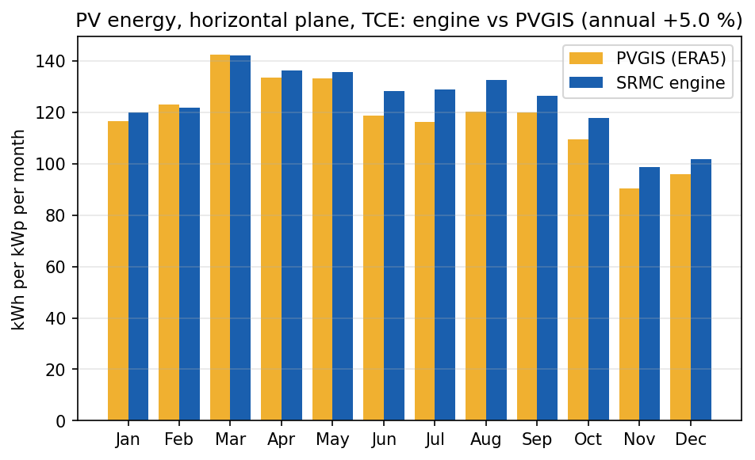
Figure 5. PV energy vs PVGIS (ERA5), horizontal plane, TCE: annual +5.0 %; irradiation +5.2 %.
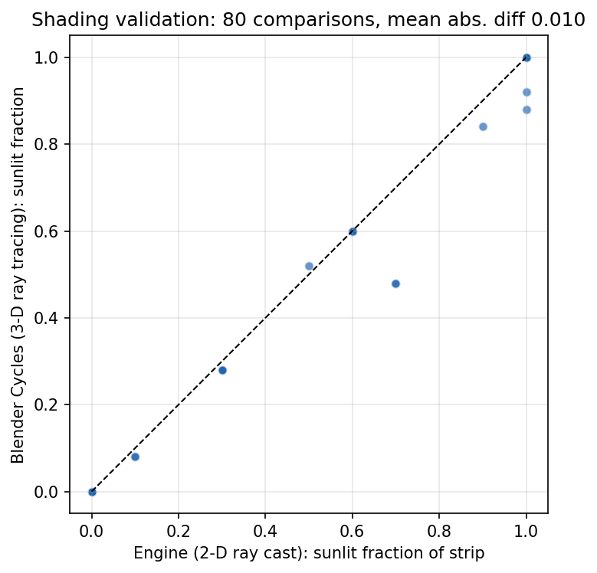
Figure 6. Shadow model vs Blender Cycles: 80 comparisons, mean abs. difference 0.010.
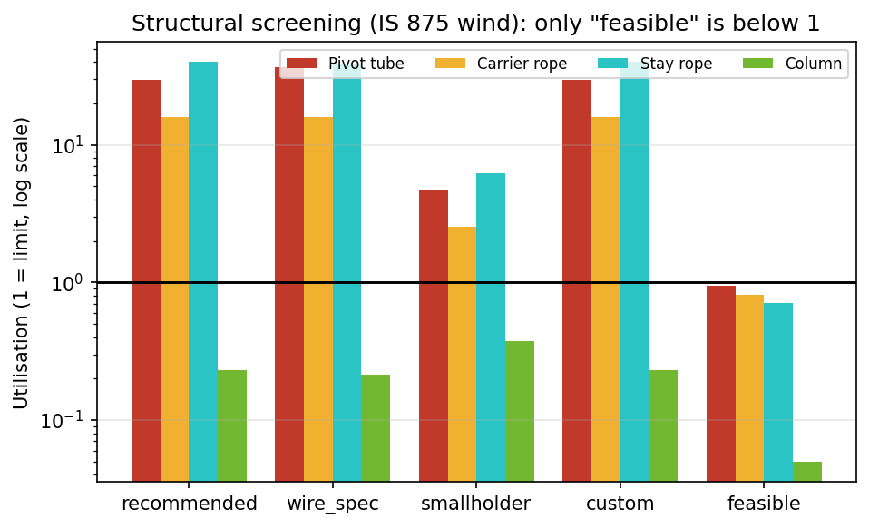
Figure 7. Structural utilisation (1 = limit). Only the checked preset is below 1.
Implementation check: the JavaScript twin and the MATLAB engine agree to 0.0000 % on 22 outputs (evidence/logs/crosscheck_js_vs_matlab.txt). This confirms they implement the same equations; the PVGIS and Blender comparisons test the physics. Not validated: crop yield, water balance, controller behaviour and economics against any measurement.
Structural screening (IS 875 wind, indicative rope strengths): the 12.5 m-bay presets are overloaded (rope 16x, stay 40x, 60 mm tube 30x). The checked 5 m grid gives utilisations of 0.94 (tube), 0.82 (rope), 0.71 (stay) and 0.05 (column). This is a hand calculation, not a certified design.

6 Results
Design | PV kWh/m2 | Light % | Solar L | Crop L | Total L | Rain-fed %
SRMC-DT controller (50% energy / 50% crop) | 238 | 34 | 52.5 | 2.53 | 55.0 | 94
Fixed 45 deg tilt stop | 233 | 32 | 50.8 | 1.63 | 52.5 | 93
PV-max fixed 15 deg | 291 | 14 | 68.2 | -0.05 | 68.2 | 94
Crop-max controller (w = 0) | 224 | 36 | 48.3 | 2.86 | 51.2 | 93
PV-max controller (w = 1) | 295 | 15 | 69.4 | -0.09 | 69.3 | 94

INR lakh per hectare per year at TCE (assumed prices). The hourly plan (SRMC-DT) improves crop income about 55 % and total value about 5 % over a fixed 45 deg design with +2 % electricity. A PV-only design earns more money; the controller benefit rests on crop, water and soil values that are not priced.
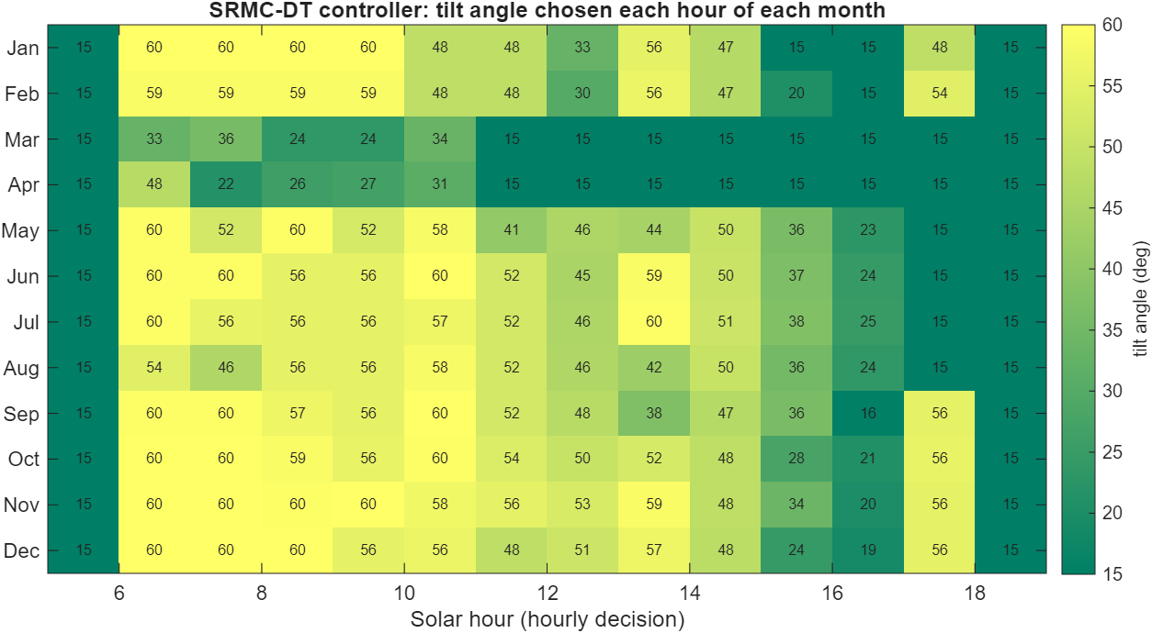
Figure 8. Tilt angle chosen each hour of each month.
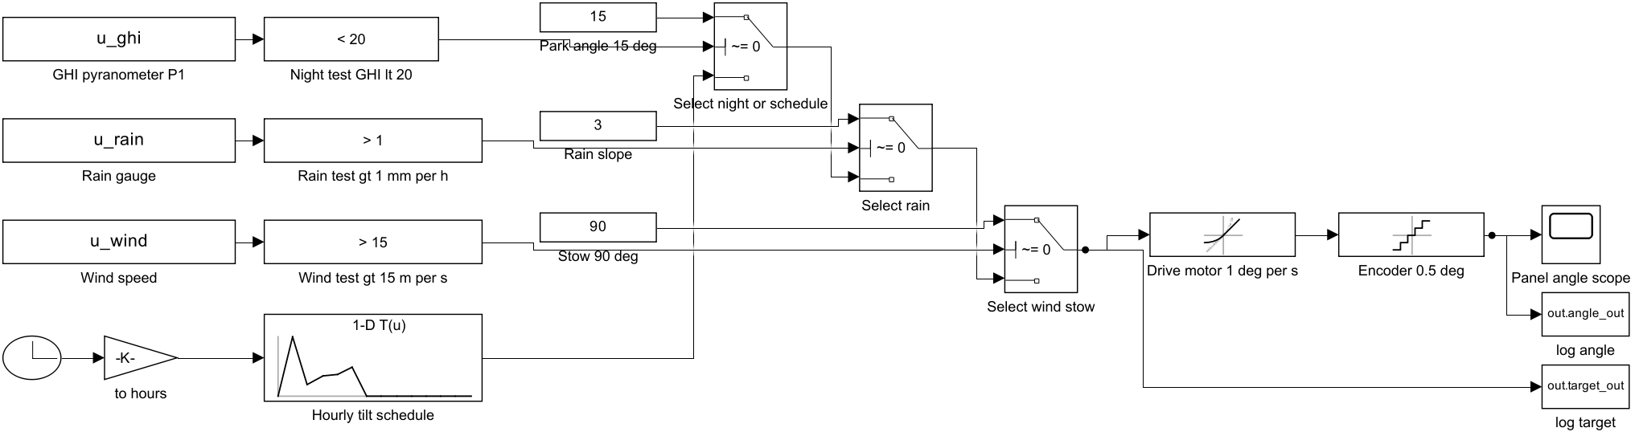
Figure 9. Simulink supervisory controller.
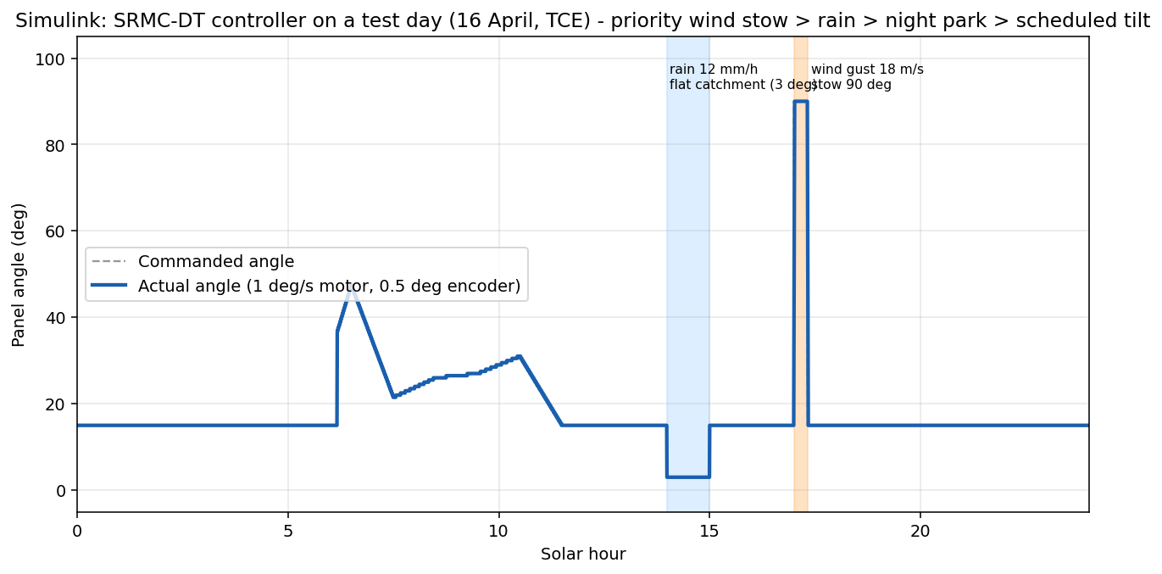
Figure 10. Simulink test day: rain at 14-15 h (3 deg), wind gust at 17 h (90 deg stow).
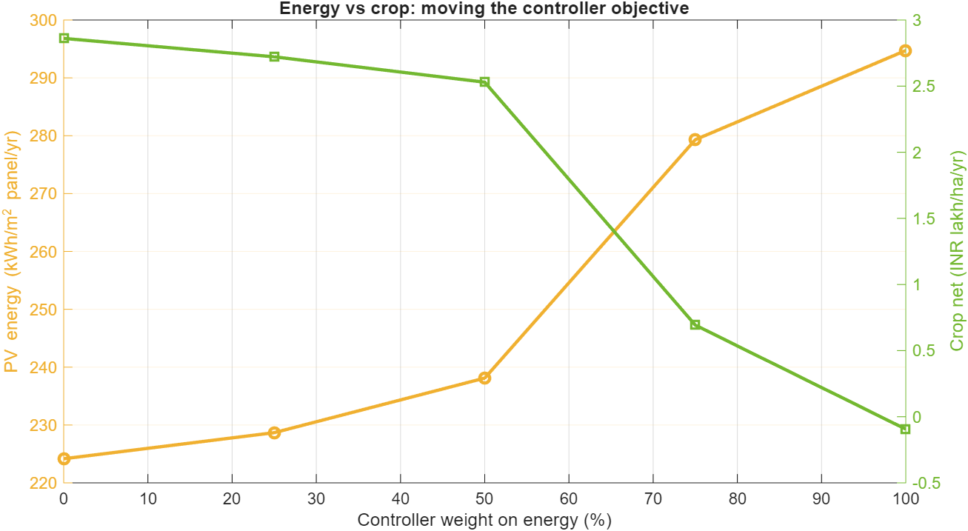
Figure 11. Moving the controller objective weight.
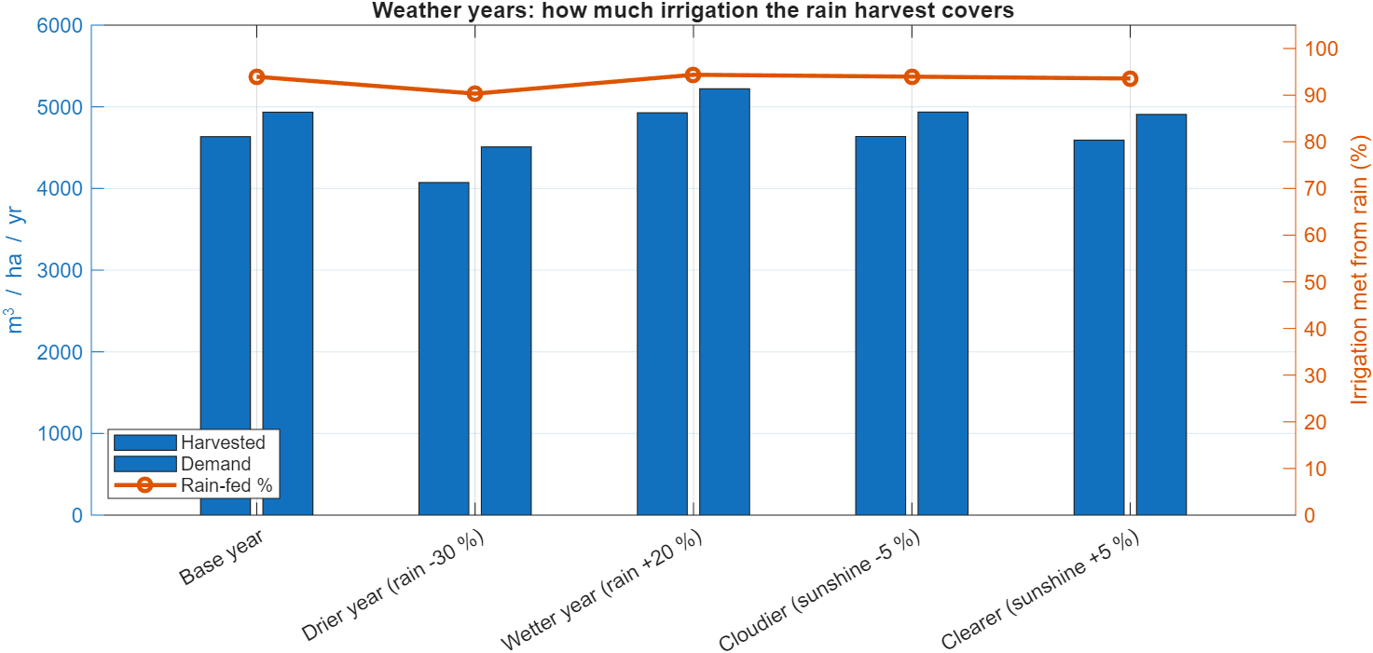
Figure 12. Weather-year scenarios.
Universal runs: the same design in seven climates and nine soils.
Climate (typical soil) | PV kWh/m2 | Light % | Rain-fed % | Farmer INR/month/ha
TCE Ground, Madurai / red_sandy_loam | 238 | 34 | 94 | 198,943
Coastal tropical / sandy | 225 | 34 | 98 | 190,442
Mountain / hill / hill_forest | 227 | 34 | 84 | 194,847
Humid tropical / laterite | 228 | 34 | 93 | 192,322
Arid desert / sandy | 243 | 31 | 72 | 179,419
Northern plains / alluvial | 215 | 32 | 82 | 174,447
Deccan plateau / black_cotton | 228 | 32 | 75 | 179,844

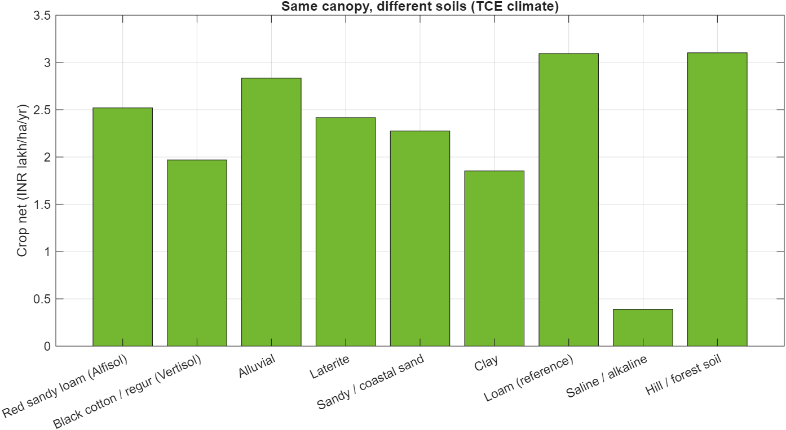
Figure 13. Crop net income by soil at the TCE climate (saline soil about 8x below loam).
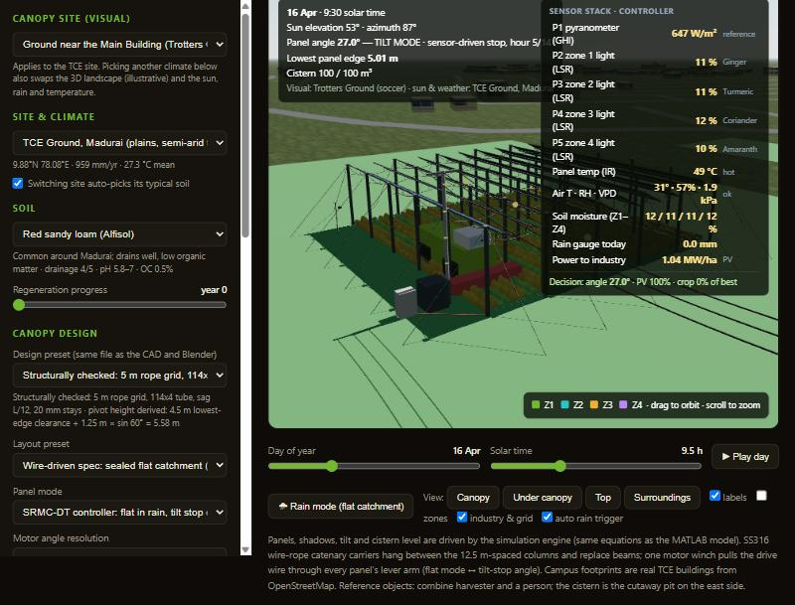
Figure 14. The running digital twin: controller angle, sensor stack, wire drive.

6A Six-sensor controller and its accuracy
Sensors and rule. Six sensors feed the controller every step: pyranometer (sunlight), PAR sensor under the canopy (light that reaches the crop), DHT11 (temperature and humidity, giving the vapour-pressure deficit), soil moisture and rain. The rule is given in Section 4. The same code runs in the web twin (default controller), in MATLAB (srmc_sensor_controller.m) and in a Simulink model.
Test. 12 representative days x 3 sky states (clear, partly cloudy, overcast) x 2 soil states (26 % and 15 %) x 14 daylight hours = 864 cases. The sensors are the true values plus noise (pyranometer 5 %, PAR 5 %, DHT11 +-2 C and +-5 % RH, soil +-3 %). The reference (100 %) is the same combined score with perfect knowledge and a 0.5 deg search.
Strategy | Electricity, % of best | Crop light value, % of best | Combined score, % of best
SRMC-SC (ideal sensors) | 81.9 | 98.1 | 99.7
SRMC-SC (noisy sensors) | 82.1 | 97.7 | 99.6
SC v1 (one reading, no guard) | 81.8 | 97.5 | 99.4
Monthly schedule (SRMC-DT) | 82.2 | 96.3 | 98.8
Fixed 45 deg | 81.0 | 84.6 | 91.2
Fixed 15 deg (PV-max) | 99.2 | 45.2 | 80.0
Sun tracking (E-W) | 88.6 | 64.3 | 84.0
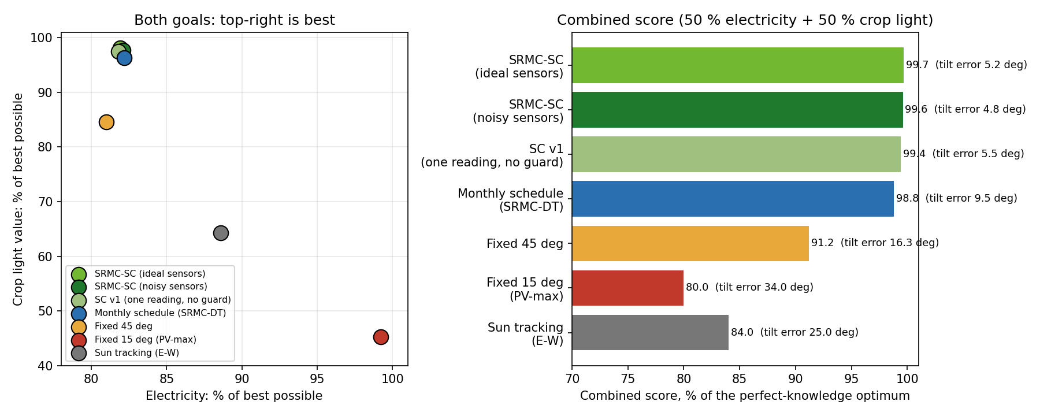
Figure 14a. Both goals: top-right is best (left); combined score (right).
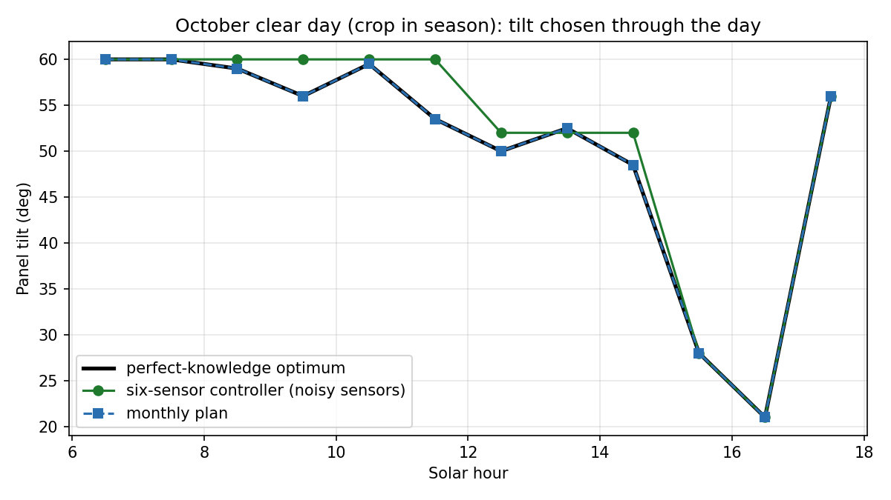
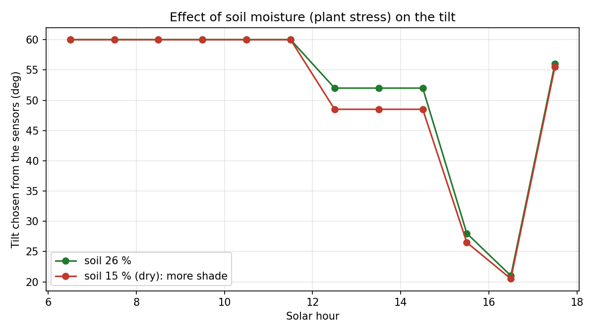
Figure 14b. Tilt chosen through an October clear day (left, crop in season) and the effect of dry soil (right).
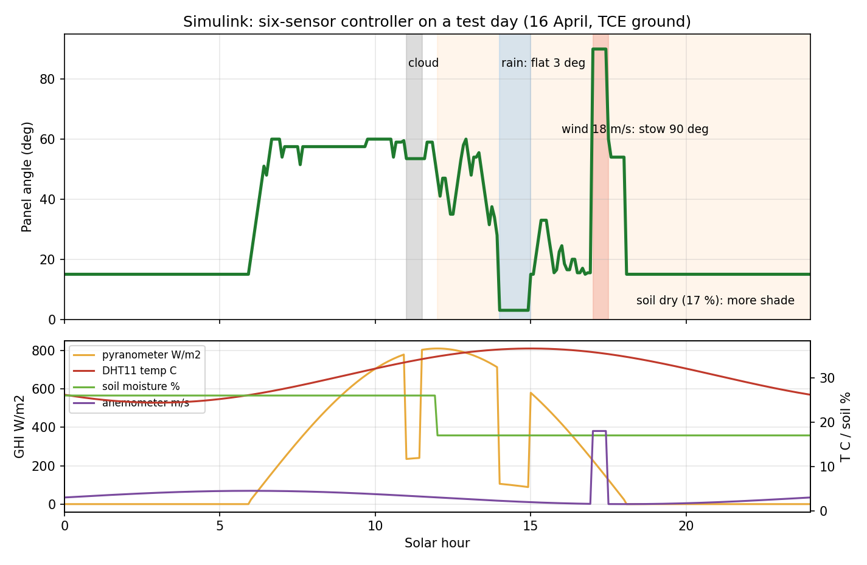
Figure 14c. Simulink six-sensor controller on a test day (cloud 11:00, rain 14:00 to 15:00, dry soil after 12:00).
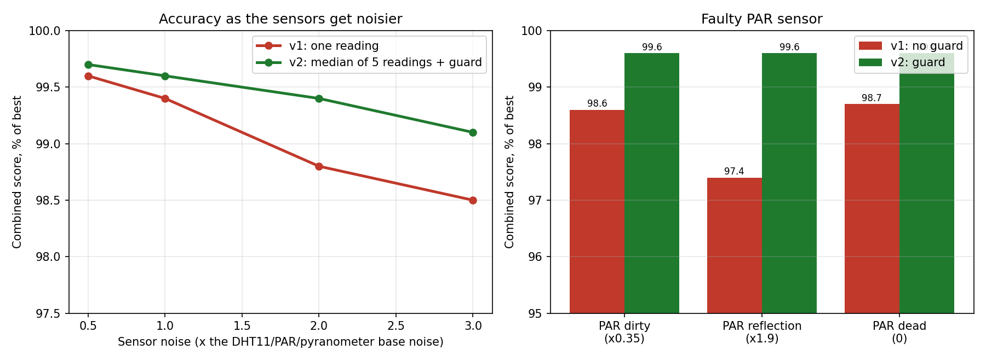
Figure 14d. Accuracy when the sensors get noisier (left) and with a faulty PAR sensor (right): v1 = one reading, v2 = median of 5 readings + fault guard.
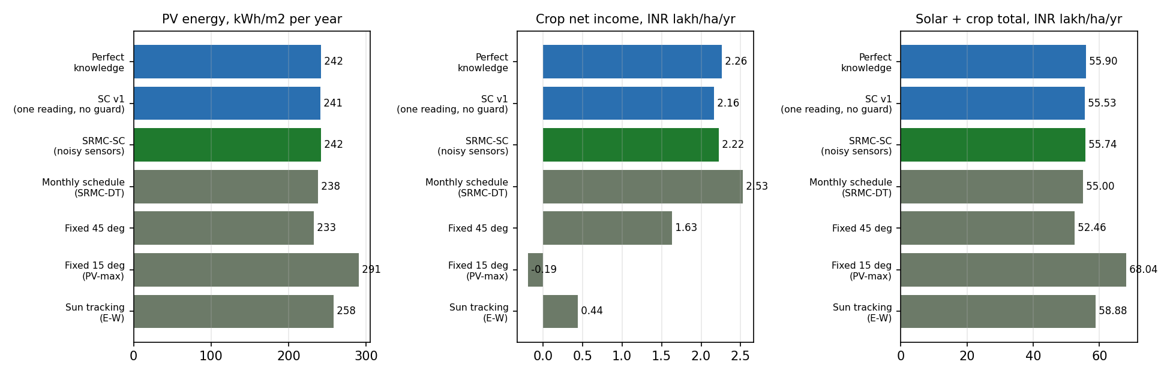
Figure 14e. Yield and rupees per hectare per year when each strategy hourly angles are run through the crop, water and economics model.
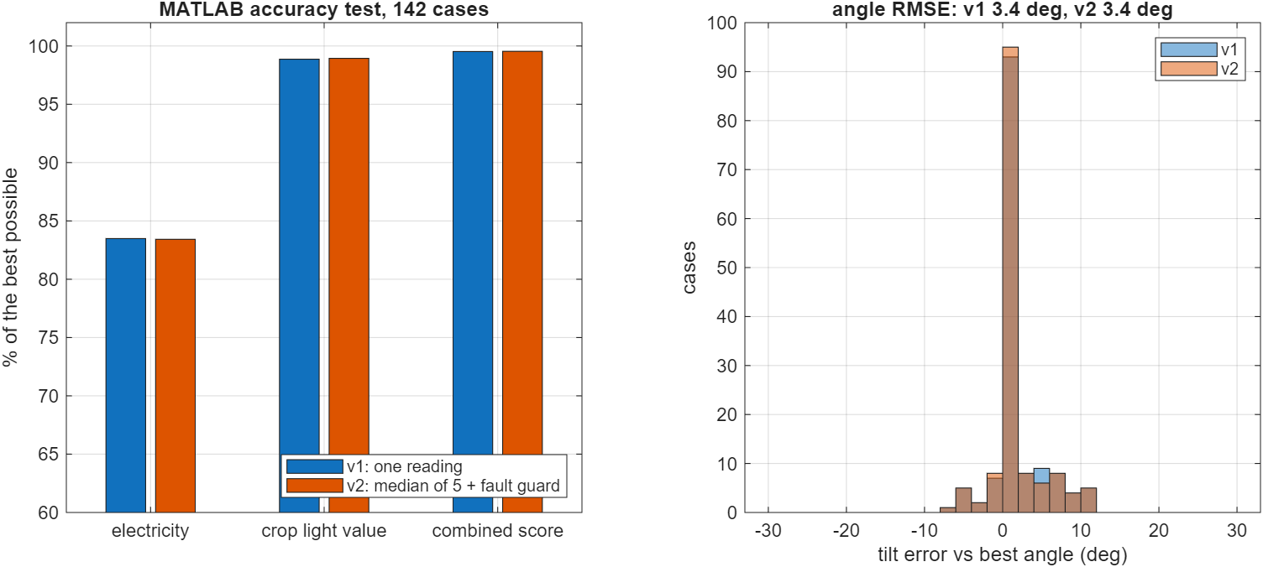
Figure 14f. The same accuracy test repeated in MATLAB (142 cases, same sensor readings).
Robustness. The controller takes the median of 5 readings per channel and ignores a PAR sensor that reads less than half or more than 1.6 times what the model predicts. At 3 times the base noise the combined score is 98.5 % for a single reading and 99.1 % with the filter; with a dirty, reflecting or dead PAR sensor a single-reading controller falls to 97.4 to 98.7 % while the guarded one stays at 99.6 %. Tilt error against the best angle is 4.8 deg (monthly plan 9.5 deg, fixed 45 deg 16.3 deg).
Yield and rupees. With the hourly angles run through the engine, the six-sensor controller gives 242 kWh/m2 and INR 55.7 lakh per hectare per year (solar plus crop), against 238 and 55.0 for the monthly plan and 233 and 52.5 for a fixed 45 deg panel. Crop net income is INR 2.2 lakh (plan 2.5, fixed 45 deg 1.6). A PV-only panel still earns the most rupees (68.0 lakh) but its crop income is negative. Prices are assumptions.
MATLAB. The test repeated in MATLAB on 142 cases with the same noisy readings gives 99.5 % of the best combined score, electricity 83 %, crop light value 99 % and a tilt error of 3.4 deg; MATLAB and the twin chose the identical angle in 140 of 142 cases.
Reading the results. The controller gets 82 % of the best electricity and 98 % of the best crop light value; a PV-only fixed 15 deg panel gets 99 % of the electricity but only 45 % of the crop light value. The combined score is the controller's own objective, so it measures how well the sensors reproduce the optimum, not crop yield; yield and money come from the hourly-plan runs. MATLAB and the web twin gave identical decisions in 40 of 40 random sensor states (results/crosscheck_sensor_controller_matlab_vs_js.txt).
Hardware after the strength check. A 3 kN winch is at its limit near 45 km/h wind (1.4 times over at 54 km/h) and a 4 mm drive wire is too tight; the final design uses a 10 kN winch, a 6 mm SS316 drive wire, a 45 degree offset lever arm and a cup anemometer for the 90 degree storm stow, M24 turnbuckles and anchors sized for 26 kN uplift each (documents/SRMC_Component_Strength_Table.docx).
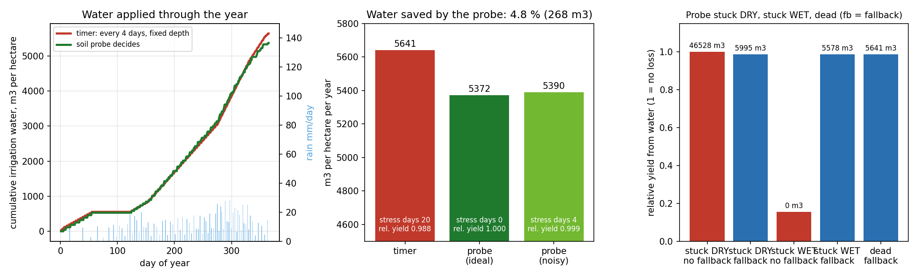
Figure 14g. Water link: the soil probe decides when irrigation runs (left: water through the year; middle: water saved; right: probe faults with and without the fallback).
Safety layer. Soil probe faults (no reading, out of range, a jump above 40 points in an hour, stuck for 3 daytime hours) switch the controller to the water-balance model value; a rain sensor stuck wet in dry sunny air for 30 minutes is ignored, and a dry reading with a rain forecast, RH of 90 % and a dark sky counts as rain. Panel moves are limited to one every 120 s, 12 an hour and 900 deg a day (rain, storm stow and night park are exempt) and the motor wear is counted (moves, degrees, metres of wire, drum turns). A clear day needs about 64 moves, 330 deg of travel, 2.5 m of wire and 6.5 drum turns. Eight simulation tests pass (results/safety_tests.md).
Water link. With the soil probe deciding irrigation the water use is 5,372 m3 per hectare a year against 5,641 m3 for a 4-day timer (4.8 % saved) with no water-stress days instead of 20. A probe that sticks dry wastes about 46,500 m3 and one that sticks wet loses almost all the yield unless the fallback (stuck for 3 days or dead: run the timer schedule) is on; with it both stay at timer level. The simulation uses the same daily water balance as the twin and assumes the borewell supplies the demand when the cistern is empty.

7 Economics, sensitivity and risk
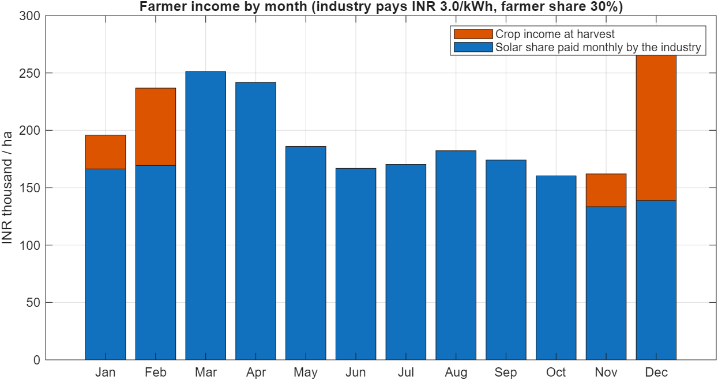
Figure 15. Farmer income by month.
Assumption | Value | Status
Industry tariff | INR 3.0/kWh | assumed
Farmer share | 30 % | assumed
Capex | INR 60,000/kWp + cistern INR 7,000/m3 | assumed
O&M | 1.5 % of capex/yr | assumed
Crop prices / costs | library values | typical, check mandi
CO2 factor | 0.71 kg/kWh | approximate
Subsidy | 0 % (sweep 0-30 %) | verify scheme eligibility

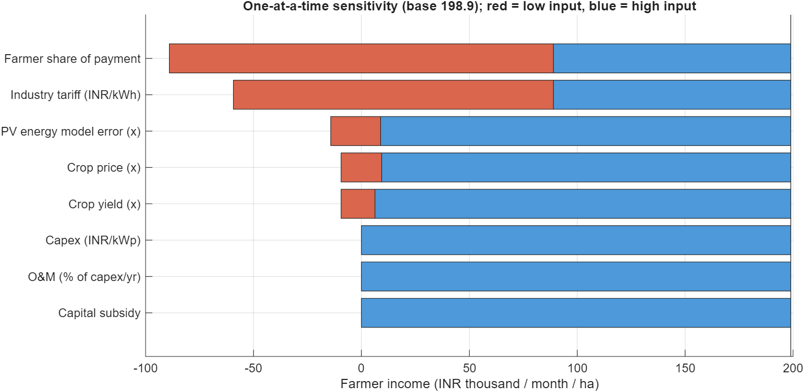
Figure 16. One-at-a-time sensitivity of farmer income.
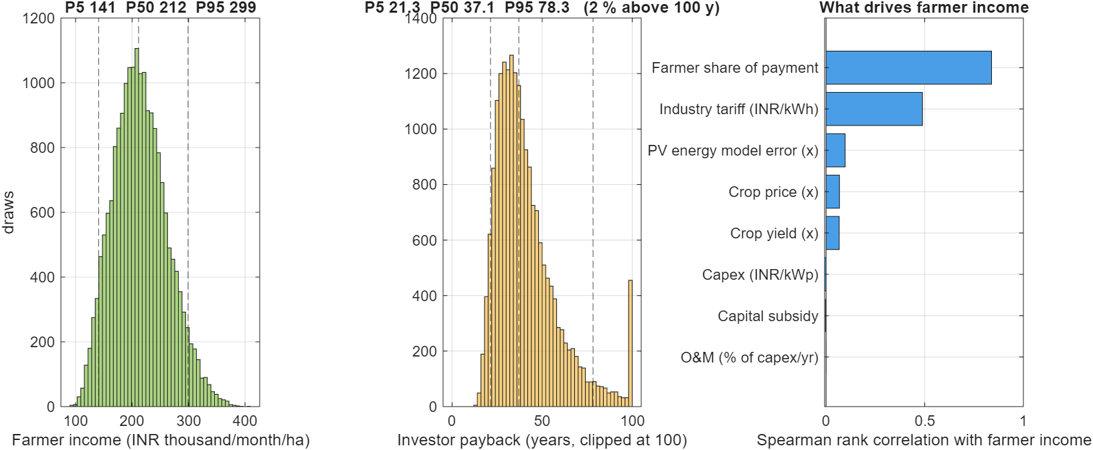
Figure 17. Monte Carlo (20,000 draws).
Monte Carlo with triangular input ranges gives farmer income P5/P50/P95 = INR 1.41 / 2.12 / 2.99 lakh per hectare per month, and investor payback P5/P50/P95 = 21 / 37 / 78 years. The probability of an investor payback within 20 years is about 3 %.
Target investor payback | Farmer share | Tariff needed (INR/kWh) | Farmer income (INR/month)
10 yr | 10 % | 6.81 | 155,649
10 yr | 30 % | 8.76 | 540,374
10 yr | 50 % | 12.26 | 1,232,879
15 yr | 10 % | 4.83 | 116,591
15 yr | 30 % | 6.22 | 389,721
15 yr | 50 % | 8.70 | 881,355
20 yr | 10 % | 3.85 | 97,062
20 yr | 30 % | 4.95 | 314,394
20 yr | 50 % | 6.92 | 705,593

The investor case is the weak link. A 15-year payback at a 30 % farmer share needs about INR 6.2/kWh, above typical industrial tariffs. Lower capex, a subsidy, a lower share, or a different financing model would be needed. Farmer income depends mainly on the contract (tariff x share), not on the crop.

8 Limitations
- All results are simulation only. There is no field or prototype data, so crop yields, water balance, controller behaviour and economics are not validated. The sensors are simulated (Review 0 uses real DHT11, soil and rain readings on an ESP board).
- Monthly-mean sky; isotropic diffuse; infinite-plate panels; crop and soil parameters are typical values.
- Structural check is screening-level with indicative rope strengths; connections, foundations, fatigue and dynamic wind are not designed.
- Tariff, farmer share, capex and prices are assumptions. Investor economics are poor at base assumptions.
- Building facades and landscapes for other climates are illustrative; only footprints of TCE buildings come from OpenStreetMap.
- The SRMC-DT note says panels trim flatter to admit light; in this geometry steeper tilt admits more light, and the model follows the physics.

9 Conclusions and future work
- A six-sensor, wire-driven canopy with sensor-based tilt and a flat rain mode was modelled consistently in MATLAB, Simulink, a live twin, CAD and ray-traced renders.
- The PV and shadow models agree with independent references (PVGIS, Blender Cycles).
- The original 12.5 m bay layout fails structural screening; a 5 m rope grid with heavier tube passes.
- The six-sensor controller reaches 99.6 % of the best combined score with noisy sensors; compared with a fixed 45 deg tilt it gives more crop light at similar electricity. A PV-only design still earns more rupees at assumed prices.
- Farmer income depends on contract terms; the investor business case needs work.
- Next: build the six-sensor pilot row and log one month of real data, replace assumptions with quotes and datasheets, obtain soil and geotechnical data, add an anemometer for wind stow, use hourly weather, price water and soil benefits, and run a formal prior-art search.

References
- Dupraz, C. et al. (2011). Combining solar photovoltaic panels and food crops for optimising land use: Towards new agrivoltaic schemes. Renewable Energy 36(10): 2725-2732. [VERIFIED by web search (title, journal, pages; predicted 35-73 % land-productivity gain, authors say preliminary)]
- Barron-Gafford, G.A. et al. (2019). Agrivoltaics provide mutual benefits across the food-energy-water nexus in drylands. Nature Sustainability 2: 848-855. doi:10.1038/s41893-019-0364-5. [VERIFIED by web search (title, journal, DOI); read the full paper for numbers]
- Weselek, A., Ehmann, A., Zikeli, S., Lewandowski, I., Schindele, S., Hogy, P. (2019). Agrophotovoltaic systems: applications, challenges, and opportunities. A review. Agronomy for Sustainable Development 39: 35. doi:10.1007/s13593-019-0581-3. [VERIFIED by web search (authors, journal, DOI)]
- Trommsdorff, M. et al. (2021). Combining food and energy production: Design of an agrivoltaic system applied in arable and vegetable farming in Germany. Renewable and Sustainable Energy Reviews 140: 110694. [VERIFIED by web search (title, journal, volume, year; LER +56-70 % in 2017, ~90 % in 2018); article number from memory]
- Huld, T. et al. (2010). Mapping the performance of PV modules, effects of module type and data averaging. Solar Energy 84(2): 324-338. [VERIFIED by web search (journal, volume, pages); the module power model used here]
- Marrou, H. et al. (2013). Productivity and radiation use efficiency of lettuces grown in the partial shade of photovoltaic panels. European Journal of Agronomy 44: 54-66. [FROM MEMORY - verify before citing]
- Erbs, D.G., Klein, S.A., Duffie, J.A. (1982). Estimation of the diffuse radiation fraction for hourly, daily and monthly-average global radiation. Solar Energy 28(4): 293-302. [FROM MEMORY - verify]
- Duffie, J.A., Beckman, W.A. (2013). Solar Engineering of Thermal Processes, 4th ed. Wiley. [FROM MEMORY - verify edition]
- Allen, R.G., Pereira, L.S., Raes, D., Smith, M. (1998). Crop evapotranspiration: guidelines for computing crop water requirements. FAO Irrigation and Drainage Paper 56. [FROM MEMORY - verify]
- Doorenbos, J., Kassam, A.H. (1979). Yield response to water. FAO Irrigation and Drainage Paper 33. [FROM MEMORY - verify]
- Hargreaves, G.H., Samani, Z.A. (1985). Reference crop evapotranspiration from temperature. Applied Engineering in Agriculture 1(2): 96-99. [FROM MEMORY - verify]
- Bureau of Indian Standards. IS 875 (Part 3): 2015, Code of practice for design loads (other than earthquake) for buildings and structures - Wind loads. [STANDARD - buy/obtain the document; basic wind speed 39 m/s for Madurai must be confirmed from its map]
- DIN SPEC 91434:2021-05, Agri-photovoltaic systems - Requirements for primary agricultural use. [FROM MEMORY - verify; useful definition of agrivoltaic categories]
- Fraunhofer ISE. Agrivoltaics: Opportunities for Agriculture and the Energy Transition - A Guideline for Germany (2020; later editions). [FROM MEMORY / press page seen in search - verify edition]
- Ministry of New and Renewable Energy (India). PM-KUSUM scheme guidelines (Components A, B, C), 2019 and amendments. [VERIFY current guidelines and eligibility on mnre.gov.in]
- European Commission Joint Research Centre. PVGIS (ERA5 radiation database) - re.jrc.ec.europa.eu/pvg_tools. [USED for validation (query saved in evidence/logs/pvgis_PVGIS-ERA5.json)]
- NASA POWER Project - Prediction of Worldwide Energy Resources, climatology API (power.larc.nasa.gov). [USED for monthly climate (tools/fetch_climate.py)]
- OpenStreetMap contributors. Map data (c) OpenStreetMap, ODbL. [USED for TCE building footprints, roads, pitches]
- ISO 2408 / EN 12385-4, Steel wire ropes; IEC 61215 / IEC 61730 module qualification. [Cited in the wire specification; obtain supplier certificates]
- Project documents: Wire-Driven Dual-Position Agrivoltaic Panel System - Technical Specification Rev 1.0 (Mar 2026); SRMC Engineering Design Guidelines v1.0; SRMC-DT concept note (2026). [OWN DOCUMENTS - the numbers (e.g. 250 kN WLL, 13 kN drive-wire MBL) need datasheet confirmation]
- MathWorks. MATLAB / Simulink R2025a. Blender Foundation. Blender 5.2 LTS (Cycles). three.js r128 (MIT). [TOOLS - versions in evidence/logs/tool_versions.txt]

Appendix A: reproducing the results
- Open MATLAB, cd matlab, run srmc_master() and srmc_sensitivity(); srmc_sc_crosscheck() (six-sensor controller, MATLAB vs web twin) and build_simulink_sensor_controller(); structural_check() for the structure. Node: Review4_Control_and_Simulation/sensor_controller/eval_sensor_controller.js (year-long accuracy test).
- node tools/export_blender.js feasible 105 9.5 0; python tools/make_dxf.py for drawings and BOM; bash tools/render_all.sh feasible for renders (Blender at D:/blender.exe).
- python -m http.server 8765 in the srmc-twin folder, then open http://localhost:8765/Review3_Digital_Twin/results/live_twin/SRMC_Digital_Twin.html for the twin.
- python tools/make_evidence.py, python tools/build_decks.py and python tools/build_report.py regenerate this pack.

Appendix B: proof index
# | Review | Claim | Evidence
1 | R3 | Geometry comes from one design file; pivot height 5.58 m derived from 4.5 m clearance | design/design.json
2 | R3 | 12.5 m bays fail structural screening (rope 16x, stay 40x, 60 mm tube 30x over) | evidence/logs/structural_report.txt; tables/T4_structural.csv; figures/val_structural_utilisation.png
3 | R3 | Checked preset (5 m rope grid, 114.3x4 tube, sag L/12, 20 mm stays) passes: 0.94/0.82/0.71/0.05 | evidence/logs/structural_report.txt
4 | R3 | AutoCAD drawings: plan, elevation, section, wire drive | evidence/cad/SRMC_feasible_*.dxf, *.png
5 | R3 | Bill of materials, 22 items | evidence/cad/SRMC_feasible_BOM.csv
6 | R3 | Ray-traced renders of the design | evidence/renders/hero.png, under.png, aerial.png, top.png, rain.png
7 | R4 | Sun path and solar geometry for 9.88 N | evidence/figures/fig1_sunpath.png
8 | R4 | Annual GHI 2,033 vs PVGIS 1,933 kWh/m2 (+5.2 %, dataset difference) | evidence/logs/pv_validation.txt; pvgis_PVGIS-ERA5.json
9 | R4 | PV energy within +5.0 % of PVGIS (Huld model + IAM) | evidence/figures/val_pv_vs_pvgis.png; logs/pv_validation.csv
10 | R4 | Shading model vs Blender Cycles: mean abs. difference 0.010, 96 % within 0.10 | evidence/logs/shading_validation.txt; shade_results.json; figures/val_shading_scatter.png
11 | R4 | Zone light by month 12-41 % (mean 34 %) | evidence/figures/fig2_zone_light.png
12 | R4 | Tilt trade-off: electricity vs crop light | evidence/figures/fig3_tilt_tradeoff.png
13 | R5 | Architecture: one source of truth feeding twin, MATLAB, CAD, Blender | evidence/figures/architecture.png
14 | R5 | Running twin with sensors, controller, water, crops, economics | evidence/screens/twin_*.jpg; SRMC_Digital_Twin.html
15 | R5 | JavaScript twin and MATLAB engine give identical results (0.0000 % on 22 quantities) | evidence/logs/crosscheck_js_vs_matlab.txt
16 | R5 | Universal: 7 climates, 9 soils | evidence/tables/T2_universal_climates.csv; T3_universal_soils.csv; figures/fig10_universal_climates.png; figures/fig11_universal_soils.png
17 | R5 | Water balance: harvest ~4,650 m3, demand ~4,930 m3, ~94 % rain-fed | evidence/figures/fig4_water_balance.png; screens/twin_water_rain.jpg; tables/summary.md
18 | R6 | Controller schedule: angle chosen each hour of each month | evidence/figures/fig8_controller_schedule.png
19 | R6 | Simulink controller model | evidence/simulink/srmc_controller.slx; srmc_controller_diagram.png
20 | R6 | Simulink test day: 15 deg night, ~24 deg morning, 3 deg rain, 90 deg stow | evidence/simulink/controller_log.csv; srmc_controller_day.png
21 | R6 | Controller vs fixed designs (total 55.0 vs 52.5 vs 68.2 INR lakh/ha) | evidence/tables/T1_controller_comparison.csv; figures/fig6_controller_comparison.png
22 | R6 | Energy/crop weight sweep | evidence/tables/T1b_weight_sweep.csv; figures/fig7_pareto.png
23 | R6 | Weather-year scenarios (rain -30 %, +20 %; sun +-5 %) | evidence/tables/T6_physics_scenarios.csv; figures/fig15_weather_scenarios.png
24 | R6 | PV-only design earns more rupees than the controller (stated honestly) | evidence/tables/T1_controller_comparison.csv
25 | R7 | Farmer monthly income (solar share monthly + crops at harvest) | evidence/figures/fig9_farmer_income.png; tables/summary.md
26 | R7 | One-at-a-time sensitivity (farmer share and tariff dominate) | evidence/tables/T5_tornado.csv; figures/fig12_tornado_farmer_income.png; figures/fig13_tornado_payback.png
27 | R7 | Monte Carlo (20,000 draws): farmer income P5/P50/P95 = 1.41/2.12/2.99 lakh per month | evidence/figures/fig14_montecarlo.png; tables/T7_montecarlo_rank_correlation.csv; tables/sensitivity_summary.md
28 | R7 | Investor payback is the weak link: 15 years needs ~INR 6.2/kWh at 30 % share | evidence/tables/T8_breakeven_tariff.csv
29 | R7 | Every price in the economics is an assumption | deck R7 slide 3; report section 7
30 | R3 | Motor-to-panel mechanism animation (motor, drum, drive wire, lever arm, pivot tube) | evidence/renders/mechanism_tilt.gif; twin tab Mechanism
31 | R3 | Close-up of one panel: wire slides d, lever arm swings theta, panel tilts theta | evidence/renders/mechanism_closeup.gif; twin tab Mechanism step A
32 | R3 | Guide pulley: with vs without (capstan friction 2.6x vs 1.02x) | evidence/renders/guide_pulley.gif; twin tab Mechanism step C
33 | All | Tool versions and file integrity | evidence/logs/tool_versions.txt; SHA256_manifest.csv

