Accurate Co-Optimization of Crop Light and Electricity by Sensor-Driven Panel Tilting in Agrovoltaic Systems
Author names and affiliations withheld for review

Abstract - Agrovoltaic systems share land between crops and solar panels, but a fixed panel angle favors either the crop or the electricity. We study how accurately a sensor-driven tilt controller can serve both goals at once. The controller reads six sensors (a pyranometer, a light sensor under the panels, an air temperature and humidity sensor, a soil moisture probe, a rain sensor, and an anemometer) and chooses the tilt that maximizes an equal-weight sum of normalized electricity and crop light value; it lays the panels flat in rain and turns them edge-on in storm wind. We define co-optimization accuracy as the controller's objective over the year divided by that of the best possible angle, and test it in simulation at seven climates between 9.9 and 30.9 degrees north, with noisy sensors. The controller reached 99.6 to 99.7 percent at every climate, against 98.2 to 99.2 percent for a monthly schedule and 89.1 to 91.5 percent for a fixed 45 degree tilt. When the crop light model was wrong by 20 percent, the light sensor kept the accuracy at 99.6 percent, against 98.6 to 99.0 percent without it. All results are simulated.

Index Terms - Agrovoltaics, co-optimization, crop light, sensor-based tilt control

Introduction
Agrovoltaic systems grow crops and generate electricity on the same land. Field and modelling studies report or predict a higher combined land productivity than growing the two separately [1]–[4], and some crops keep their yield under partial shade because they intercept light more efficiently [5]. How much the crop gains depends on the light it receives and when it receives it [3]. With fixed panels, that light is set once, at design time: a panel steep enough to let light through to the crop loses electricity, and a panel at the angle for maximum electricity shades the crop heavily.
Panels that tilt can move this compromise hour by hour. Dynamic panels that change how sunlight is shared between solar cells and crops have been demonstrated [6], and crop-specific metrics of light sharing have been proposed for bifacial agrovoltaic arrays [7]. DIN SPEC 91434 lists light availability and homogeneity under the array among its planning requirements [8]. What is less clear is how accurately a practical controller, which sees the field only through a few low-cost sensors, can find the angle that serves both goals, and which of those sensors actually matter.
This paper addresses that question in simulation. Our contributions are as follows:
- a definition of co-optimization accuracy that scores a tilt strategy against the best possible angle for the same objective;
- a six-sensor tilt controller that scores both goals in one objective, corrects its crop light model with a light sensor under the panels, lowers the crop light requirement under heat and drought stress, and has a safety layer for sensor faults and panel movement;
- an evaluation at seven climates, a sensor ablation under model error, a repeatability test over independent noise draws, and robustness tests with faulty sensors;
- a low-cost implementation in which one motor and one drive wire tilt every row of a wire-rope canopy, and an assessment of what the accuracy is worth in yield, income, and water.

Related Work
Agrophotovoltaic systems have been reviewed in terms of applications, challenges, and opportunities [3]. A demonstration plant in Germany reported land-equivalent-ratio gains of 56 to 70 percent in 2017 and close to 90 percent in the hot, dry summer of 2018, with a vertical clearance of 5 m for farm machinery [4]. A modelling study predicted land-productivity gains of 35 to 73 percent, which its authors called preliminary [1], and a field study in drylands reported benefits across food, energy, and water [2]. Lettuce under panel shade kept its yield by intercepting light more efficiently [5]. A dynamic semitransparent panel has been used to allocate sunlight between solar cells and crops [6], and the light productivity factor has been proposed to rank array designs for particular crops [7]. Most of this work concerns layout, crop response, or the panel itself. We concentrate on the control loop: how a tilt controller fed by sensors should decide, and how close it gets to the best possible decision. We have not carried out a formal prior-art search, so we claim no more novelty than the combination described here.

Problem Formulation
For a row of panels at tilt θ in a given hour, let P(θ) be the panel power and C(θ) the crop light value: the price-weighted light factor of the crop zones under the row, counted only in each crop’s growing season. The controller chooses the admissible angle that maximizes
J(θ) = w P(θ) / P_{max} + (1 — w) C(θ) / C_{max}, (1)
where P_{max} and C_{max} are the maxima over the admissible angles in that hour and w is the electricity weight, set to 0.5 unless stated. Normalizing each term by its own maximum lets the two goals be compared without prices. We define the co-optimization accuracy of a strategy as
A = 100 Σ_{k} g_{k} J(θ_{k}) / Σ_{k} g_{k} J(θ_{k}*), (2)
where θ_{k} is the angle the strategy chooses in case k, θ_{k}* is the best angle found by searching every admissible angle with perfect knowledge of the weather, the soil, and the true crop light, and g_{k} is the weight of the case (its share of the year) times its global horizontal irradiance, so that bright hours count more. The electricity score is the electricity produced divided by the best possible, and the crop light score uses the same sum as (2) with C/C_{max} in place of J. A is 100 when the strategy always picks the best angle. The scores measure how well the controller solves its own objective; they are not a measure of field crop yield.

Sensor-Driven Controller
Table 1 lists the rules in order of priority. In normal operation the controller evaluates (1) on a coarse grid of 5° from 15° to 60° and then on a 0.5° grid around the best coarse angle, which matches the resolution of the motor.
Table 1. Controller rules in order of priority
No. | Condition | Action
1 | Wind 15 m/s or more (resume below 12 m/s) | Stow at 90°
2 | Rain sensor wet | Flat at 3°
3 | Pyranometer below 20 W/m² | Park at 15°
4 | Otherwise | Maximize J over 15° to 60°

Sensors. The pyranometer gives the global horizontal irradiance (GHI), which is split into beam and diffuse parts with the correlation of Erbs et al. [9]. A sensor for photosynthetically active radiation (PAR) under the panels measures the light that actually reaches the crop. The model predicts the ratio of PAR to GHI at the angle in use, and the correction applied to the modelled crop light is
c = (PAR / GHI)_{measured} / (PAR / GHI)_{model}, (3)
limited to the range 0.7 to 1.3. A ratio outside 0.5 to 1.6 is treated as a faulty sensor and ignored. The correction lets the controller follow dirt on the panels, shading errors, or a canopy that differs from the model. An air temperature and humidity sensor (a DHT11) gives the vapor pressure deficit, and a soil moisture probe gives the root-zone water. A deficit rising from 1.6 to 2.5 kPa, or soil moisture falling from 20 percent to zero, raises a stress index from 0 to 1; the larger of the two that lowers the crop’s light thresholds by up to 30 percent, so a stressed crop is given more shade. A rain sensor and a cup anemometer trigger the flat and stow positions.
Filtering and safety. Each channel is the median of five readings, and a new angle is accepted only if it improves J by more than 2 percent, which stops the panels from hunting under passing cloud. A safety layer replaces a soil probe that gives no reading, reads outside 0 to 100 percent, jumps by more than 40 points in an hour, or repeats the same raw value for three daytime hours with a water-balance estimate or its last good value. A rain sensor that stays wet for 30 minutes in dry, sunny air is ignored, and a dry reading together with a rain forecast, humidity of 90 percent or more, and a dark sky is taken as rain. The panels must hold an angle for at least 120 s and may move at most 12 times an hour and 900° a day; the rain, storm, and night positions are exempt.

Simulation Framework
Models. Sun position follows the usual declination and hour-angle equations. Monthly climate comes from the NASA POWER data set [10]; hourly irradiance is the clearness index times the extraterrestrial value. Panel power uses the Huld et al. model [11] with 14 percent system losses, row self-shading, and an incidence-angle modifier. Ground light is found by casting rays in the east–west plane to 40 points per row pitch every hour, with an isotropic sky view factor, and is averaged over four crop zones per pitch. Reference evapotranspiration follows Hargreaves and Samani [12], the daily root-zone water balance follows FAO-56 [13], and yield is
Y = Y_{pot} f_{L} f_{T} f_{S} [1 — K_{y} (1 — ET_{a} / ET_{c})], (4)
where f_{L}, f_{T}, and f_{S} are light, temperature, and soil factors, ET_{a} and ET_{c} are actual and crop evapotranspiration, and K_{y} is the yield response factor of Doorenbos and Kassam [14]. The light factor is 1 at or above an optimum light level of the crop, falls linearly to 0.35 at a minimum level, and falls to zero in darkness. Crop parameters are typical literature values rounded for a screening model. The modelled array has rows of panels 2.5 m wide on a 2.5 m pitch, a pivot axis 5.58 m above ground, and a tilt range of 15° to 60°.
Verification. The panel power model was compared with PVGIS ERA5 data [15] for a horizontal plane at the reference site: the annual energy is 5.0 percent higher and the irradiation 5.2 percent higher, with monthly differences from –1.0 to 10.8 percent. The shadow model was compared with a 3D ray tracer (Blender Cycles, direct light) in 80 cases; the mean absolute difference in lit fraction is 0.010, and 96 percent of cases are within 0.10. The models and the controller exist as a MATLAB engine, a browser digital twin in JavaScript, and a Simulink model of the supervisory rules. The two engines agree to 0.0000 percent on 22 outputs, and the two controllers chose the same mode and angle in 40 of 40 random sensor states. This checks the code, not the physics; the crop and water models are not validated against field data.

Experimental Design
Sites. Seven climates were used, from 9.9° to 30.9° N and from 234 to 2,652 mm of annual rain: a semi-arid tropical plain (the reference site, Madurai), a coastal tropical site, a hill site, a humid tropical site, an arid desert, a northern plain, and a plateau, each with its typical soil and with the same four crops (ginger, turmeric, coriander, and amaranth).
Cases. For each site the test has 864 cases: a representative day for each month, three sky states (clear, partly cloudy, and overcast, weighted 0.5, 0.3, and 0.2), two soil states (26 and 15 percent moisture, weighted 0.7 and 0.3), and the daylight hours of each day. Sensor readings are the true values plus Gaussian noise with standard deviations of 5 percent for the pyranometer and PAR sensor, 1.2 °C for temperature, 3 percent for relative humidity, and 1.8 points for soil moisture.
Baselines. A monthly schedule (the best angle for each hour of a typical day of each month, chosen in advance from climate data), a fixed 45° tilt, a fixed 15° tilt (close to the best angle for electricity alone), and single-axis sun tracking limited to 15° to 60°.
Model error and ablation. In reality the crop light differs from any model. We therefore multiplied the true crop light by a mismatch m of 0.8, 1.0, or 1.2, which the controller can learn only through the PAR sensor, and removed sensors one at a time: no PAR sensor, no temperature, humidity, and soil stress, and single readings without the median filter and fault guard.

Results

I. Accuracy across climates
Table 2 and Fig. 1 give the result. The controller reached a co-optimization accuracy of 99.6 to 99.7 percent at every site, with 81.0 to 84.5 percent of the best electricity, 97.5 to 98.7 percent of the best crop light value, and a root-mean-square tilt error of 4.6° to 6.0°. The monthly schedule reached 98.2 to 99.2 percent with a tilt error of 9.1° to 10.6°, a fixed 45° tilt 89.1 to 91.5 percent, sun tracking 84.0 to 85.1 percent, and a fixed 15° tilt 80.0 to 82.4 percent. The fixed 15° tilt reaches 98.7 to 99.4 percent of the best electricity but only 45.2 to 51.7 percent of the best crop light value.
Table 2. Co-optimization accuracy (%) at seven climates
Site | Lat. (°N) | E | C | A | A_{M} | A₄₅
Reference | 9.9 | 81.8 | 97.9 | 99.6 | 98.8 | 91.2
Coastal | 13.1 | 81.8 | 98.4 | 99.6 | 99.1 | 91.5
Hill | 11.4 | 81.2 | 98.5 | 99.7 | 99.2 | 91.2
Humid | 9.9 | 81.0 | 98.7 | 99.7 | 99.2 | 91.1
Arid | 26.9 | 84.5 | 97.5 | 99.6 | 98.2 | 89.1
North plain | 30.9 | 84.4 | 98.0 | 99.6 | 98.3 | 90.7
Plateau | 20.9 | 83.8 | 98.5 | 99.6 | 98.7 | 90.1

E and C are the controller’s electricity and crop light scores, A is its accuracy (2), and A_{M} and A₄₅ are the accuracies of the monthly schedule and the fixed 45° tilt.
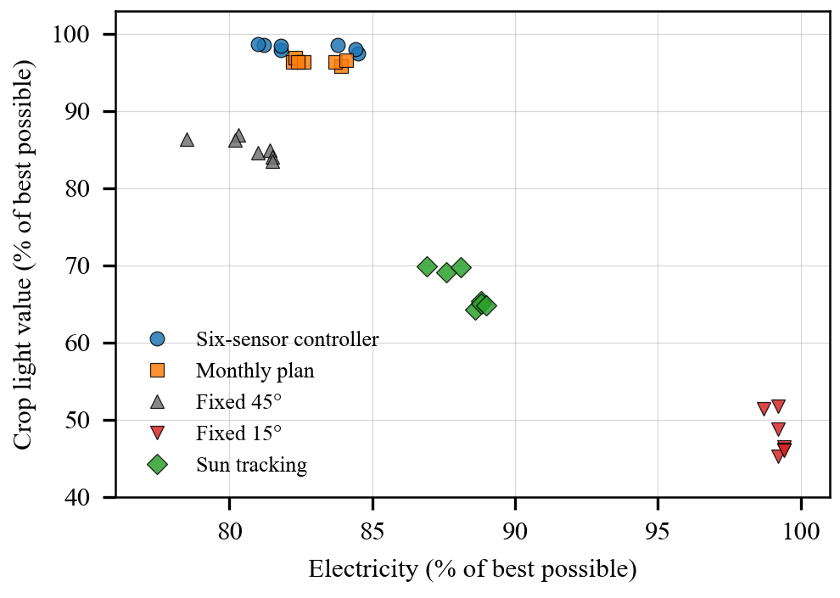
Figure 1. Electricity and crop light at seven climates. Each marker is one strategy at one site, and the top right is best. At every site the controller sits close to the crop light optimum and gives up part of the electricity to keep that light.
Seen as a co-optimization, the controller gives up about 18 percent of the best possible electricity to keep about 98 percent of the best crop light value. A fixed 45° tilt keeps less electricity (78.5 to 81.5 percent) and only 83.5 to 86.9 percent of the crop light value. The controller keeps more electricity at the three northern sites (83.8 to 84.5 percent) than at the four southern ones (81.0 to 81.8 percent).

II. What each sensor contributes
Table 3 gives the mean accuracy over the seven sites. When the crop light model is right (m = 1.0), the PAR sensor adds nothing; removing it even gains 0.1 point, because the correction then only adds noise. When the model is wrong by 20 percent, the full controller keeps 99.6 percent, while the controller without the PAR sensor drops to 98.6 percent (m = 0.8) and 99.0 percent (m = 1.2) and its crop light score falls from 98.6 to 94.9 percent at m = 0.8. Removing the temperature, humidity, and soil stress costs 0.4 to 0.8 point and raises the tilt error, and the worst site drops to 97.9 percent. The median filter and fault guard add 0 to 0.2 point here; their main value appears with faulty sensors, as shown next. The monthly schedule, which has no sensors, scores 98.3 to 98.8 percent.
Table 3. Mean accuracy (%) over seven sites for three values of the crop light mismatch
Variant | m = 0.8 | m = 1.0 | m = 1.2 | Worst site
Full controller | 99.6 | 99.6 | 99.6 | 99.5
No PAR sensor | 98.6 | 99.7 | 99.0 | 98.2
No stress sensors | 99.2 | 99.0 | 98.8 | 97.9
Single readings | 99.6 | 99.5 | 99.4 | 99.3
Monthly schedule | 98.7 | 98.8 | 98.3 | 97.6

Worst site is the lowest single-site accuracy over the three values of m.

III. Robustness and repeatability
Repeatability. Eight independent noise draws at the reference site gave a mean accuracy of 99.57 percent with a standard deviation of 0.04 (95 percent interval 99.53 to 99.60), an electricity score of 81.8 ± 0.2 percent, and a crop light score of 97.9 ± 0.2 percent. Perfect sensors would raise the accuracy only to 99.7 percent, so the sensor noise costs about 0.1 point.
Sky, soil, and season. Split by sky, soil, and season at the reference site, the accuracy stayed between 99.5 and 99.7 percent in every group, while that of a fixed 45° tilt ranged from 89.4 to 95.3 percent. The electricity score depended on the season (75.9 to 93.1 percent), and the tilt error was largest under overcast sky (8.1° against 4.3° in clear sky), when the objective is nearly flat across angles and a wrong angle costs little.
Noise and faults. At three times the base noise the accuracy was 98.5 percent with single readings and 99.1 percent with the median filter. With a dirty PAR sensor (reading 0.35 of the true value), a sensor with reflections (1.9 times), or a dead sensor, single readings without the guard gave 98.6, 97.4, and 98.7 percent, while the full controller gave 99.6 percent in all three cases. The safety layer passed eight scenario tests covering a rain sensor stuck wet, a dead rain sensor, four soil probe faults, cloud flicker, and wear. In two hours of one-minute cloud flicker an unprotected controller made 92 moves, and the 2 percent threshold reduced this to 14.
Second implementation. The same test in MATLAB on 142 cases gave 99.5 percent, with 83 percent of the best electricity, 99 percent of the best crop light value, and a tilt error of 3.4°; the MATLAB and JavaScript controllers chose the identical angle in 140 of the 142 cases.

IV. From accuracy to yield and income
At the reference site, each strategy’s hourly angles were run through the crop, water, and economic model for a year (Table 4), at assumed prices: an electricity tariff of INR 3.0 per kWh, operation and maintenance of 1.5 percent of capital cost a year, and typical crop prices (1 lakh is 100,000 rupees). The controller gives 36 percent more crop income than a fixed 45° tilt (INR 2.22 against 1.63 lakh per hectare a year) with 4 percent more electricity. Two results go against it. The monthly schedule earns more from crops (INR 2.53 lakh), and a fixed 15° tilt earns the most in total (INR 68.04 lakh) because electricity is worth far more than crops at these prices.
Table 4. Yearly value per hectare at the reference site (energy in kWh/m² of panel, money in lakh rupees)
Strategy | Energy | Crop net | Solar net | Total
Controller | 241.6 | 2.22 | 53.52 | 55.74
Monthly schedule | 238.1 | 2.53 | 52.47 | 55.00
Fixed 45° | 232.6 | 1.63 | 50.83 | 52.46
Sun tracking | 258.0 | 0.44 | 58.44 | 58.88
Fixed 15° | 290.7 | –0.19 | 68.23 | 68.04

We therefore swept the weight w in (1) from 0 to 1 (Fig. 2). Total income follows electricity, from INR 49.97 lakh at w = 0 to 69.22 lakh at w = 1, while crop income falls from INR 2.82 lakh to below zero. At w = 0.5 the controller keeps 82 percent of the largest electricity and 78 percent of the largest crop income. An income objective alone would therefore remove the crop. The weight is a design decision, for example a minimum crop income or crop light level, and the controller’s accuracy is the accuracy with which it meets that decision.
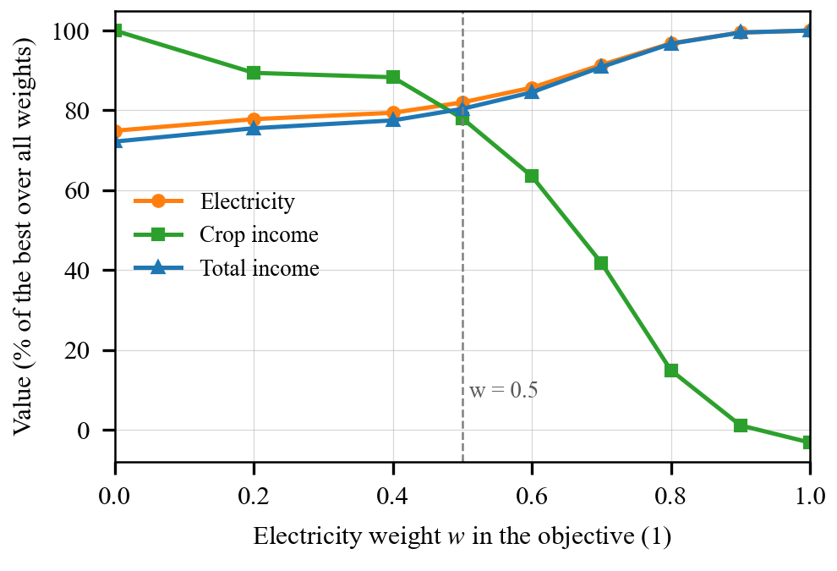
Figure 2. Effect of the electricity weight. Electricity, crop income, and total income at the reference site as percentages of their largest values over the weights. Total income follows electricity, so an income objective alone would push the weight toward one.

Implementation
The controller needs an actuator that turns many rows together at low cost. In our design, rows of panels on torque tubes hang from stainless-steel carrier ropes (16 mm) between columns 5 m apart, with the lowest panel edge 4.5 m above the crop at 60° (Fig. 3). One drive wire is clamped to the tip of a lever arm of length L = 0.44 m on each tube. The arm is fixed at an offset α = 45°, so the wire travel from the flat position of 3° to a tilt θ and the useful lever are
d(θ) = L [sin(θ — α) — sin(3° — α)], (5)
l(θ) = L cos(θ — α). (6)
The wire moves 408 mm to reach 60° and 606 mm to reach the 90° storm position, and a lever of at least 0.31 m remains at 90°, where a plain arm without the offset has none (Fig. 4). Both ends of the wire are fastened to a 120 mm drum, which turns 1.61 times over the full range, so the wire pulls in both directions. A screening check of the structure with the wind loads of IS 875 (Part 3) [16] at 140 km/h, with an assumed basic wind speed of 39 m/s, gave load-to-capacity ratios of 0.37 for the carrier rope, 0.32 for the stays, and 0.76 for the torque tube; a layout with 12.5 m spans failed the same check. With a 6 mm drive wire and a 10 kN worm-gear winch, the drive works at 0.41 of capacity at a wind of 54 km/h, the speed at which the controller stows the panels.
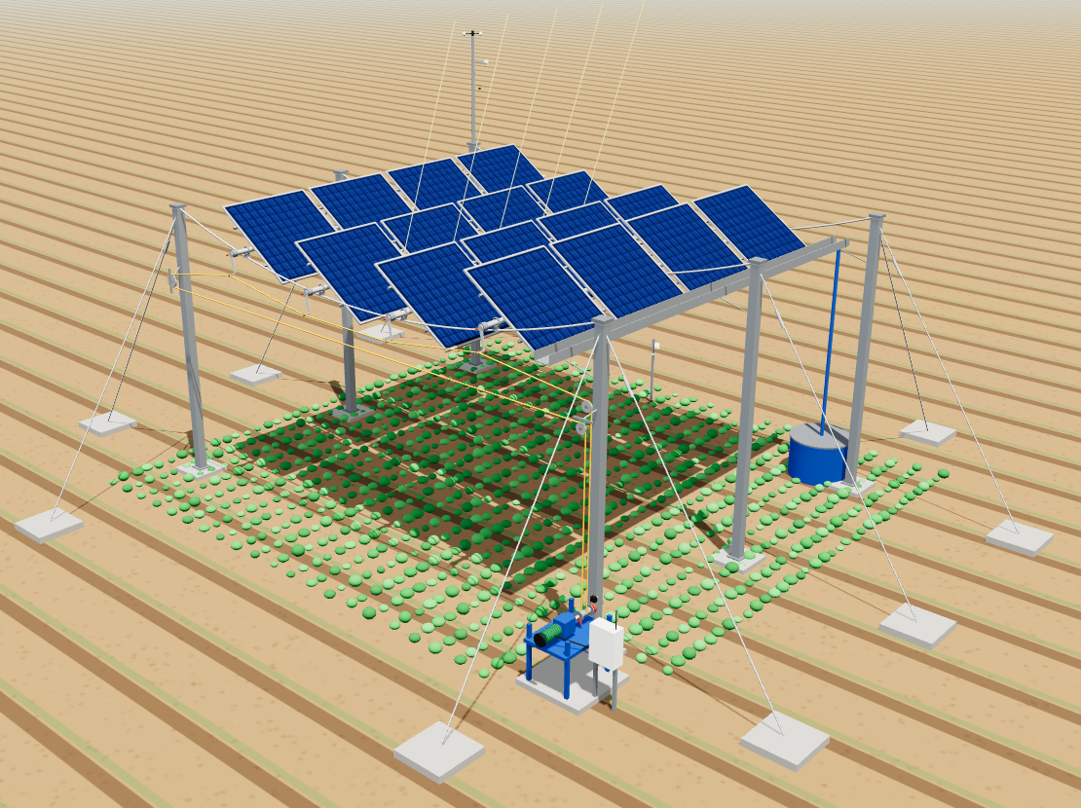
Figure 3. Wire-driven canopy. A four-row section of the canopy. The winch, drum, and drive wire are at the front, the weather mast is at the back left, and a gutter and cistern collect water when the panels are flat. Wires are drawn thicker than real so that they can be seen.
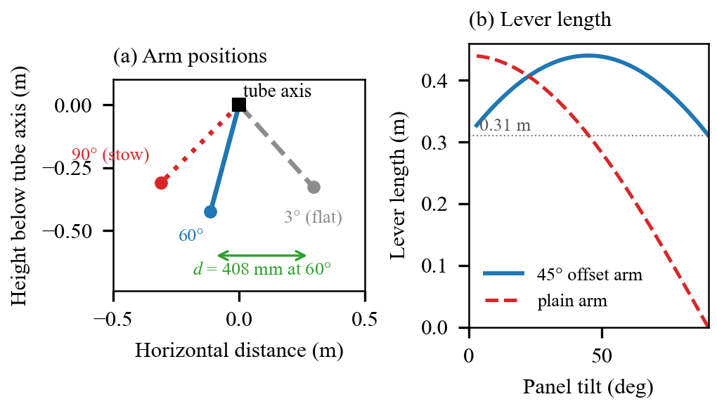
Figure 4. Lever arm geometry. (a) Arm positions at the flat position, at 60°, and at the 90° storm position, with the wire travel to 60°. (b) Lever length against tilt for the 45° offset arm and for a plain arm.
Water and storms. When the panels lie flat in rain they form a sealed roof that drains to a gutter and cistern. At the reference site (959 mm of rain a year) this supplies about 94 percent of the irrigation demand of about 4,930 m³ per hectare. With the soil probe deciding when to irrigate, the model used 4.8 to 5.5 percent less water than timers every 2, 4, or 7 days and gave no water-stress days, against 14.8 to 29.3 days with the timers. In a simulated year with four assumed storm days of four hours at 15 to 24 m/s, the anemometer stowed the panels in all 16 storm hours at a cost of 0.14 percent of the annual electricity. With hourly decisions the panels made about 1,860 moves a year, which corresponds to 918 drum turns.
Prototype. A microcontroller prototype reads a DHT11, a soil probe, and a rain sensor and runs the decision rules in a MATLAB dashboard; 16 of 16 software-in-the-loop tests passed, including the wind and rain priorities and agreement with the JavaScript engine. No field data are reported here.

Limitations
All results come from simulation, and the sensors are simulated. The accuracy is measured against the controller’s own objective, so it shows that the controller solves the problem it is given, not that crop yield in the field improves by that amount. The crop model, its light thresholds, the stress relaxation, and the prices are typical or assumed values. The sky is a monthly mean with representative clear, partly cloudy, and overcast states and an isotropic diffuse part, the ground light is computed in two dimensions, and the model error was represented by a single multiplier on crop light. The seven sites are all in India, between 9.9° and 30.9° N. The wind and storms in the storm test are generated, the structural check is at screening level, and the drive layout has not been built. A field pilot with logged sensors, a crop yield trial, and sites at higher latitudes are needed before the accuracy can be stated for real fields.

Conclusion
A six-sensor tilt controller reached 99.6 to 99.7 percent of the best possible combined score of electricity and crop light at seven climates, against 98.2 to 99.2 percent for a monthly schedule and 89.1 to 91.5 percent for a fixed 45° tilt, and over independent noise draws its accuracy had a standard deviation of 0.04 point. The light sensor under the panels is what keeps the accuracy when the crop light model is wrong, and the temperature, humidity, and soil sensors add a further 0.4 to 0.8 point; the median filter and fault guard protect against faulty sensors. The accuracy only has value once the weight between the two goals is fixed, because an income objective alone would favor electricity. The next steps are a field pilot that logs all six sensors, a crop yield trial under the controlled canopy, and tests at higher latitudes.

Data Availability
The simulation code, data files, and result tables are available from the authors on request.

References

[1] C. Dupraz et al., “Combining solar photovoltaic panels and food crops for optimising land use: Towards new agrivoltaic schemes,” Renew. Energy, vol. 36, no. 10, pp. 2725–2732, 2011.

[2] G. A. Barron-Gafford et al., “Agrivoltaics provide mutual benefits across the food–energy–water nexus in drylands,” Nature Sustain., vol. 2, pp. 848–855, 2019, doi: 10.1038/s41893-019-0364-5.

[3] A. Weselek et al., “Agrophotovoltaic systems: Applications, challenges, and opportunities. A review,” Agron. Sustain. Dev., vol. 39, Art. no. 35, 2019, doi: 10.1007/s13593-019-0581-3.

[4] M. Trommsdorff et al., “Combining food and energy production: Design of an agrivoltaic system applied in arable and vegetable farming in Germany,” Renew. Sustain. Energy Rev., vol. 140, 2021.

[5] H. Marrou et al., “Productivity and radiation use efficiency of lettuces grown in the partial shade of photovoltaic panels,” Eur. J. Agron., vol. 44, pp. 54–66, 2013, doi: 10.1016/j.eja.2012.08.003.

[6] A. Yano and Z. Li, “Application of a dynamic semitransparent agrivoltaic panel for controlling sunlight allocation to solar cells and crops,” Adv. Sustain. Syst., 2025, doi: 10.1002/adsu.202500603.

[7] M. H. Riaz et al., “Crop-specific optimization of bifacial PV arrays for agrivoltaic food-energy production: The light-productivity-factor approach,” IEEE J. Photovolt., vol. 12, no. 2, pp. 572–580, 2022, doi: 10.1109/JPHOTOV.2021.3136158.

[8] Agri-Photovoltaic Systems – Requirements for Primary Agricultural Use, DIN SPEC 91434:2021-05, DIN, Berlin, Germany, 2021.

[9] D. G. Erbs et al., “Estimation of the diffuse radiation fraction for hourly, daily and monthly-average global radiation,” Sol. Energy, vol. 28, no. 4, pp. 293–302, 1982.

[10] NASA, “Prediction of Worldwide Energy Resources (POWER) project.” [Online]. Available: power.larc.nasa.gov

[11] T. Huld et al., “Mapping the performance of PV modules, effects of module type and data averaging,” Sol. Energy, vol. 84, no. 2, pp. 324–338, 2010.

[12] G. H. Hargreaves and Z. A. Samani, “Reference crop evapotranspiration from temperature,” Appl. Eng. Agric., vol. 1, no. 2, pp. 96–99, 1985.

[13] R. G. Allen et al., Crop Evapotranspiration: Guidelines for Computing Crop Water Requirements, FAO Irrigation and Drainage Paper 56. Rome, Italy: FAO, 1998.

[14] J. Doorenbos and A. H. Kassam, Yield Response to Water, FAO Irrigation and Drainage Paper 33. Rome, Italy: FAO, 1979.

[15] European Commission Joint Research Centre, “Photovoltaic Geographical Information System (PVGIS).” [Online]. Available: re.jrc.ec.europa.eu/pvg_tools

[16] Code of Practice for Design Loads (Other Than Earthquake) for Buildings and Structures, Part 3: Wind Loads, IS 875 (Part 3): 2015, Bureau of Indian Standards, New Delhi, India, 2015.

About the Authors
Author information is withheld for review and will be added to the camera-ready version.

