Review 0 Evidence Book
Agrovoltaic Canopy for Protection and Sustainable Farming: six-sensor smart tilt controller, TCE Madurai (9.88 N, 78.08 E)
What this is: the answers to "where did this number come from, can I see the datasheet, and why should I trust it?". Every file named here is in the Proof folder (Proof/10_Review0_Sensors_and_Panels/) and on GitHub.
Status in one line: a validated computer simulation. The sensors are software models of real, named devices; the readings are generated or typed, not measured. No field trial yet.

1. The one-minute answer
- The system has six sensors. Each one is simulated after a real device with a published datasheet; the datasheets are downloaded and stored.
- Sunlight is not measured: it is calculated from the sun position and a clearness index from NASA POWER for our site, then checked against NASA POWER and the EU PVGIS datasets (daily energy within about 1 to 3 percent on 15 April and within 10 percent in every month against NASA POWER 2023).
- The solar panel is a real model (JinkoSolar Tiger Pro JKM550M-72HL4-V, 550 Wp); 8 panels give 4.4 kWp. Its datasheet numbers are read from the downloaded official PDF.
- Accuracy of the co-optimisation: 99.6 percent of the best possible score over 864 noisy test cases; ordinary designs reach 80 to 91 percent.
- Everything is simulation; the limits are listed in section 8.

2. The six sensors and their datasheets
# | Reading | Real device simulated | Key datasheet numbers | Downloaded proof file
1 | Sunlight | Apogee SP-110 pyranometer | 0-2000 W/m2; 0.20 mV per W/m2; calibration +-5 %; non-linearity <1 % to 1750 W/m2; drift <2 %/yr; response <1 ms; 360-1120 nm | 01_pyranometer_ApogeeSP110_manual.pdf
2 | Plant light (PAR) | Apogee SQ-110 quantum sensor | 0-4000 umol/m2/s; 0.20 mV per umol; +-5 %; non-linearity <1 %; 410-655 nm | 02_PAR_ApogeeSQ110_manual.pdf
3 | Air temperature | DHT11 | 0-50 deg C; +-2 deg C; digital | 03-04_airTemp_and_humidity_DHT11_datasheet.pdf
4 | Air humidity | DHT11 (same chip) | 20-90 % RH; +-5 % RH; digital | 03-04_airTemp_and_humidity_DHT11_datasheet.pdf
5 | Soil moisture | DFRobot SEN0193 v1.2 capacitive | output 2.5 V (dry) to 1.2 V (wet); 3.3-5.5 V supply; needs dry/wet calibration | 05_soilMoisture_DFRobotSEN0193_product_page.html and _wiki.html
6 | Rain | YL-83 / FC-37 raindrop plate with LM393 | wet or dry; digital pin LOW when wet; trimmer sets the threshold | 06_rain_YL83_FC37_vendor_page.html (no official datasheet exists)
7 | Wind speed | Adafruit 1733 anemometer (analog) | 0.4 V = 0 m/s, 2.0 V = 32.4 m/s, speed = (V - 0.4) / 1.6 x 32.4; worst-case accuracy 1 m/s | 07_wind_Adafruit1733_datasheet_C2192.pdf and product page

How a "simulated reading" works in the dashboard: the slider is the physical quantity, and the dashboard shows the signal the real device would output (for example 837 W/m2 on the SP-110 is 167 mV; 20 m/s on the Adafruit 1733 is 1.39 V). Every sensor can be set by hand, by slider or typed number.
What I checked inside the downloaded files: SP-110 and SQ-110 sensitivity 0.2 mV per unit and +-5 %; DHT11 +-5 %RH and +-2 C at 25 C; the Adafruit wind formula; the Jinko electrical values, size and weight. Not verified: the rain sensor (vendor page only) and the soil sensor readings in air and water (the page does not give them).
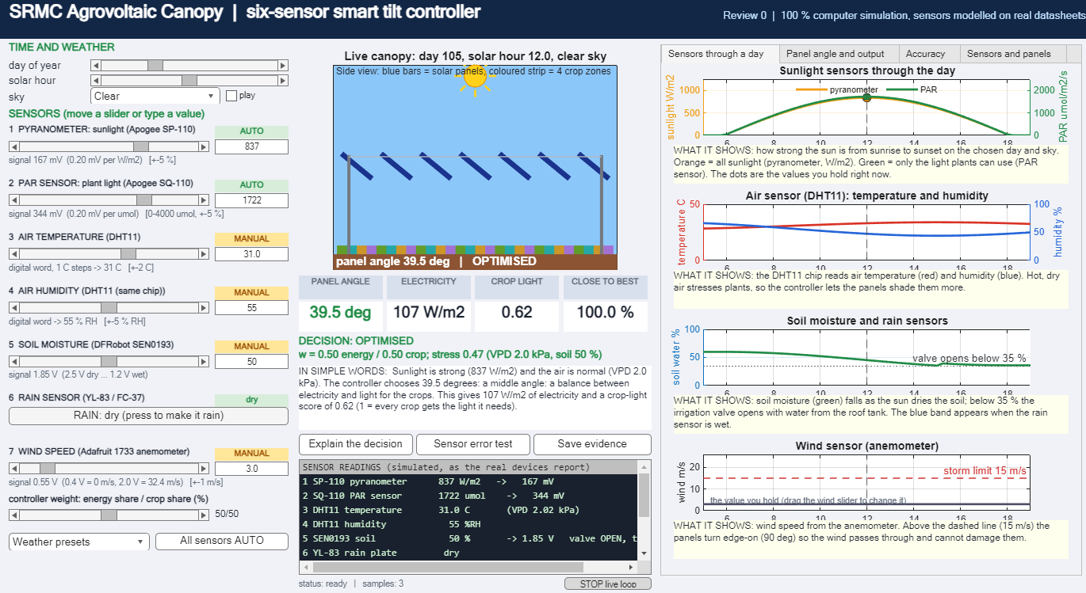
Figure: the dashboard. Left: the seven sensor readings, each with its device name, signal and MANUAL or AUTO tag. Right: sensors through a day.

3. The solar panels
Item | Value (official JinkoSolar datasheet, file P1_panel_JinkoSolar_JKM550M-72HL4-V_datasheet.pdf)
Model | JinkoSolar Tiger Pro JKM550M-72HL4-V, monocrystalline
Number of panels | 8 (2 rows x 4, landscape across the tube) = 4.4 kWp (hardware pack, Review 1)
Size and weight | 2274 x 1134 x 35 mm, 28.9 kg
Maximum power (test conditions) | 550 Wp
Vmp / Imp | 40.90 V / 13.45 A
Voc / Isc | 49.62 V / 14.03 A
Efficiency | 21.33 %
Tilt range in this project | 15-60 deg tracking, 3 deg rain, 90 deg storm stow

Where the numbers are used: the dashboard maximum-power-point tracker uses these five electrical numbers (single-diode model). The controller energy model uses 21 % module efficiency with the PVGIS temperature model. The temperature coefficients of the tracker are typical values, not read from this datasheet. The datasheet is the Chinese-language edition; the structure calculation earlier used 2278 mm and 27.5 kg from retailer listings (small difference).

4. Where the sunlight comes from
No sunlight was measured. The dashboard calculates it, and the pyranometer on screen is a stand-in that holds that value or the one you type.
- Sun position: standard astronomy (declination, hour angle) for 9.88 N, 78.08 E, for the day and hour on the sliders.
- Sunlight above the air: solar constant 1361 W/m2 corrected for the Earth-sun distance of the day.
- Through the sky: multiplied by a clearness index kt. Skies: Clear 0.62, Hazy 0.50, Partly cloudy 0.36, Overcast 0.18. Clear is set close to the NASA POWER April average of 0.60 for the site.
- Direct and diffuse split: Erbs model. PAR: 45 percent of the sunlight, 4.57 umol per joule (PAR = 2.06 x sunlight).
- If you move the pyranometer or PAR slider, the controller uses exactly your number.
Datasets downloaded as proof (Proof/10_Review0_Sensors_and_Panels/sunlight_datasets/, downloaded 2026-11-01):
File | What it is | Source
NASA_POWER_hourly_2023-04-15_LST_TCE.json | hourly all-sky and clear-sky sunlight, PAR, temperature, humidity, wind for 15 April 2023 | NASA POWER API (power.larc.nasa.gov), community AG, MJ/m2/hour
NASA_POWER_monthly_climatology_TCE.json | monthly sunlight, clearness index, temperature, humidity, wind, rain | NASA POWER climatology API
PVGIS_ERA5_hourly_2020_TCE.csv | hourly direct and diffuse sunlight, 2020 | PVGIS (EU Joint Research Centre), ERA5
PVGIS_monthly_radiation_TCE.csv | monthly sunlight 2005-2020 | PVGIS MRcalc
DASHBOARD_model_ghi_day105.csv | what the dashboard model gives for 15 April for the four skies | review0_physics.m

5. How the dashboard compares with those datasets
15 April, TCE, flat ground | Dashboard Clear | NASA actual day | NASA clear-sky | PVGIS April mean | PVGIS clearest April-2020 day
Daily sunlight (Wh/m2) | 6502 | 6539 | 7144 | 6337 | 7544
Noon peak (W/m2) | 837 | 897 | 986 | - | 1043

- The dashboard Clear day gives the same daily energy as a real average April day: within 0.6 percent of NASA actual day, 2.6 percent above the PVGIS April mean.
- It is not a perfectly cloudless sky: a truly clear day gives 15 to 25 percent more at noon. Say "a typical clear April day".
- Shape and timing agree: RMSE 78 W/m2 against NASA actual day, 104 W/m2 against NASA clear-sky.
- PAR share: NASA POWER 0.444, dashboard 0.45.
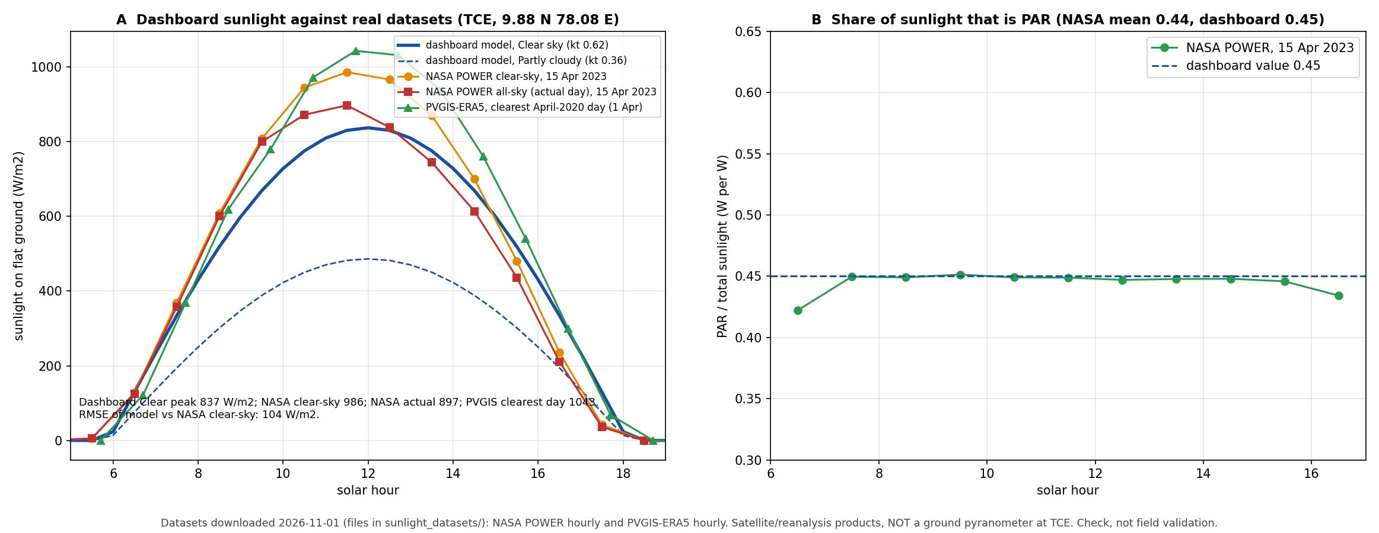
Month by month (file MONTHLY_sunlight_model_vs_NASA_PVGIS.csv, full-year NASA POWER hourly data of 2023 and PVGIS-ERA5 hourly data of 2020):
- Against NASA POWER 2023 the model year average is +2.0 percent; monthly differences range from -6.9 to +9.9 percent; hourly shape RMSE 40 to 91 W/m2 (mean 67).
- Against PVGIS-ERA5 of the single year 2020 the model is +7.9 percent on average, and +16 to +26 percent in June to September and December. One reanalysis year differs from the long-term climate; the earlier multi-year PVGIS comparison gave +5.0 percent. The model is a good typical year, not a prediction of one year.
- Real hourly wind at TCE in 2023 never exceeded 10.9 m/s (hourly means at 10 m, no gusts), so the 15 m/s storm stow never triggered in that data.
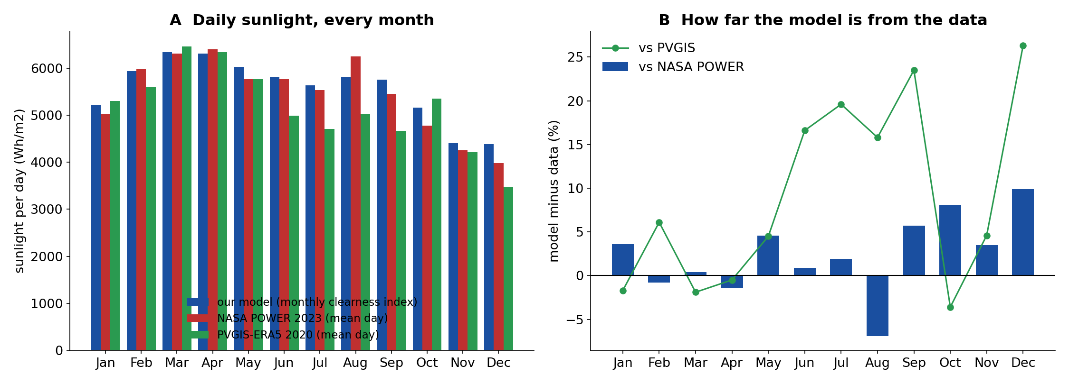
Other checks already in the project (Proof folder): yearly electricity against PVGIS +5.0 percent (03_Solar_Generation/pv_validation.txt, monthly errors 8 to 11 percent in June to August); shadow model against Blender 3-D ray tracing, mean difference 0.010 in lit fraction (shading_validation.txt); the web twin and the MATLAB model give identical results (crosscheck_js_vs_matlab.txt); Review 0 tests pass (Review0_Prototype_Demo/results/test_results.md).

6. Accuracy of the co-optimisation (the main result)
Accuracy = how close the controller angle is to the best possible angle on the combined score (half electricity, half crop light), found by trying every angle from 15 to 60 degrees at 0.5 degree steps. 100 percent = as good as the best angle.
Design | Combined score | Electricity | Crop light value | Angle error
Fixed 15 deg (max power) | 80.0 % | 99.2 % | 45.2 % | 34.0 deg
Sun tracking | 84.0 % | 88.6 % | 64.3 % | 25.0 deg
Fixed 45 deg | 91.2 % | 81.0 % | 84.6 % | 16.3 deg
Monthly plan, no sensors | 98.8 % | 82.2 % | 96.3 % | 9.5 deg
OUR controller, six noisy sensors | 99.6 % | 82.1 % | 97.7 % | 4.8 deg

Source: Proof/05_Controller_and_Accuracy/T11_accuracy_v2.csv (864 noisy test cases, sensor noise: pyranometer and PAR 5 percent, DHT11 +-2 C and +-5 %RH, soil +-3 percent). On the Review 0 dashboard, one clear April day with datasheet-sized random sensor errors (one fixed random draw): our controller 99.4 percent, fixed 45 degrees 87.0 percent, plain sun tracking 87.5 percent.
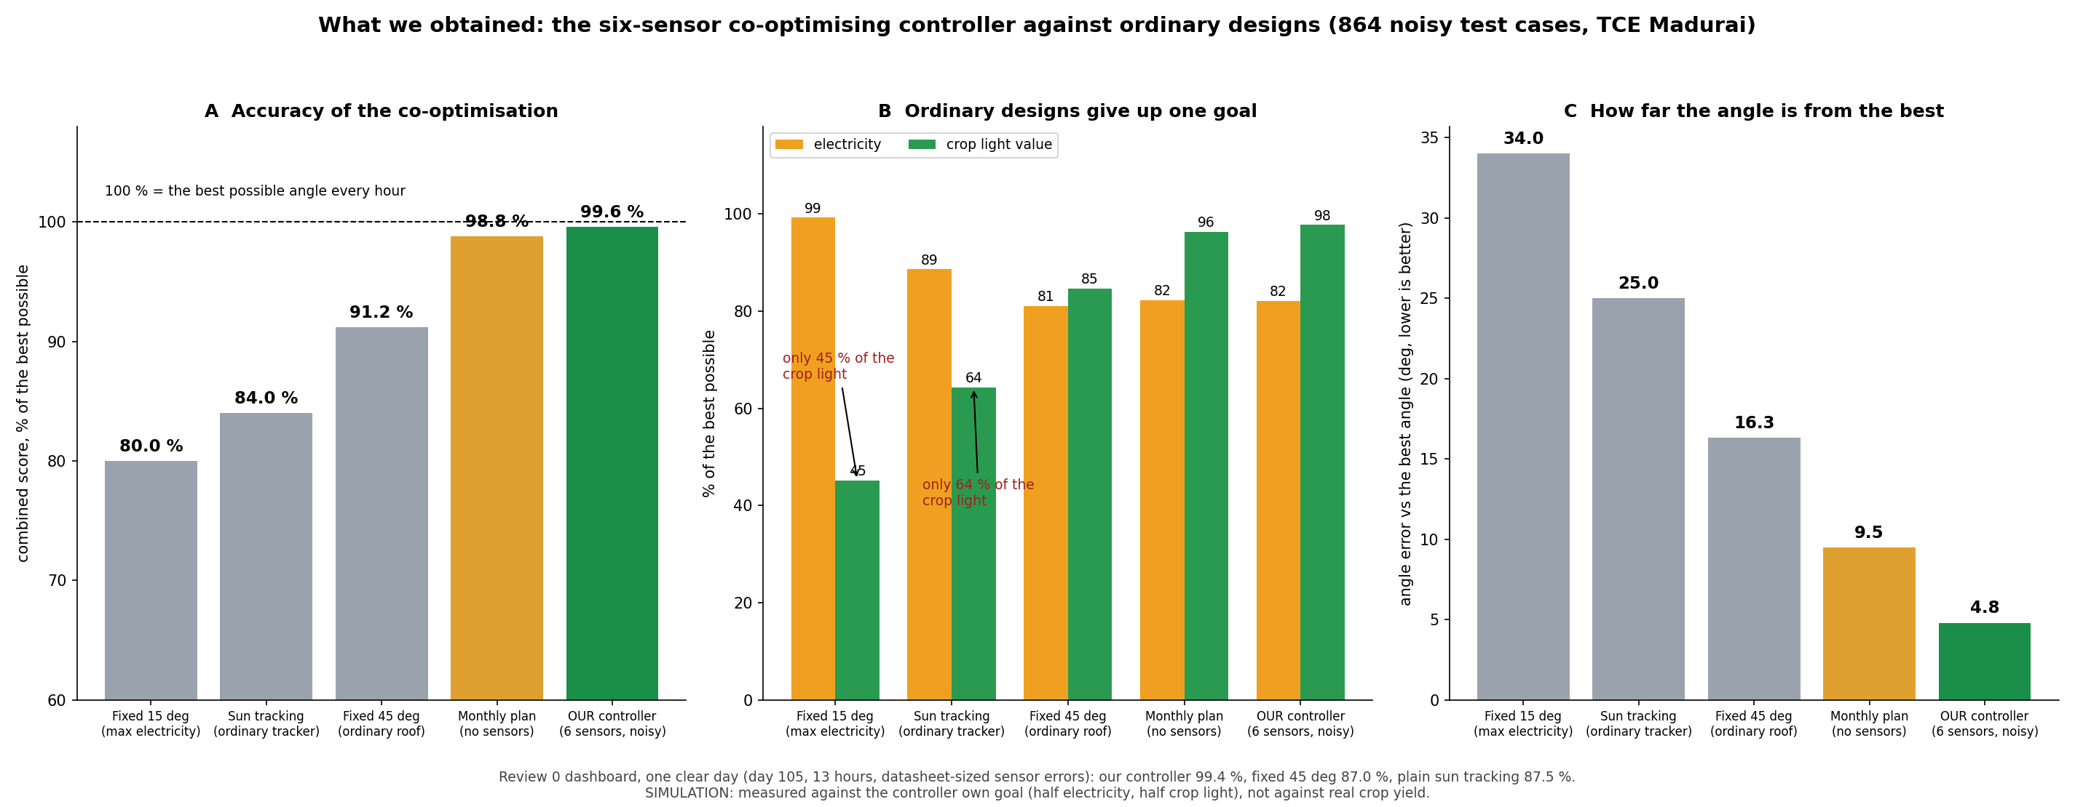

7. Where every input came from (data lineage)
Input | Source | Real, typical or assumed
Weather (monthly temperature, humidity, wind, rain, clearness index) | NASA POWER climatology, 9.88 N 78.08 E | Real dataset (monthly means)
Sunlight reference for checks | PVGIS-ERA5, NASA POWER | Real datasets (satellite/reanalysis, not a roof sensor)
Sun position | astronomical equations | Physics
Sensor behaviour (range, accuracy, signal) | manufacturer datasheets, files in sensor_datasheets/ | Published datasheet values
Sensor readings in every run | calculated or typed | SIMULATED
Panel electrical values | JinkoSolar datasheet | Published datasheet values
Module efficiency in the energy model (21 %), system loss 14 % | typical monocrystalline module, PVGIS default | Typical
Soil, crop light limits, crop prices, tariff, farmer share | typical library values and project assumptions (Proof/01_Data_and_Sources/DATASET_SOURCES.md) | Typical / assumed, not measured at TCE

8. Limits (say them before a judge does)
- It is a simulation. No field trial and no sensor was wired. Sensor readings are generated or typed, not measured.
- NASA POWER and PVGIS are satellite and reanalysis products, not a pyranometer on the TCE roof: this is a check, not a field validation.
- Hour by hour: 15 April, and the monthly mean day of every month of 2023. Against PVGIS of the single year 2020 the model is 16 to 26 percent high in some months; the long-term PVGIS comparison gives +5 percent.
- The dashboard Clear sky is a typical clear April day, below a perfectly cloudless sky (noon 837 against 986 W/m2).
- Accuracy is measured against the controller own goal (half electricity, half crop light) in simulation, not against real crop yield.
- The rain sensor has no official datasheet, only vendor pages. The Jinko datasheet is the Chinese-language edition.
- Prices, farmer share and crop values are assumptions.

9. Questions a judge may ask
Q: Are the sensors real? A: No. They are software models of real devices (SP-110, SQ-110, DHT11, SEN0193, YL-83, Adafruit 1733), set from their datasheets. The datasheets are in the proof folder. Hardware is the next step.
Q: Where does the sunlight number come from? A: It is calculated from the sun position and a clearness index from NASA POWER for our site, and checked against NASA POWER and PVGIS (daily energy within about 1 to 3 percent on 15 April and within 10 percent in every month against NASA POWER 2023, PAR share 0.444 against 0.45).
Q: Why should I trust the accuracy figure? A: It is the controller score against the best angle found by trying every angle, with datasheet-sized sensor errors added; the data file is T11_accuracy_v2.csv. It measures our own goal in simulation, not crop yield.
Q: Which solar panel? A: JinkoSolar Tiger Pro JKM550M-72HL4-V, 550 Wp, 8 panels = 4.4 kWp; the datasheet is stored.
Q: Why is the clear sky 837 W/m2 and not 1000? A: The dashboard Clear day is a typical clear April day (clearness index 0.62, close to the NASA POWER April mean 0.60). A perfectly cloudless day gives about 986 W/m2.
Q: What is new? A: Choosing the panel angle from sensors to co-optimise crop light and electricity, with a safety layer for rain, wind and faulty sensors.
Q: What is next? A: Build the real sensor set, log a month, compare with the twin; measure crop light or yield; finish the paper.

10. Where to find things
What | Where
Sensor datasheets | Proof/10_Review0_Sensors_and_Panels/sensor_datasheets/
Sunlight datasets | Proof/10_Review0_Sensors_and_Panels/sunlight_datasets/
Sunlight trust figure and numbers | TRUST_sunlight_model_vs_NASA_PVGIS.png, TRUST_numbers.json
Accuracy figure | ACCURACY_obtained_vs_ordinary.png; data Proof/05_Controller_and_Accuracy/T11_accuracy_v2.csv
Sources and sensor/panel table (Markdown) | SENSOR_AND_PANEL_PROOF.md, WHERE_SUNLIGHT_COMES_FROM_AND_WHY_TRUST_IT.md
Data lineage of the whole project | Proof/01_Data_and_Sources/DATASET_SOURCES.md
Dashboard | Review0_Prototype_Demo/matlab/review0_dashboard.m (type review0_dashboard in MATLAB)
Checksums of every proof file | Proof/MANIFEST.csv
Code | GitHub: thanwin19/agrovoltaic-canopy-srmc

