DS 5110: Introduction to Data Management and Processing (Fall 2024)
Student name: Thanya Mysore Santhosh
PS5: MongoDB and Big Data
1 MongoDB (50%)
1. Load the file restaurants.json into a MongoDB database. The file contains data on 3,772 restaurants in New York City. Write the following queries in MongoDB (show the output of your queries):
(a) Display all the restaurants located in the boroughs Bronx or Brooklyn.
Solution:
db.restaurants.find(
{ borough: { $in: ["Bronx", "Brooklyn"] } }
)

(b) Find the restaurant id, name, borough and cuisine for those restaurants whose name starts with the letters ’Mad’.
Solution:
db.restaurants.find(
{ name: { $regex: /^Mad/i } },
{ restaurant_id: 1, name: 1, borough: 1, cuisine: 1, _id: 0 }
)
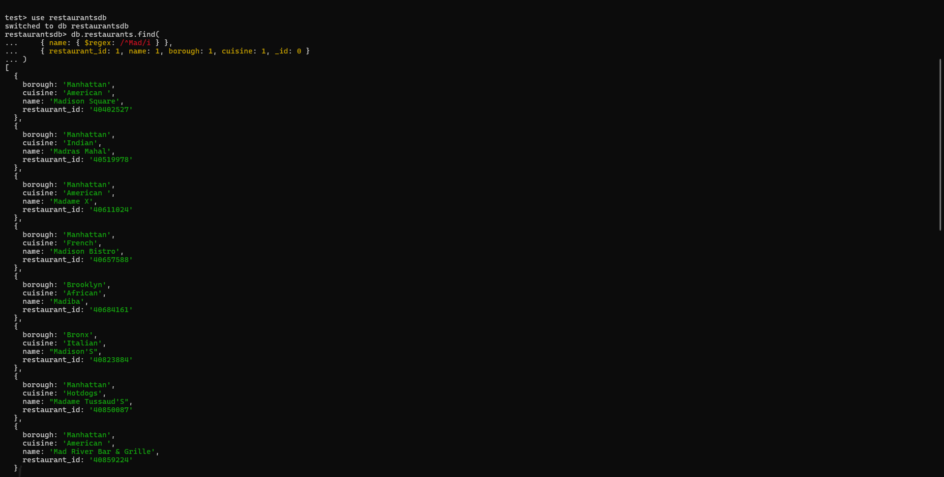

(c) Find the restaurants that have received a score between 80 and 90 (inclusive).
Solution:
db.restaurants.find(
{ "grades.score": { $gte: 80, $lte: 90 } }
).pretty()

(d) Display the restaurant id and name of restaurants which have received a ’C’ grade in year 2014.
Solution:
db.restaurants.find(
{
"grades.grade": "C",
"grades.date": { $gte: new ISODate("2014-01-01"), $lt: new ISODate("2015-01-01") }
},
{ restaurant_id: 1, name: 1, _id: 0 }
).pretty()
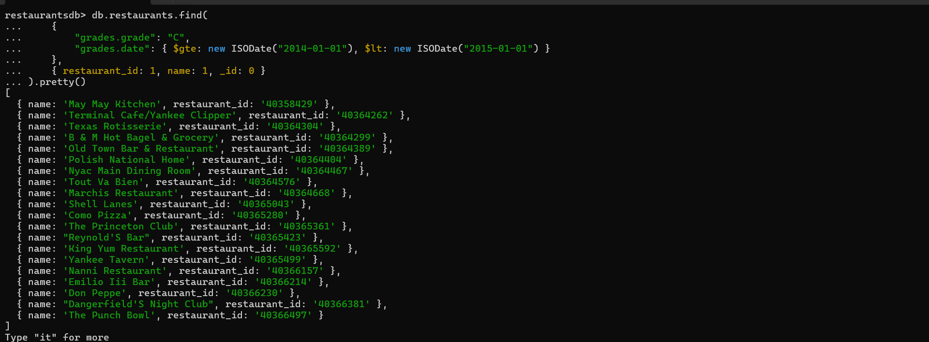
(e) Find the cuisine that has the highest number of restaurants.
Solution:
db.restaurants.aggregate([
{ $group: { _id: "$cuisine", count: { $sum: 1 } } },
{ $sort: { count: -1 } },
{ $limit: 1 }
])

(f) Find the restaurants that do not prepare an ’American’ cuisine and their average grade score is higher than 30. Display the restaurant ids and their average score.
Solution:
db.restaurants.aggregate([
{ $match: { cuisine: { $ne: "American" } } },
{ $unwind: "$grades" },
{ $group: {
_id: "$restaurant_id",
avgScore: { $avg: "$grades.score" }
}},
{ $match: { avgScore: { $gt: 30 } } },
{ $project: { restaurant_id: "$_id", avgScore: 1, _id: 0 } }
])
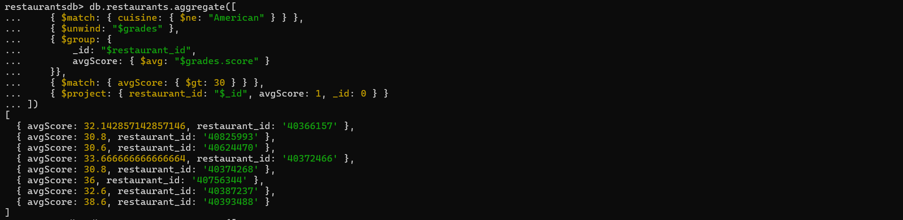

(g) For each restaurant display only the grades that were recorded from the year 2014 onwards.
Solution:
db.restaurants.find(
{},
{
"name": 1,
"restaurant_id": 1,
"grades": {
"$filter": {
"input": "$grades",
"as": "grade",
"cond": { "$gte": ["$$grade.date", new Date("2014-01-01")] }
}
},
"_id": 0
}
)
(h) Calculate the average score across all the restaurants in the collection.
Solution:
db.restaurants.aggregate([
{ $unwind: "$grades" },
{ $group: { _id: null, avgScore: { $avg: "$grades.score" } } },
{ $project: { _id: 0, avgScore: 1 } }
])

2. Create a collection named sales with the following documents:
{ " _id ": 1 , " city ": " Berkeley " , " state ": " CA " , " qty ": 648 } ,
{ " _id ": 2 , " city ": " Bend " , " state ": " OR " , " qty ": 491 } ,
{ " _id ": 3 , " city ": " Kensington " , " state ": " CA " , " qty ": 233 } ,
{ " _id ": 4 , " city ": " Eugene " , " state ": " OR " , " qty ": 842 } ,
{ " _id ": 5 , " city ": " Reno " , " state ": " NV " , " qty ": 655 } ,
{ " _id ": 6 , " city ": " Portland " , " state ": " OR " , " qty ": 408 } ,
{ " _id ": 7 , " city ": " Sacramento " , " state ": " CA " , " qty ": 574 }
Solution:
db.sales.insertMany([
{ "_id": 1, "city": "Berkeley", "state": "CA", "qty": 648 },
{ "_id": 2, "city": "Bend", "state": "OR", "qty": 491 },
{ "_id": 3, "city": "Kensington", "state": "CA", "qty": 233 },
{ "_id": 4, "city": "Eugene", "state": "OR", "qty": 842 },
{ "_id": 5, "city": "Reno", "state": "NV", "qty": 655 },
{ "_id": 6, "city": "Portland", "state": "OR", "qty": 408 },
{ "_id": 7, "city": "Sacramento", "state": "CA", "qty": 574 }
])
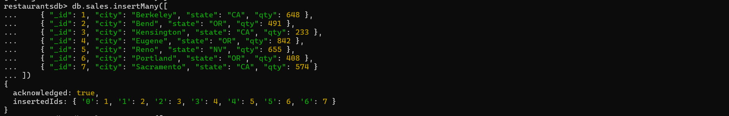

(a) Find the total quantity of sales for each state and sort the quantities in descending order. The result should look as follows:
[
{ state : ’OR ’ , total_qty : 1741 } ,
{ state : ’CA ’ , total_qty : 1455 } ,
{ state : ’NV ’ , total_qty : 655 }
]
Solution:
db.sales.aggregate([
{ $group: { _id: "$state", total_qty: { $sum: "$qty" } } },
{ $sort: { total_qty: -1 } }
])
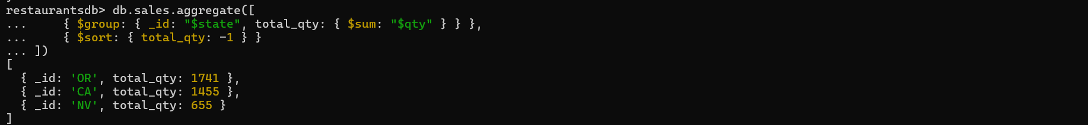

(b) Perform the following update operations on the sales collection:
i. Change the quantity of the sales in Berkeley from 648 to 750.
Solution:
db.sales.updateOne(
{ city: "Berkeley" },
{ $set: { qty: 750 } }
)
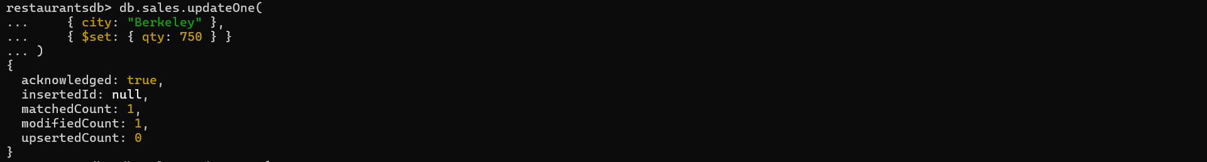
ii. Increase the quantity of all the sales in Oregon by 50.
Solution:
db.sales.updateMany(
{ state: "OR" },
{ $inc: { qty: 50 } }
)
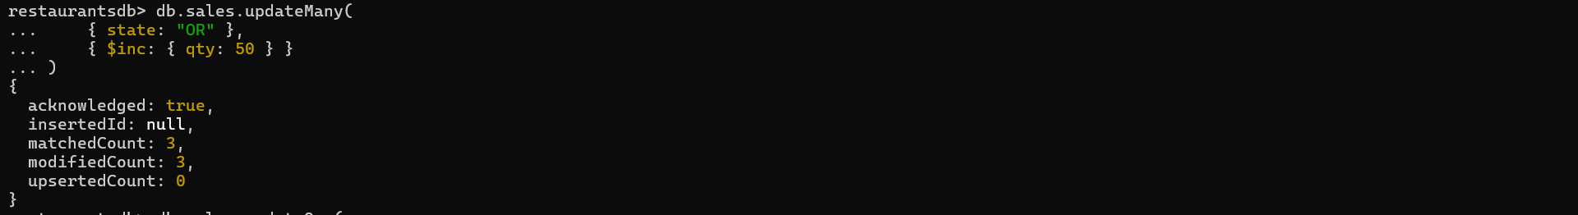
iii. Add to sales no. 5 the names of the salespeople: David and Martha.
Solution:
db.sales.updateOne(
{ _id: 5 },
{ $set: { salespeople: ["David", "Martha"] } }
)
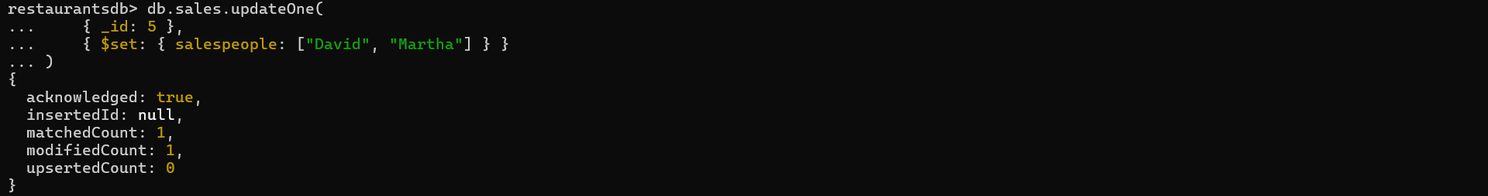
iv. Add James to the list of salespeople of sales no. 5.
Solution:
db.sales.updateOne(
{ _id: 5 },
{ $addToSet: { salespeople: "James" } }
)
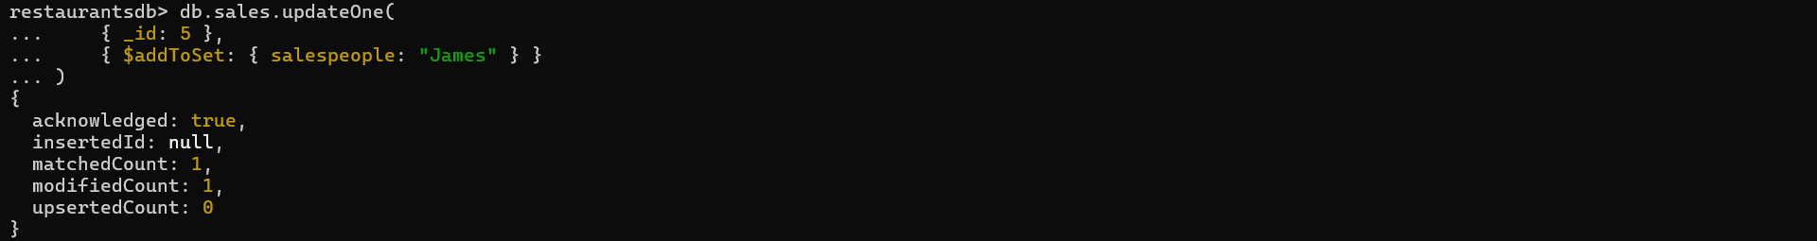
v. Replace Martha with Lisa in the salesperson list of sales no. 5.
Solution:
db.sales.updateOne(
{ _id: 5, salespeople: "Martha" },
{ $set: { "salespeople.$": "Lisa" } }
)
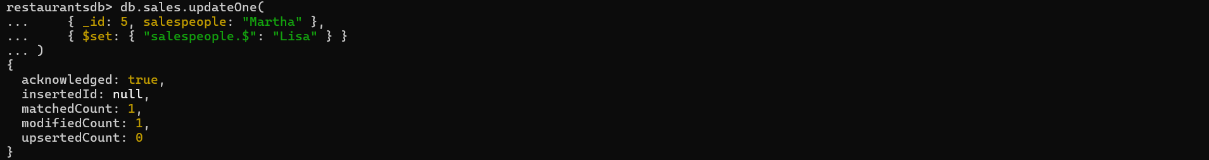
vi. Delete all the sales from California.
Solution:
db.sales.deleteMany(
{ state: "CA" }
)

(c) Print the final sales collection.
Solution:
db.sales.find().pretty()
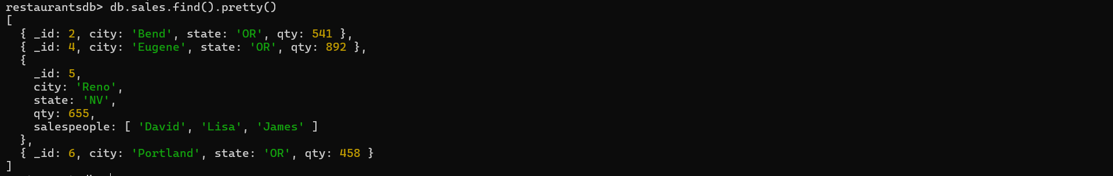

3. Load the file books.json into a MongoDB database. Write a Python script that lets the user enter a books category and prints the ISBN and titles of all the books in that category. A sample run:
Enter category : Computer Graphics
ISBN : 1884777902 , title : 3 D User Interfaces with Java 3 D
ISBN : 133034054 , title : Graphics File Formats
ISBN : 1933988398 , title : Gnuplot in Action
ISBN : 1884777473 , title : The Awesome Power of Direct3D / DirectX
ISBN : 138412146 , title : Power -3 D
ISBN : 1930110022 , title : Graphics Programming with Perl
Solution:
from pymongo import MongoClient

client = MongoClient("mongodb://localhost:27017/")
db = client["booksdb"]
books_collection = db["books"]

categories = books_collection.distinct("categories") # Get all available categories
print("Available categories:", categories)

category = input("Enter category: ") # Prompt the user for a category

# Query the books collection by category
books = books_collection.find(
{"categories": {"$in": [category]}},
{"ISBN": 1, "isbn": 1, "title": 1, "_id": 0}
)

found = False
print(f"Books in category '{category}':")
for book in books:
isbn = book.get('ISBN') or book.get('isbn', 'N/A')
title = book.get('title', 'N/A')
print(f"ISBN: {isbn}, Title: {title}")
found = True

if not found:
print("No books found in this category.")

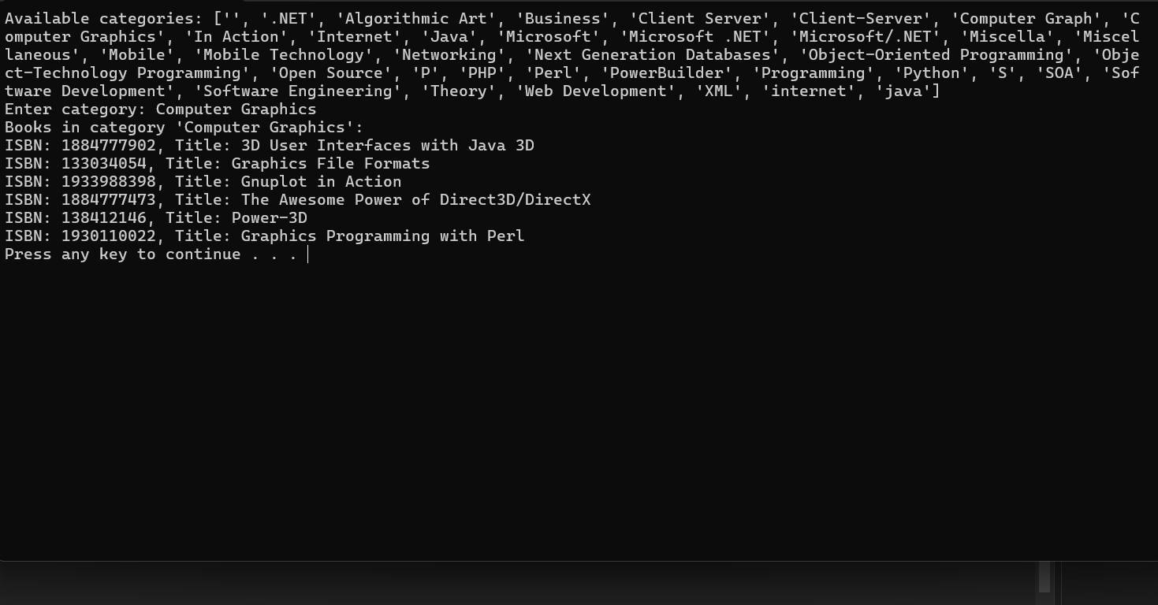

2 MapReduce (20%)
Describe how to implement the following relational operations using MapReduce. Write the map and reduce functions in pseudocode.
1. Projection πS (R): From each tuple of relation R produce only the components for the attributes in S.
Solution:
# Map function
def map(tuple):
projected_tuple = {attr: tuple[attr] for attr in S} # Extract only the attributes in S
emit(null, projected_tuple)

# Reduce function
def reduce(key, values):
for value in values:
emit(value)

2. Intersection R∩S: Return the tuples that are present in both relations R and S. Assume that relations R and S have the same schema (same attributes and same type).
Solution:
# Map function
def map(tuple, relation_name):
emit(tuple, relation_name)

# Reduce function
def reduce(tuple, relation_names):
if "R" in relation_names and "S" in relation_names:
emit(tuple)

3. Grouping γA,θ(B)(R).
Given a relation R(A, B, C), with one grouping attribute A, one aggregated attribute B, and another attribute C, which is neither grouped or aggregated:
(a) Partition the tuples of R according to their values in attribute A.
(b) For each group, aggregate the values in attribute B and apply function θ on the aggregated value (θ is an aggregation operation such as SUM, COUNT or MAX).
The result of this operation is one tuple for each group. That tuple has a component for the grouping attribute A, with the value common to tuples of that group. It also has a component for each aggregation θ(B), with the aggregated value for that group
Solution:
# Map function
def map(tuple):
emit(tuple["A"], tuple["B"]) # Extract only the attributes in S

# Reduce function
def reduce(a_value, b_values):
aggregated_value = θ(b_values) #Apply aggregation function θ on the list of B values
emit({"A": a_value, "θ(B)": aggregated_value})

