How to set up and program Olimex ESP32-PRO in Arduino IDE
under Windows OS

1. Download and install Arduino IDE.

Skip this part if you already have Arduino IDE 1.8.19 installed. Newer versions are not guaranteed to work.

We’ve used Arduino IDE 1.8.19. It can be downloaded from this page, scroll down for the legacy 1.8.19 version:

https://www.arduino.cc/en/Main/Software

2. Add the URLs of third party packages in Arduino IDE.

This requires adding the URLs of few packages to the Arduino IDE: an Espressif Arduino package, an Olimex packages (for AVR and PIC boards), and a Chipkit one.

The Espressif Arduino package is needed to program the ESP32 part of the design.

The Olimex and Chipkit packages are needed to program the PIC32 part. You might skip installing them if you are only interested in programming the ESP32 part.

Launch Arduino IDE. Open the menu File → Preferences. A dialog window would be displayed. Search for the field called "Additional Boards Manager URLs". At the end of the field, there is a button, which represents two dialog windows. When you click on it there should appear another dialog window, with a text box area. Please enter as it is the following:

https://espressif.github.io/arduino-esp32/package_esp32_index.json

https://raw.githubusercontent.com/OLIMEX/Arduino_configurations/master/PIC/package_olimex_pic_index.json

https://github.com/chipKIT32/chipKIT-core/raw/master/package_chipkit_index.json

It should look similar to this:

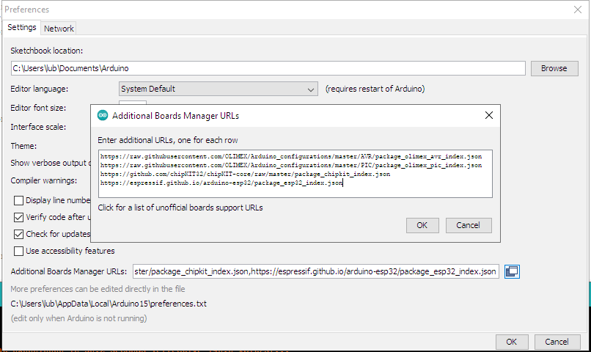
After that click on the OK button the dialog should hide. Then click the OK button of the Preferences dialog window. You will return to the main IDE window.

3. Install the third party packages:

Click the menu Tools → Board: XXXXX → Boards manager (where XXXXX is your current board selection). Install the Espressif boards package. To do so from the search field type "esp32", you should see among the results “"esp32” by Espressif Systems". Install this package.

If you are not interested in programming the PIC32 part over USB you can skip the next part, else search for Olimex. You must see two packages, which could be installed - "chipKIT by chipKIT Community", "Olimex PIC Boards by OLIMEX LTD”. Install them. This will add all Olimex PIC boards along with chipKIT boards that are supported by Arduino IDE. Installing the boards also installs the cores/tools/packages needed in Arduino.
The packages I used here successful are the following versions:

- chipKIT by chipKIT Community – 2.1.0
- Olimex PIC Boards by OLIMEX LTD – 1.2.6
- esp32 by Expressif Systems – version 3.0.0

4. Install the Windows driver.

Install the proper chipKIT CDC driver. ESP32-PRO has a PIC32 MCU onboard, which is programmed to provide USB->Serial bridge, so you can upload your sketches to ESP32 chip via the USB interface. Unfortunately you must install drivers, as Windows doesn't recognize the device as standard CDC device. You can download the driver from here:

https://s3.amazonaws.com/chipkit/drivers/chipKIT Drivers/chipKITDriverInstaller_v10.exe

After downloading, install the driver. Windows should now recognize ESP32-PRO board as stk500v2 device. You will also see new COM port created.

After plugging PIC32-PRO it should be listed in Windwos Device Manager similar to this (the COM number should be different):

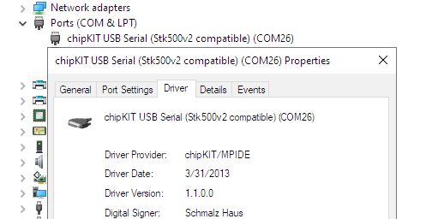

Now that preparation is complete, lets program the board via the USB.

5. Programming the ESP32 part

Plug the PIC32-PRO board to the computer via the USB micro connector and cable and check what COM port it got associated with in “Windows Device Manager”. Here I get it as COM26 but you would get different COM port number.

Then from Tools → Board select “ESP32 Dev Module” and change the upload speed to 115200, flash mode to DIO, and select the COM port assigned to the board. It should look similar to this (make sure you put your COM port number):

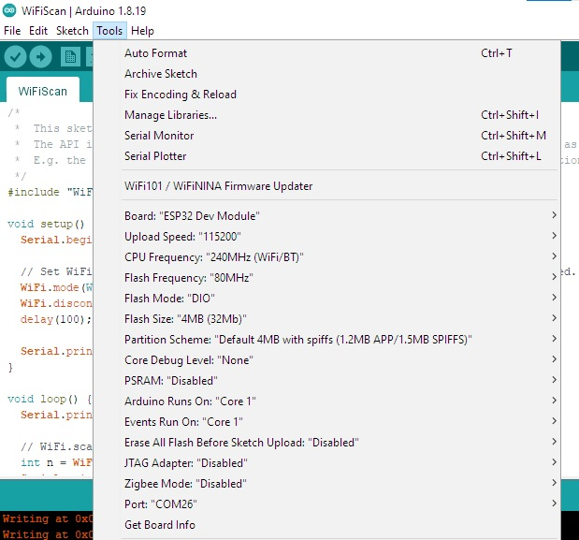
Then load an example suitable for the board. I usually load the WiFiScan demo. Go to File → Examples → (under Examples for ESP32 Dev Module) → WiFi → WiFiScan.

Click upload and wait. Once the example is downloaded successfully to the board, open Tools → Serial monitor and press Enter or send any symbol (this auto bauds the serial) and see if you get the WIFI scan results.

You can test other ESP32 examples or write your own.

6. Programming the PIC part of the design (changing the firmware)

IMPORTANT! Modifying and overwriting the PIC32 firmware would likely result in inability to further program the ESP32 part via USB. In rare cases you might even disable the option to re-program the PIC32 part via USB any further (and you will need PIC32 ISP programmer to restore that functionality). Modify the PIC32 firmware at your own risk, preferably only if you know what you are doing!

PIC32 firmware can be modified and changed via the USB but this requires additional hardware effort. There are two extra requirements:

1. PROG_EN SMT jumper has to be closed (it is closed by default, so nothing special here);

2. You need to set the PIC32 in bootloader mode. This requires connecting RB2 and GND for a couple of seconds. This is done usually like that: after you have connected the board to the micro USB, you need to establish connection between RB2 and GND (pins #7 and #4 of EXT1 header), either by a wire or by soldering a button there. Additionally a breadboard and wire or button can be used. It looks like this:

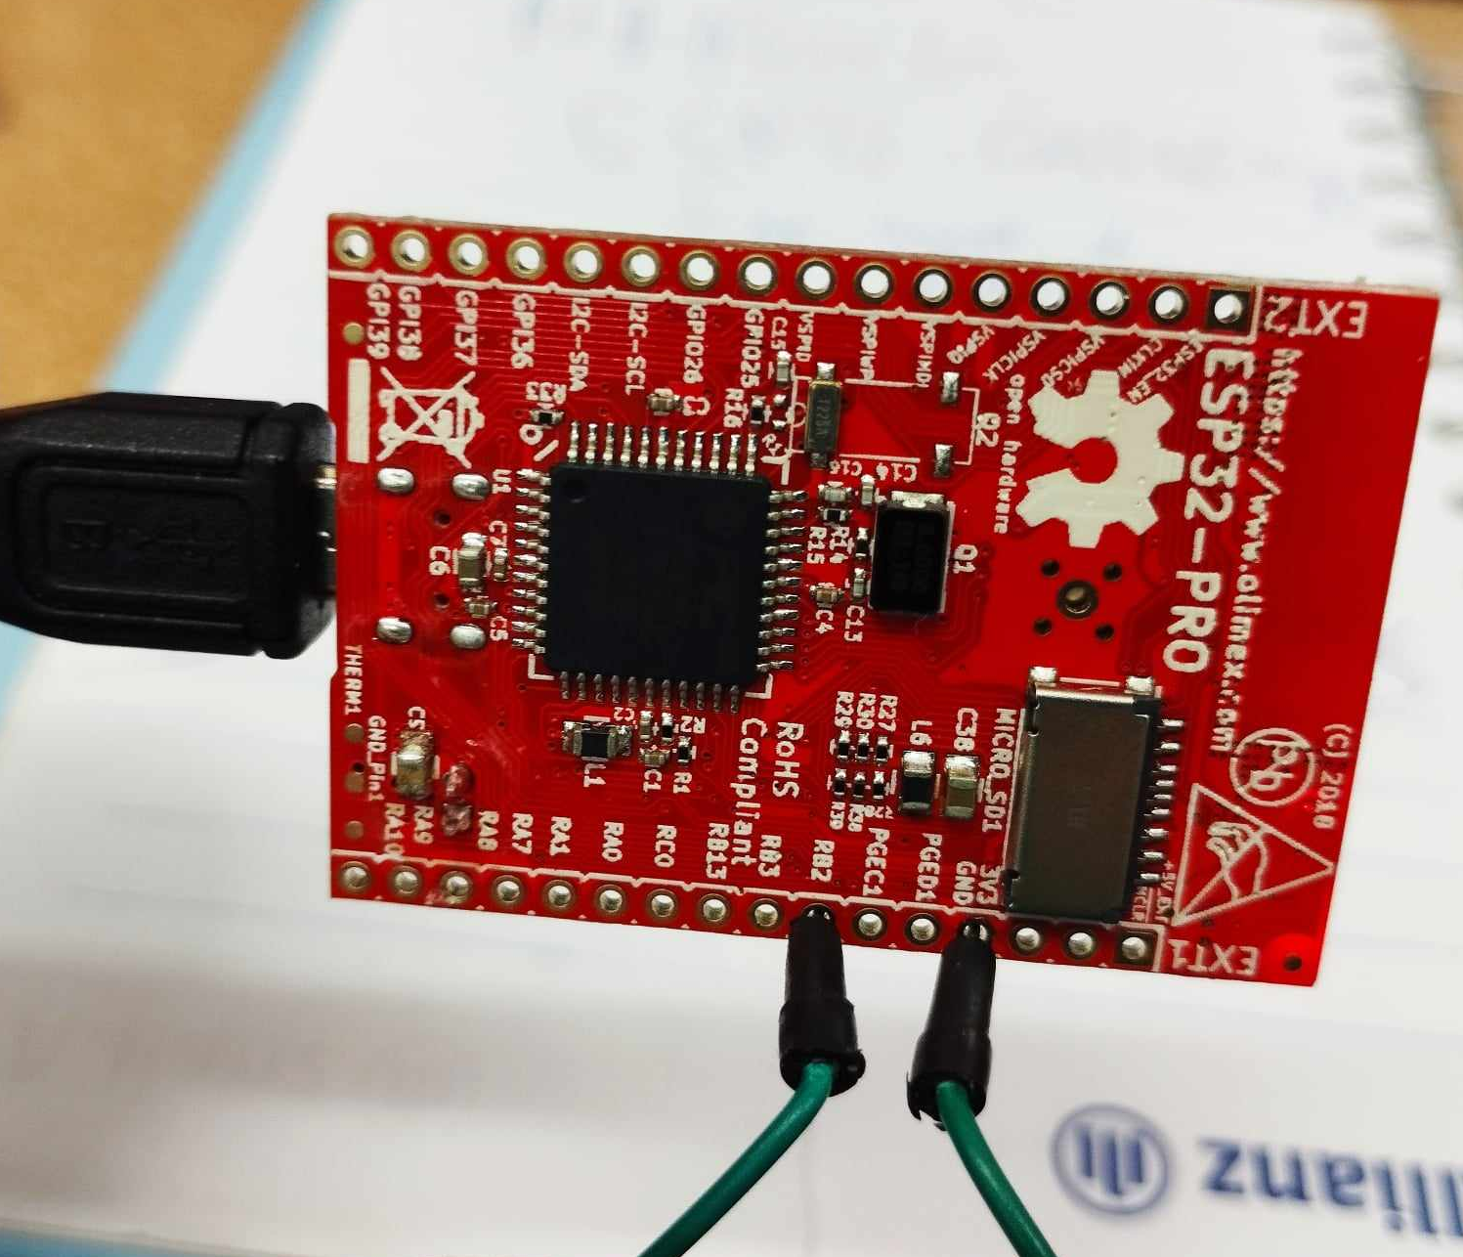
After you have established the connection, new COM port should appear. Go to the “Device Manager” to find what is the new COM port associated with the device. You can also remove the wiring now, but every time you want to program the PIC32 part you would need to establish that connection (if you focus on the PIC32 part, it might be wise to install a button between RB2 and GND, this way you can enter PIC32 bootloader mode via button press).

Start Arduino IDE and select ESP32-PRO board from the Olimex package. It should look like this:

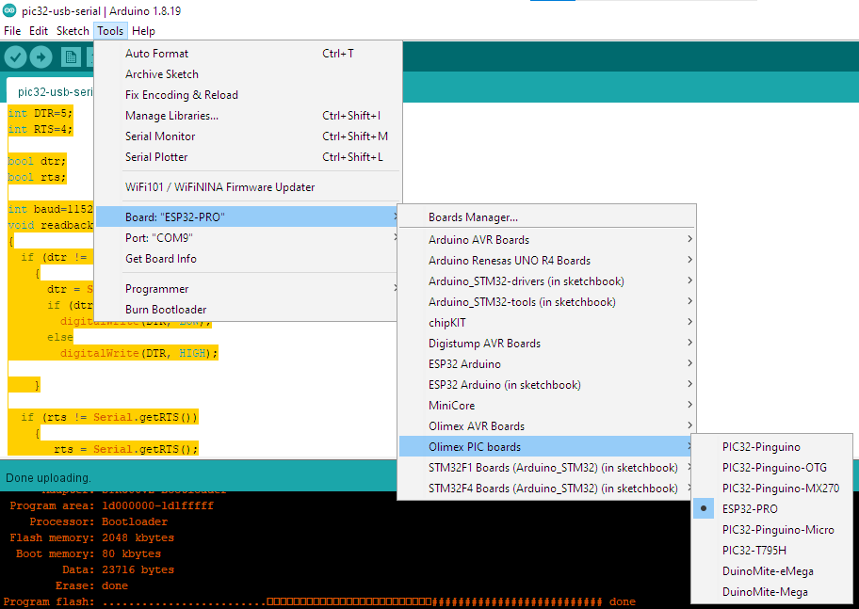
Now you can download code to the board. The code that we load by default is USB-serial converter, can be downloaded from here:

https://github.com/OLIMEX/ESP32-PRO/tree/master/SOFTWARE/PIC32_part_Arduino_IDE/PIC32_USB-Serial_Bridge/pic32-usb-serial

Feel free to analyze the schematic and expand on the firmware with more PIC32 functions!

The firmware of the PIC can be also changed by an external ISP programmer. Required pins can be found at the EXT1 header. The pinout for the ISP is as follows:

# | ISP signal | ESP32-PRO location
1 | RST | EXT1 #2
2 | 3.3V | EXT1 #3
3 | GND | EXT1 #4
4 | PGD | EXT1 #5
5 | PGC | EXT1 #6
6 | PGM | NOT CONNECTED

