|  |
| --- |
| Rico Foundation Grants |

* Objective: To provide assistance for disadvantaged children in Desruisseaux area.
* The foundation will offer a special grant this year in honor of Mrs. Anne Euriza James. This will be a one-time payment.

|  |
| --- |
| Mrs. Anne Euriza James |

Anne Euriza James

1. 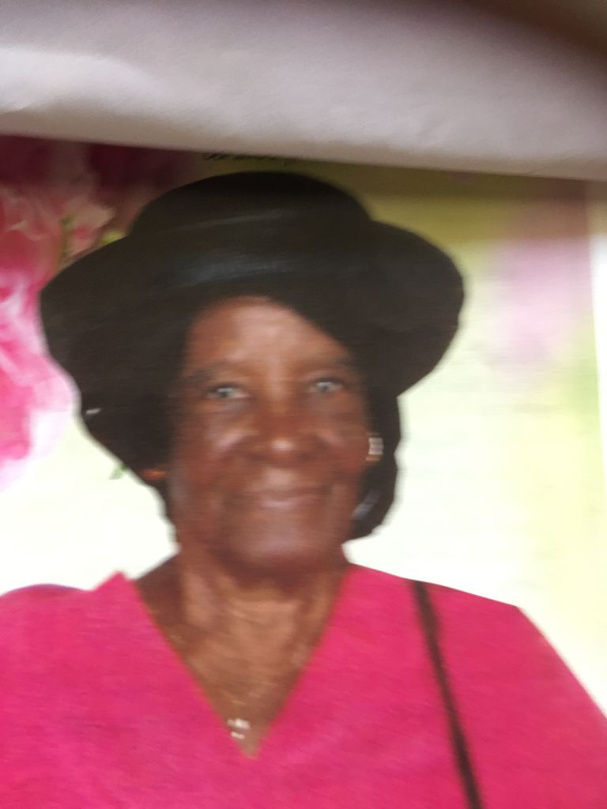Anne Euriza James was a community person. She was known by most people as Mrs. Euriza. She was a pupil teacher in Micoud and after her first two eldest children immigrated to the United Kingdom, she adopted three other children.
2. Her house was a haven for many. She played the organ in church. Indeed, she was passionate about the church, playing the organ whenever she was needed including weddings, funerals and Masses. She also had a passion for her confraternities. The Legion of Mary, the Sacred Heart and Mount Carmen, which she belonged.
3. Monthly she would visit all the sick people in the community, whether they were Catholics or not. She would encourage many Catholics who had left the church to come back, encouraged those who were not baptised or had not received the other sacraments to do so. She was always successful.
4. Of course, she was best known for her pre-school and also cared for her deceased father in his latter days. Her pre-school gave the majority of the little ones a good educational foundation, leading to prominent posts like ministers, nurses, doctors, teachers and lawyers. She was recognised for her long service in the community and received the Order of British Empire (OBE) award.
5. She was a very generous person. Sometimes too generous. She would often give all the proceeds of her pre-school concerts, for which she was famous, to the church as a donation. Mrs. Euriza would ask the whole school who wanted to buy icicles to come forward. The whole school of 40 to 50 children would come forward. She would give all the children in the school icicles whether they had money or not. And that she did quite often.
6. Some parents would send their children to school without food and Mrs. Euriza would give them food from hers. Some parents could not afford to pay school fees and she would tell them: never mind, send the children to school. Some parents would give her little by little and at times not paying all the school fees. She would speak to some parents if she saw that their daughters were speaking to someone who she thought was not right.
7. At the age of 92 Mrs. Euriza still cared for children. When parents wanted to leave early for work, she would keep the children in her balcony from 7am until the teachers arrived at 8:30am to open the schoolhouse. She would also keep and care for some children after school until their parents returned from work.
8. Mrs. Anne Euirza James died at the age of 93 with happy memories to most.

Mrs. Menna Flood

April 2021

|  |
| --- |
| Requirements |

* This is for a student with consecutive averages of 70 and above for the last two terms and their family is going through some hardship.
* Total Grant amount is $1,000 EC.

|  |
| --- |
| Completed Applications |

Please email all completed applications to Aymar Sinaise at [ricosfoundation@hotmail.com](mailto:ricosfoundation@hotmail.com)

Applications will be accepted between May 15th and July 20th, 2021.

|  |
| --- |
| Rico Foundation Grants Application |

|  |  |  |
| --- | --- | --- |
| **Please fill in your response** | | |
| 1 | LAST NAME: | FIRST NAME: |
| 2 | ADDRESS: | |
| 3 | AGE: | GENDER: |
| 4 | CURRENT SCHOOL: | AVERAGE: |
| 5 | PHONE NUMBER: | EMAIL: |
| 6 | TEACHER’S NAME: | |

|  |
| --- |
| On a separate sheet can you please provide a brief summary of how this Grant will be helpful this school year? |